Niobicon-Based AUV Docking Development 902106
Brett Hobson, François Cazenave, Andrew Hamilton

We have spent the last few months designing and building a prototype of the AUV dock and the supporting surface buoy. We are currently testing the system in MBARI’s test tank and performing docking on it with the LRAUV. We are planning to deploy this system in Monterey Bay in February and will leave it out for a few weeks, depending on performance.
We also performed tests of the AUV docking procedure in Monterey Bay using a simple mooring without any power-transfer capability.
In the coming months, we will be collaborating with WHOI engineers to design the final version of the AUV dock buoy. That system will be deployed around August 2022, for up to 6 months and will allow AUV charging and support science missions.

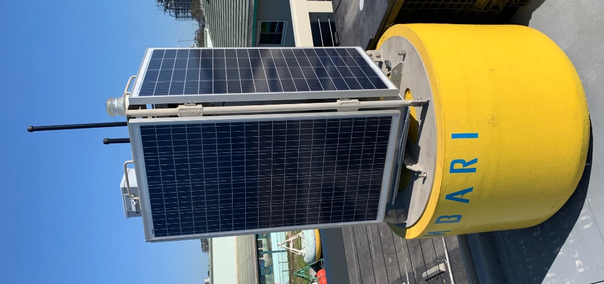  Figure 1: Solar energy will be harvested on the buoy and transfered to the AUV dock via a cable. | 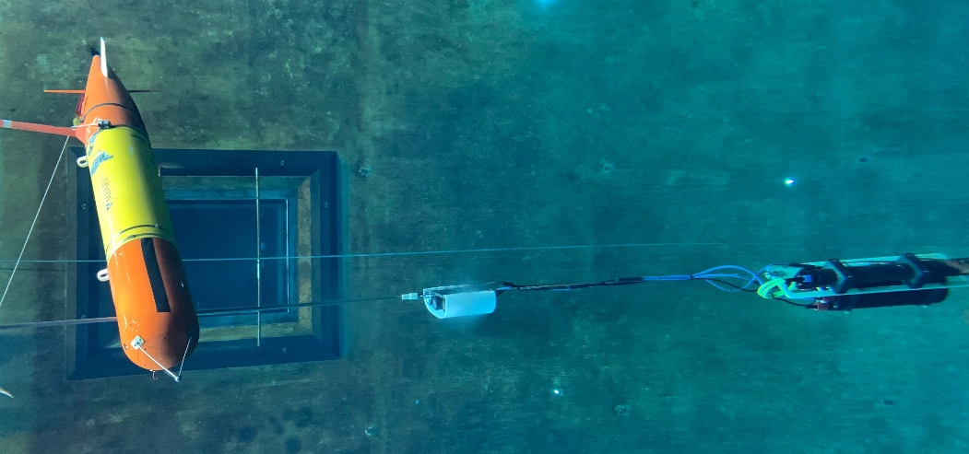  Figure 2: The LRAUV on the AUV dock in the test tank.

