Niobicon-Based AUV Docking Development 902106
Brett Hobson, François Cazenave, Andrew Hamilton

On March 24, we deployed the prototype of the docking system, including the solar harvesting buoy (figure 1) and the seafloor AUV dock. We were able to dock the AUV as soon as the system was in place and captured video on the AUV on the dock (figure 2). Unfortunately we quickly lost communications to the dock, due to a ground fault on the cable, and were not able to test charging of the AUV. Bad weather and ship unavailability have prevented us from recovering the system thus far. We are planning to recover, repair, and redeploy the system in the coming days.
We collected some very useful data during this deployment, especially on the performance of the buoy and the solar harvesting system. This data will be very helpful when we design the final version of the system. We also continued practicing docking the AUV, although we were not able to transfer power because of the ground fault.
Intellectual properties issues have prevented us from starting our collaboration with WHOI. These issues have been solved and we expect to sign an agreement with them in the next few days.
We designed and built an improved version of the dock’s power transfer device and used it to test data transfer. Early tests in the lab and the test tank were promising.

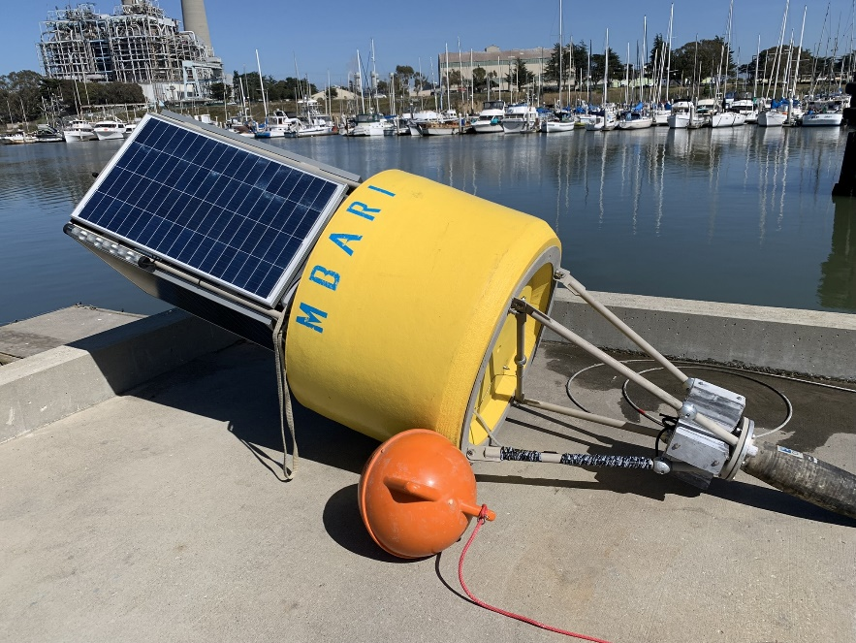  Figure 1: Solar energy harvesting buoy, before deployment | 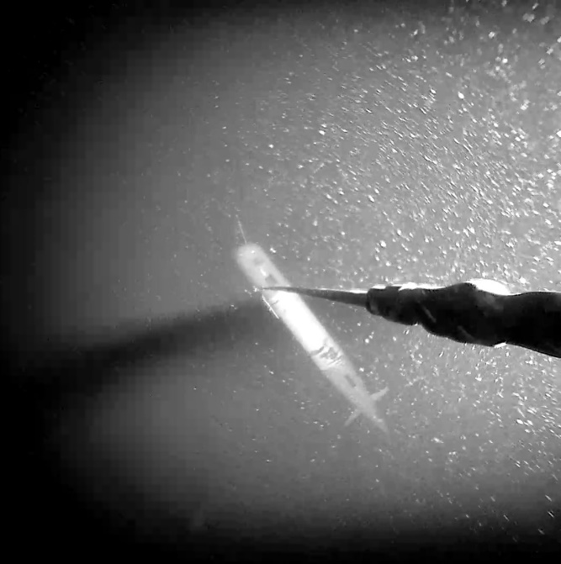  Figure 2: View of the AUV on the dock, captured by the upward-looking camera located at the bottom of the dock.

