Niobicon-Based AUV Docking Development 902106
Brett Hobson, François Cazenave, Andrew Hamilton

We recovered the docking buoy in early December, after nearly 6 months at sea. During the last few weeks of the deployment, we succeeded in docking the AUV to the dock numerous times and were able to transfer power from the buoy to the AUV. Engineers are currently analyzing the data collected during these missions and are working to improve the AUV’s docking algorithm. We also successfully tested the improved latching and power transfer device.
Over the last 3 months, we are been building the new mooring system. It includes a new buoy, a new housing with a large battery pack to allow full charge of the AUV, a more robust and durable mooring, a new camera, among other improvements. We are planning to deploy the new mooring in April for a months-long test.
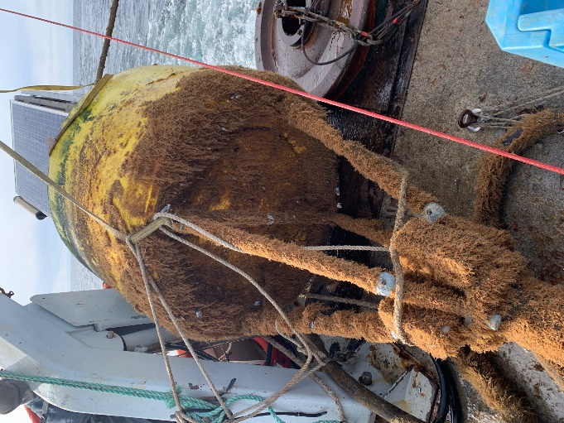
Figure 1: The docking buoy after recovery in December 2022

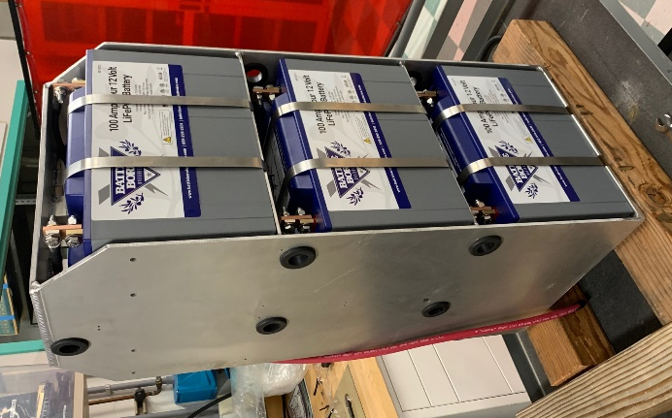
Figure 2: The new battery pack will store energy collected by the solar panels on the buoy.

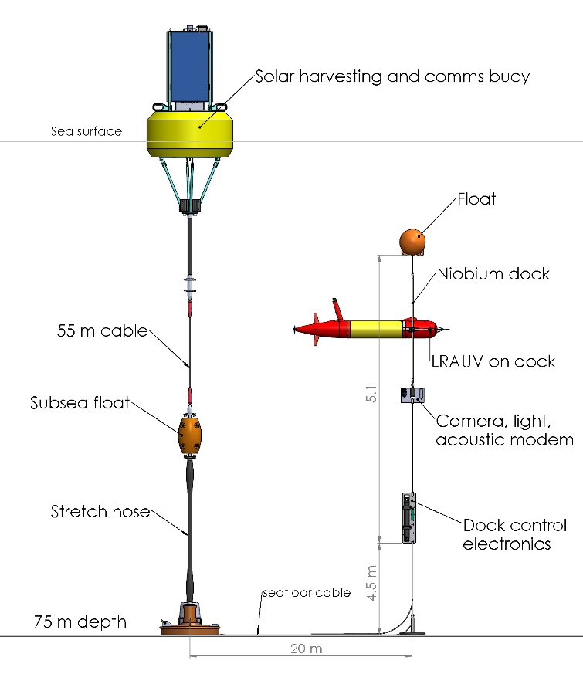
Figure 3: Schematic of the new docking mooring to be deployed in spring 2023

