Niobicon-Based AUV Docking Development 902106
Brett Hobson, François Cazenave, Andrew Hamilton

The AUV docking team has been busy assembling the new AUV docking system. The solar energy harvesting buoy was recently tested in the tank and is nearly ready for deployment (figure 1 and 2). The new mooring system (lower left, figure 3) has been delivered by Woods Hole Oceanographic Institute and has been tested at MBARI. Various other components are being assembled and tested, including a new anchor system, a new camera, and a new niobium charge rod. We are planning to deploy the system in late May in South Monterey Bay. The deployment will support engineering tests at first, in order to improve the AUV’s docking reliability and to verify power and data transfer. Once the system has been tested, it will be used to support scientific missions in the fall of 2023. If needed, the system will be recovered for repairs or upgrades and redeployed.
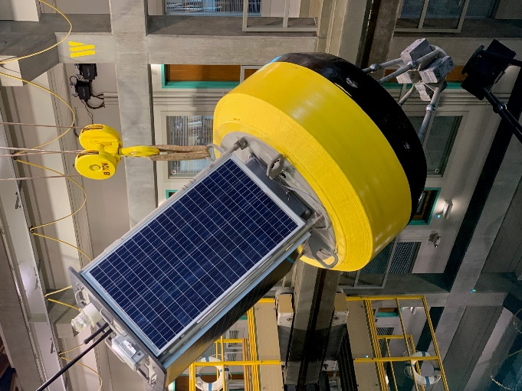
Figure 1: The new docking buoy being lowered in the tank for testing.

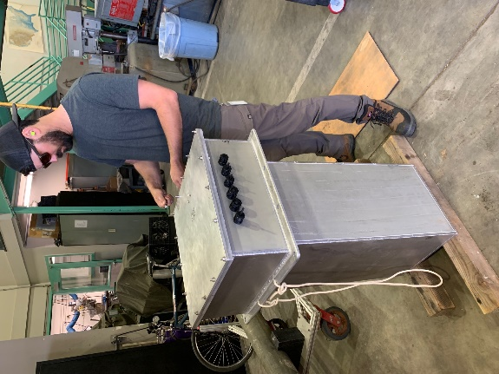
Figure 2: Leak testing the enclosure that will store lithium batteries and electronics on the buoy.

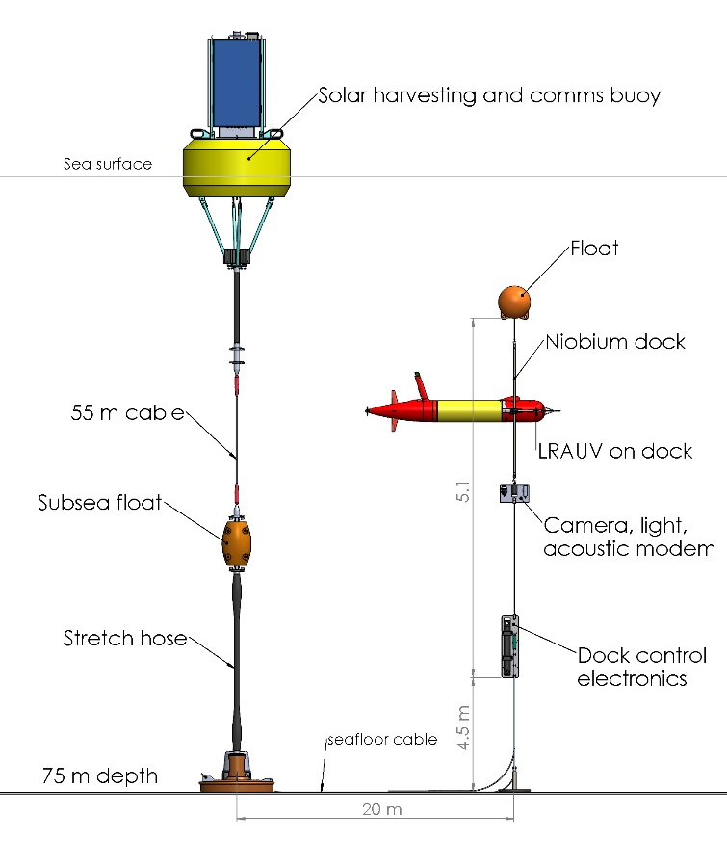
Figure 3: Schematic of the new docking mooring to be deployed in May 2023

