Niobicon-Based AUV Docking Development 902106
Brett Hobson, François Cazenave, Andrew Hamilton

- The AUV docking team has been focusing on the new docking system.
- The system has been fully assembled, tested in the test tank and will be deployed on October 13 in South Monterey Bay. During the first few weeks of the deployment, engineering tests will be performed with LRAUV Tethys. We will test charging the LRAUV’s batteries at 24 V and 240 W, and data transfer. We will also test the AUV’s dock approach algorithm. Next, the dock will be used for surveys with AUV Galene, which will be outfitted with the dock latch and the Chiton camera.

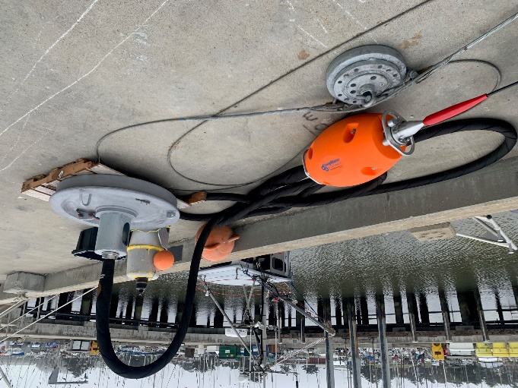
Figure 1: The new mooring and anchor system.

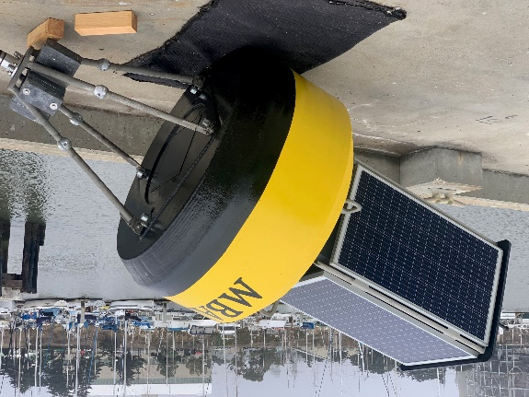
Figure 2: The buoy will store energy from the solar panel in a large battery pack and transfer it to the AUV dock near the seafloor via a cable.

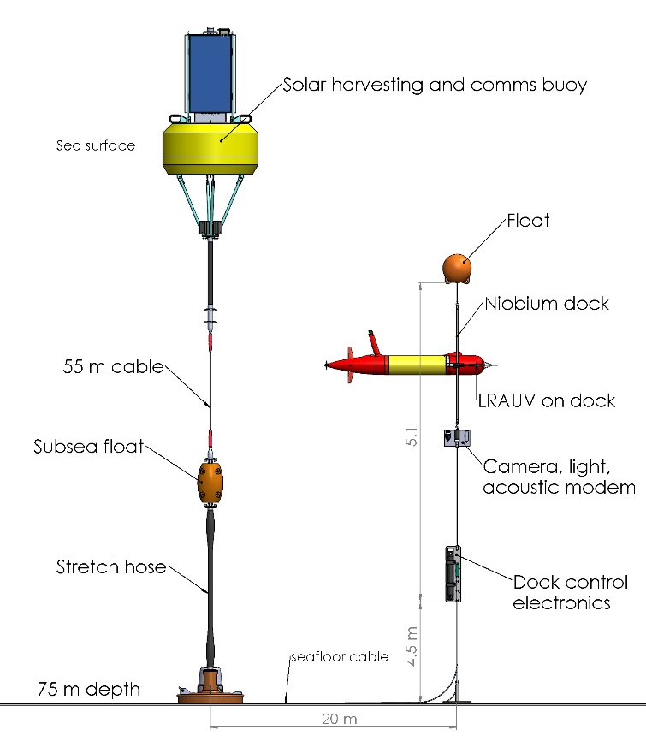
Figure 3: Schematic of the new docking mooring.

