Niobicon-Based AUV Docking Development 902106
Brett Hobson, François Cazenave, Andrew Hamilton

- We deployed the AUV docking system in Monterey Bay on October 13, 2023. The mooring performed well and allowed us to run AUV dock tests.
- The radio connection between the buoy and the cell network was poor which slowed our progress, until found a way to improve it.
- At first, we had a low success rate when attempting to dock the AUV (1 out of 10). We made numerous improvements to the homing algorithm and to the hardware and were able to increase the success rate to 1 out of 3. When the AUV missed the dock, it turned around and made other attempts. The AUV was always able to dock eventually, usually within 45 minutes, which is satisfactory. We think we can further improve the success rate.
- We successfully tested power transfer at 240 W and charged the AUV’s batteries.
- We were not able to transfer data through the niobium connector, most likely due to networking issues that can be solved.
- On January we lost communications to the subsea part of the docking system. The cause of the failure is still unknown. We plan to recover the mooring as soon as the weather is good enough.
- After servicing the mooring and making several upgrades we will deploy it in North Monterey Bay to continue testing and to support a scientific survey of upwelling.

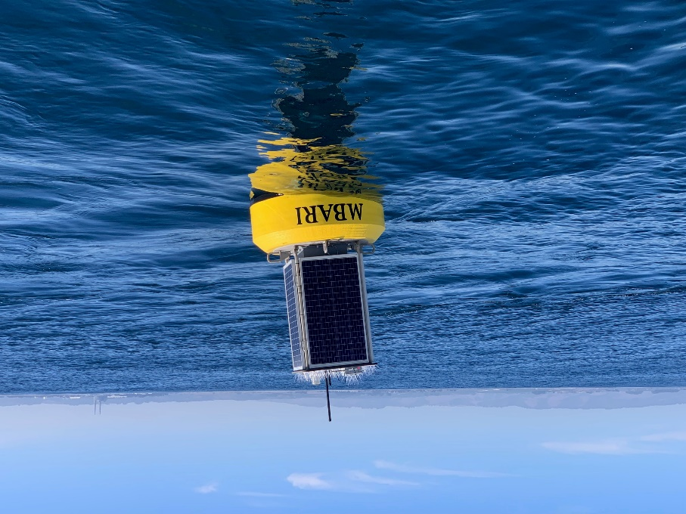
Figure 1: The surface buoy of the docking mooring captures solar energy and allows communications.

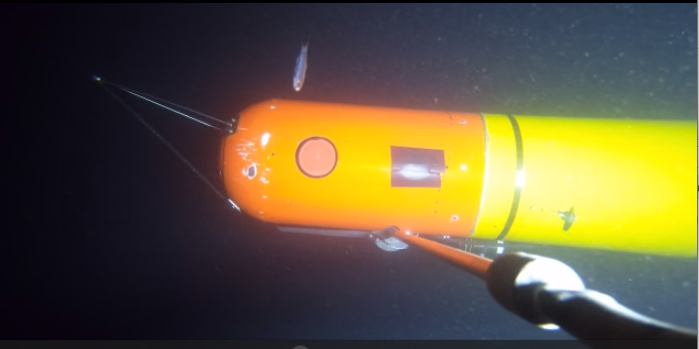
Figure 2: LRAUV connected to the AUV dock. The camera is below the dock and faces up.

