Niobicon-Based AUV Docking Development 902106
Brett Hobson, François Cazenave, Andrew Hamilton

In February 2024, we recovered the AUV docking station after a successful 4-month deployment. During this deployment, we met most of our goal:
- we transferred power from the buoy to the AUV at 240 W reliably,
- we made improvements to the homing algorithm and to the hardware and were able to increase the success rate of docking the AUV. The AUV was always able to dock eventually, sometime after several attempts, and usually within 45 minutes, which is satisfactory.
- we tested the mooring’s ability to survive stormy condition and to be easily deployable and recoverable,
- we tested the system’s electronics, including solar charging, energy storage, communications, video recording,
- we were not able to transfer data, due to networking problem.
The stretch hose and the EM cable, two important components of the system leaked and caused a ground fault during the deployment, forcing us the recover the system earlier than planned. We worked with the supplier to replace these components.
We have been working on an improved latching system and installed it on LRAUV Pontus. We performed maintenance and upgrade to the buoy and the docking station and we are planning to deploy it in the coming weeks. The system will be located near Santa Cruz and will support surveys in that area to study upwelling. In addition to this scientific application, we will continue to perform engineering tests, using a second AUV.
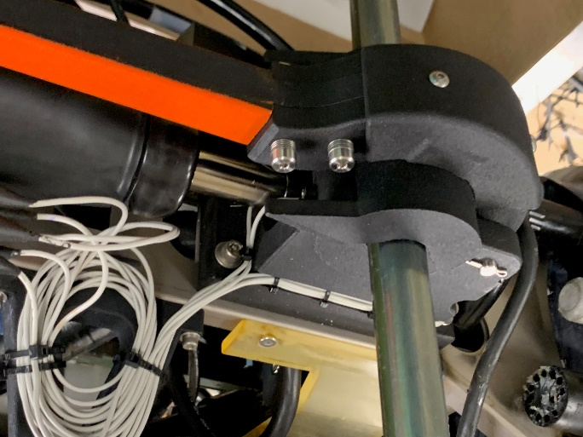
Figure 1: An improved version of the latching device was installed on LRAUV Pontus
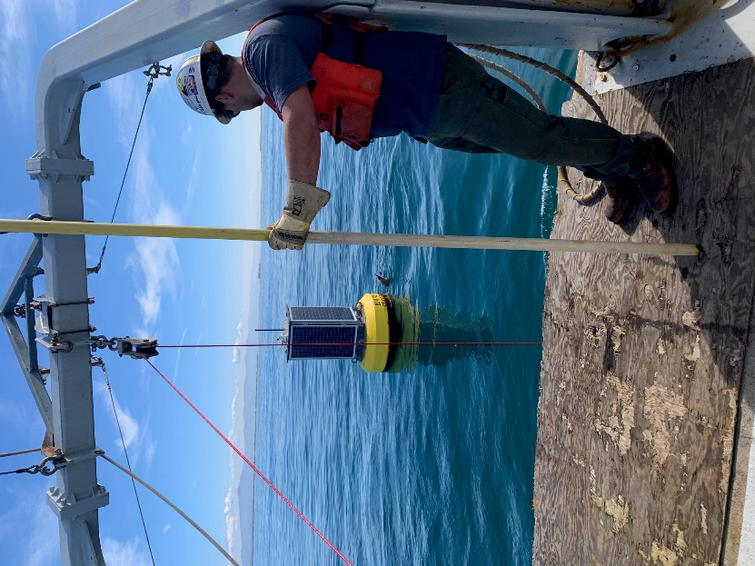
Figure 2: Recovering the docking station mooring in February 2024.

