Niobicon-Based AUV Docking Development 902106
Brett Hobson, François Cazenave, Andrew Hamilton

During the spring of 2024, we made several improvements to the LRAUV’s docking hardware, including a new housing and some modifications to the latch mechanism. We also made repairs to the components of the mooring that had failed of been damaged during the previous deployment.

In June 2024, we redeployed the docking station near Santa Cruz to support upwelling surveys in that area with LRAUV Pontus. The new location is conveniently located near an upwelling center and gives the LRAUV greater reach northward along the coast.

Unfortunately, a failure of the sensor that reports when the AUV has docked prevented the vehicle from docking as part of science operations. So, during June and July we alternated between upwelling surveys in the vicinity of the dock and engineering tests to diagnose and fix the sensor problem. In August and September we transitioned to engineering-focused AUV deployments.

Over the course of these deployments we made homing algorithm and docking behavior reliability improvements to meet several milestones:
- we verified the new latching system on LRAUV Pontus,
- we tested the mooring's ability to withstand a more exposed location,
- we exercised long-duration docking and charging (docked the AUV for over 36 hours continuously, and many hundreds of hours total),
- we enabled the AUV to start and stop its own charge on the dock, instead of requiring the operator to turn charge on/off from shore,
- we established reliable automatic two-way network communication between the AUV and shore control dashboard and tested high-rate data transfer while docked,
- we demonstrated science mission operations with docking: we enabled the AUV to autonomously dock, charge and communicate with shore, undock at a scheduled time, run a science survey, and return to the dock with charge and communications; without direct supervision or operator intervention.

A blown subsea fuse in September necessitated the recovery of the docking station. We recovered the station; performed repairs, upgrades, and maintenance at sea and redeployed the system immediately for more testing. We are now focusing on making further docking reliability and usability improvements, and exercising an operational cadence in advance of science missions in the spring. This work will enable watchstanders for these missions to easily command docking behaviors without significant assistance from the engineering team.

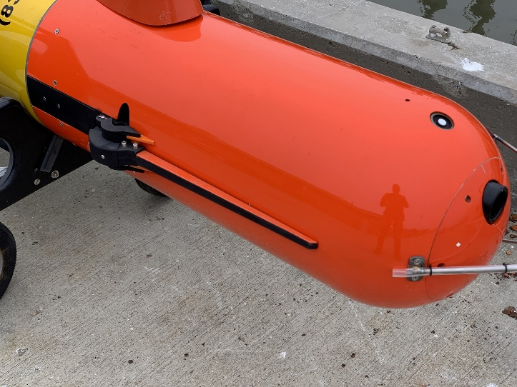
Figure 1: LRAUV Pontus outfitted with the docking latch, shown in the retracted position.

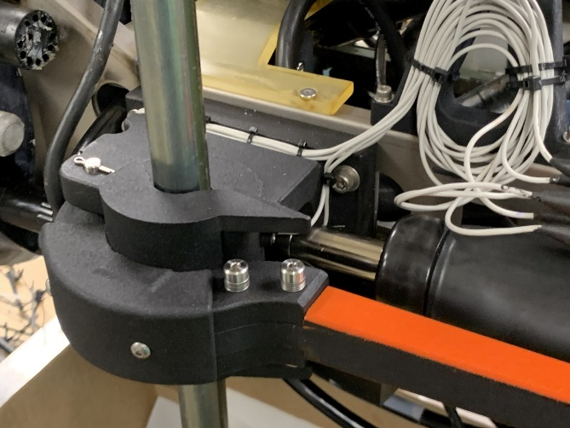
Figure 2: Detail view of the latching and power transfer mechanism.

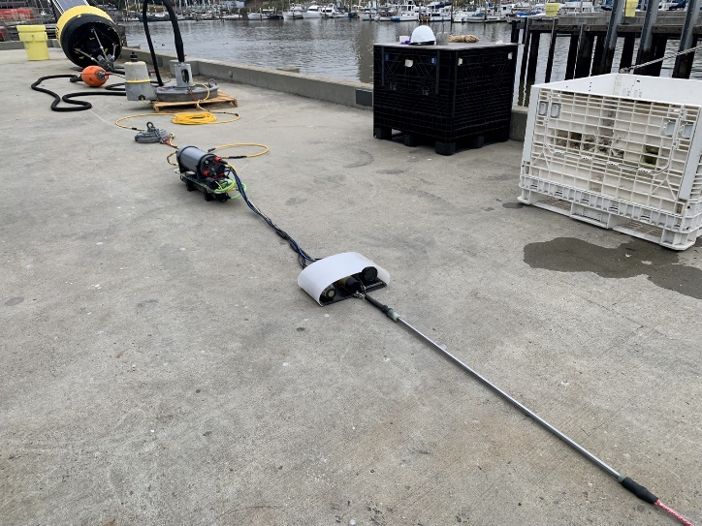
Figure 3:The AUV docking mooring before deployment.

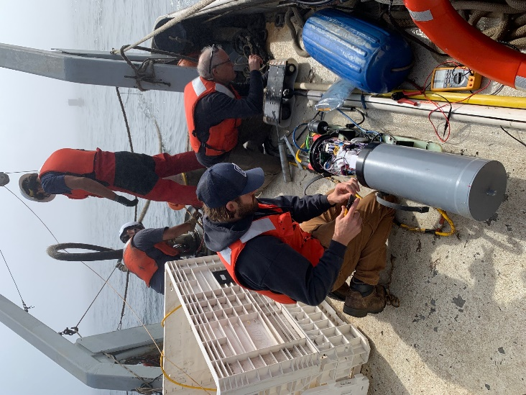
Figure 4: Engineers and technician made repairs to the system at sea.

