Niobicon-Based AUV Docking Development 902106
Brett Hobson, François Cazenave, Andrew Hamilton

The summer was a very productive time, with a long deployment of the AUV dock supporting two science surveys.

On May 31, we deployed the docking station in Northern Monterey Bay to support a survey of phytoplankton during upwelling events. We conducted engineering tests and a 33-day upwelling survey with LRAUV Pontus. The AUV completed 55 successful docking attempts and was able to recharge its batteries. A mid-deployment recovery was required to service a broken component, but docking enabled the extended mission duration without recharging the batteries on shore.
On August 13, we recovered the mooring and redeployed it in South Monterey Bay to support the CANON experiment (figure 1).

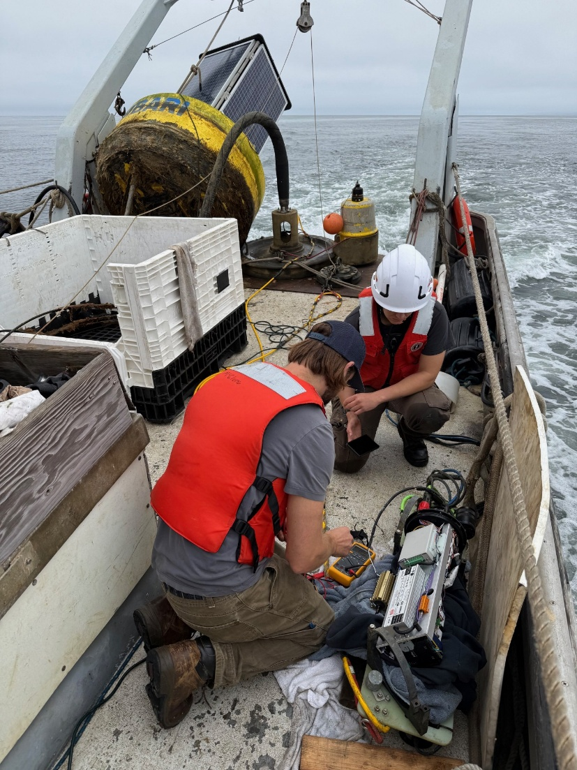
Figure 1: Engineers make repairs to the docking station while transiting to a new location for the mooring.

We integrated the docking hardware on LRAUV Brizo, our first docking integration on an ESP-equipped vehicle. We completed engineering testing and adjustments for ESP vehicle docking.
We recharged LRAUV Brizo from the dock several times during the 18-day CANON experiment. We demonstrated ESP sampling and science data collection while docked. The AUV completed approximately 60 successful docking runs with LRAUV.

Because we experienced some current dropouts during charge, due to poor electrical contact, we made important design changes to the power-transfer device. In the new design (figure 2), the contact area is much larger, and the clamping force is greater. This system has been assembled on LRAUV, and will be tested at sea in the coming weeks.

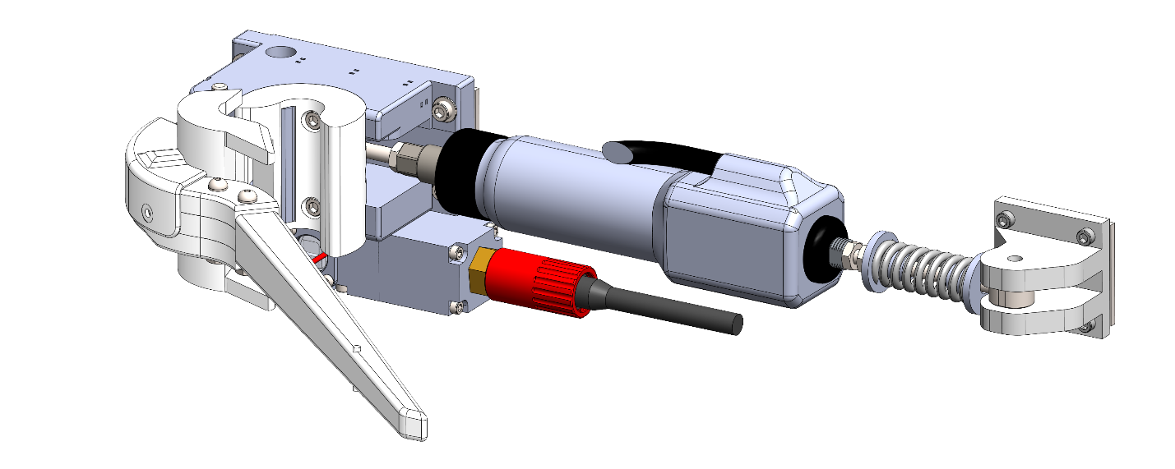
Figure 2: Model of the upgraded power-transfer device, including large niobium contacts.

We are planning to leave the docking station deployed until December to continue engineering and science missions.

