Dock on MARS note
François Cazenave
4/26/2021

Discussion with Kelly BB :
Her echosounder has a 7 degree beam with 60 degree side lobes. Objects in the beam will be a problem, especially floats and air-filled housing because they will create and intense reflection that will shadow other targets. The noises caused by the AUV (especially be the acoustic homing device) will be a problem also, though not as much because it will not be constant.
To avoid interfering, the dock riser would need to be at least 500 m away from MARS.

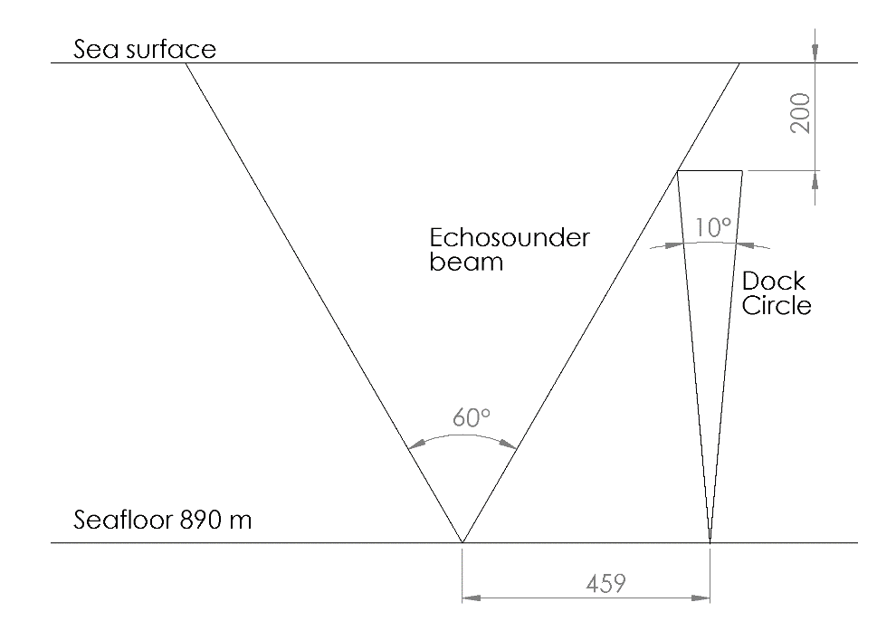

Discussion with Craig
Craig first said the dock would need to be 1 km away to avoid being in the ROV’s way. He later mentioned that we could us a cable that he has to connect MARS to the bottom of the riser. That cable is 680 m long, so I assume that it 680 m would be far enough. He recommended checking with Knute.
He though it would be easier to have two cables, with a connection at the bottom of the riser.
Deployment would be done with the cable-laying sled. It would be 1 day of ROV work. The riser and anchor would be deployed with the Carson, in one day.
He may have connectors that we can use.
The MARS node will be refurbished soon. A temporary ‘mini node’ will be put in place until 2nd quarter 2021, when the new MARS node will be deployed. It would make sense to deploy the dock after the new node has been deployed.
The current at MARS is typically 0.25 m/s. There is historical ADCP data. I have access to the data and will take a look.
The spec sheet and quote of the cable that Craig can give us is in this folder.

Discussion with John Ryan:
John Ryan has a hydrophone at MARS. A dock at MARS would not be a problem for him. “It’s all good”, he said.
He thinks that considering how easy it is to deploy the LRAUV, it might be hard to justify building a dock for it. He would like to be invited if we give the PI group at presentation

Discussion with Paul McGill:
Paul has a tool to measure how much power can be transfer through cable. Here is is 4/23/21 email
“ I’m happy to help you with this calculation and I did write a tool for this purpose, but it depends on a few things that we don’t know yet. We need to know things like the low-voltage limit of the DC-to-DC converters used, and the lay angle of the wires inside the cable. I think you’ll want the smallest cable that can do the job because you’ll be hoisting 700 m of it into the water column.
Just to give you an idea of what may be required, the cable I used for my MOBB seismometer was Falmat SB-46974A (datasheet attached). It has a wattacity (like ampacity, but for power) of 632 W-km when driving a Vicor converter from MARS, and 806 W-km when driving a Synqor converter. For your 1.3 km length, it could deliver 486 W and 620 W, respectively. Note that this is before converter losses so you’ll lose an additional 10 to 15% there.
700 m of this cable would weigh 57 kg in water. It also contains twisted pairs that I’ve used successfully for DSL data.”

