902106 and 902101 AUV Docking

Principal Investigators: Andy Hamilton and Brett Hobson

Note this project was not included in our previous report but was approved via email communications with the Sanctuary in November 2020.

Purpose
MBARI seeks to develop technology to enable oceanographic observation anywhere in Monterey Bay, anytime of the year. AUVs can carry instruments throughout the bay, but are limited in their endurance so MBARI is developing an AUV docking station that can recharge the AUV’s batteries without recovering the vehicles. This enabling new technology will allow near continuous observation throughout the bay.

Methods/Procedures
During 2020 the engineering team developed a prototype of a novel power transfer system for the LRAUV that is now performing tank testing. In early 2021 the team plans to begin offshore testing of this power transfer system as well as the homing and docking systems and this will require a fixed mooring. The mooring will be relatively small to allow deployment from the small vessel Paragon. A taught line mooring will extend from a ~250 lb. anchor to the surface, where a buoy equipped with solar panels, a battery and electronics are mounted. Eight meters above the seafloor the vertical mooring line will transition to a 1.8 meter long, 20 cm diameter metal power transfer rod, then back to mooring line and electromechanical cable up the surface float. Two 40 cm diameter floats above the charging rod will keep the lower section taught and provide a mounting spot for an electronics housing, camera, light and acoustic modem. The AUV will use this acoustic modem to locate the docking station, and just before it arrives the AUV will extend a docking arm to capture the charging rod and hold it in place while the batteries are charged. The camera and light will document the docking event. A cellular modem on the surface buoy will allow real-time monitoring and control of the docking system from shore.

We hope to keep this mooring in place for up to 6 months, but as this is a technology development project, the mooring system will likely be recovered, repaired/modified and redeployed several times during this 6 month period. The position will be at approximately 36.7436°, -121.8800°, which is about 10 km WSW of Moss Landing in 75 meters of water. To minimize the potential for marine mammal entanglements, the mooring has been designed in consultation with a marine mammal expert to maintain a vertical, taught line (see Figure 1 below). Between deployments, the entire mooring and associated equipment and anchor will be recovered.

Sanctuary Prohibition
These moorings utilize anchors, and therefore cause very minor disturbances to the seafloor. Upon recovery of the equipment, the seafloor will rapidly return to its pre-deployment condition.

Activities in 2020
No activities for this project occurred in Sanctuary waters.

Plans for 2021
We expect to deploy this mooring around March/April and recover it in September/October. During this time we expect to conduct intensive tests on about a bi-weekly routine. As the AUV begins its docking approach it will emit a short acoustic interrogation and the transponder on the dock will reply. The AUV is able to detect the direction of this incoming acoustic reply ping and steer towards it, pinging every 5-30 seconds. Each docking approach should take about 10 minutes and require about 100 of these short acoustic pings. Once securely docked, power will be applied to the power transfer system and the batteries aboard the AUV will be charged. It is not likely we’ll perform routine full battery charging during this testing phase, but in the future, a complete battery charge should take about 10 hours.

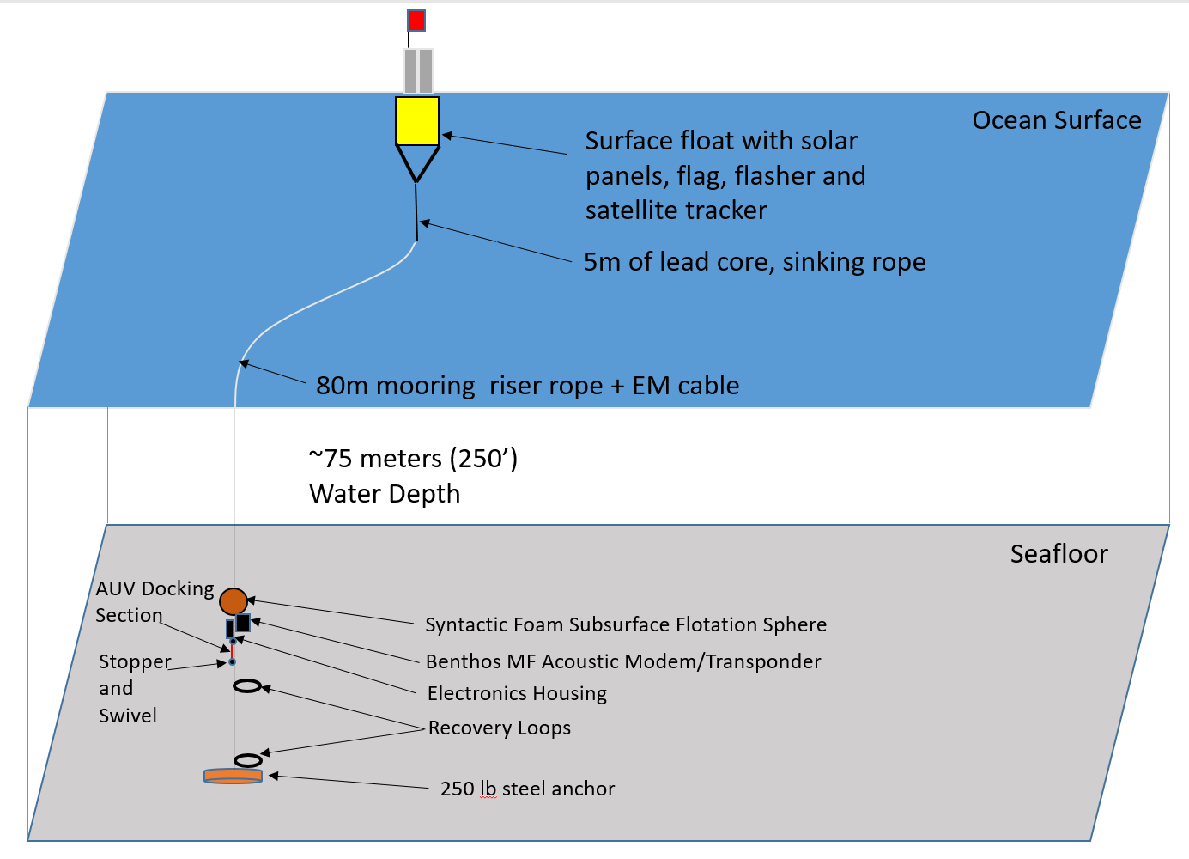

Figure 1. Schematic of mooring design to be used for this project.

