Notes on testing of Niobium power transfer device:

Date: October 13, 2020

We tested a prototype designed by François and machined at MBARI.
We submerged the prototype in a bucket of seawater and ran various tests:

Diode bridge:
The diode bridge worked as planned and current kept flowing even with the device rotating around the niobium tube.
Maximum voltage:
We increased the voltage and found the leakage through seawater to increase sharply at 80V. 60V seems like a safe voltage to operate, though more testing is needed.
Maximum current:
We tested at 10 A successfully. The size of the wires becomes a limit at high current.
Resistance at the brush:
We measured the resistance at the niobium brush. While moving, it was approximately 0.5 ohm. At rest, it was slightly lower.
Concave brush:
We machined the tip of a brush to match the diameter of the niobium tube. We tested it and compared with the regular (flat tipped) brushes and found no difference. We rotated the concave brush 90º, where we would expect to have the worst contact, but there was no significant difference. It is possible that there are too many irregularities on the tip and the tube to get a large area of contact.
Brush force:
When we applied a higher force on the brush, the resistance decreased slightly. The test was performed while still and while moving. More force results in more friction and wear.
Tighter rollers:
In an earlier test, the rollers on the device were slightly loose and which allowed the brushes to occasionally loose contact with the niobium tube and to arc. The tighter rollers solved the problem.
Rollers shaft clearance:
In an earlier test, the rollers were too tight on their shaft and wouldn’t roll easily. Some clearance was added and the rollers performed much better.

Testing mechanical behavior of power transfer device on LRAUV in Test tank

October 20, 2020.
We attached the power transfer device to the side of the AUV, a few inches in front of the main housing (figure 1). The device was mounted using hose clamps and a plastic adapter. A float was attached to counteract the added weight. The niobium brushes were included in the device but there were no electrical connections.
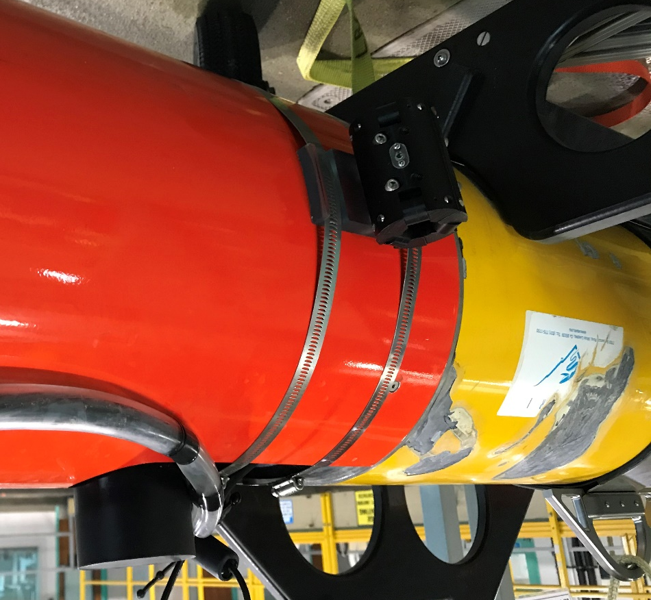
Figure 1: Power transfer device mounted on the side of Tethys LRAUV

The AUV was ballasted to be nearly neutrally buoyant and level. An 8’ long, 0.75” diameter stainless steel tube was hung in the tank, with a heavy weight at the bottom to keep it vertical and steady. The rod was inserted inside the power transfer device. White delrin collars were mounted at each end of the tube to serve as stops.
Test 1:
With the AUV about 1.5’ below the surface, the rod was moved horizontally in the test tank using the crane. The purpose was to see how the AUV would behave in a current, when attached to the cable. The AUV rapidly aligned with the direction of travel, with little resistance. A video of this test is included in the folder (Horizontal_Travel).

Test 2:
Using the crane, we moved the rod up and down, and observed the AUV’s behavior. The friction caused the AUV to tilt and the power transfer device to bind on the tube. This behavior can be observed on the second video (Vertical_Travel).
Test 3:
We attempted to have the AUV use its buoyancy engine go up and down the tube, but it was not successful. The buoyancy being at the back of the vehicle causes a large moment and a lot of friction.
Test 4:
As a strength test, we filled the buoyancy engine’s bladder and move the LRAUV moveable mass (batteries) all the way back, to cause a high moment of the power transfer device. There was no damage.

Separately, I measured the friction force of the device on the rod, with no external moment applied. F = 1 N. With a significant moment applied, the friction force increases to several Newton, which is more than the force the buoyancy engine can generate.

Test with roller bearings
October 28, 2020
We modified the device to include a pair of ball bearings in each of the six rollers. We repeated the tests first performed on October 20.
The device performed much better. With the vehicle slightly buoyant, we were able to move the tube all the way down with the crane. When we pulled the tube up, the AUV started to move with the tube after a few inches of travel (video: Vertical_Travel_10-28-20).
We were not able to make the AUV go up and down the tube using the VB. The friction from the brushes was too large to overcome. Also, the VB being in the back of the AUV caused a large moment, which increases friction.
We repeated the same test with the crane also moving horizontally at full speed (still to be measured), to simulate a current. We able to move the tube down a few inches before the AUV started following (video: Horizontal_Travel_10-28-20).
Finally, we held the tube by hand and moved it rapidly, similar to the action of the waves. It worked remarkably well. (video: Held_By_Hand_10-28-20).
Testing the power transfer device in the test machine:
The test machine moves the niobium rod up and down, simulating wave motion, and the brush housing rotates, simulating the rotation of the AUV around the dock, due to tidal currents. Power is transferred through the brushes and is dissipated in the load dump. The rod and brushes are submerged in seawater.
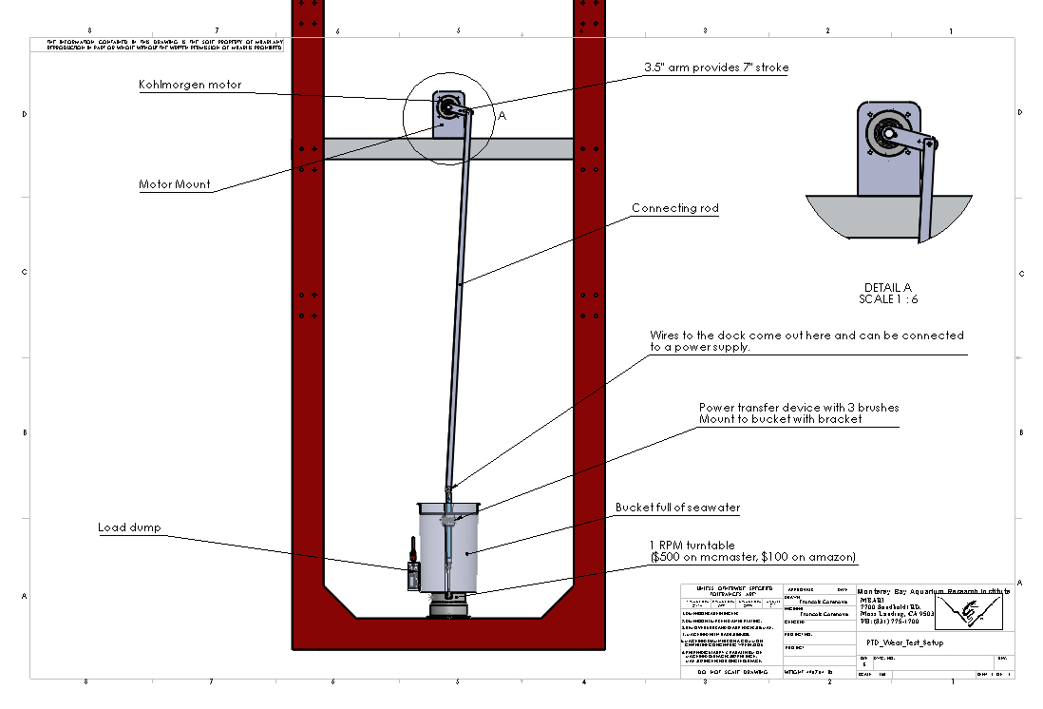

First test, started on 3/3/21 at 4 pm.
This test was intended to reproduce a situation where there is constant wave action and tidal current (i.e. buoy mounted dock). The machine was set as follows:
- Vertical travel: 7”
- Vertical period: 6 s
- Rotation: 80 s per rev.
- Voltage was 22 VDC and current 3.8 A. (83.6 W)

Test result: After 2 days, at 29000 cycle I noticed that the current was no longer flowing (I was not able to monitor the test so it is possible that it had happened much earlier). I stopped the test and inspected the brushes. They were badly worn, even as far as the copper wire. The delrin body was also slightly worn (see photos below).
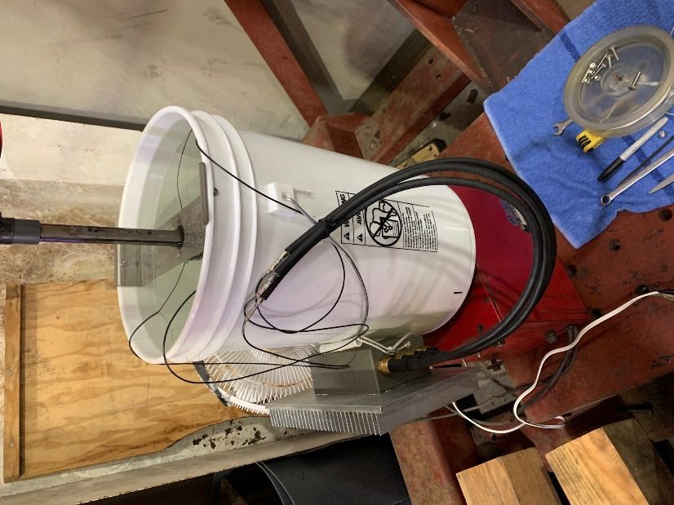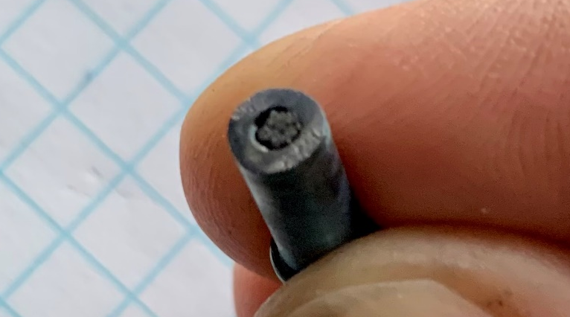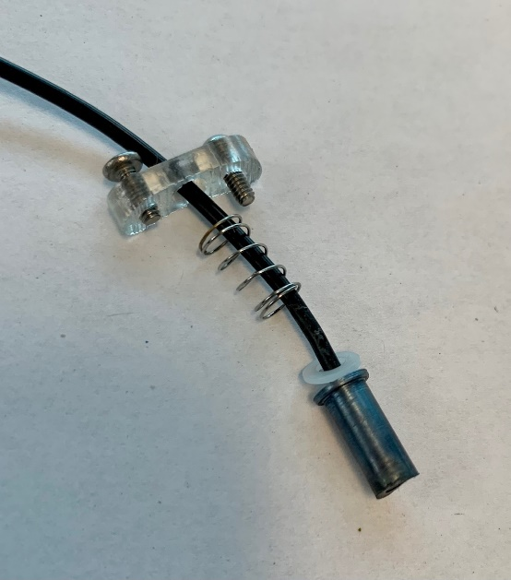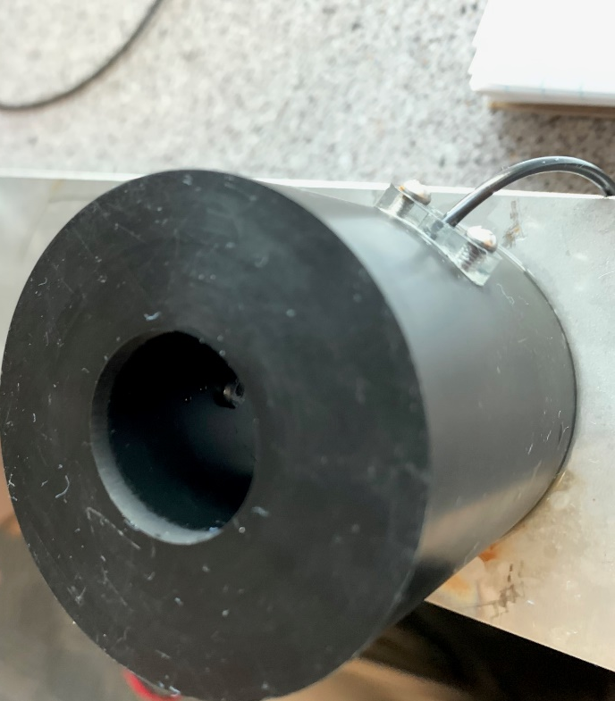

Second test:
We performed a second test meant to simulate conditions where there is very little vertical motion and some rotation due to current (seafloor-mounted dock).
- Vertical travel: 7”
- Vertical period: 6.8 minutes
- Rotation: 80 s per rev.
- Voltage was 40 VDC and current 14 A (560 W)

As soon as we started this test, we noticed bubbling, which we thought was caused by arcing. We should have stopped the test immediately, but we let it run. After about 20 minutes, I noticed the current had stopped flowing. I inspected the components and noticed that the brushes were stuck in their races. They had become very hot and had melted the plastic around them. In addition, the arcing had caused bad pitting of the niobium rod. After more testing, we concluded that there was a bad contact inside the nb brushes and between the nb brushes and the rod, which caused them to get very hot and melt the plastic. We also realized that the nb rod had been damaged and contaminated by the previous test, which caused arcing and make the problem even worse, as arcing further degraded the surface quality.

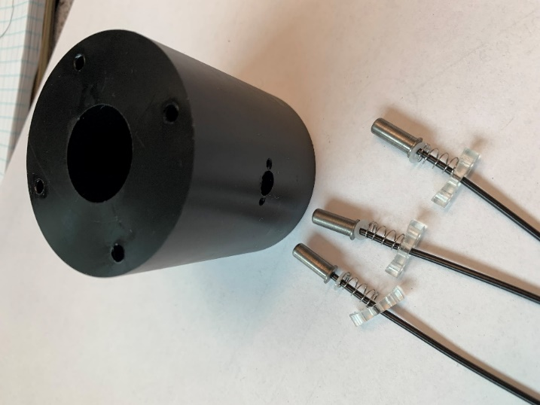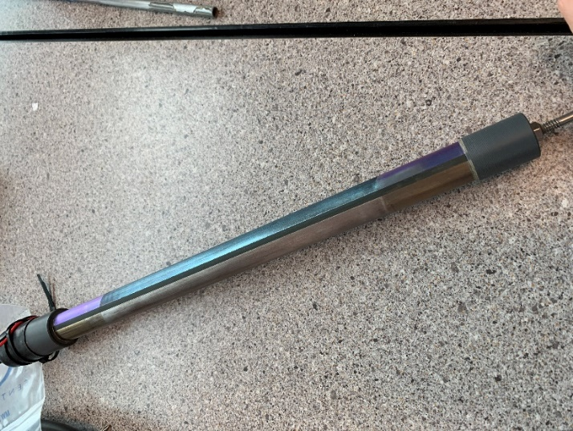
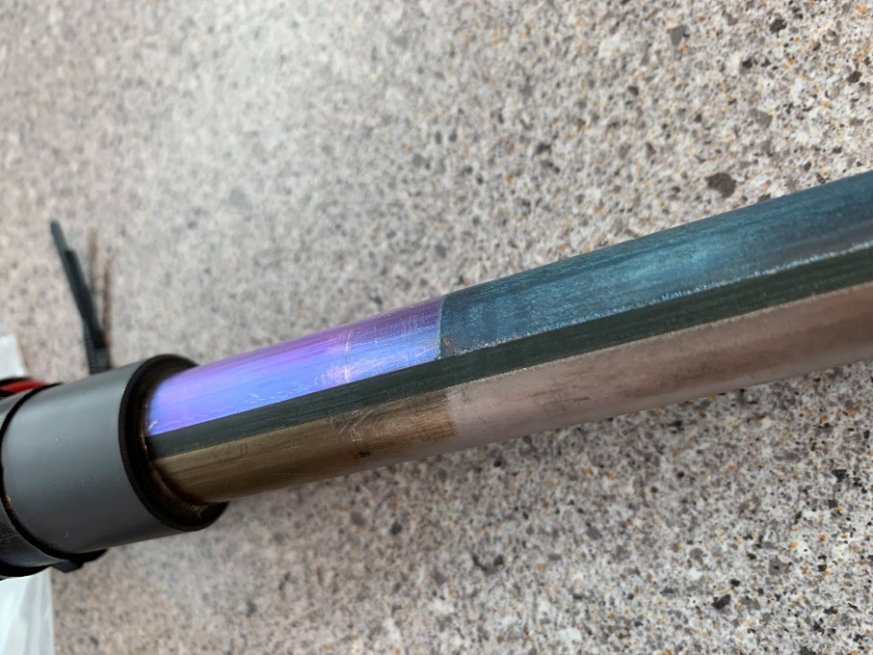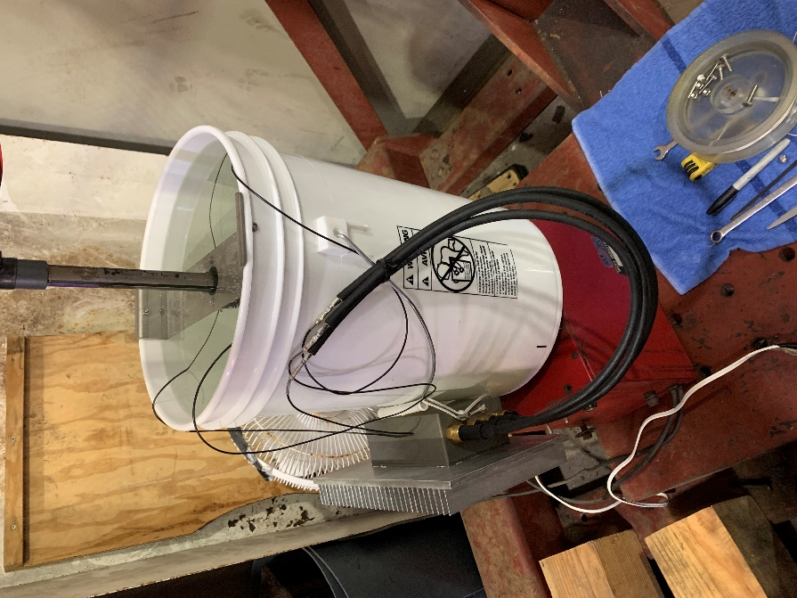
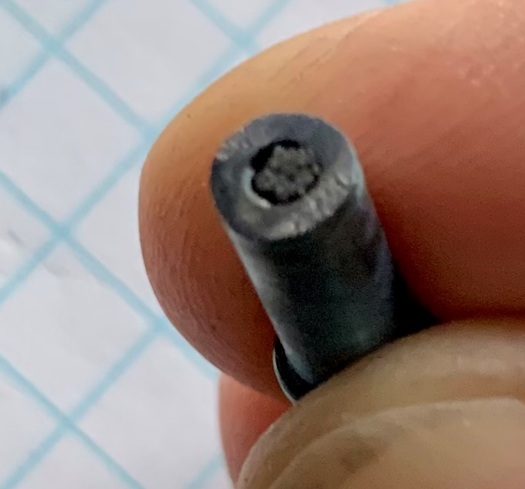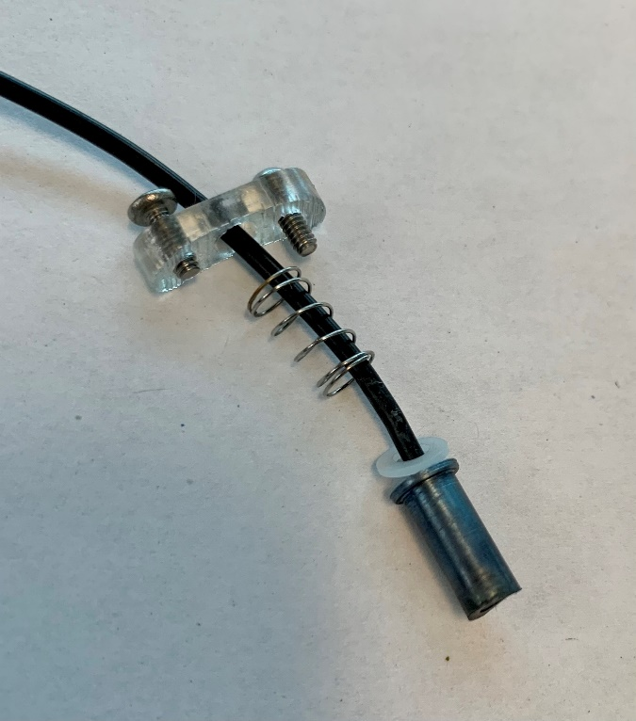

Third test, April 14, 2021
For this test, the contact between the copper wire and the inside of the brush was made using a pressed in copper insert, which reduced the resistance a lot. So there was no heating problem.
The motor for vertical motion was set to a ¼ turn every 12 hours and the rotation was about ¼ turn, every six hours. The voltage was 42 V and the current 5.5 A. After one day I noticed a lot of arcing and current dropouts. After some analysis, I concluded that the brush springs are too soft. As soon as arcing starts, the surface is damaged and the soft spring don’t make a good enough contact.

Fourth test, April 19, 2021
I ordered much stiffer springs for the brushes.
Spring part number: 61151SCS
Spring rate: 9.25 lb/in
Spring force is now approximately 1.5 lb (8 times more than previous test)
Also, I made a shoulder bearing to constrains the rod more tightly.
Voltage was set to 42.3V. Current was about 5.25 A. Power = 225 W
The setup was left still overnight. The current stayed steady. The voltage drop across the brush was measured at 0.65 V to 1.05 V.
On April 20, at 10:24, vertical motion was started. 900 units every 6 hours (about ¼ turn). Current remained steady.
On April 21, the rotation of the bucket was started. 15 s every 3 hours. 15 s is about 1/3 turn. Current is logged with digital meter. Min 5.19 A. Max 5.34 A

On April 26, current data was downloaded and analyzed. There were no current dropouts.
Total number of days: 7
Total linear travel: 14”*6 days = 84”
Total bucket rotations: 13.
Total number of starts and stop: 8 x 4 x 5 days = 160

April 26, 2021, 14:20:20.
Vertical motion changed to 200 counts every 5 minutes (one rotation is 4096 counts). That is about 14 rotations per day, or 14 x 14” = 196” travel

April 27, 2021` 9:30
Bucket rotation changed to continuous. 3m7s per rotation.
Current data downloaded and saved.
There seems to be a problem with the up and down motion.
At 10:50, the up and down was increased to 200 units, every 30 s.

I measured the voltage at:
Power supply: 43.2 V 226.8 W
At nb tube: 42.5 V 223.1 W
At leads to load dump: 41.4 V, 40.8 V, 0.6 V 217 W
Current: 5.25 A
Power consumed at dock to brush contact: 6 W

April 28, 2021
At 12:44, I stopped the test and took things apart. There had been some drops in the current (down to 4 amps) but never a full dropout. I noticed some arcing marks on the rod, on the lower part of the negative side. This might be related to the fact that the higher part of the rod comes out of the water some of the time. There was minimal wear on the brushes. See photos below.
I sanded the rod, and removed the shoulder bearings.
At 13:52 I restarted the test. Rotation was programed to 1 minute every 3 hours and vertical motion was set to 200 units every 10 minutes. Data file was saved (file 3).
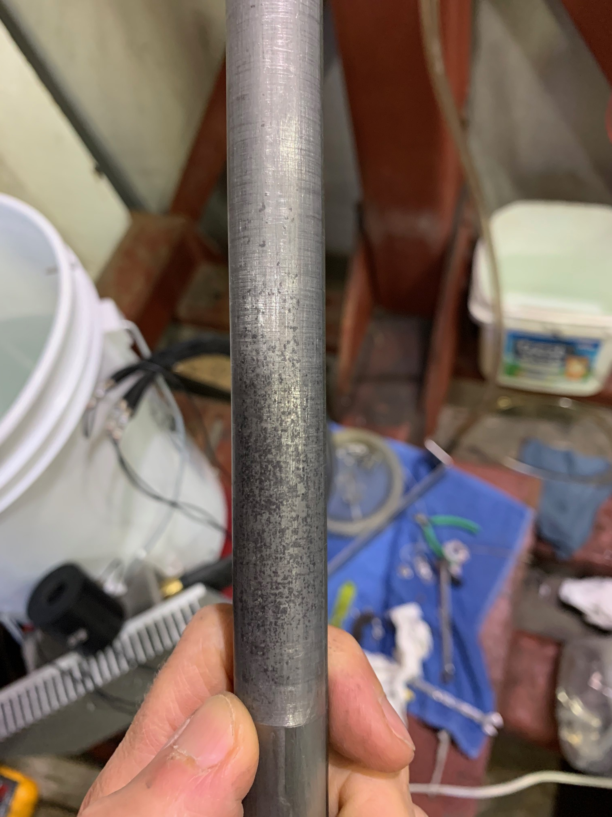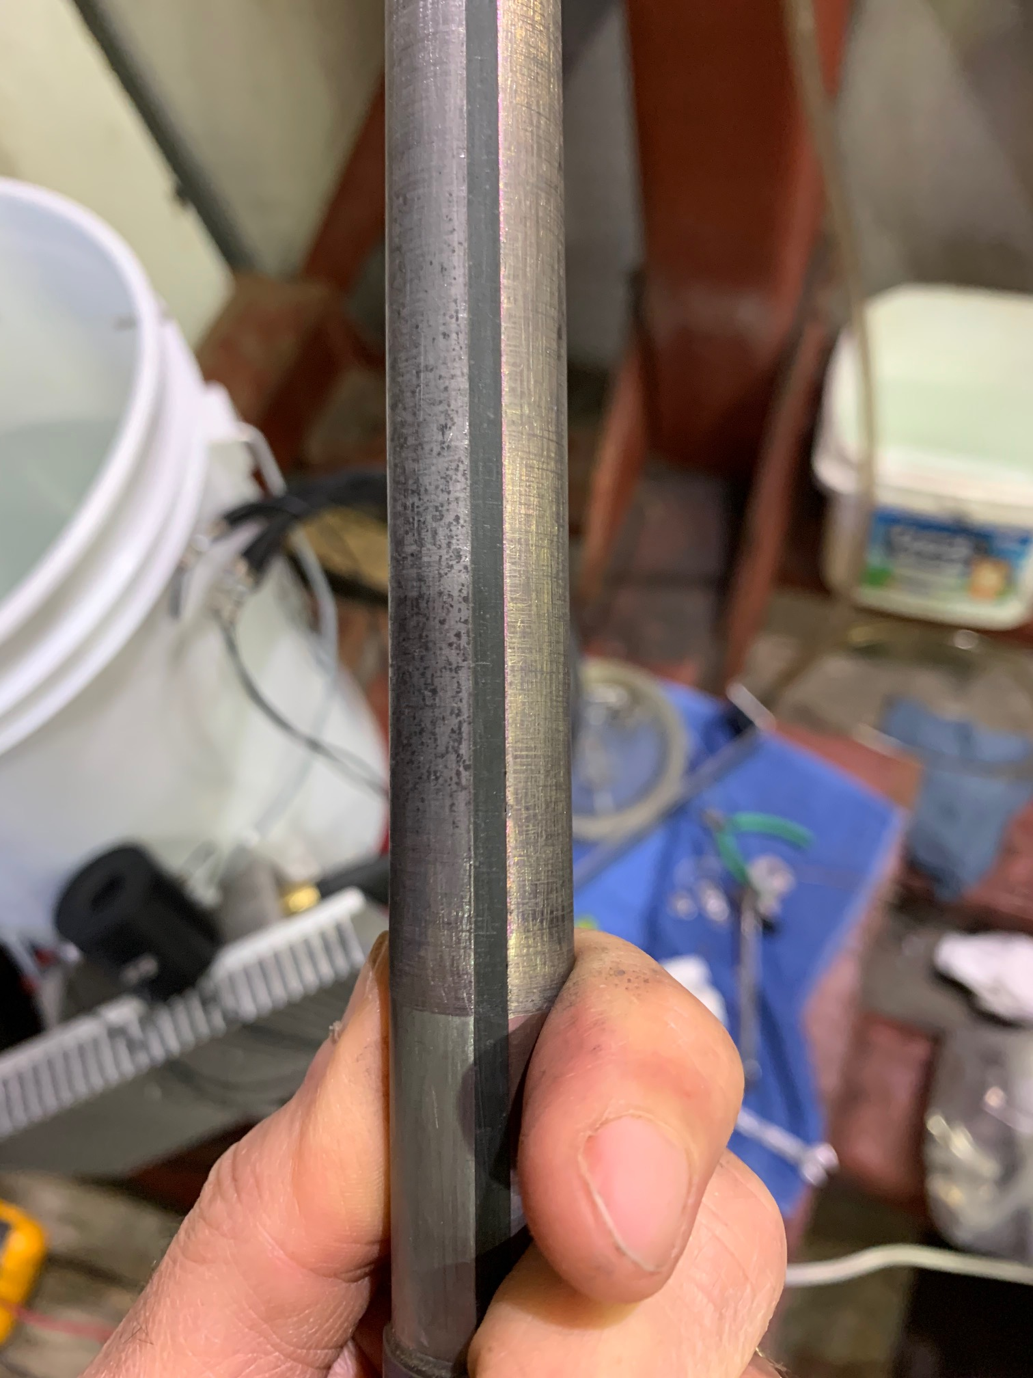

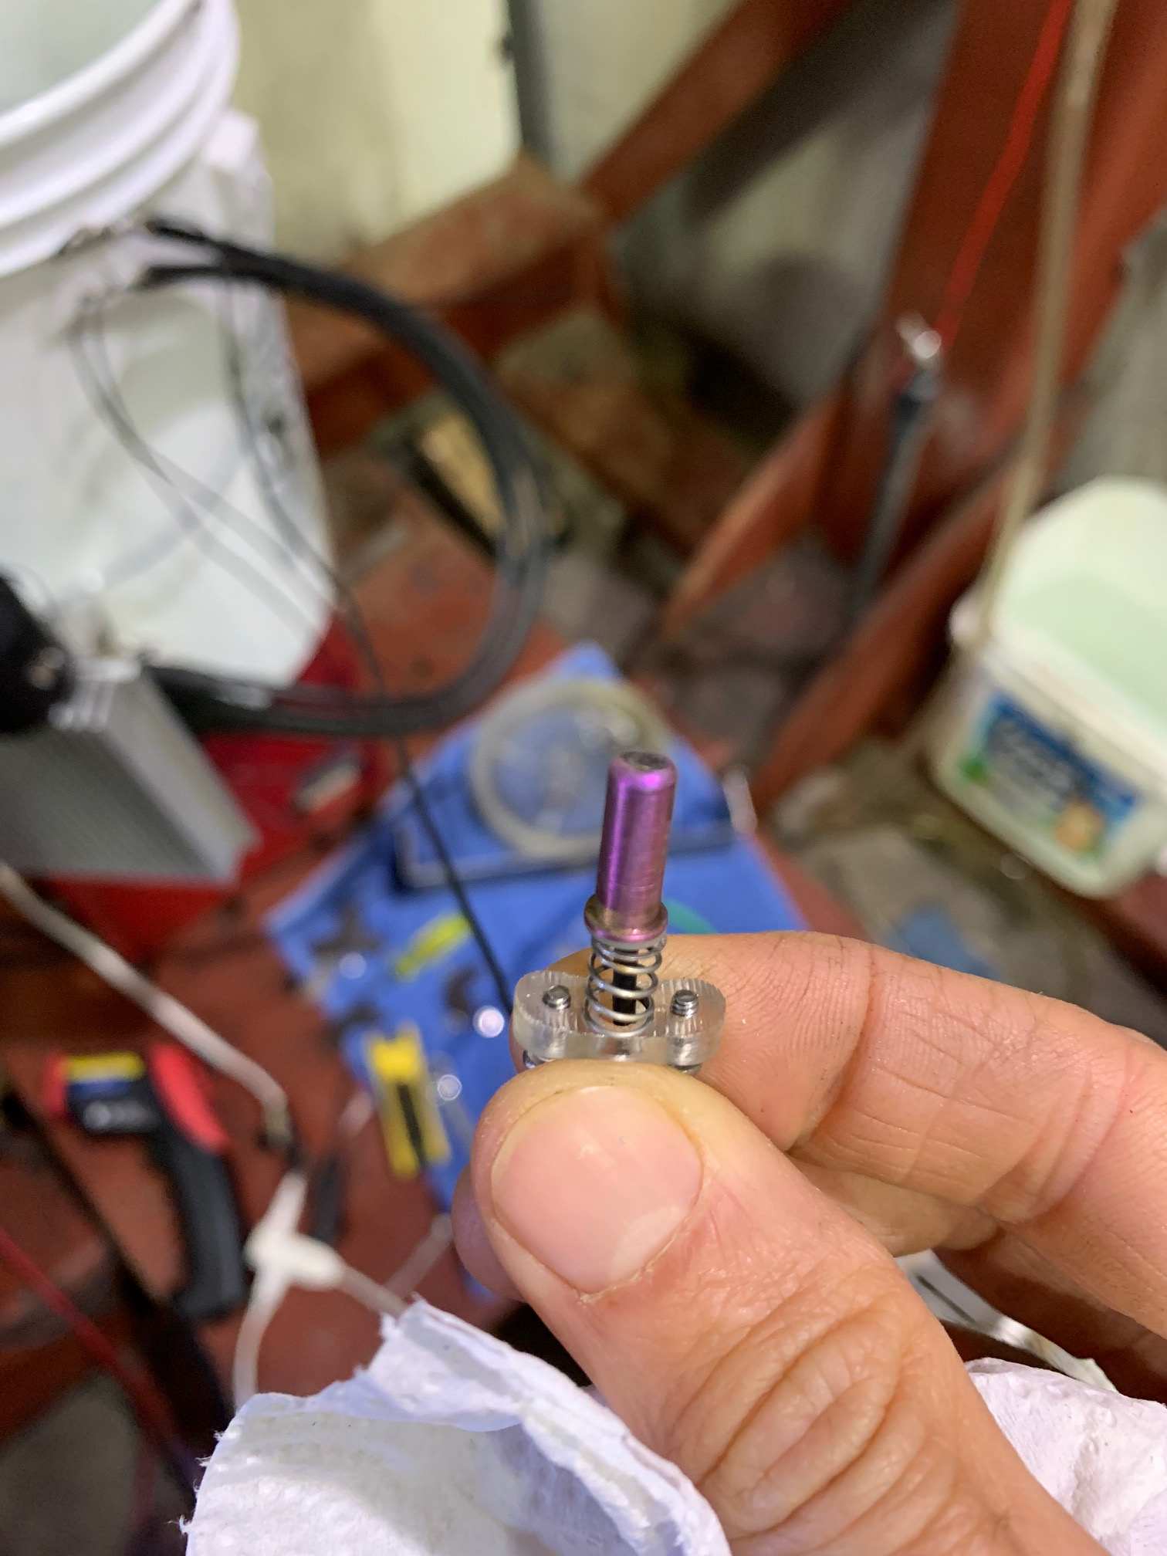

April 30, 2021, 16:00. Data was downloaded and saved as Nb_Brush_Current_Data_04

May 3, 2021
At 9:16 AM I stopped the test. I saved the data (05). It looks like the vertical motion did not work. As a result, it stayed in the same spot and there was arcing, causing a few drops in current.

May 4, 2021
Test restarted with new load dump (5 ohm). Voltage set to 42.3 V and current 7.8 A. Rotation of bucket set to 1 minutes every 3 hours, and vertical set to 200 unit every 10 minutes.

May 7, 2021
The vertical stopped probably on May 5. I restarted it this morning but it stopped again. I reduced the moment arm to the shortest setting and restarted the motion.
There were a few short dropouts, due to the poor surface quality at the bottom, where it’s been spending a lot of time.
I saved the data. (#06)

May 12, 2021
Data saved. There have been a few stops and gos since last time on the up and down but it seem to be fixed since 5/11.
Test stopped at 14:30.

