Project Number: | 902106

Project Start: Jan | , 2021 | Project Duration (in years): | 1 of 3 ¹

Please indicate if proposal includes requests for any of the following (mark all that apply).

Ship Time |  |  | ROV |  |  | AUV |  |  | Wave Glider |  |  | Mini ROV

Please indicate what type of project is being proposed (mark only one).

 |  |  |  | X
Feasibility/Scoping  [Less than 100 days effort] |  |  | Development |  |  | Research |  |  | Infrastructure² |  |  | Education |  |  | Time Series |  |  | Institute Initiative

Project Manager: Andrew Hamilton
Principal Investigator: Andrew Hamilton/Brett Hobson
Lead Engineer: François Cazenave
Project Title: Niobicon Based AUV Docking Development

Please indicate which category best describes the project theme (mark only one).

 |  |  |  |  |  |  |  |  |  | X
Ocean  biogeochemistry |  |  | Ecosystem dynamics |  |  | Ocean visualization |  |  | Exploration & discovery

Please indicate percentage of effort on this project anticipated for 2021 toward these three highest institutional goals (percentage total should equal 100%).

Goal | Developing/adapting innovative technologies | Utilizing developments to explore and understand ocean systems | Technology/knowledge transfer
Percentage | 75 | 0 | 25

- ABSTRACT (if submitted during abstract phase)

This project is a technology development effort to enable power and data transfer over a “wiredock” for Autonomous Underwater Vehicles by utilizing the Niobium based self-insulating material demonstrated and patented by Northrop Grumman (Niobicon). A wire-dock arrangement is a divergence from past “cone-dock” efforts and involves the AUV latching onto a vertically oriented mooring wire instead of being guided into a tube by a cone. The advantage is that a seafloor installation is not required. By utilizing the self-insulating Niobicon material developed by Northrop Grumman, we hope to develop a power and data transfer mechanism that works in spite of the fact that the vehicle remains relatively free to slide up and down the mooring wire. The LRAUV team has demonstrated the process of homing and latching onto a vertical wire. This alone has applications for the Park-And-Fly type applications as well as Wave Glider tow out. Adding a power and data transfer capability along with the homing, control, and behaviors work being pursued in the LRAUV project will provide a complete solution to the docking problem.

- PROPOSAL

  - All Projects

Statement of the challenge, why it is important

Although the LRAUV project has significantly advanced the ability for our AUVs to operate unattended for up to a few weeks, truly remote and extended operations will require battery re-charging. Although there have been a number of AUV docking projects in the past to address this, few have led to a routine docking capability for AUVs. This is especially true for non-hovering AUVs of which the MBARI fleet is currently comprised. Due to the requirement of close alignments for power transfer, AUV docks are typically in the form of a garage for the vehicle, often with guide vanes arranged in a cone shape to lead the vehicle into the dock. These approaches have been demonstrated, but the significant structure involved is usually seafloor mounted, with associated costs and ROV installation capabilities which preclude many applications in oceanography. Furthermore, there are challenges to adapting this approach to a surface buoy, as the surface-wave motions are transferred down the mooring line, resulting in a moving target the AUV would have to dock to.

Recent work with the LRAUV has demonstrated success at homing to, and latching onto, a simple vertical mooring wire. This work utilized “whiskers” at the nose of the vehicle to guide the wire into a mechanical latch on the vehicle itself. This wire latch docking is an attractive solution given that there is minimal infrastructure and a large target in the vertical direction, unaffected by vertical motions of the mooring wire. Currently, however, there is no mechanism for transferring power and communication across the latch that does not involve moving the vehicle into a garage of some type to allow inductive or mechanical-plug charging and communications. The challenge addressed in this project is to develop technology to transfer electricity across the wire-latch without significantly constraining the vehicle. If successful, this type of AUV docking would reduce the dependence on large vehicle-specific infrastructure on the seafloor.

Relevance

How does it relate/contribute to MBARI’s mission and strategic plan?

These activities lie within the strategic plans overarching goal of “develop or adapt innovative technologies that allow researchers to … advance an understanding of our ocean.”

Does it relate to the Technology Roadmap? If so, please describe how. (See http://mww.mbari.org/oed/TechnologyRoadmap.pdf.)

This and associated research involving vehicle development and wave-energy conversion make up a group of projects that implement the overarching institutional priority described as “Advancing a Persistent Presence” in the technology roadmap.

The proposed project includes elements that involve intellectual property of an external entity and hold the promise of subsequent technology transfer in conjunction with that external company.

How does it relate/contribute to the Packard Foundation’s Ocean Grantmaking Program? (See https://www.packard.org/what-we-fund/ocean/ and documents therein.)

The Packard Foundation’s Ocean Grantmaking Program contains a component of “investments to expand our understanding of the ocean” and this project is working to advance this goal through engineering research and technology development.

Overall approach to the challenge: Over the complete term of the project, what is needed to address the challenge (e.g., sensors, platforms, marine operations, de novo R & D, etc.)
Engineering/Technology Development
The recent identification of electrical conductors that do not require insulation in seawater during operation has led to an opportunity to develop a power and communication transferring wire latch. Northrop Grumman has patent protection on this material and are marketing the intellectual property as Niobicon, which consists of the commonly available element Niobium. These intellectual property considerations dictate the need to obtain a license from Northrop Grumman to pursue this development. The details of the license arrangement being pursued are described in the Intellectual Property section of the proposal below. The goal of the license is three-fold; (1) to secure the rights to experiment with the possibilities this material holds for this project and to use the result in MBARI projects, (2) to chart a path of shared IP and subsequent commercialization of any result, and (3) to protect existing MBARI background IP as needed.

With this material we aim to develop a connector that includes three Niobium based electrical brushes equally spaced such that two are always in contact with Niobium electrodes on the mooring wire. This principle is illustrated in Figure 1. As the vehicle rotates around the wire, the polarity of

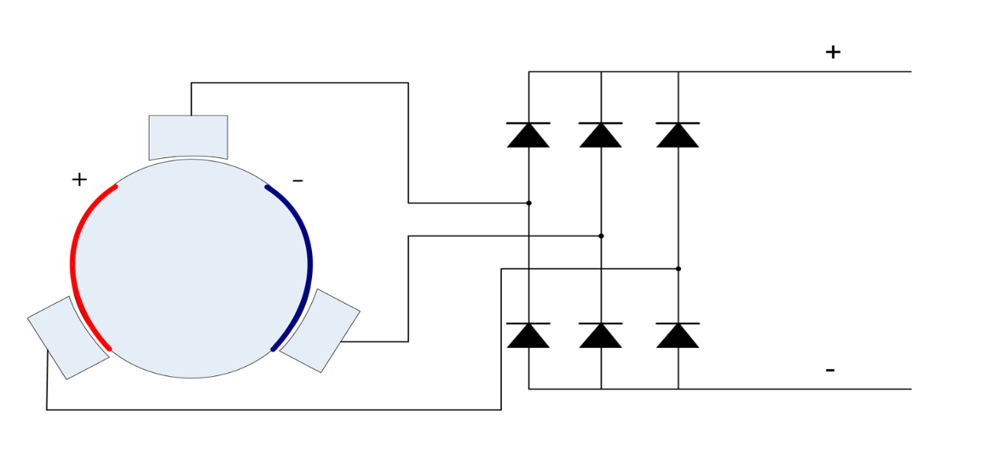
Figure 1: Illustration of brush arrangement around a round cable with Niobium contacts.

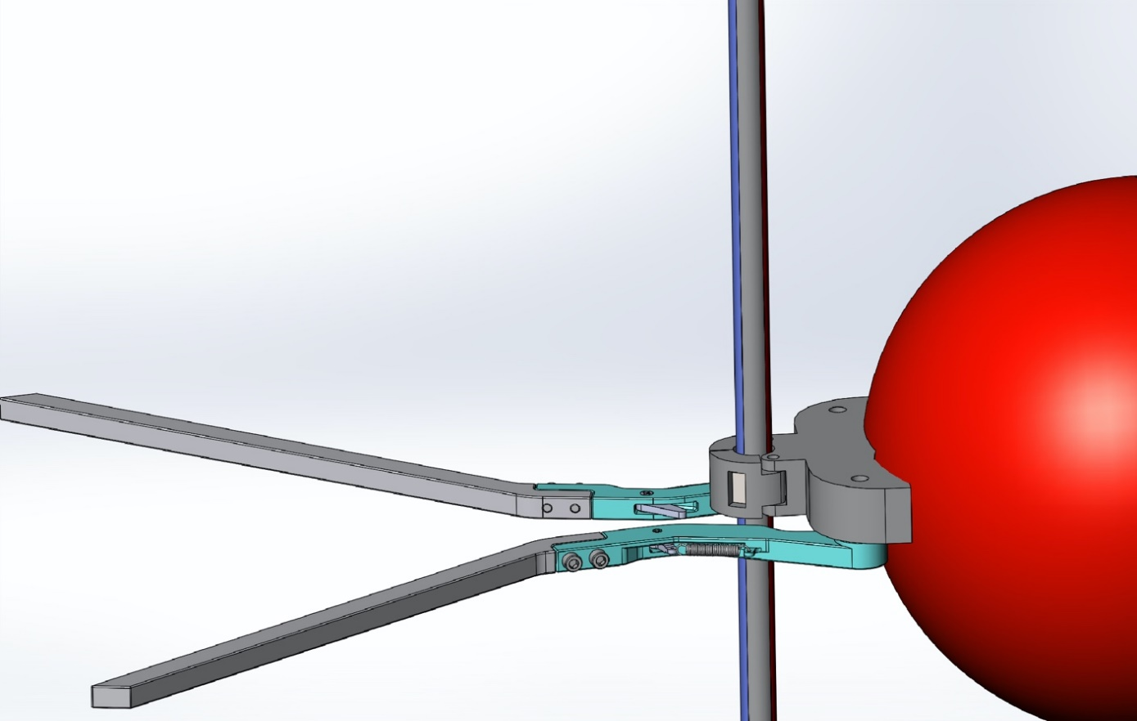
Figure 2: Concept rendition of guide whiskers and latch clamped onto wire with Niobium contact strips.

any given brush will change, this necessitates the diode bridge to convert back to DC voltage for AUV battery charging. Since the Niobium material loses its self-insulating properties above 60 volts, this system will transfer voltage below that point and a DC-DC converter (not shown) may be necessary to provide the appropriate voltage to the AUV. An important requirement for this design is that the result leaves the vehicle relatively free to move vertically and around the wire during use, reducing requirements on close positioning of the vehicle while charging. The tradeoffs in the mechanical design to achieve electrical contact while providing this flexibility is a primary focus of this development.

In addition to power transfer, communication over this link is important. The project will work to enable this capability by superimposing a higher frequency signal on the power line. This is a common approach and is for example used in residential devices to provide an internet connection in homes over the existing AC house wiring. Communication over a Niobium connection has been demonstrated by Northrop Grumman, but is complicated by the rotating brush and diode rectification scheme. It will be necessary to adapt these techniques to the slightly more complicated electrical topology planned here.

Integration of such a latch, power system, and communication system into an AUV and subsequent demonstration of the full concept also brings some design challenges. As shown in the concept sketch in Figure 2, additional details involving articulating guide whiskers and a mechanism to guide the cable into the latch and subsequently close the latch are important. Solving these mechanical design challenges in a manner that is consistent with the AUV design are also an important part of this project. Although we will aim first to implement this concept at the nose of the vehicle, alternative possibilities are also worth investigating. In particular, if the guide whiskers and latch can be moved behind the nose section, the valuable sensor area at the nose is maintained, which could result in a more even movement of the vehicle along the mooring wire. There are tradeoffs in these details that will be an area of investigation of this project. The LRAUV is an excellent platform to perform this testing and will be the initial and primary use case pursued in this project, although there are other platforms used in oceanographic science such as vertical profilers that may benefit from these developments.

Marine Operations/Field Programs

At sea testing of the latching device will be necessary to demonstrate effectiveness and ways to improve/refine the design. In order for this project to accurately reflect the development costs of the proposed device, at-sea testing (and subsequent use) activities are included in 902101 - LRAUV Technology Development and Fleet Operations. As such, this project does not currently plan to directly include any marine operations/field programs but does include resources for support of those efforts. While this applies to the primary use case of the LRAUV, it is possible that other uses of this technology could become apparent through the life of the project. In that case the appropriate way to test any such uses will be identified in subsequent proposals.

Data
What data products will be generated?

All of the data generated by this project will be engineering test data.

How will the data products be managed?
Storage in project folder on the Project Library share.
Describe data availability outside of the project team.

We may have occasion to share test results with Northrop Grumman engineering staff, which will be done under the provisions of a licensing agreement for the Niobicon material.

Describe data storage requirements.

Minimal.

Anticipated Impact

Who are the consumers of the instruments, methods, systems, and data that will be generated?

By creating the technology needed for a long-term presence of AUVs in the ocean, we aim to enable capabilities of autonomous oceanographic observing and process characterization over extended time scales and in remote locations that lack shore support. Therefore, the consumers of this development are ocean observing systems and those interested in making such measurements.

Anticipated Outreach

What outreach assets might you need to better reach the audience/consumers you are targeting? Specify how you might like to reach your audience (published paper, seminar, conference, social media, etc.) and what type of assets (graphic, animation, video, etc.) you might need ITD to help generate.

No outreach specific activities are planned.

Intellectual Property (IP) Considerations

Do you anticipate a need for a cooperative research and development agreement or licensing arrangement with an external entity?

Yes, we are working on a license and Joint IP agreement with Northrop Grumman to allow MBARI to use the Niobicon material for this project. Negotiations are currently underway to ensure this license agreement meets the needs and requirements of both MBARI and Northrop Grumman. We aim to create a collaborative environment with this agreement such that Northrop Grumman has motivation to market the developments of this project if successful.

Will novel IP be created, and how might it be disseminated (e.g., open-source, royalty-free license, commercial license agreement)?

The draft Joint IP agreement with Northrop Grumman has specific provisions for sharing IP developed by this project. In summary, joint IP developed by this project will be usable by Northrop Grumman free of charge, and licensable by Northrop Grumman to third parties in a manner that benefits both MBARI and Northrop Grumman. The intention is also that background IP from MBARI and Northrop Grumman is not included in the Joint IP or Joint IP rights. This goal is one reason for not including AUV testing in this project. These details are currently being negotiated.

Will the work potentially result in a patentable product or service?

Yes, potentially. Because these opportunities will most likely be dependent upon existing Northrop Grumman patents on the Niobicon materials, the Joint IP agreement under negotiation identifies Northrop Grumman as the agent that would pursue patent protection of joint IP developed in this project.

  - Continuing Projects

Current status of project and results to date

Although this is a new project proposal, we have worked throughout 2020 to secure access to the Niobicon material, experiment with it in lab testing, and design a first prototype to explore the mechanical and electrical design options in the test tank.

  - All Projects: Specific Plans for 2021

Engineering/technology development

In 2021, this project will work to develop and refine prototypes of the envisioned latching connector, integrate them into the LRAUV, and do at-sea testing. The project plan includes a number of prototypes of progressive complexity. The first effort will be limited to test-tank use and will not include features needed to open and close. The purpose of this is to demonstrate the basic power transfer, learn how loosely coupled the latch can be on the wire, and experiment with simultaneously transmitting data over the connection while charging. Figure 3 illustrates the design of this initial prototype. Subsequent prototypes will refine this design as needed to meet the requirements, add the capability to open and close around the wire, and add features to be integrated into the LRAUV (whiskers, mounting, etc). We have begun the initial test-tank prototype design in 2020 with resources freed up by the curtailed wave-energy buoy deployment season. Figure 3 illustrates that design. Much of this work is mechanical and electrical design work to enable power and communications over the latch. In both cases this work includes developing interfaces to a mooring system, and the LRAUV.

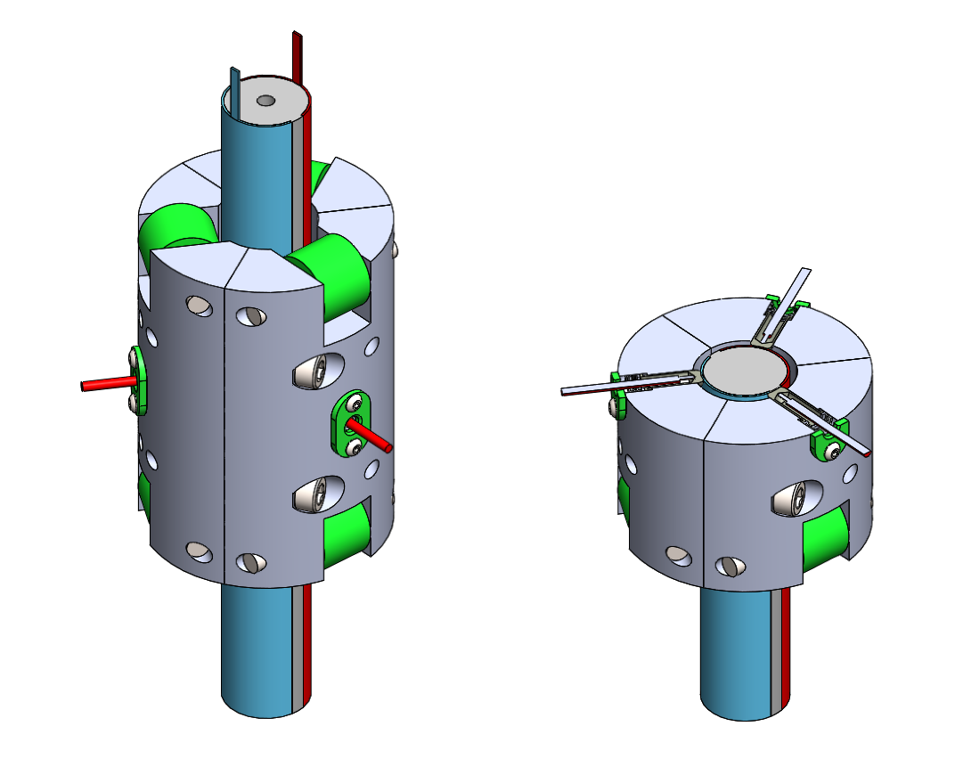
Figure 3: The image on the left is the design for the first test-tank prototype and is about 3” long. The image on the right is a cut-away view of the same device illustrating the spring-loaded Niobium brushes that will impinge on the Niobium strips in the cable. The rollers are to promote vertical motion. This prototype is for initial tank testing of the power and communications transfer and will simply be assembled on the test cable for that purpose, so does not require a mechanism to open and close.

Will novel intellectual property be developed and/or disseminated?
Dissemination includes patenting, licensing, and collaboration agreements.

The License and Joint IP agreements described above will potentially be in place by the end of 2020. The 2021 period will include intellectual property developments related to the specific engineering/technology developments planned. Because the initial focus is on development, dissemination of that IP is unlikely in 2021, but not impossible. The dissemination mechanisms will follow those in the Joint IP agreement that is currently being negotiated.

Field programs (detail ship requirements/deployments/diver requirements)

In addition to describing anticipated field programs, please be sure to include requirements for specific platforms and equipment (Dorado AUVs, LRAUVs, Wave Glider, mini ROV, etc.) for each proposed field program so that expectations are clear. Requests must also be entered in the budget entry system.

Field programs to test the device developed in this project are planned as part of LRAUV Technology Development and Fleet Operations, 90210. In order to keep this project’s developments linked to the wave energy developments without involving the hardware in that project directly, we are planning to have specific mooring equipment developments and integrations for the needed tests to be performed as part of Wave Energy Conversion for Oceanographic Applications, 901405. We currently do not anticipate a need for other at-sea testing that would be part of this project.

Isotope Usage
Project teams must provide details regarding any planned isotope use on shore, on ships, in the Sanctuary, etc. Please review the guidance on isotope usage at http://www.mbari.org/at-sea/cruise-planning/hazardous-materials/ and policy at http://mww.mbari.org/safety/SafetyManual/Isotope_Use_Policy.pdf, and then provide details on plans below.

None

Safety Disposal Needs

So the Safety office can plan and budget accordingly, please respond to the questions below regarding any anticipated safety disposal needs for the coming year. Budget for cost of such removal will be captured by the safety office based on responses received.

Will this project generate more than 1 gallon (4 liters) of battery waste per year?

No

If yes, please indicate the type of batteries (alkaline, NiCad, NiMH, lithium ion or lithium metal) and the approximate amount of each to be generated.

N/A

Will this project generate more than 15 gallons (60 liters) of hazardous liquid waste per year?

No

If yes, please indicate the composition of the waste(s) and the quantity of each to be generated.

N/A

Specific deliverables

Tested Prototypes.

Milestones and required personnel (see personnel classification list for staff classifications)

Milestone 1: Completion and Testing of First Prototype
Milestone 2: Completion and Testing of Second Prototype
Milestone 3: Completion and Testing of Third Prototype and Payment of License Fee

2021 Project Start Date:  MM/DD/2021 | Milestone 1 | Milestone 2 | Milestone 3 | Total Resources (in hours) for each resource category for all milestones listed here
Milestone Date | 3/1/2021 | 8/1/2021 | 12/1/2021
Milestone Description | 1st Prototype | 2nd Prototype | 3rd Prototype
Electrical Engineer | Jensen: 100 | Jensen: 100 | Jensen: 100 | Jensen: 300
Mechanical Engineer | Cazenave: 88  Hobson: 36  Hamilton: 60  Total: 208 | Cazenave: 108  Hobson: 36  Hamilton: 60  Total: 180 | Cazenave: 128  Hobson: 24  Hamilton: 68  Total: 188 | Cazenave: 324  Hobson: 108  Hamilton: 188  Total: 632
Electrical Tech | 20 | 20 | 20 | 60
Mechanical Tech | 20 | 20 | 20 | 60
Machinist | 40 | 40 | 40 | 120

Budget justification

- For each prototype, $5000 dollars in material is requested. This is for Niobium and other metals and plastics, wiring, electronics housings, etc.
- Electrical components costs are estimated as starting at $5000 for the first prototype and decreasing to $2000 for subsequent prototypes due to expected component re-use.
- In the draft license agreement, a $25000 licensing fee will be required 1 year after the license agreement goes into effect, this payment is expected to occur in 2021.

Project team
François Cazenave and Scott Jensen will be the primary mechanical and electrical engineers on the project. These individuals are extremely well suited to the task and as key members of the wave-energy conversion team, are assets in making these developments relevant to that platform. Andrew Hamilton and Brett Hobson as Co-PI also provide connections to the wave-energy conversion project and the LRAUV technology development and fleet operations project.

Project lab and office space requirements
In addition to any changes to current space usage, please also include anticipated office and lab needs for students, postdocs, collaborators, etc.

We do not anticipate that this project will require significant space. The labs the wave-energy conversion and LRAUV projects inhabit will be more than sufficient.

R/V Paragon Requests
If the project team will be requesting time for the R/V Paragon, please specify the operators in the group and provide estimates of their availability to operate the vessel. DMO staff have extremely limited availability to be operators and only with advanced budgeting and planning.

None, at-sea testing will be done through 902101.

Risk matrix (development and infrastructure projects only)

 | Technical Risk | Organizational Risk | Tech Transfer Risk | Labor Estimate Risk
High | X
Medium |  | X | X
Low |  |  |  | X

  - Compliance Considerations

Export Regulation
Does the project team anticipate any foreign collaborations or international travel? If so, please identify collaborators by name, institution, and country.

No

Does the project team plan or anticipate export-controlled purchases, shipments, or transfers of items (e.g., research instruments, proprietary data, hand-carried tools or samples) outside the U.S. temporarily or permanently? If yes, please identify country or countries and indicate whether these items will remain under MBARI control while abroad or controlled by others. Will the items be exported to more than one country? Please include foreign collaborator information as described above.

No.

Monterey Bay National Marine Sanctuary (MBNMS)

General Permit
Projects teams need to indicate if any work will be performed that is either: (1) currently authorized under our general permit; or (2) will require that we obtain authorization. The current permit can be viewed at https://mww.mbari.org/pco/permits/mbnms-2020-006_exp28feb2025.pdf. Please see Mandy Allen for questions.

Is a permit with MBNMS required for your work?

No

SESAs (General map)
Projects will need to indicate whether or not work will be conducted within one of the Monterey Bay National Marine Sanctuary's Ecologically Significant Areas (SESAs). If your work will be conducted in one of these areas, please indicate which area by number or name.

None

Anchors
For activities conducted under MBARI's permit for the Monterey Bay National Marine Sanctuary, Paragraph 16, we are required to recover anchors weighing less than 500 pounds. Project proposals, which involve anchors weighing less than 500 pounds, shall specifically indicate cruise time allocated to anchor recovery. Lack of cruise time is not an acceptable reason for deeming an anchor less than 500 pounds “unrecoverable” under Paragraph 17 of MBNMS permit. Also under Paragraph 17, ALL anchors not recovered during the year must be reported detailing location, description of anchor, and reason not recovered. (Mandy Allen will collect this information from project teams to submit as part of the annual report to the Sanctuary.) Each ship will be tracking anchors deployed, duration of attempted anchor recovery, and anchors abandoned on the seafloor with the intent that they be recovered in the future as per MBNMS permit requirements.

Will you be deploying equipment that will require anchoring? If so, please indicate approximate weight of anchors to be used and recovery plans.

No

California Department of Fish & Wildlife
A Scientific Collecting Permit will be required for biological and geological sample collections offshore California (even in Federal waters and beyond), and for many activities in State Marine Protected Areas (MPAs). Please see Mandy Allen for questions.

Will you be collecting samples that require a permit?

No

Will you be working in a State Marine Protected Area?(See link above for Statewide MPAs or this link for Central California MPAs.)

No

United States Coast Guard

If your project will deploy or maintain moorings, the project team must ensure proper compliance and notification of these activities to the US Coast Guard. DMO does not automatically do these notifications on behalf of projects. Two common types of permits and notifications that may apply to your project are Private Aid to Navigation (PATON) authorizations (required for buoys deployed for six (6) months or longer) and Notice to Mariners, which must be submitted for temporary PATONs (less than 6-month deployments). Other science operations may submit a request for a Local Notice to Mariners and are useful for missions or deployments with risk of 3rd Party Liability such as the Wave Glider.

Will your project require a PATON?

No

If yes, have you obtained a PATON? (Please provide a copy to Mandy Allen.)

N/A

Will your project require submission of a Local Notice to Mariners?

No

If yes, please indicate who will be submitting request and provide a copy of the submission to Mandy Allen.

N/A

Authorizations/Permits from other Agencies or Organizations
Is the project team aware of any other permits or authorizations that will be necessary to perform the proposed work? If so, please list below along with status of authorizations (obtained, pending, need to apply, etc.). Please see Mandy Allen if you have questions.

None

Active Acoustics
We are keeping an inventory of acoustic instrumentation. The current list is posted here: https://mww.mbari.org/resources/2021_Proposal_Process/mbari_acoustic_instruments_updated_may_13_2020_ver_13.xlsx. If you have or plan to use equipment that is not already on this list, please be sure to include that information here.

None specific to this project. Active acoustics for homing are part of the LRAUV project.

This date and number should remain the same for the duration of the project. If your project start date for 2021 is not January 1, please indicate the start date in the first cell of the milestone chart. Format for duration example: “Year 2 of 5”.
Development and infrastructure projects must complete the risk matrix (see end of the proposal form).
Not all projects will require all four titles to be filled in. Please indicate individuals only for those titles that are appropriate for your project.
This category includes transfer of hardware, know-how, publications, presentations, etc.
This number should be the same number you entered on the resource requests for this particular resource.

