Project Number: | 902106

Project Start: Jan. 1, | 2021 | Project Duration (in years): | Year 2 of 3¹

Please indicate if the proposal includes requests for any of the following (mark all that apply).

Ship Time |  |  | ROV |  |  | AUV |  |  | Wave Glider |  |  | Mini ROV

Please indicate what type of project is being proposed (mark only one).

 |  |  |  | X
Feasibility/Scop.  [<100 days effort] |  |  | Development |  |  | Research |  |  | Infrastructure² |  |  | Education |  |  | Time Series |  |  | Institute Initiative

Project Manager: François Cazenave
Principal Investigator: Andrew Hamilton and Brett Hobson
Lead Engineer: François Cazenave

Project Title: Niobicon-Based AUV Docking Development

Please indicate which category best describes the project theme (mark only one).

 | X |  |  | X |  |  |  |  |  | X
Ocean  biogeochemistry |  |  | Ecosystem dynamics |  |  | Ocean visualization |  |  | Exploration & discovery

Please indicate percentage of effort on this project anticipated for 2022 toward these three highest institutional goals (percentage total should equal 100%).

Goal | Developing/adapting innovative technologies | Utilizing developments to explore and understand ocean systems | Technology/knowledge transfer
Percentage | 90 | 0 | 10

- ABSTRACT (all projects)
Briefly provide a high-level summary of the project (ideally no more than 1/2 page).

This is a proposal for the second year of a three-year effort to develop an AUV Docking station that will enable extended deployments for MBARI’s fleet of LRAUVs. The enabling technology being developed is a power transfer system utilizing the niobium-based, self-insulating technology demonstrated and patented by Northrop Grumman (Niobicon). This Niobicon power transfer system can be added to a simple vertical line-capture type of AUV docking station, thereby simplifying the process of docking and recharging an AUV. This simplification will improve the reliability of AUV docking to the level required for persistent ocean science operations. The important features of this vertical line-capture dock, or Line-Dock, are the ability to always approach the dock up-current, soft-stop though adjustment in the vertical line tension, both of which are especially important for docking cruising type long-range AUVs used for most ocean science missions.

In 2021, prototypes of the dock, the power transfer device and the latching device were built and extensively tested at MBARI. Plans are underway to deploy a fair-weather, low-power prototype docking station that includes a surface buoy with solar energy harvesting and cellular telemetry in the fall of 2021.

For 2022, we are proposing to design and build a robust, all-weather, buoy-supported dock, addressing any issues uncovered during the fall testing of the prototype. We will also upgrade the power harvesting, storage and transfer rate and add high-speed data transfer to support extended LRAUV operations for limited science operations. In the final year of this project, we plan to revise the system again, but replace the surface buoy and mooring with the power and communications available at MARS. We also have plans during the final year to develop a version of the standalone, shelf-depth docking system that can be powered by MBARI’s Wave Energy Converter (WEC).

The necessary software and hardware upgrades required for the LRAUV and all AUV operations during 2022 are included in the LRAUV core project proposal #902101. The design of the mooring will be performed with WHOI’s collaboration. The Y3 MARS deployment will be simplified if there is a 1500-m depth rated LRAUV, though it is possible to develop a 700-meter riser to extend from near MARS up to the standard 300-meter depth range of the LRAUVs. We expect this design to apply to the Dorado-class AUVs, we include this expansion as a goal, although no explicit requirements to do so are in place as part of this project.

- PROPOSAL (all projects)

Background
Provide context for the project, being sure to address these questions:
- What fundamental problem does this project address, and why is it important?
- What makes this work relevant to MBARI and the Packard Foundation?
- Is this effort linked to other internal or externally funded projects or collaborative efforts?
- Where does this work fit into the ~5–10-year plan for your group, at MBARI, and in the field?

Although the LRAUV project has significantly advanced the ability for our AUVs to operate unattended for up to a few weeks, truly remote and extended operations will require battery re-charging. There have been a number of AUV docking projects in the past to address this, including one at MBARI, but few have led to a routine docking capability for AUVs. This is especially true for the cruising-type AUVs used by MBARI and most other ocean science groups. There are several AUV docking stations for short-range, hovering-type AUVs where the AUV maneuvers into a ‘garage’. These systems are referred to as Resident AUVs (R-AUVs) and are targeted at oil and gas applications. Power transfer is performed with an electrical connector or contact-less inductive system, both of which require close alignments. MBARI developed and successfully demonstrated a cone-type docking station with inductive power transfer for the Dorado cruising-type AUV about 15 years ago. While this approach could be used again, we have concerns:
- The fixed approach heading required large crab-angles to compensate for cross currents. WHOI and OOI allowed their REMUS dock to weathervane in the current, but it wasn’t reliable and that effort was abandoned.
- The impact of the AUV hitting the fixed dock at cruising speed is traumatic.
- It is challenging to fly cruising-type AUV’s below an altitude of 4 meters, and it is difficult to build a docking station that high off the seafloor.

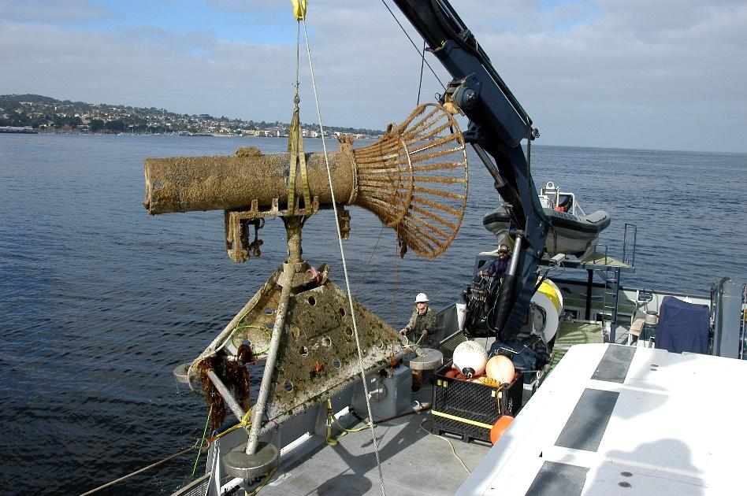

Figure 1: Figure 1 MBARI’s AUV dock being recovered after a deployment in Monterey Bay in 2006.

Recent work with the LRAUV funded by the DHS/Coast Guard has demonstrated success at homing to, and latching onto, a simple vertical mooring line. This work utilized “whiskers” at the nose of the vehicle to guide the line into a mechanical latch on the vehicle itself. This line latch docking is an attractive solution given that there is minimal infrastructure and a large target in the vertical direction, unaffected by vertical motions of the mooring line. The AUV can approach the line from any direction. The line provides a soft stop for the AUV. Currently, however, there is no mechanism for transferring power on a line dock. The challenge addressed in this project is to develop technology to transfer electricity across a line-latch. If successful, this type of AUV docking would reduce the dependence on large vehicle-specific infrastructure on the seafloor, and it would greatly simplify the docking procedure. Durability and reliability of the docking system would be improved.

These activities lie within the strategic plan’s overarching goal to “develop or adapt innovative technologies that allow AUV operations to be conducted anywhere along the continental shelf, at any time. The proposed stand-alone mooring dock can be deployed by a Shana Rae-sized vessel anywhere on the continental shelf, providing a 500 km zone of AUV range coverage. This organic positioning option combined with a dramatic expansion of the operational window will allow new event response missions, operations across lunar cycles and through seasons, including under sea and lake ice where scientific observations have so far been denied.

The proposed project includes elements that involve intellectual property of an external entity and hold the promise of subsequent technology transfer in conjunction with that external company.

Nature and Scope of the Proposed Project
Please provide a sense of the scale and scope of the proposed work. Is this a large de novo R&D effort, modest platform/sensor integration, targeted science investigation with minimal or no engineering needs, extension of current program, small-scale scoping exercise expected to lead to a larger effort, or other? If the project is intended to be multiple years, how will the anticipated level of effort likely change over time?

This project is a medium-sized R&D effort, involving a team of 7 MBARI engineers, Northrop Grumman collaborators, and WHOI collaborators. The goal for 2022 is to design, build and test a buoy-supported dock. The goal for 2023 is to deploy the dock at MARS.

In 2020 and 2021 we designed and built a niobium-based line dock, a line capture mechanism for the LRAUV and a power transfer device.

The line capture mechanism is an arm that extends out from the side of the AUV (figure 2). The arm closes automatically when the line dock is detected by a photosensor and clamps on the line dock.
The dock is made of a 0.75” diameter, thin-wall niobium tube bonded to a fiberglass core. The niobium is separated in two electrically isolated halves and each is energized (figure 3).
The power transfer device relies on three niobium brushes that make contact with the line dock. They are equally spaced such that two are always in contact with the niobium halves on the line dock. This principle is illustrated in Figure 4. As the vehicle rotates around the line dock (because of tidal currents for example), the polarity of any given brush will change, which necessitates the diode bridge to rectify the polarity. Since the Niobium material loses its self-insulating properties above 60 V, this system will transfer voltage below that point. An important requirement for this design is that the vehicle be relatively free to move vertically and around the line during use, reducing requirements on close positioning of the vehicle when docking and while charging. The tradeoffs in the mechanical design to achieve electrical contact while providing this flexibility is a primary focus of this development.
In addition to power transfer, data transfer will be considered and tested in the lab. We will work to enable this capability by superimposing a higher frequency signal on the power line. Communication over a niobium connection has been demonstrated by Northrop Grumman, but is complicated by the sliding contact and the diode rectification scheme. We might find out that reliable communication is not feasible; therefore, we are not relying on it. There are COTS technologies (acoustic or optical) that could be integrated to transfer data from the AUV to the dock if needed. We are requesting funds for an optical modem.

We have extensively tested prototypes of all the components. The power transfer device was tested for several weeks in a specially built test-machine to simulate field conditions (https://youtu.be/CH53ZmWCDrs ). We demonstrated that the device can transfer power reliably for at least 2 weeks (equivalent to months of operation at sea). We also demonstrated the reliability of the line capture mechanism and the dock by performing docking with a free-flying LRAUV in the test tank. (https://youtu.be/P5xNHkBz-mc ). We are planning a short test on a temporary buoy-supported dock in Monterey Bay in the fall of 2021. In 2022, our main activity will be to design and deploy a robust buoy-supported dock in Monterey Bay for 6 months. This will allow us to test and refine the docking system and to support research activities. In 2023 we are planning to deploy a dock at MARS. f
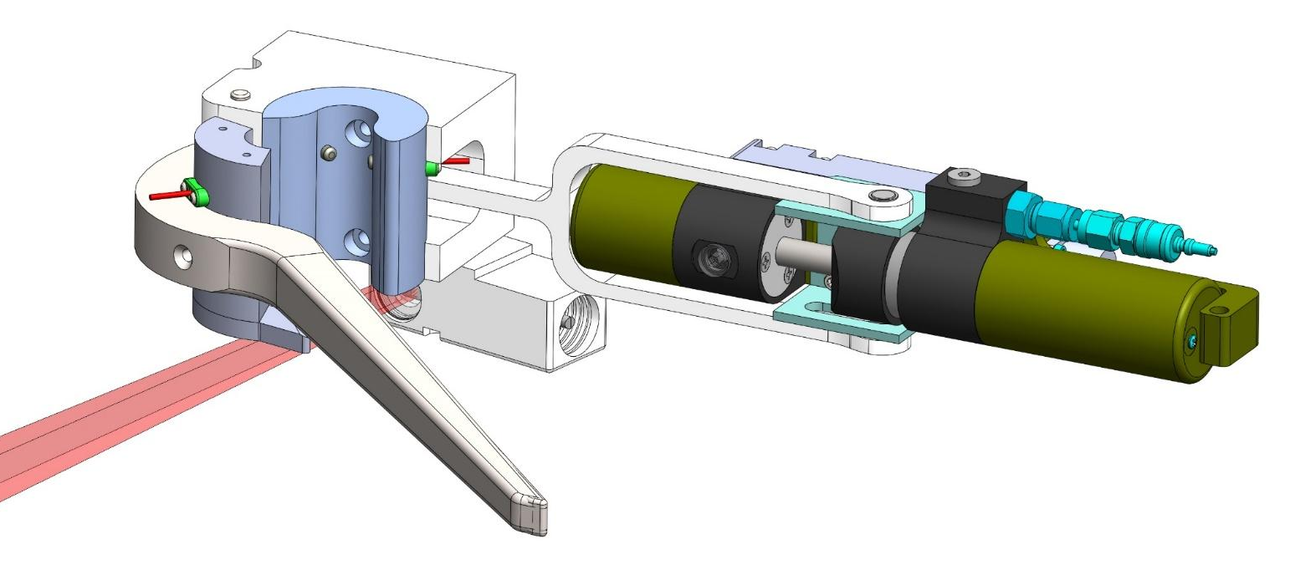
Figure 2: Rendition of the line capture latch and Niobicon-based power transfer device.

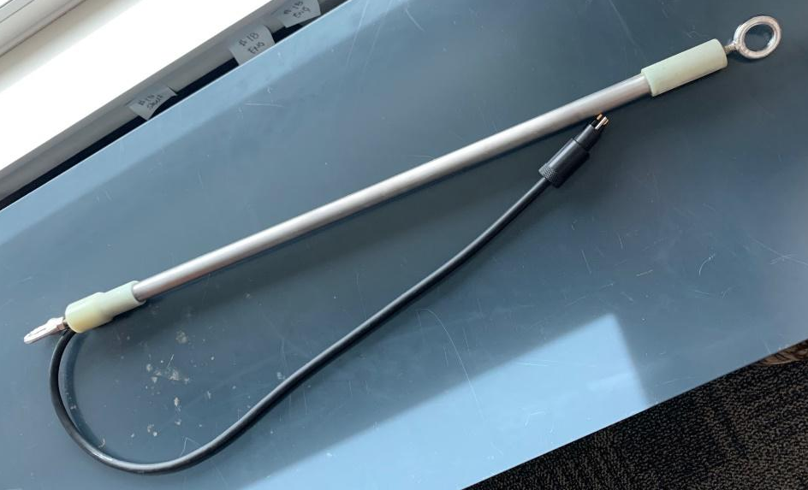
Figure 3: 2' long prototype of the niobium line dock.

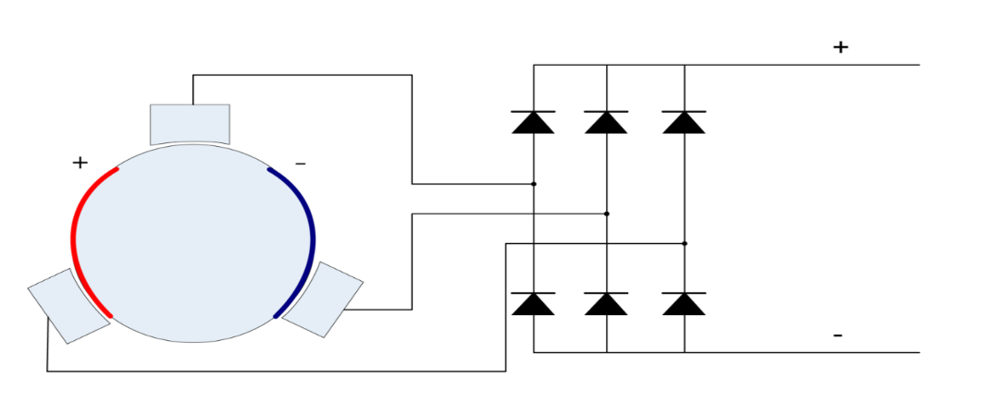
Figure 4: Illustration of the electrical arrangement of a niobium dock with Niobium brushes.

Anticipated Shared Resource Needs
What staffing is required to advance the work in 2022 (e.g., is this a multi-faceted engineering development or a targeted science investigation that does not require significant use of shared personnel)? Is in-house or contract manufacturing needed? What level of ship/ROV/AUV (DMO) support is likely? If this is intended to be a multi-year effort, please provide a rough indication of anticipated shared resource needs over the duration of the project (e.g., will stay flat, will significantly increase in Year X, will significantly decrease by Year Y).

We are requesting 400 hours of electrical engineer (Jensen), 160 hours of embedded software engineering (Raanan, Kieft, Henthorn), 1040 hours of mechanical engineering (Cazenave, Hamilton, Hobson), 540 hours of machinist, 260 hours of mechanical technician, and 220 hours of EE technician.
We are requesting 3 days of R/V Paragon support for buoy maintenance.

R/V Shana will be contracted for 2 days for the deployment and recovery of the buoy and the dock.
In 2023, we anticipate requesting a similar amount of labor. We are also planning to request 1 day of ROV Ventana for deploying the dock on MARS, and associated preparations with ROV pilots. We are planning to use one port at MARS.

Anticipated Expenses
What rough order of magnitude direct expense budget is anticipated annually over the course of the project? Is procurement of specialized capital equipment or outside contractors required? Will there be annual travel?

- The budget for 2022 is approximately $153,300, including $25000 for the Northrop Grumman License fee payment, $10,000 for engineering consulting work and design transfer from the WHOI mooring group, and $4300 for external ship time (Shana Rae). A $53,000 pair of optical data transfer modems were included to provide a complete power and data system, though it is possible to operate the docking system without them. The budget for 2023 is expected to be much less (~$50,000) due to re-use of components developed in 2022, and the fact that the Northrop Grumman license fees will be completed in 2022.

Intellectual Property (IP) Considerations
Do you anticipate a need for a cooperative research and development agreement or licensing arrangement with an external entity? Will the work potentially result in a patentable product or service? Will novel IP and/or custom-made equipment be created, and how might it be disseminated (e.g., license agreement and/or collaborations)?

For additional guidance please review MBARI’s intellectual property internal web page: https://mww.mbari.org/itd/ip/.

Do you anticipate a need for a cooperative research and development agreement or licensing arrangement with an external entity?

Yes, a key component of this project is the license agreement in place with Northrop Grumman that allows MBARI to use the Niobicon material for this project. A final $25,000 license fee is due in 2022 and is included in this project's
expense budget.

Will novel IP be created, and how might it be disseminated (e.g., open-source, royalty-free license, commercial license agreement)?

The Joint IP agreement we have signed with Northrop Grumman has specific provisions for sharing IP developed by this project. In summary, joint IP developed by this project will be usable by Northrop Grumman free of charge, and licensable by Northrop Grumman to third parties in a manner that benefits both MBARI and Northrop Grumman. Background IP from MBARI and Northrop Grumman is not included in the Joint IP or Joint IP rights.

Will the work potentially result in a patentable product or service?

Yes, potentially. Because these opportunities will most likely be dependent upon existing Northrop Grumman patents on the Niobicon materials, the Joint IP agreement identifies Northrop Grumman as the agent that would pursue patent protection of joint IP developed in this project.

Data
What data will be generated? How will they be managed/stored? Are any special data visualization needs anticipated?

All of the data generated by this project will be engineering test data. It will be stored in the project library and will be of moderate size.

Anticipated Impact
Who are the consumers of the instruments, methods, technology, and data that will be generated within and beyond MBARI? Will the project create tangible connections with other organizations (e.g., academic, NGO, MBA, MBNMS, state or federal agency)?

By creating the technology needed for a long-term presence of AUVs in the ocean, we aim to enable capabilities of autonomous oceanographic observing and process characterization over extended time scales and in remote locations that lack shore support. Therefore, the consumers of this development are ocean observing systems and those interested in making such measurements.

Anticipated Outreach Needs
Thinking about the audiences/consumers you highlighted in the question above, do you anticipate needing to create outreach assets to help increase your impact? If so, please specify whether you anticipate needing to work with ITD and also specify what type of asset (story, graphic, animation, video, etc.) you might need.

No specific outreach activities are planned.

Continuing Projects Only: Status Report
Briefly provide an update of the current project relative to what was proposed for 2021 by responding to the prompts below. If the project includes multiple subproject projects, please list each of these under a subheading as you deem appropriate.

Current status of project and results to date

The project has made great progress in designing, building and testing the docking system in 2021. Most of it was described in the first section of this document (page 3-4). Here is a list of accomplishments:
- Design and fabrication of the line capture device
- Design and fabrication of the power transfer device
- Design and fabrication of the line dock
- Integration in the LRAUV of the docking hardware
- Extensive testing in the lab and the test tank.

What percentage of labor and budget have been used through the 1st half of year?

36% of budgeted Labor has been used.
75% of budgeted Expense has been used (includes first $25000 license fee to NG, which was a large component of the 2021 expense budget).

Will you complete the current year’s scheduled work?

Yes

Significant changes from previous project proposal

We only had vague plans to deploy the system at sea. Now we have detailed plan to deploy it in Monterey Bay in 2022 and on MARS in 2023.

All Projects: Specific Plans for 2022

Engineering/technology development

For 2022, we are planning several development and testing activities:

- Improvement of the line capture mechanism
The actuator will be upgraded to provide more force for a larger safety margin to solve alignment issues during periods of high water current.
Many of the components of the prototype were 3D printed, so improved, machined versions will need to be manufactured to increase robustness.
- Improvement of the power transfer device and addition of optical communication.
The current power transfer device is limited to about 250 W. By modifying the shape of the niobium brushes and the clamps, we will aim to increase the current carrying capacity to 500 W, which would allow completely recharging the AUV in 10 hours. This requires significant design work and lab testing. This will also require installation of a new battery charger controller in the LRAUV, which should be available in late 2021 or early 2022. A COTS optical modem capable of 5 Mbps data transmission rate will be purchased and integrated into the AUV and the dock.
- Design of a buoy-supported dock
Based on the short test that we are planning to perform in late 2021, we will design a robust mooring that harvests energy at the surface (wind and solar) and transfers it to the dock on the seafloor. The dock will hang vertically on a float a few meters above the seafloor (figure 5). The purpose of the U-shaped mooring is to isolate the dock from wave motion. Much of the mooring design will be provided by WHOI and performed in conjunction with the wave-energy project to promote future interoperability.
- Buoy-supported dock deployment
The dock will be deployed in Monterey Bay, in 80-m-deep water, from April 2021 to October 2022.
- AUV operations and science
At sea testing of the dock will be necessary to demonstrate its effectiveness and to improve the design. The dock will be tested and operated throughout its deployment. Research activities will be supported by the dock as needed. In order for this project to accurately reflect the development costs of the proposed device, at-sea testing (and subsequent use) activities are included in 902101 - LRAUV Technology Development and Fleet Operations

For 2023, we are planning to build and deploy a dock on MARS. The availability of ample electrical power and high bandwidth communications, the absence of wave action or biofouling and the remote location make MARS an ideal site for an AUV dock. We expect that by then, the 1500 m-rated version of the LRAUV may be ready for operations, which will allow the dock to be placed at 900 m depth, a short distance from MARS. We have talked to Craig Dawe, ROV pilots and researchers conducting experiments at MARS to make sure that our plans are sound. If the deep LRAUV is not ready by then, we will place the dock on a 700-m riser, connected to a 1000-m seafloor extension from MARS, allowing the 300-m rated LRAUV to reach it. This configuration is less desirable due to the added complexity.

- MARS dock design and fabrication.
The dock itself will be very similar. The mooring and the connection to MARS will need to be designed and built. Much of the required hardware (floats, ODI connectors, housings) is already available, from past MBARI projects.
- Transfer of docking hardware to deep-rated LRAUV.
The line capture device will be transferred to the deep LRAUV, which will require minor modifications. The docking procedure with the deep LRAUV will be tested in the tank.
- Deployment on MARS dock
The dock will be deployed in the spring of 2023. This will require 1 day of ROV Ventana. Our goal is to leave the dock at MARS for continuous operation for two years.
- AUV operations at MARS
AUV operations for testing and research will be performed as part of 902101 and other projects.
- Wave energy buoy and docking
We will explore the possibility of powering the dock with the wave energy buoy.
- Buoy-supported Dock deployment
Depending on the state of the hardware, on the results from the 2022 deployment, and on the need for scientific research, the buoy-supported dock could be redeployed in 2023.

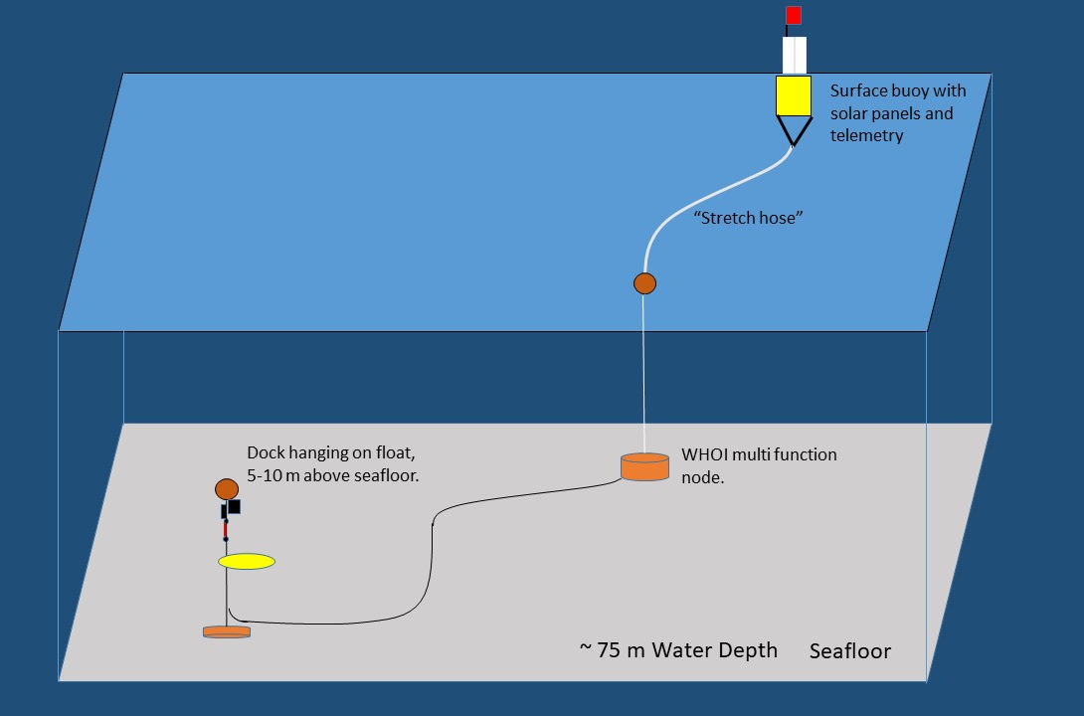
Figure 5: Buoy-supported AUV dock

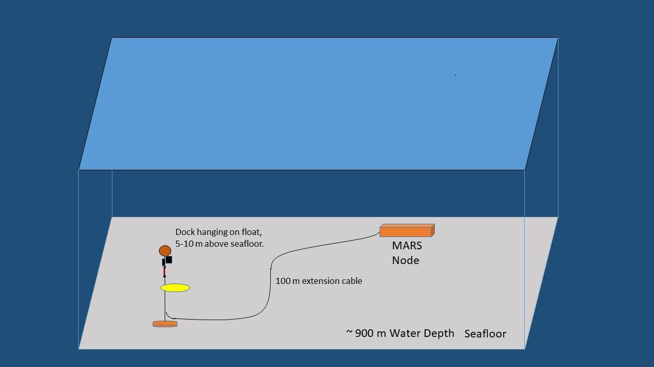
Figure 6: AUV dock connected to MARS

Field programs (detail ship requirements/deployments/diver requirements)
In addition to describing anticipated field programs, please be sure to include requirements for specific platforms and equipment (Dorado AUVs, LRAUVs, Wave Glider, mini ROV, etc.) for each proposed field program so that expectations are clear. Requests must also be entered in the budget entry system.

April 2022:
Deployment of buoy-supported dock in Monterey Bay, using R/V Shana Rae.

October 2022:
Recovery of buoy-supported dock, using R/V Shana Rae.

April 2023:
Deployment of MARS-supported dock using ROV Ventana.

Summer 2023
Possible second deployment of buoy-supported dock.

Specific deliverables

2022
Upgraded line capture device
Upgraded power transfer device for 500 W power transfer.
Integration of optical communication device for data transfer
Buoy electronics
Line dock and support electronics
Mooring system

Milestones and required personnel (see personnel classification list for staff classifications)

Milestone 1:
Design, fabrication and test of improved line capture and power transfer device
Milestone 2:
Design and fabrication of mooring. Much of the design work will be based on an existing WHOI design.
Milestone 3:
Design and fabrication of dock and subsea electronics
Milestone 4:
Design and fabrication of buoy and topside electronics
Milestone 5
Deployment of buoy-supported dock in Monterey Bay
Milestone 6:
Recovery of buoy-supported dock in Monterey Bay

2022 Project Start Date:  01/01/2022 | Milestone 1 | Milestone 2 | Milestone 3 | Milestone 4 | Milestone 5 | Milestone 6 | Total Resources (in hours) for each resource category for all milestones listed here
Milestone Date | 03/01/2022 | 04/01/2022 | 05/01/2022 | 05/01/2022 | 06/01/2022 | 12/01/2022
Milestone Description | Line Capture/ Power transfer device built and tested in the lab. | Design and Fabrication of mooring | Design and fabrication of dock and subsea electronics | Design and fabrication of buoy and topside electronics | Deployment of buoy-supported dock in MB | Recovery of buoy-supported dock in MB
Electrical Engineer | Jensen 40 |  | Jensen 120 | Jensen 200 | Jensen 20 | Jensen 20 | Jensen 400
Software Eng-Embedded | Kieft 8  Raanan 8 |  | Kieft 8  Raanan 8 | Kieft 8  Raanan 8  Henthorn 40 | Kieft 8  Raanan 8  Henthron 40 | Kieft 8  Raanan 8 | Kieft 40  Raanan 40  Henthorn 80
Mechanical Engineer | Hobson: 80  Cazenave: 140  Hamilton: 20 | Hobson: 40  Cazenave: 60  Hamilton: 80 | Hobson: 80  Cazenave: 140  Hamilton: 20 | Hobson: 80  Cazenave: 140  Hamilton: 20 | Hobson: 20  Cazenave: 40  Hamilton: 10 | Hobson: 20  Cazenave: 40  Hamilton: 10 | Hobson: 320  Cazenave: 560  Hamilton: 160
Electrical Tech | 20 |  | 80 | 120 |  |  | 220
Mechanical Tech | 20 | 40 | 80 | 80 | 20 | 20 | 260
Machinist | 120 | 120 | 120 | 120 | 40 | 20 | 540

Budget justification

- $6000 in material and components for the improved line-capture device.
- $6000 in materials and components for the improved power-transfer device.
- $52,000 for a pair of optical communication modems (Sonardyne Bluecomm 100)
- $50,000 in materials and components for buoy-supported dock (components for dock, cable, anchors, multi function node, buoy float, hardware, housings, solar panels, stretch hose, etc).
- $10,000 Engineering consulting from WHOI.
- $4300 for deployment and recovery of buoy with R/V Shana Rae.
- $25000 license fee for Northrop Grumman

Project team

The team in 2022 will be very similar to 2021.
François Cazenave: mechanical design, lab testing, fabrication, assembly and deployment supervision.
Scott Jensen: electrical design (dock, power transfer device, buoy telemetry and power system).
Andy Hamilton: mooring design, system engineering.
Brett Hobson: mechanical design, electrical design, LRAUV integration and operations.
Brian Kieft: Docking related software on LRAUV, in-lab and at-sea testing
Ben Raanan: Docking related software on LRAUV, in-lab and at-sea testing
Rich Henthorn: Shore network and data management.

Project lab and office space requirements
In addition to any changes to current space usage, please also include anticipated office and lab needs for students, postdocs, collaborators, etc.

We do not anticipate that this project will require significant space. The labs the wave-energy conversion and LRAUV projects inhabit will be more than sufficient.

Risk matrix (development and infrastructure projects only)

 | Technical Risk | Organizational Risk | Tech Transfer Risk | Labor Estimate Risk
High
Medium | X | X | X | X
Low

Compliance Considerations
Please respond “Yes” or “No” to each line item below, and provide details as necessary.

CATEGORY | Yes/No | DETAILS
Isotope Use (see policy and cruise planning)  Will the project use stable or radioisotopes? | No
Battery waste over 4 liters (1 gallon)  Indicate type and amount. | No
Liquid hazardous waste over 60 liters (15 gallons)  Indicate composition and quantity. | No
Export Regulation  Foreign collaborations or international travel? | No
Export controlled purchases  Items purchased/in possession or to be purchased that are not on list? | No
Export controlled items (hardware, software, tech data)  Items to be transferred outside US (temporarily or permanently)? To what countries (including International Waters)? | No
Work covered by Marine Sanctuary permit?  Yes, if work falls under blanket authorization. | Yes
Work conducted in SESAs?  ID # for Sanctuary Ecologically Significant Areas | No
Equipment deployed with anchors?  Give details for deployment; recovery if < 500lbs | Yes | One 400 lb anchor, one 200 lb anchor, both will be recovered
CA Fish & Wildlife permit required for samples? | No
Working in State Marine Protected Area? | No
Require Coast Guard PATON for buoys?  Private Aid to Navigation. Permit in hand? | No | Deployment will be less than 6 months.
Require Local Notice to Mariners  Indicate who will be submitting | Yes | Cazenave will submit
Permits from other agencies? | No
Use of active acoustics not already on list? | No

This date and number should remain the same for the duration of the project. If your project start date for 2022 is not January 1, please indicate the start date in the first cell of the milestone chart. Format for duration example: “Year 2 of 5”.
Development and infrastructure projects must complete the risk matrix (see end of the proposal form).
Not all projects will require all four titles to be filled in. Please indicate individuals only for those titles that are appropriate for your project.
This category includes transfer of hardware, know-how, publications, presentations, etc.
This number should be the same number you entered on the web budget resource requests for this particular resource.

