Project Number: | 902106

Project Start: Jan. 1, | 2021 | Project Duration (in years): | 3 of 3¹

Please indicate if proposal includes requests for any of the following (mark all that apply).

Ship Time |  |  | ROV |  |  | AUV |  |  | Wave Glider |  |  | Mini ROV

Please indicate what type of project is being proposed (mark only one).

 |  |  |  | x
Feasibility/Scoping  [<100 days effort] |  |  | Development |  |  | Research |  |  | Infrastructure² |  |  | Education |  |  | Time Series |  |  | Institute Initiative

Project Manager: François Cazenave
Principal Investigator: Andrew Hamilton and Brett Hobson
Lead Engineer: François Cazenave

Project Title: Niobicon-Based AUV Docking Development

Please indicate which category best describes the project theme (mark only one).

 |  |  |  |  |  |  |  |  |  | x
Ocean  biogeochemistry |  |  | Ecosystem dynamics |  |  | Ocean visualization |  |  | Exploration & discovery

Please indicate percentage of effort on this project anticipated for 2023 toward these three highest institutional goals (percentage total should equal 100%).

Goal | Developing/adapting innovative technologies | Utilizing developments to explore and understand ocean systems | Technology/knowledge transfer
Percentage | 80 | 10 | 10

- ABSTRACT (all projects)
Briefly provide a high-level summary of the project (ideally no more than 1/2 page).

This is a proposal for the third year of an effort to develop an AUV docking station that will enable extended deployments for MBARI’s LRAUV. The enabling technology being developed is a power transfer system utilizing the niobium-based, self-insulating technology demonstrated and patented by Northrop Grumman (Niobicon).
In 2021 and 2022, prototypes of the charge rod, the power transfer device and the latching device were built and extensively tested in the labs, the test tank and the ocean. A prototype docking station that includes a surface buoy with solar energy harvesting and cellular telemetry was built and is currently deployed and being tested. A more robust and more capable docking station is being developed and will be deployed in early 2023.
We will start the year 2023 by deploying the upgraded AUV-docking system for a 3-month test deployment to make sure that all systems work reliably. In parallel, we will work on integrating the docking hardware onto the AyeRIS nose and one of the ESP nose assemblies. Having addressed any issues and made necessary upgrades, we will deploy the system again in the fall to support a scientific experiment for at least 3 months.
Meanwhile, we will design a new docking station to be deployed at MARS in 2024 and the power-transfer device will be adapted to the new deep-rated LRAUV so that it can be operated there. Fabrication and deployment of the system at MARS will be performed under a 2024 proposal in early 2024.
The necessary software and hardware upgrades required for the LRAUV and all AUV operations during 2023 are included in the LRAUV core project proposal #902101.

- PROPOSAL (all projects)

Background
Provide context for the project, being sure to address these questions:
- What fundamental problem does this project address, and why is it important?
- What makes this work relevant to MBARI and the Packard Foundation?
- Is this effort linked to other internal or externally funded projects or collaborative efforts?
- Where does this work fit into the ~5–10 year plan for your group, at MBARI, and in the field?

This paragraph is intended for readers who are unfamiliar with AUV docking at MBARI and mostly contains information that was included in earlier proposals.

Although the LRAUV project has significantly advanced the ability for our AUVs to operate unattended for up to a month, truly remote and extended operations will require battery re-charging at sea. There have been a number of AUV docking projects in the past to address this, including one at MBARI, but few have led to a routine docking capability for AUVs. Power transfer is performed with an electrical connector or contact-less inductive system, both of which require close alignments. MBARI developed and successfully demonstrated a cone-type docking station with inductive power transfer for the Dorado cruising-type AUV about 15 years ago. However, several challenges remained:
- difficult alignment of the vehicle with the dock especially in strong cross currents,
- the risk of damage caused by the impact of the AUV hitting the fixed dock at cruising speed,
- the challenge of flying the AUVs below an altitude of 4 meters (it is difficult to build a docking station more than a few meters above the seafloor).

In recent years, MBARI engineers demonstrated the ability of an LRAUV to home to and latch onto a simple vertical mooring line using a latch in the nose of the vehicle. This line latch docking is an attractive solution given that there is minimal infrastructure, a large target in the vertical direction and can be approached from any direction, including up-current. In addition, the flexible line provides a soft stop for the AUV. However, transferring power between the dock and AUV is challenging with line docks.The challenge addressed in this project is to develop technology to reliably transfer electricity across a line-latch. If successful, this type of AUV docking would reduce the dependence on large vehicle-specific infrastructure on the seafloor, and it would greatly simplify the docking procedure. Overall durability and reliability of the docking system would be improved.

These activities lie within the strategic plan’s overarching goal to “develop or adapt innovative technologies that allow AUV operations to be conducted anywhere along the continental shelf, at any time. The proposed stand-alone mooring dock can be deployed by a small vessel anywhere on the continental shelf, providing a 500-km zone of AUV range coverage. This flexible positioning option combined with a dramatic expansion of the operational window will allow new event response and time-series missions, as well as operations across lunar cycles and through seasons, including under sea and lake ice where scientific observations have so far been denied.

The proposed project includes elements that involve intellectual property of an external entity and hold the promise of subsequent technology transfer in conjunction with that external company.

Nature and Scope of the Proposed Project
Please provide a sense of the scale and scope of the proposed work. Is this a large de novo R&D effort, modest platform/sensor integration, targeted science investigation with minimal or no engineering needs, extension of current program, small-scale scoping exercise expected to lead to a larger effort, or other? If the project is intended to be multiple years, how will the anticipated level of effort likely change over time?

This project is a medium-sized R&D effort, involving a team of 6 MBARI engineers, MBARI technicians, external collaborators at Northrop Grumman, and WHOI (mooring system). The first goal for 2023 is to deploy and test the updated buoy-supported docking system that is being built during the second half of 2022. The second goal for 2023 is to integrate the docking hardware to a science LRAUV and to use the docking system to support at least one scientific experiment. The third goal is to adapt the docking system and the deep LRAUV for a deployment at MARS in 2024.

In the paragraphs below, we will first outline the progress we have made since last year and we will describe our plans for the rest of 2022, 2023 and beyond.

July 2021 to June 2022: first test mooring
As described in last year’s proposal, we built a buoy-supported docking system largely out of spare components and deployed it in early 2022 (figure 1). This deployment was delayed by several months compared to our original plan due to increased complexity, limited availability of team members, and other factors. We first deployed it in March but a failure of the power cable required us to recover and redeploy it in May. It has since been at sea and is fully functional. We have succeeded in docking the AUV to it and transferred power from the buoy to the LRAUV (figure 2). This system is well suited for testing the mooring system, the AUV docking behavior, the latch and the power transfer device. However it is not suited for a long deployment and lacks some critical functions, including transferring more than a few hundred Watt-hours of energy, charging the AUV at more than 250 W, and it does not support high-speed data transfer. Currently, the power is transferred at 24 V and 200 W and is dissipated in a resistor onboard the AUV, as a proof of concept. The AUV’s homing behavior still requires improvement.
A revised power transfer device with two sets of brushes was recently built and will soon be mounted on the AUV. The two brushes allow the transfer of twice the power and reduce brush arcing and charging interruptions when the AUV moves on the dock.

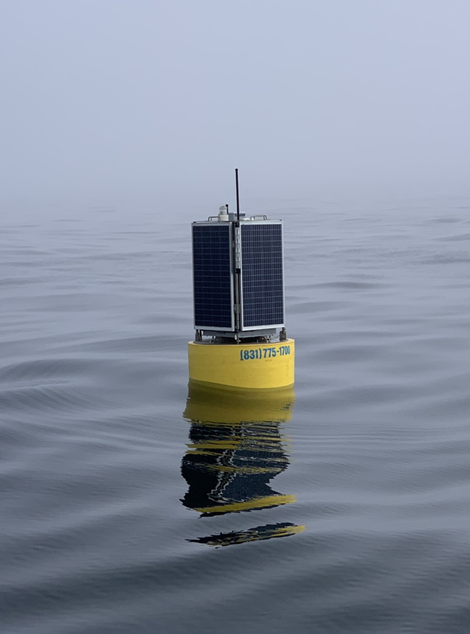
Figure 1: The solar powered AUV dock was deployed in Monterey Bay in May 2022.
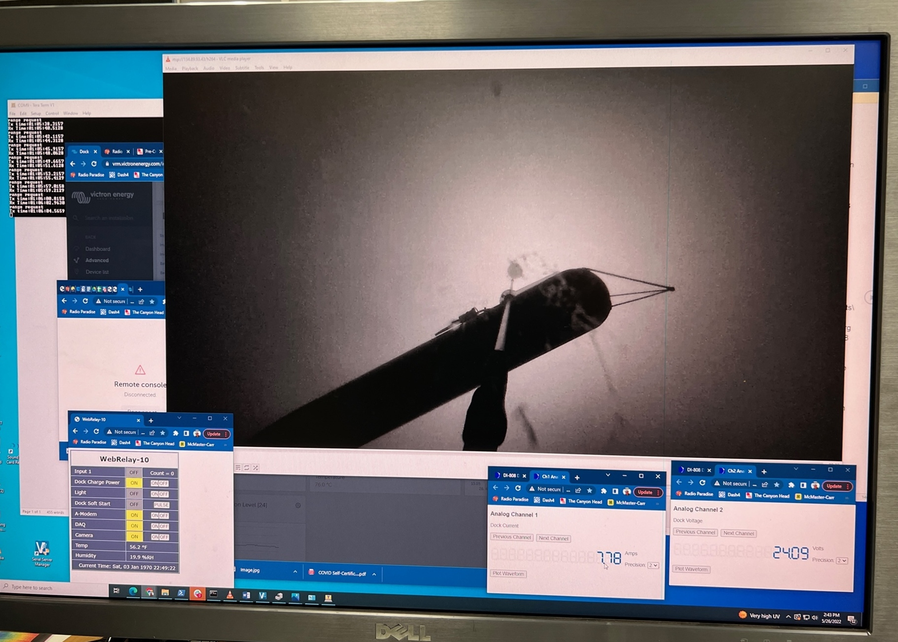
Figure 2: Screenshot of the AUV on the dock and meters showing 7.7 A at 24 V flowing to the AUV.

2nd half of 2022: fabrication of new mooring, upgrades
We have learned a great deal from the deployment of the test mooring and we are in a good position to design and build an improved system. In fact, many of the test mooring’s components will be reused on the final version. After long delays caused by IP issues, we have signed an agreement with WHOI where a group of engineers are collaborating with us to design and build the mooring (figure 3, 4). In last year’s proposal, we had expected this mooring to be ready by mid-2022, but due to the delays described earlier, fabrication is now set to start in September, and assembly and tank testing in late 2022. This mooring will include a new stretch hose, a fully recoverable anchoring system, a new electro-mechanical cable, and a larger, more stable float. These features will increase the reliability and durability and make deployment and recovery easier and safer. Moreover the buoy will carry a new housing with a battery pack large enough to fully recharge the LRAUV. Upgrades will be made to the dock and the AUV’s power system to allow recharge of the batteries at 48 VDC for a 500 watt transfer rate, allowing a full recharge in about 8 hours. Corrosion resistance and robustness will be improved to allow long deployments.

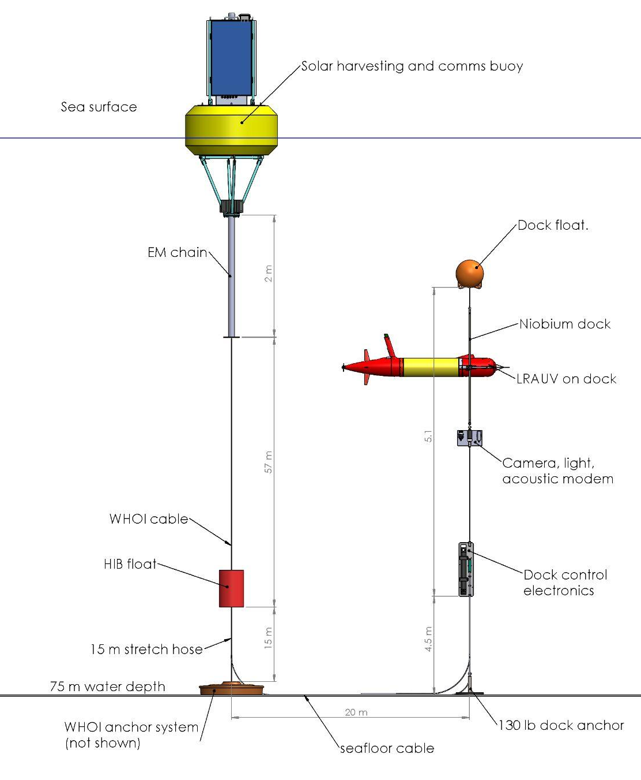
Figure 3: Schematic of the new docking mooring to be built in 2022 and deployed in early 2023.
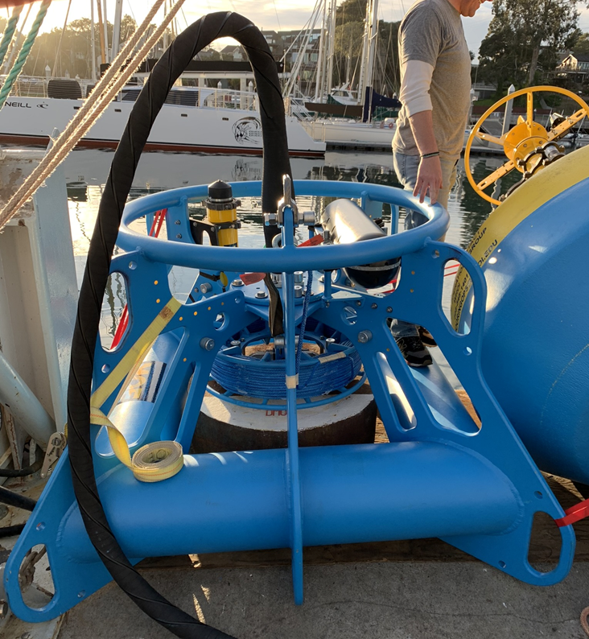
Figure 4: WHOI’s multi function node (MFN). A similar anchoring system will be built at MBARI for the AUV dock.

First half of 2023: first deployment of new mooring
We expect the new mooring and upgraded docking station to be ready for deployment by early 2023 and we plan to deploy it in March using the R/V Shana Rae. The goal of this deployment will be to test the system, and to improve the reliability of the docking process. We plan to recover the dock in late spring to address any new issues during the summer.

Second half of 2023: second deployment of new moorings, preparation for MARS:
In the fall, we will deploy the dock again to support a three month long LRAUV event response mission at the Blue Whale Observatory (project #902201). The dock will be deployed as long as possible, with a goal of 6 months.

While the dock is at sea, we will turn our attention to a future deployment at MARS which presents ideal conditions for a dock: ample electrical power and solid communications. Moreover, biofouling and wave-induced wear will be greatly reduced compared to the shallow deployment. We plan to rely on a 1500-m rated vehicle the LRAUV team has been developing. We will adapt the latch and the power-transfer device to the deep-rated LRAUV, while the dock itself should stay essentially the same. We will perform tests with the deep-rated AUV and a test dock in the test tank and in the ocean on the buoy-supported dock (similar to what we did with the standard LRAUV) to ensure high reliability before we deploy at MARS.
Our goal is to have the system fully designed by the end of year 2023.

2024 and beyond:

We have been informed that a port at the MARS node would be available in late 2023 or early 2024. We will propose to deploy the AUV dock at MARS for 1 year starting in early to mid 2024. We are also considering several research activities for 2024:
- improve and redeploy the buoy-based AUV dock,
- power the dock using the wave-energy buoy (this would allow the dock to support several LRAUVs),
- build a dock and latch for DORADO AUV
- Seek external funding for two high-value missions. The first is to deploy an LRAUV docking station at the Regional Cabled Axial Seamount Array for volcanic eruption event response. The second is to provide wintertime under-ice access in the Great Lakes for fisheries science with our collaborator GLERL. There is funding for the GLERL work available as soon as we’re ready.

Does this activity relate to one or more 2023 proposals your team is submitting?
If so, provide a list of relevant projects by project/DQ # and provide a brief description of how they are related. Since resources are limited and cuts during Phase 1 are likely, please indicate where this project fits in the hierarchy of your priorities. Does this proposal take precedent over other ongoing or planned activities?

This effort is tightly coupled with the LRAUV Technology Development proposal #902101, which carries the AUV development. In particular, all of the systems on the AUV side of the docking system which includes docking missions, power and data transfer modifications.

Anticipated Shared Resource Needs
What staffing is required to advance the work in 2023 (e.g., is this a multi-faceted engineering development or a targeted science investigation that does not require significant use of shared personnel)? Is in-house or contract manufacturing needed? What level of ship/ROV/AUV (DMO) support is likely? If this is intended to be a multi-year effort, please provide a rough indication of anticipated shared resource needs over the duration of the project (e.g., will stay flat, will significantly increase in Year X, will significantly decrease by Year Y).

We are requesting 280 hours of electrical engineering (Jensen), 950 hours of mechanical engineering (Cazenave, Hamilton, Hobson), 160 hours of machinist, 240 hours of mechanical technician, and 100 hours of EE technician.
We are requesting 3 days of R/V Paragon support for buoy maintenance.

R/V Shana will be contracted for 6 days for the two deployments and two recoveries of the buoy and the dock (1.5 days required for each trip).
In 2024, we anticipate requesting an extension. We are also planning to request 1 day of ROV Ventana for deploying the dock at MARS, and associated preparations with ROV pilots. We are planning to use one port at MARS.

Anticipated Expenses
What rough order of magnitude direct expense budget is anticipated annually over the course of the project? Is procurement of specialized capital equipment or outside contractors required? Will there be annual travel?

- The budget for 2023 is $65000, including approximately $15000 for acoustic releases and $15000 for external ship time (Shana Rae). The budget for 2024 is expected to be similar.

Intellectual Property (IP) Considerations
Do you anticipate a need for a cooperative research and development agreement or licensing arrangement with an external entity? Will the work potentially result in a patentable product or service? Will novel IP and/or custom-made equipment be created, and how might it be disseminated (e.g., license agreement and/or collaborations)?

For additional guidance please review MBARI’s intellectual property internal web page: https://mww.mbari.org/itd/ip/.

Do you anticipate a need for a cooperative research and development agreement or licensing arrangement with an external entity?

Yes, a key component of this project is the license agreement in place with Northrop Grumman that allows MBARI to use the Niobicon technology for this project. A final $25,000 license fee was paid in 2022.

Will novel IP be created, and how might it be disseminated (e.g., open-source, royalty-free license, commercial license agreement)?

The Joint IP agreement we have signed with Northrop Grumman has specific provisions for sharing IP developed by this project. In summary, joint IP developed by this project will be usable by Northrop Grumman free of charge, and licensable by Northrop Grumman to third parties in a manner that benefits both MBARI and Northrop Grumman. Background IP from MBARI and Northrop Grumman is not included in the Joint IP or Joint IP rights.

Will the work potentially result in a patentable product or service?

Yes. On May 16th, 2022, a provisional patent was filed for the use of Niobicon for AUV docking, and that patent describes in some detail the techniques employed. A full patent application needs to be completed by May 16th, 2023 and we plan to work with Northrop Grumman and their law firm (Shapiro) to complete this work under the terms of the MBARI/NG Joint IP agreement.

Data
What data will be generated? How will they be managed/stored? Are any special data visualization needs anticipated?

All of the data generated by this project will be engineering test data. They will be stored in the project library and will be of moderate size.

Anticipated Impact
Who are the consumers of the instruments, methods, technology, and data that will be generated within and beyond MBARI? Will the project create tangible connections with other organizations (e.g., academic, NGO, MBA, MBNMS, state or federal agency)?

By creating the technology needed for a long-term presence of AUVs in the ocean, we aim to enable capabilities of autonomous oceanographic observing and process characterization over extended time scales and in remote locations that lack shore support. Therefore, the consumers of this development are ocean observing systems and those interested in making such measurements.

Anticipated Outreach Needs
Thinking about the audiences/consumers you highlighted in the question above, do you anticipate needing to create outreach assets to help increase your impact? If so, please specify whether you anticipate needing to work with ITD and also specify what type of asset (story, graphic, animation, video, etc.) you might need.

No specific outreach activities are planned.

Continuing Projects Only: Status Report
Briefly provide an update of the current project relative to what was proposed for 2022 by responding to the prompts below. If the project includes multiple subproject projects, please list each of these under a subheading as you deem appropriate.

Current status of project and results to date

What percentage of labor and budget have been used through the 1st half of year?

As of June 27, we have used 32% of the labor and 27% of the budget. We expect to use labor and budget faster in the fall as we build the new mooring.

Will you complete the current year’s scheduled work?

All other work scheduled for 2022 will be completed except the deployment of the new mooring, which will take place in early 2023 instead.

Significant changes from previous project proposal

In the last proposal, we had planned to deploy the first test buoy in late 2021 and the final buoy in mid 2022. Due to various delays, we ended up deploying the first test buoy in May 2022 and the final buoy will be deployed in 2022. Fortunately, the test buoy has been sufficient to achieve most of our technical goals for 2022.
Also, we had planned on purchasing and testing an optical modem. We abandoned that idea because we expect to be able to communicate over the Niobicon device. Also, the optical modem is quite bulky and would use a lot of the AUV’s payload space.

Over the past two years, what peer-reviewed publications, education and/or outreach activities have resulted directly from this project? Please be brief.

None

All Projects: Specific Plans for 2023

Engineering/technology development

January-February: buoy-supported dock preparations
We expect the system to be mostly built by the end of 2022. In January, we will test the system in the lab and test tank and make final preparations. We will build a new charge rod with more reliable electrical connections. We will integrate a new actuator for the latch to improve reliability. We will integrate new acoustic releases in the anchor system.

March-April: First deployment. Preparation of a science-ready docking vehicle.
We will deploy the new dock in early March and start performing engineering tests. The goal of this deployment will be to test the new mooring, and to improve the reliability of the docking process.
We will integrate the latch and power-transfer device to LRAUVs that can perform scientific missions (currently the docking AUV does not carry any scientific payload). Ideally the device can be adapted to both AyeRIS and EPS LRAUV.

May-June: Recovery of AUV dock mooring, upgrades.
In May we will recover the mooring, in order to make upgrades and solve problems that are likely to come up. The goal is to have a more reliable platform when we start supporting scientific operations during a second deployment.

July-August: Preparations for Science Experiment (Blue Whale Observatory), deep-rated LRAUV latch.
We will continue to work on upgrades to the mooring and the AUV dock and to prepare the science-ready docking AUV.
At that point the deep-rated long range AUV is likely to be ready for testing. We will design a new latch and power-transfer device for it. Because of its larger diameter, and heavier weight, we expect the latch will need to be modified, though the design should remain essentially the same.

September-October: Whale experiment. Preparations of deep-rated LRAUV.
We will support docking-related issues during the Science Experiment.
We will integrate the new latch and the power-transfer device onto the deep rated vehicle and test it in the test tank.

November-December:
We will continue to support science operations with the deployed dock. We plan to recover the dock mooring in mid december, though we will consider leaving it deployed into 2024 if it performs well and is still needed for AUV operations.
Depending on the deep-rated AUV’s readiness, we will test it at sea on the deployed dock.
We will start designing a new dock for MARS. The design will be very similar, with a few necessary changes (e.g. the power system will need to be modified, the mooring will be different).

For 2024, we will build a new dock for MARS. We will deploy it there in the spring of 2024. That will require 1 day of ROV Ventana. Our goal is to leave the dock at MARS for continuous operation for 1 year. AUV operations for testing and research will be performed as part of 902101 and other projects.
We will explore the possibility of powering the dock with the wave energy buoy.
Depending on the state of the hardware, on the results from the 2023 deployment, and on the need for scientific research, the buoy-supported dock could be redeployed in 2024.

Field programs (detail ship requirements/deployments/diver requirements)
In addition to describing anticipated field programs, please be sure to include requirements for specific platforms and equipment (Dorado AUVs, LRAUVs, Wave Glider, mini ROV, etc.) for each proposed field program so that expectations are clear. Requests must also be entered in the budget entry system.

March 2023
Deployment of buoy-supported dock in Monterey Bay, using R/V Shana Rae.
May 2023
Recovery of buoy-supported dock in Monterey Bay, using R/V Shana Rae.
September 2023
Deployment of buoy-supported dock in Monterey Bay, using R/V Shana Rae.
December 2023
Recovery of buoy-supported dock in Monterey Bay, using R/V Shana Rae.

AUV operations during these experiments will be performed as part of 902101 and other projects.

Specific deliverables
Fully assembled buoy-supported dock (originally planned for 2022)
Upgraded power-transfer device for 500 W power transfer (originally planned for 2022)
Integration of ethernet-over-power device for data transfer (originally planned for 2022)
Buoy electronics upgrade for power transfer (originally planned for 2022)
Docking hardware integrated in science LRAUV
Docking hardware integrated in deep LRAUV
MARS docking system designed

Milestones and required personnel (see personnel classification list for staff classifications)

Milestone 1:
Mooring prepared and deployed for engineering test
Milestone 2:
Docking hardware adapted to and mounted on AyeRis and ESP LRAUV
Milestone3:
Mooring prepared and deployed for scientific experiment
Milestone 4:
Docking hardware adapted to and mounted on deep LRAUV
Milestone 5:
MARS AUV dock designed

2023 Project Start Date:  MM/DD/2023 | Milestone 1 | Milestone 2 | Milestone 3 | Milestone 4 | Milestone 5 | Total Resources (in hours) for each resource category for all milestones listed here
Milestone Date | 03/01/2023 | 06/01/2023 | 09/01/2023 | 11/01/2023 | 12/31/2023
Milestone Description | 1st deployment | Science docking AUV | 2nd deployment | Deep LRAUV | MARS design
Electrical Engineer | 50 (Jensen) | 50 (Jensen) | 50 (Jensen) | 50 (Jensen) | 80 (Jensen) | 280 (Jensen)
Software Eng-Embedded
Software Eng-Info Eng
Mechanical Engineer | 150 (Cazenave)  16  (Hobson)  16  (Hamilton) | 150 (Cazenave)  16  (Hobson)  16  (Hamilton) | 150 (Cazenave)  16  (Hobson)  16  (Hamilton) | 150 (Cazenave)  16  (Hobson)  16  (Hamilton) | 150 (Cazenave)  36  (Hobson)  36  (Hamilton) | 750 (Cazenave)  100 (Hobson)  100 (Hamilton)
Mechanical Eng-Division
Mechanical Eng-Mfg
Associate Engineer
Electrical Tech | 40 | 20 | 20 | 20 |  | 100
Software Tech
Mechanical Tech | 60 | 60 | 60 | 60 |  | 240
Machinist | 40 | 40 | 40 | 40 |  | 160
Divers
Video Lab
(Add other categories/rows as needed)

Budget justification

We are requesting $65000 for hardware, materials and outside services:

- Materials and components for the fabrication of 2 new AUV latches and Niobicon devices: $14000 (including 2 Ultramotion actuators at $4500 each)

- Materials and components for making upgrades to the mooring systems and buoy: $22500. This includes two Edgetech acoustics releases at approximately $7800 each. We had originally planned to use releases that MBARI already owns but purchasing new ones now appears to be a more effective solution.

- Materials for fabrication of new charge rod: $5000 (including $2000 in niobium tubing).

- Materials and components for upgrades to subsea housing: $2500

- 6 days of R/V Shana Rae for deployments and recoveries: $15000

- Miscellaneous expenses: $6000

Click here to access a Spreadsheet with expense and labor details

Project team

The team in 2023 will be very similar to 2022.
François Cazenave: project management, mechanical design, lab testing, fabrication, assembly and deployment supervision.
Scott Jensen: electrical design (dock, power transfer device, buoy telemetry and power system).
Andy Hamilton: mooring design, system engineering, IP issues.
Brett Hobson: mechanical design, electrical design, LRAUV integration and operations. Much of Brett’s labor will be requested as part of 902101.
Brian Kieft: Docking related software on LRAUV, in-lab and at-sea testing. Brian’s labor on the project will be requested as part of 902101.

External consultants/contractors
If you propose to engage an external consultant/contractor, please attach a sufficiently detailed SOW and budget proposal from the vendor. If approved, a fully executed Independent Contractor Agreement must be in place before work can begin.

Project lab and office space requirements
In addition to any changes to current space usage, please also include anticipated office and lab needs for students, postdocs, collaborators, etc.

Risk matrix (development and infrastructure projects only)

 | Technical Risk | Organizational Risk | Tech Transfer Risk | Labor Estimate Risk
High
Medium | X | X | X | X
Low

Compliance Considerations
Please respond “Yes” or “No” to each line item below, and provide details as necessary.

CATEGORY | Yes/No | DETAILS
Isotope Use (see policy and cruise planning)  Will the project use stable or radioisotopes? | No
Battery waste over 4 liters (1 gallon)  Indicate type and amount. | No
Liquid hazardous waste over 60 liters (15 gallons)  Indicate composition and quantity. | No
Export Regulation  Foreign collaborations or international travel? | No
Technology access  Any potential exposure to proprietary information about export controlled equipment? | No
Export controlled purchases  Items purchased/in possession or to be purchased that are not on list? | No
Export controlled items (hardware, software, tech data)  Items to be transferred outside US (temporarily or permanently)? To what countries (including International Waters)? | No
Encryption Items  Use of non-commercial (specially licensed, non-mass-market) encryption or information security software? | No
Work covered by Marine Sanctuary permit?  Yes, if work falls under blanket authorization. | Yes
Work conducted in SESAs?  ID # for Sanctuary Ecologically Significant Areas | No
Equipment deployed with anchors?  Give details for deployment; recovery if < 500lbs | No | 1000 lb anchors will be recovered
CA Fish & Wildlife permit required for samples? | No
Working in State Marine Protected Area? | Yes
Require Coast Guard PATON for buoys?  Private Aid to Navigation. Permit in hand? | Yes | Permits will be request when needed
Require Local Notice to Mariners  Indicate who will be submitting | Yes | Cazenave will be submitting
Permits from other agencies? | No
Use of active acoustics not already on list? | No

This date and number should remain the same for the duration of the project. If your project start date for 2023 is not January 1, please indicate the start date in the first cell of the milestone chart. Format for duration example: “Year 2 of 5”.
Development and infrastructure projects must complete the risk matrix (see end of the proposal form).
Not all projects will require all four titles to be filled in. Please indicate individuals only for those titles that are appropriate for your project.
This category includes transfer of hardware, know-how, publications, presentations, etc.
This number should be the same number you entered on the web budget resource requests for this particular resource.

