Project Number: | 902106

Project Start: Jan. 1, | 2024 | Project Duration (in years): | 1 of 3

Please indicate if proposal includes requests for any of the following (mark all that apply).

 | x
Ship Time |  |  | ROV |  |  | AUV |  |  | Wave Glider |  |  | Mini ROV

Please indicate what type of project is being proposed (mark only one).

 |  |  |  | x |  |  | x
Feasibility/Scoping  [<100 days effort] |  |  | Development |  |  | Research |  |  | Infrastructure² |  |  | Education |  |  | Time Series |  |  | Institute Initiative

Project Manager: François Cazenave
Principal Investigator: Andy Hamilton, Brett Hobson
Lead Engineer: François Cazenave

Project Title: Niobicon-Based AUV Docking Development and Use

Please indicate which category best describes the project theme (mark only one).

 |  |  |  |  |  |  |  |  |  | x
Ocean  biogeochemistry |  |  | Ecosystem dynamics |  |  | Ocean visualization |  |  | Exploration & discovery

Please indicate percentage of effort on this project anticipated for 2024 toward these three highest institutional goals from the Strategic Roadmap (percentage total should equal 100%).

Goal | Innovate and Build | Explore and Protect | Inspire and Engage
Percentage | 50 | 25 | 25

- ABSTRACT (all projects)

The overarching goal of AUV docking is to allow battery recharging at sea, to extend unattended operation of AUVs from a few days to months which enables new event response missions and increased spatial and temporal resolution of time-series observations. Over the last three years, we have developed a reliable Niobicon-based power-transfer device, and a solar-powered mooring supporting an AUV dock on the seafloor. Through extensive lab and at-sea experimentation and testing, we have demonstrated that AUV docking can work. An upgraded mooring and an AUV dock will be deployed in the coming weeks to support engineering tests and science missions. We are proposing to continue our work over the next three years to make use of the existing system, to make improvements to it, and to develop new docking-related technologies. In 2024, we plan to continue using the existing docking system in Monterey Bay. In particular, we plan to support a two-month event-response mission to investigate changes in the plankton community during an upwelling event using Monique Messié’s plankton proxy method. We also plan to support a month-long survey looking at the variability of sinking detritus for the Bioinspiration Lab and Henry Ruhl.

We want at-sea charging of the AUV to become a routine part of AUV operations. Regular use of the dock will allow us to improve the reliability and to make upgrades when needed. Separately, the development of the 1500-m depth-rated LRAUV will continue (as part of proposal 902010). We plan to design and build a latching device for this slightly larger vehicle and perform testing on the existing dock in late 2024. In 2025, we plan to deploy the AUV dock at MARS. Most of the existing dock design can be used at MARS. In late 2025 and 2026, we would like to explore several technologies, depending on our progress and on the institute’s needs:
- Adapt the AUV docking system to DORADO AUVs, potentially leading to a seafloor mapping experiment at MARS.
- Provide power to the AUV dock using the wave energy buoy, so that more power-hungry experiments can be supported (part of this work would be done under project 901405).

- PROPOSAL (all projects)

Background
Provide context for the project, being sure to address these questions:
- What fundamental problem does this project address, and why is it important?
- What makes this work relevant to MBARI and the Packard Foundation?
- Is this effort linked to other internal or externally funded projects or collaborative efforts?
- Where does this work fit into the ~5–10 year plan for your group, at MBARI, and in the field?

Over the last decades AUVs have become one of MBARI’s primary platforms for observations in the ocean. Their endurance is limited by their battery’s capacity. LRAUVs can be deployed up to 1 month with restricted power usage, and Dorado class AUVs can be deployed for 1 or 2 days. Certain surveys and experiments require longer autonomy. They can be of two types: event response operations, where an AUV stays on site for weeks or months until an event in detected and the AUV starts sampling an area of interest (for example during an upwelling event), and time-series operations, where the AUV performs a regular survey repeatedly over weeks or months, before being recovered.

To enable such long deployments, MBARI and other groups have developed docking stations to autonomously recharge AUVs at sea. For example MBARI developed and successfully demonstrated a cone-type docking station with inductive power transfer for the Dorado cruising-type AUV about 16 years ago. Other groups have built and tested similar ‘garage’ type docking stations with contactless inductive systems, or electrical connectors that require precise alignment. Garage-type docking stations work well for ROV-like hovering AUVs with many thrusters, but do not work well for long-range cruising vehicles that are routinely used for ocean science because of various challenges:

- a fixed approach heading between the AUV and the dock is challenging in strong cross currents,
- seafloor-mounted garage docks require low-altitude approach,
- the risk of damage caused by the impact of the AUV hitting the fixed dock at cruising speed.

In recent years, two new developments have allowed a breakthrough in AUV docking technology. First, MBARI engineers demonstrated the ability of an LRAUV to home to and latch onto a vertical mooring line using a latch in the nose of the vehicle. Second, the Niobicon technology, patented by Northrop Grumman has allowed reliable transfer of electricity across a line-latch. Niobicon relies on niobium’s self-insulating property to make underwater electrical connectors without waterproofing. Niobicon technology enables power and data transfer across a vertical line dock. The AUV can approach the dock from any direction, including up-current to reduce docking speed. The mid-water, compliant vertical line dock reduces impact forces, allowing docking at cruising speed.

This group has worked over the last three years to develop, build and test a reliable AUV dock, based on the Niobicon technology and the line latch. In 2021, we designed the new latching mechanism, and a power transfer device that we tested in the lab and in the test tank. In 2022, we built a relatively simple mooring to support an AUV dock that we deployed in Monterey Bay. We successfully connected an AUV to the dock and transferred power (190 W) to it. After that successful experiment, we designed a more advanced, more robust and durable buoy-supported dock, using proven mooring technology from WHOI (figure 1). We are planning to deploy it in August 2023 and to use it to support several science deployments using LRAUV Galene equipped with the Chiton imaging system. During this deployment we expect to add Niobicon data transfer. In May 2023, we filed a non-provisional patent application for the latching and power transfer device.

This proposal aims to further develop and to use the docking system to support event-response and time-series scientific research. For 2024, we are proposing the following activities:
- Use the docking station to perform an event-response mission for Monique Messié using LRAUV Pontus with the bioluminescence payload and the Plankton Proxies algorithms to explore the response of the plankton community to an upwelling event. Engineering tests and other scientific surveys may also be conducted.
- Use the docking station to sustain routine operations of the LRAUV Galene using the Chiton imaging system to document variations in sinking detritus as a part of the ocean’s biological carbon pump.
- Develop and test a latching system for the new deep-rated LRAUV, to allow operations at greater depth (specifically at MARS).
- Design a new AUV dock specifically for deploying at MARS (to be deployed in 2025) .
- Make improvements to the docking system as needed.

In 2025, we are planning to deploy the dock at MARS and to support scientific research there, using the deep-rated LRAUV. We are also planning to investigate the possibility of adapting the docking system to the AUV Dorado. If our analysis shows that it's likely to work and will be used for valuable science deployments, we will build a latching and power-transfer device for it and test it in Monterey Bay. Should this effort be successful, we will use the dock at MARS to support a mapping survey in 2026, in collaboration with Dave Caress.

Extending the docking capability to Dorado class AUVs will be enabling for many use cases of interest. The potential utility of docking a seafloor mapping capable AUV onto a cabled observatory or a powered mooring has been highlighted in multiple recent initiatives, including these concepts:
- A resident mapping AUV on the OOI cabled observatory at Axial Seamount could respond to eruptions by repeat mapping to detect and measure new lava flows.
- A resident mapping AUVs on a cable or powered mooring could cover large areas around their docking site by conducting many successive survey missions without intervention.
- A resident mapping AUVs on a cable or powered mooring could observe geodetic deformation across a fault zone by conducting many long baseline repeat survey missions without intervention.

Finally, we are interested in powering the AUV dock with MBARI’s wave energy converter (WEC). The existing solar-powered buoy only generates enough energy to recharge a single AUV about every 10 days but some of the higher power payloads being proposed (Chiton, Biolum, Plantivore) require recharging every 5-7 days. In addition, one of the valuable features of MBARI’s LRAUV fleet is multi-vehicle collaboration, which would require more frequent charging. The WEC could provide enough energy to recharge every 2 to 3 days.

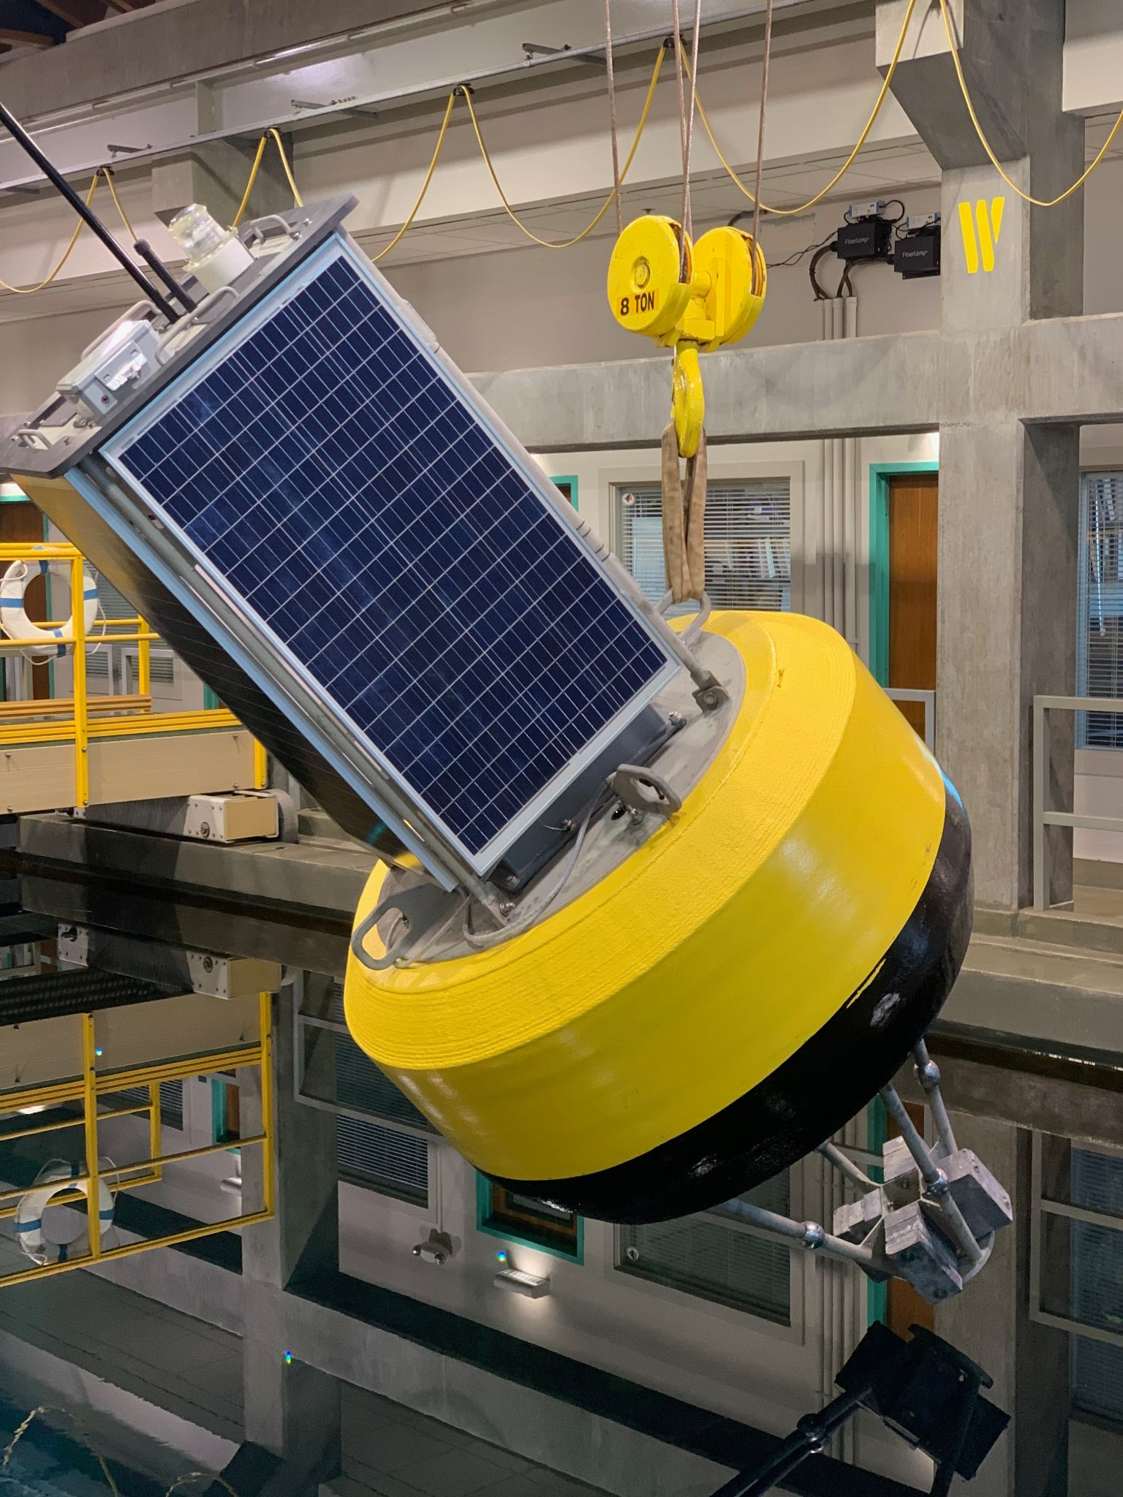
Figure 1: Surface expression of the AUV docking system to be deployed in August 2023. Solar energy is stored on the buoy and transferred to the AUV dock, near the seafloor, via a cable.

These activities lie within the strategic plan’s overarching goal to “develop or adapt innovative technologies that allow AUV operations to be conducted anywhere along the continental shelf, at any time. The stand-alone buoy-based dock can be deployed by a small vessel anywhere on the continental shelf, providing a 500-km zone of AUV range coverage. This flexible positioning option combined with a dramatic expansion of the operational window will allow new event response and time-series missions, as well as operations across lunar cycles and through seasons, including under sea and lake ice where scientific observations have so far been denied. We are working with NOAA GLERL to eventually install our docking station in the Great Lakes to enable year-round observations. For under-ice work, we would replace the surface buoy with a large seafloor battery or fuel-cell
(https://www.teledynees.com/who-we-are/stories/subsea-power).

The proposed project includes elements that involve intellectual property of an external entity and hold the promise of subsequent technology transfer in conjunction with that external company.

Nature and Scope of the Proposed Project
Please provide a sense of the scale and scope of the proposed work. Is this a large de novo R&D effort, modest platform/sensor integration, targeted science investigation with minimal or no engineering needs, extension of current program, small-scale scoping exercise expected to lead to a larger effort, or other? If the project is intended to be multiple years, how will the anticipated level of effort likely change over time?

This project is the continuation of the AUV docking work done over the last 4 years. It is a medium-sized R&D effort, involving a team of 6 MBARI engineers and technicians. The scope and the budget for 2024 is similar to previous years, and it’s likely to also be similar in 2025 and 2026.
We also plan to collaborate with several scientists at MBARI who will use the AUV dock to support scientific research.

Does this activity relate to one or more 2024 proposals your team is submitting?
If so, provide a list of relevant projects by project/DQ # and provide a brief description of how they are related. Since resources are limited and cuts during Phase 1 are likely, please indicate where this project fits in the hierarchy of your priorities. Does this proposal take precedence over other ongoing or planned activities?

- LRAUV Technology Development #902101: AUV development, docking missions, power and data transfer modifications.
- Plankton Proxies #901910: We will be supporting the upwelling event response from the dock.
- Bioinspiration lab #901809: We will be supporting LRAUV dives with the Chiton sensor, and with the Optim camera.
- MBARI Wave Energy Conversion #901405: Developments to support powering of this dock.

Anticipated Shared Resource Needs
What staffing is required to advance the work in 2024 (e.g., is this a multi-faceted engineering development or a targeted science investigation that does not require significant use of shared personnel)? Is in-house or contract manufacturing needed? What level of ship/ROV/AUV (DMO) support is likely? If this is intended to be a multi-year effort, please provide a rough indication of anticipated shared resource needs over the duration of the project (e.g., will stay flat, will significantly increase in Year X, will significantly decrease by Year Y).

We are requesting approximately 1100 hours of engineering time and 730 hours of technician time.

We are requesting 4 days of R/V Paragon support.

R/V Shana Rae will be contracted for 4.5 days.

In 2025, we anticipate requesting 1 day of ROV Ventana for deploying the dock at MARS, and associated preparations with ROV pilots. We are planning to use one port at MARS.
Budget and labor will be similar in 2025 and 2026.

Anticipated Expenses
What rough order of magnitude direct expense budget is anticipated annually over the course of the project? Is procurement of specialized capital equipment or outside contractors required? Will there be annual travel?

The budget for 2024 is approximately $55000.
No procurement of specialized capital equipment is required.
No travel is expected.
The budget for 2025 is expected to be similar.

Intellectual Property (IP) Considerations

Do you anticipate a need for a cooperative research and development agreement or licensing arrangement with an external entity?

Yes, a key component of this project is the license agreement in place with Northrop Grumman that allows MBARI to use the Niobicon technology for this project. This agreement was put in place in February 2021, and has a five year term, at which point some renewal may be necessary.

Will novel IP be created, and how might it be disseminated (e.g., open-source, royalty-free license, commercial license agreement)?

The Joint IP agreement we have signed with Northrop Grumman has specific provisions for sharing IP developed by this project. In summary, joint IP developed by this project will be usable by Northrop Grumman free of charge, and licensable by Northrop Grumman to third parties in a manner that benefits both MBARI and Northrop Grumman. Background IP from MBARI and Northrop Grumman is not included in the Joint IP or Joint IP rights.

Will the work potentially result in a patentable product or service?

Yes. On May 11th, 2023, a non-provisional patent was filed for the use of Niobicon for AUV docking, and that patent describes in some detail the techniques employed. This followed the provisional patent filing in May 2022.

Data
What data will be generated? How will they be managed/stored? Are any special data visualization needs anticipated?

All of the data generated by this project will be engineering test data. They will be stored in the project library and will be of moderate size. Science users of the AUV dock will take care of storing the data they generate.

Anticipated Impact
Who are the consumers of the instruments, methods, technology, and data that will be generated within and beyond MBARI? Will the project create tangible connections with other organizations (e.g., academic, NGO, MBA, MBNMS, state or federal agency)?

By creating the technology needed for a long-term presence of AUVs in the ocean, we aim to enable capabilities of autonomous oceanographic observing and process characterization over extended time scales and in remote locations that lack shore support. Therefore, the consumers of this development are ocean observing systems and those interested in making such measurements.

Anticipated Outreach Needs
Thinking about the audiences/consumers you highlighted in the question above, do you anticipate needing to create outreach assets to help increase your impact? If so, please specify whether you anticipate needing to work with ITD and also specify what type of asset (story, graphic, animation, video, etc.) you might need.

No specific outreach activities are planned.

Continuing Projects Only: Status Report
Briefly provide an update of the current project relative to what was proposed for 2023 by responding to the prompts below. If the project includes multiple subproject projects, please list each of these under a subheading as you deem appropriate.

Current status of project and results to date

2021 and 2022: Development of latch, charge rod, and power transfer device and first test mooring
We spent much of 2021 designing and testing the latch mechanism, the niobium charge rod and the power transfer device. We first tested it in MBARI’s test tank. In 2022 we built and deployed a buoy-supported docking system largely out of spare components. It stayed at sea for over 6 months and was functional the entire time, except for a flooded camera. We succeeded in docking the AUV to it and transferred power from the buoy to the LRAUV. This system was well suited for testing the mooring system, the AUV docking behavior, the latch and the power transfer device. However it was not suited for a long deployment and lacked some critical functions, including high power charging, and high-speed data transfer.

2023: Fabrication of new mooring, upgrades
Having learned a great deal from the deployment of the test mooring, we were in a good position to design and build an improved system (figure 2). We collaborated with WHOI to design and build the mooring. We also built a new power transfer device to allow the transfer of twice the power and to reduce brush arcing and charging interruptions when the AUV moves on the dock. On the AUV side, we made upgrades to the docking hardware (including 48 V battery charging, instead of 24 V, effectively doubling the power capacity).
The new mooring includes a new stretch hose, a fully recoverable anchoring system, a new electro-mechanical cable, and a larger, more stable float. These features will increase the reliability and durability and make deployment and recovery easier and safer. Moreover the buoy will carry a new housing with a battery pack large enough to fully recharge the LRAUV and we expect this mooring design to be suitable for year-round operations.
Most of the hardware is ready to be deployed. We are waiting for an acoustic release for the anchor system. As soon as it’s delivered (hopefully mid August), we will deploy the mooring and start engineering tests.
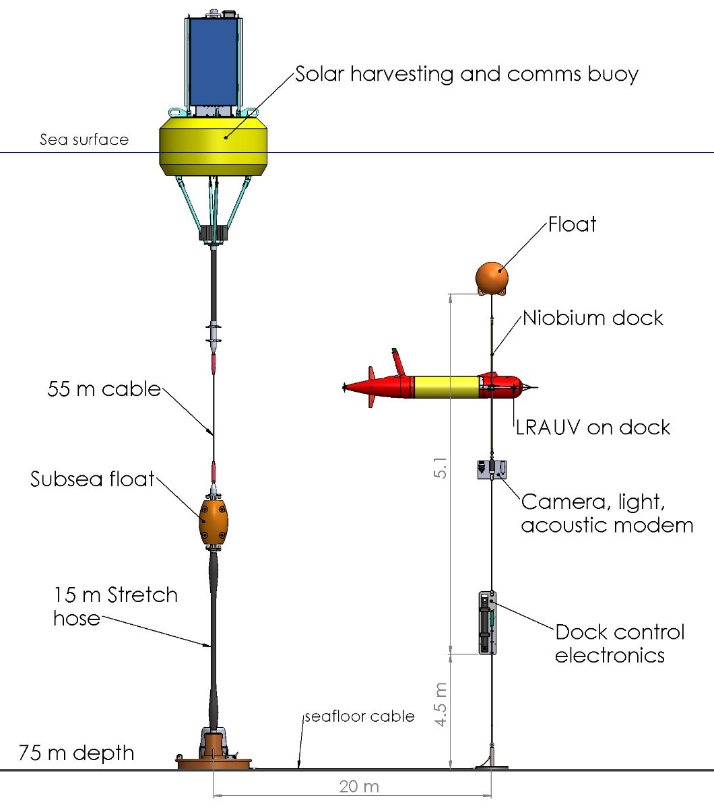
Figure 2: Schematic of the new docking mooring to be deployed in August 2023.

What percentage of labor and budget have been used through the 1st half of year?

We’ve used 54% of the labor and about 70% of the budget. We don’t expect to exceed the budget.

Will you complete the current year’s scheduled work?

Yes, except for the MARS dock design work, which is postponed to next year.

Significant changes from previous project proposal

Our original plan was to deploy the new mooring in the spring of 2023. Due to various delays, the mooring won’t be ready to be deployed until late August. Also, we had planned to do two short deployments. Instead, we will deploy the mooring only once, but for a longer time. The engineering tests and scientific surveys will take place in the fall as planned.
Also, we had planned to start design work for a deployment at MARS, but we are postponing this work to 2024. We need more experience with the shallow water dock before moving to MARS. Moreover, the deep rated LRAUV is not yet ready.

Over the past two years, what peer-reviewed publications, education and/or outreach activities have resulted directly from this project? Please be brief.

None

All Projects: Specific Plans for 2024

Research Activities

1- Event Response Science Mission:
During the 2nd quarter we will move the docking station to the north bay near the upwelling center. We will upgrade LRAUV Pontus with the docking arm and charging/comms hardware in addition to the UBAT biolum instrument. Pontus will be operated along a East/West trackline and based at the docking station as shown in Figure 3. We expect to run a simple Sci2 YoYo mission primarily at night and the bioluminescence proxies for various plankton groups (diatoms, dinoflagellates, larvaceans, copepods) will be calculated on-board and transmitted to shore. The goal of the deployment is to characterize the succession of plankton communities following upwelling, which can only be achieved from the daily resolution permitted by docking. The duty cycle of this mission will be modified from shore based on the variability of the oceanography. We expect a deployment duration of about two months.

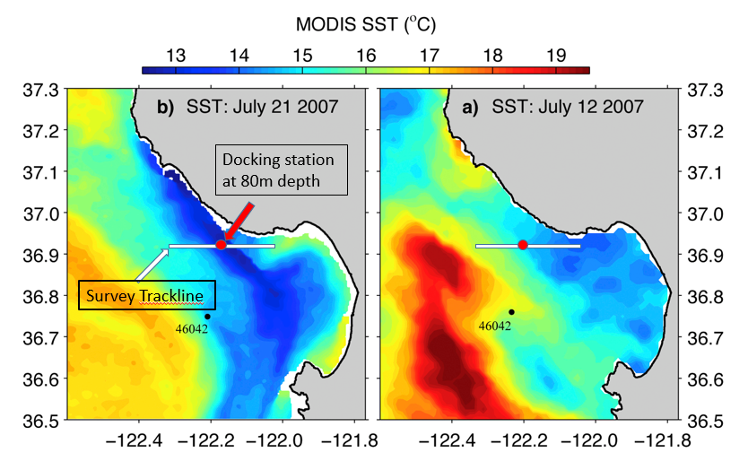
Figure 3: Approximate location of the docking station and the trackline.

2- Time-Series mission:
During the summer months we will operate LRAUV Galene equipped with the Chiton imaging system from the docking station moored in North Monterey Bay. Again, a fairly simple Sci2 YoYo mission will be run to collect a time-series of the particle field. On-board processing of these data will be performed, though no adaptive sampling is planned. Galene will be upgraded with the docking arm and charging hardware.

Engineering/technology development

July-August 2023:
Integrate the docking hardware on LRAUV Galene for Chiton deployment (modify hull, deflector, adapt brackets to titanium frame).
Install the acoustic release on the mooring anchor.
Make final preparations for the mooring.

September 2023:
Deploy the buoy-based AUV dock in South Monterey Bay (4 nm SW of Moss Landing, same site as last year).
Deploy LRAUV Tethys to perform engineering tests: data transfer, AUV charging at 500 W, homing reliability.

October-December 2023:
Deploy LRAUV Galene with Chiton and support operation for bioinspiration Lab.

1st quarter 2024:
Design latch mechanism for deep AUV.
Continue operations on the deployed dock with Chiton, as needed.
Recover the dock mooring in February and perform maintenance.
Assemble a spare charge rod and a new latch on LRAUV Pontus. Upgrades will be made to the design based on results from past deployment.

2nd quarter 2024:
Fabricate deep LRAUV latch.
Finish preparing the mooring for redeployment, make upgrades if necessary.
Deploy the mooring in North Monterey Bay in early May.
Run Monique Messié’s event response experiment over May and June (see Research Activities, above).

3rd quarter 2024:
Continue Monique's experiment if needed.
Deploy LRAUV Galene with Chiton (see Research Activities, above).
Integrate latch on deep LRAUV and test it in MBARI’s test tank, then at sea on the deployed dock.

4rd quarter 2024
Recover the dock and perform maintenance.
Design MARS dock hardware and plan deployment. Fabrication will take place in 2025.

2025
Fabricate and deploy the dock at MARS.
Support Operations with Deep LRAUV
Possible re-deployment of buoy supported dock if needed for science
Make numerical model of AUV Dorodo docking on line in Proteus software..
Design and test of Dorado latch/power transfer device
Upgrade of dock for Dorado if needed.

2026
Deployment of the dock at MARS for Dorado mapping experiment.
Deployment of the dock in Monterey Bay with the MBARI wave-energy buoy.

Field programs (detail ship requirements/deployments/diver requirements)
In addition to describing anticipated field programs, please be sure to include requirements for specific platforms and equipment (Dorado AUVs, LRAUVs, Wave Glider, mini ROV, etc.) for each proposed field program so that expectations are clear. Requests must also be entered in the budget entry system.

February
Recovery of the buoy-supported dock in Monterey Bay, using R/V Shana Rae.

Early May
Deployment of the buoy-supported dock in North Monterey Bay, using R/V Shana Rae.

May-June
Support of event response experiment (LRAUV time requested by other project)

July-October
Support of bioinspiration lab time-series experiment (LRAUV time requested by 902101)

November
Recovery of buoy-supported dock, using R/V Shana Rae.

AUV operations during these experiments will be performed as part of 902101 and other projects.

Specific deliverables
Fully assembled and tested latch mechanism for Deep LRAUV.
Maintenance of docking buoy and upgrades.
Fully assembled and tested docking hardware for LRAUV Pontus.
Assembled and tested spare charge rod.
MARS docking system designed and reviewed.

Milestones and required personnel (see personnel classification list for staff classifications)

Tasks will run in parallel, therefore milestone dates are not chronological.

2024 Project Start Date:  01/01/2024 | Milestone 1 | Milestone 2 | Milestone 3 | Milestone 4 | Total Resources (in hours) for each resource category for all milestones listed here
Milestone Date | 10/1/2024 | 12/1/2024 | 5/1/2024 | MARS dock design
Milestone Description | Design and Fab of latch for Deep LRAUV | Mooring recovery, maintenance and deployment | Build and integrate docking hardware | MARS dock design
Electrical Engineer | Jensen 16 | Jensen 4 | Jensen 8 | Jensen 72 | 100
Software Eng-Embedded | Kieft 28 |  | Kieft 32 | Kieft 16 | 76
Mechanical Engineer | Hamilton 16  Cazenave 182  Hobson 32 | Hamilton 20  Cazenave 170  Hobson 30 | Hamilton 20  Cazenave 250  Hobson 20 | Hamilton 24  Cazenave 146  Hobson 18 | 928
Electrical Tech | McLure 84 | McLure 76 | McLure 68 | McLure 80 | 308
Mechanical Tech | 56 | 88 | 50 | 8 | 202
Machinist | 88 | 40 | 80 | 16 | 224

Budget justification

We are requesting $54800 for hardware, materials and outside services:

- Materials and components for the fabrication of new Deep LRAUV latch and Niobicon devices: $15000 (including $5300 Ultramotion actuator, printed parts, materials).

- Materials, components, supplies, EM cable, solar panels, outside services for maintenance and upgrades to the mooring systems and buoy: $15500

- Materials and components for the fabrication of LRAUV Pontus latch, Niobicon devices: $8500 (including $5300 Ultramotion actuator)

- Materials and components for the fabrication of spare charge rod (niobium, G10, etc.): $2000

- 4.5 days of R/V Shana Rae for deployments and recoveries: $10800

- Miscellaneous expenses $3000.

Click here to access a Spreadsheet with expense and labor details

Project team

The team in 2024 will be very similar to 2023’s.
François Cazenave: project management, mechanical design, lab testing, fabrication, assembly and deployment supervision.
James McClure: electrical design and assembly (dock, power transfer device, buoy telemetry and power system).
Scott Jensen: electrical design (dock, power transfer device, data transfer).
Andy Hamilton: system engineering, project management, IP issues.
Brett Hobson: mechanical design, electrical design, LRAUV integration and operations. Much of Brett’s labor will be requested as part of 902101.
Brian Kieft: Docking related software on LRAUV, in-lab and at-sea testing. Much of Brian’s labor on the project will be requested as part of 902101.
Michael Anderson: Docking related software on LRAUV. Michael’s labor on the project will be requested as part of 902101.
Rob McEwen: Docking related software on LRAUV. Michael’s labor on the project will be requested as part of 902101.

External consultants/contractors
If you propose to engage an external consultant/contractor, please attach a sufficiently detailed SOW and budget proposal from the vendor. If approved, a fully executed Independent Contractor Agreement must be in place before work can begin.

None

Project lab and office space requirements
In addition to any changes to current space usage, please also include anticipated office and lab needs for students, postdocs, collaborators, etc.

No changes planned.

Risk matrix (development and infrastructure projects only)

 | Technical Risk | Organizational Risk | Tech Transfer Risk | Labor Estimate Risk
High
Medium | x | x | x | x
Low

Compliance Considerations

All responses must be recorded in the Google form linked below. A form must be submitted for every project.

Link to Google Compliance Considerations form -OR- https://forms.gle/wVCb9VRRuYBU5yvF8

This date and number should remain the same for the duration of the project. If your project start date for 2024 is not January 1, please indicate the start date in the first cell of the milestone chart. Format for duration example: “Year 2 of 5”.
Development and infrastructure projects must complete the risk matrix (see end of the proposal form).
Not all projects will require all four titles to be filled in. Please indicate individuals only for those titles that are appropriate for your project.
This category includes transfer of hardware, know-how, publications, presentations, etc.
This number should be the same number you entered on the web budget resource requests for this particular resource.

