Project Number: | 902106

Project Start: Jan. 1, | 2024 | Project Duration (in years): | Year 2 of 3¹

Please indicate if proposal includes requests for any of the following (mark all that apply).

 | x
Ship Time |  |  | ROV |  |  | AUV |  |  | Wave Glider |  |  | Mini ROV

Please indicate what type of project is being proposed (mark only one).

 |  |  |  | x |  |  | x
Feasibility/Scoping  [<100 days effort] |  |  | Development |  |  | Research |  |  | Infrastructure² |  |  | Education |  |  | Time Series |  |  | Institute Initiative

Project Manager: François Cazenave
Principal Investigator: Brett Hobson, Andy Hamilton
Lead Engineer: Francois Cazenave

Project Title: Niobicon-Based AUV Docking Development and Use

Please indicate which category best describes the project theme (mark only one).

 |  |  |  |  |  |  |  |  |  | x
Ocean  biogeochemistry |  |  | Ecosystem dynamics |  |  | Ocean visualization |  |  | Exploration & discovery

Please indicate percentage of effort on this project anticipated for 2025 toward these three highest institutional goals from the Strategic Roadmap (percentage total should equal 100%).

Goal | Innovate and Build | Explore and Protect | Inspire and Engage
Percentage | 50 | 30 | 20

- ABSTRACT (all projects)

The overarching goal of AUV docking is to allow battery recharging at sea, to extend unattended operation of AUVs from a few days to months. Over the last four years, we have developed a reliable Niobicon-based power-transfer device, and a solar-powered mooring supporting an AUV dock on the seafloor. Through extensive lab and at-sea experimentation and testing, we have demonstrated that AUV docking can work. An AUV dock is currently deployed in Northern Monterey Bay to support engineering tests and a science mission. We are proposing to continue our work over the next two years to make use of the existing system, to make improvements to it, and to develop new docking-related technologies. In 2025, we plan to support three science missions in Monterey Bay:
- a two-month event-response mission to investigate changes in the plankton community during an upwelling event (April-May).
- a month-long adaptive eDNA sampling survey using the 3G ESP LRAUV (September).
- a month-long survey using LRAUV Galene to perform video transects with the Chiton camera system.

We’ve decided to postpone AUV docking at MARS with the deep LRAUV, which we had proposed last year. Instead, we propose to focus on reliability, performance and safety. Several upgrade will be made to the system:
-a new more durable charge rod
-improved homing, latching and power transfer reliability
-streamlined and more robust packaging of the electronics
-continued work on data transfer
-release mechanism in case of AUV latch failure when docked.

The current mooring is solar-powered and barely provides enough energy to support one LRAUV. We are proposing to power to the AUV dock using the wave energy buoy, so that several LRAUVs or more power-hungry experiments can be supported. Mooring hardware as well as engineering time is requested for that effort.

- PROPOSAL (all projects)

Background

Over the last decades, AUVs have become one of MBARI’s primary platforms for observations in the ocean. Their endurance is limited by their battery’s capacity. LRAUVs can be deployed up to 1 month with restricted power usage, and Dorado class AUVs can be deployed for 1 or 2 days. Certain surveys and experiments require longer autonomy.

To enable such long deployments, MBARI and other groups have developed docking stations to autonomously recharge AUVs at sea. For example, MBARI developed and successfully demonstrated a cone-type docking station with inductive power transfer for the Dorado cruising-type AUV about 17 years ago. Other groups have built and tested similar ‘garage’ type docking stations with contactless inductive systems, or electrical connectors that require precise alignment. Garage-type docking stations work well for ROV-like hovering AUVs with many thrusters, but do not work well for long-range cruising vehicles that are routinely used for ocean science because of various challenges.

In recent years, two new developments have allowed a breakthrough in AUV docking technology. First, MBARI engineers demonstrated the ability of an LRAUV to home to and latch onto a vertical mooring line using a latch in the nose of the vehicle. Second, the Niobicon technology, patented by Northrop Grumman has allowed reliable transfer of electricity across a line-latch. Niobicon relies on niobium’s self-insulating property to make underwater electrical connectors without waterproofing. Niobicon technology enables power and data transfer across a vertical line dock. The AUV can approach the dock from any direction. The mid-water, compliant vertical line dock reduces impact forces, allowing docking at cruising speed.

This group has worked over the last four years to develop, build and test a reliable AUV dock, based on the Niobicon technology and the line latch. After numerous experiments in the lab and at sea, we developed an advanced, robust and durable buoy-supported dock, using proven mooring technology from WHOI (figure 1). We deployed it from October 2023 to February 2024 and again starting in June 2024 to perform engineering tests and to support a scientific experiment. We were able to demonstrate reliable homing and power transfer.

In May 2023, we filed a non-provisional patent application for the latching and power transfer device.

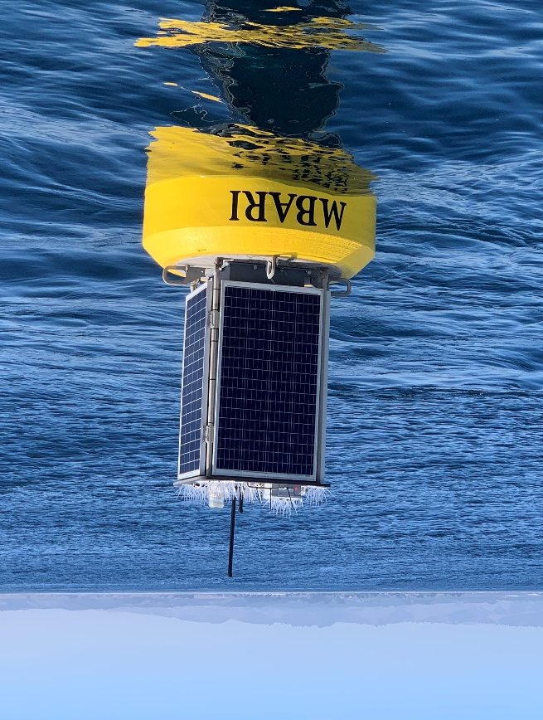
Figure 1: Surface expression of the AUV docking system that is currently deployed. Solar energy is stored on the buoy and transferred to the AUV dock, near the seafloor, via a cable.

These activities lie within the strategic plan’s overarching goal to “develop or adapt innovative technologies that allow AUV operations to be conducted anywhere along the continental shelf, at any time. The stand-alone buoy-based dock can be deployed by a small vessel anywhere on the continental shelf, providing a 500-km zone of AUV range coverage. This flexible positioning option combined with a dramatic expansion of the operational window will allow new event-response and time-series missions, as well as operations across lunar cycles and through seasons, including under sea and lake ice where scientific observations have so far been denied.

The proposed project includes elements that involve intellectual property of an external entity and hold the promise of subsequent technology transfer in conjunction with that external company.

Nature and Scope of the Proposed Project

This project is the continuation of the AUV docking work done over the last 4 years. It is a medium-sized R&D effort, involving a team of 9 MBARI engineers and technicians. The scope and the budget for 2025 is similar to previous years, and it is likely to also be similar in 2026.
We also plan to collaborate with several scientists at MBARI who will use the AUV dock to support scientific research.

Does this activity relate to one or more 2025 proposals your team is submitting?

- LRAUV Technology Development #902101: AUV development, docking missions.
- Plankton Proxies #901910: We will be supporting the upwelling event response from the dock.
- MBARI Wave Energy Conversion #901405: Developments to support powering of the dock with the wave energy buoy.
- SURF Center #901205. We will be supporting an eDNA sampling deployment with LRAUV Brizo
- Bioinspiration lab #901809. We will be supporting surveys with LRAUV Galene and the Chiton camera system.

Anticipated Shared Resource Needs

We are requesting 830 hours of engineering time and 1030 hours of technician time.

We are requesting 2 days of R/V Paragon support

R/V Shana Rae will be contracted for 6 days.

Anticipated Expenses

The budget for 2025 is $60300.
No procurement of specialized capital equipment is required.
No travel is expected.
The budget for 2026 is expected to be similar.

Intellectual Property (IP) Considerations

Do you anticipate a need for a cooperative research and development agreement or licensing arrangement with an external entity?

Yes, a key component of this project is the license agreement in place with Northrop Grumman that allows MBARI to use the Niobicon technology for this project. This agreement was put in place in February 2021, and has a five-year term, at which point some renewal may be necessary.

Will novel IP be created, and how might it be disseminated (e.g., open-source, royalty-free license, commercial license agreement)?

The Joint IP agreement we have signed with Northrop Grumman has specific provisions for sharing IP developed by this project. In summary, joint IP developed by this project will be usable by Northrop Grumman free of charge, and licensable by Northrop Grumman to third parties in a manner that benefits both MBARI and Northrop Grumman. Background IP from MBARI and Northrop Grumman is not included in the Joint IP or Joint IP rights.

Will the work potentially result in a patentable product or service?

Yes. On May 11th, 2023, a non-provisional patent was filed for the use of Niobicon for AUV docking, and that patent describes in some detail the techniques employed. This followed the provisional patent filing in May 2022.

Data

All of the data generated by this project will be engineering test data. They will be stored in the project library and will be of moderate size. Science users of the AUV dock will take care of storing the data they generate.

Anticipated Impact

By creating the technology needed for a long-term presence of AUVs in the ocean, we aim to enable capabilities of autonomous oceanographic observing and process characterization over extended time scales and in remote locations that lack shore support. Therefore, the consumers of this development are ocean observing systems and those interested in making such measurements.

Anticipated Outreach Needs

No specific outreach activities are planned.

Continuing Projects Only: Status Report

Current status of project and results to date

2021 and 2022: Development of latch, charge rod, and power transfer device and first test mooring
We spent much of 2021 designing and testing the latch mechanism, the niobium charge rod and the power transfer device. We first tested it in MBARI’s test tank. In 2022 we built and deployed a simple buoy-supported docking system for over 6 months. We succeeded in docking the AUV to it and transferred power from the buoy to the LRAUV. This system was well suited for testing the mooring system, the AUV docking behavior, the latch and the power transfer device. However it was not suited for a long deployment and lacked some critical functions, including high power charging, and high-speed data transfer.

2023-2024: Fabrication and deployment of a new mooring, upgrades
In 2023 we designed and built an improved system (figure 2). We collaborated with WHOI to design and build the mooring. We also built a new power transfer device to allow the reliable transfer of higher power. On the AUV side, we made numerous upgrades to the docking hardware.
The mooring includes a stretch hose and a recoverable anchoring system. These features increase the reliability and durability and make deployment and recovery easier and safer. Moreover, the buoy carries a housing with a battery pack large enough to fully recharge the LRAUV. This mooring is suitable for year-round operations.
The mooring was deployed from October 2023 to February 2024 and was used to perform engineer tests. We were able to dock the AUV 24 times and to charge the batteries. Unfortunately, a ground fault in the mooring’s cables cut the deployment short. We obtained a new cable from WHOI and redeployed the mooring in June 2024. We started supporting engineering and science missions and will continue to do so in the coming months.
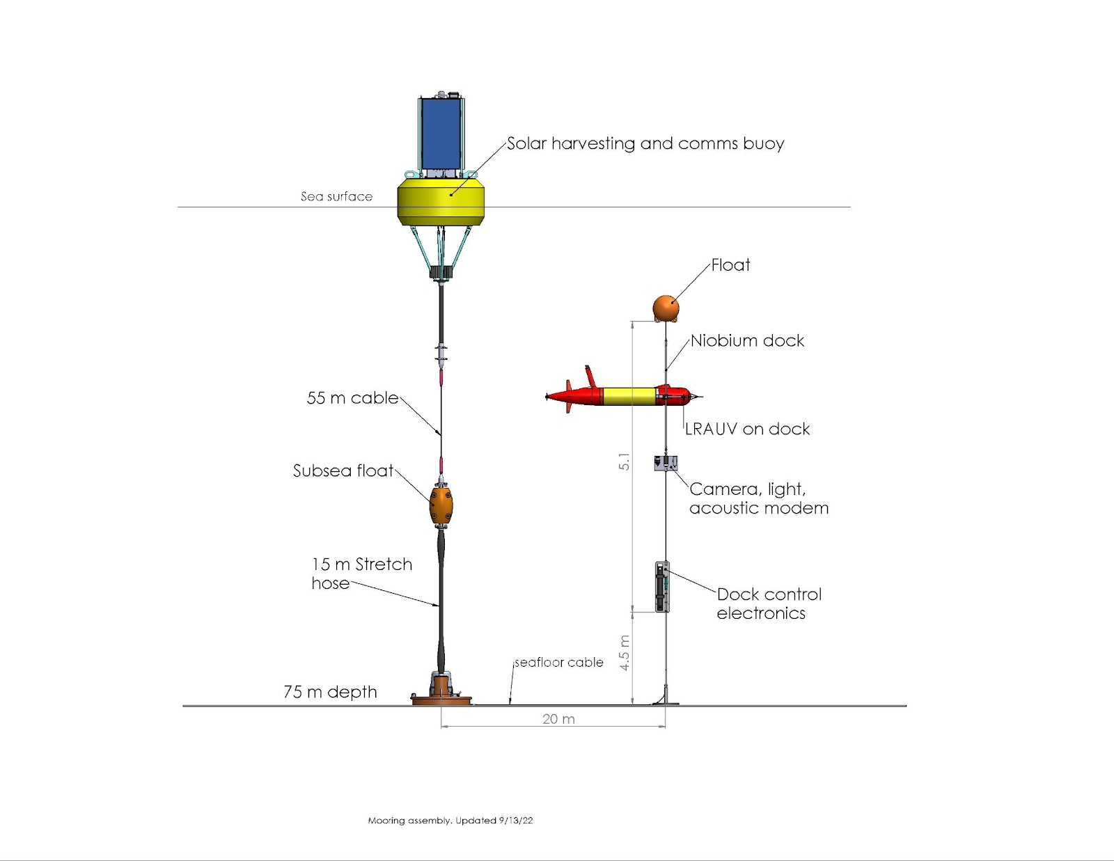
Figure 2: Schematic of the docking mooring currently deployed in North Monterey Bay.

What percentage of labor and budget have been used through the 1st half of year?

We have used 43% of the labor and about 56% of the budget. We do not expect to exceed the budget.

Will you complete the current year’s scheduled work?

We will not complete all of the scheduled work. We decided to postpone the work on Deep LRAUV and MARS. We also postponed the deployment of LRAUV Galene to 2025.

Significant changes from previous project proposal

We had proposed to integrate the latch mechanism to the Deep LRAUV and to prepare for a deployment at MARS. We’ve decided not to pursue these activities for several reasons. First, the Deep LRAUV is not yet ready. Second, there is uncertainty about the timing of the installation of the new node at MARS. Last, progress has been slower than expected on the AUV dock development and testing due to failures of mooring components and technical challenges. We want to improve the reliability of the docking system before moving to a new platform.
We still want to deploy the dock at MARS in the future but we will wait for the Deep LRAUV to be operational and tested, for the new node to be installed, and for technical issues to have been resolved.

Over the past two years, what peer-reviewed publications, education and/or outreach activities have resulted directly from this project? Please be brief.

None

All Projects: Specific Plans for 2025

Research Activities

We are planning to use the docking system to support three event-response and time-series scientific surveys, as detailed below.

1- Upwelling survey in North Monterey Bay (April-June 2025)
We had planned to deploy the AUV dock in April 2024 and to support an upwelling survey for 2 months. We equipped LRAUV Pontus with the docking hardware. Unfortunately, due to technical problems with the mooring and personnel availability, the deployment was delayed and only a few transects were performed. Next year, we will be much better prepared and to run this experiment successfully during the peak of the upwelling season.
We plan to deploy the docking station in the North Bay near the upwelling center in early April. Pontus will be deployed to run daily transects for 30 days and will recharge its battery on the dock at night. We expect to run a simple Sci2 YoYo mission and the bioluminescence proxies for various plankton groups (diatoms, dinoflagellates, larvaceans, copepods) will be calculated on-board and transmitted to shore. The goal of the deployment is to characterize the succession of plankton communities following upwelling, which can only be achieved from the daily resolution permitted by docking. The duty cycle of this mission will be modified from shore, based on the variability of the oceanography.

2- ESP survey in Central Monterey Bay (September 2025)
We will outfit LRAUV Brizo with the docking hardware and support a 1-month deployment with the dock to undertake adaptive eDNA sampling.

3- Siphonophore monitoring using LRAUV Galene carrying Chiton or Chiton-like payload (October 2025)
A limiting factor in deploying imaging payloads on the LRAUV is the high power consumption of the imaging system. This results in less frequent sampling or short duration (~ 4 days) deployments. By providing both recharging and data access during a deployment, the dock will enable us to significantly extend the deployment duration and to increase the sampling frequency to a time scale of months. With onboard machine learning and object identification, we can use the data access provided by the dock to send summary statistics along with example images to shore without recovering the LRAUV. A user can then command the vehicle to perform dense sampling during times of high abundance of target species and then recharge and return to a monitoring mode. The ability to toggle between monitoring and sampling without recovery greatly increases our chances of observing changes in siphonophore distributions over day/night cycles.
Deployment plan:
- Deploy for one month
- (Monitoring) Run horizontal transects at different depths conserving battery and fitting within the available docking recharge envelope.
- (Sampling) If high abundance of siphonophores are detected during a transect, send example images to shore for confirmation, and then begin dense sampling to capture changes in day/night distributions of siphonophores while abundance remains high or several days pass.
- Recharge
- Return to Monitoring

Engineering/technology development

1st quarter 2025:
Fabricate a new charge rod to replace the current unit, which is likely to be worn out.
Address technical problems such as biofouling of the charge rod, impact damage to the charge rod, reliability of power transfer device and robustness of subsea electronics package.
Upgrade the power transfer device from 24 V 48 V (this will double the transferable power).
Fabricate the latch and power-transfer components for LRAUV Galene and Brizo.
Perform needed maintenance and upgrades to the buoy and mooring components.
Prepare LRAUV Pontus for deployment.
Perform testing of data transfer through the dock in the test tank.
Start design work for wave-powered dock mooring (in collaboration with wave energy buoy 901405)

2nd quarter 2025:
Deploy the solar-powered dock and LRAUV Galene in north Monterey Bay for the upwelling survey. Recover in June.
Start assembly work of the wave-powered dock mooring.
Assemble the latch and power-transfer device on LRAUV Galene and Brizo.
Design and build a system for releasing the AUV from the dock (such as an ROV-operable release pin) in case the latch gets stuck.

3rd quarter 2025:
Prepare the wave-powered dock for deployment and deploy in South Monterey Bay in August.
Continue assembly work on Galene and Brizo.
Perform engineering tests on wave-powered dock at sea.
Support ESP survey with Brizo in September.

4rd quarter 2025:
Support Chiton survey with Galene in October.
Recover the dock in December and perform maintenance.

2026
Activities in 2026 will depend on the progress we make in 2026. We are considering various activities:
- Build and deploy a dock at MARS to support operations using the deep LRAUV.
- Support more science deployments in Monterey Bay, using the solar or wave-powered dock.
- Start development for AUV DORADO docking.

Field programs (detail ship requirements/deployments/diver requirements)

April-June 2025
Deploy solar-powered AUV dock in North Monterey Bay, using R/V Shana Rae.
Support upwelling survey with LRAUV Galene.

August-December 2025
Deployment of the AUV dock coupled with the wave-energy buoy in South Monterey Bay, using R/V Shana Rae.
Support LRAUV Brizo in September and LRAUV Galene in October.

AUV operations during these experiments will be performed as part of 902101 and other projects. R/V Paragon may be needed for occasional maintenance on the moorings.

Piloting/Watchkeeping
If you plan to use a platform that requires piloting/watchkeeping, please provide a high level staffing plan, including who will be responsible for these duties.

Staffing for AUV piloting will be requested by other proposals.

Specific deliverables

Fully assembled and tested latch mechanism and power transfer devices for LRAUV Galene and LRAUV Brizo.
New charge rod assembled.
Subsea electronics package upgraded.
Maintenance of docking buoy and upgrades.
Wave-powered dock mooring designed and assembled.

Milestones and required personnel (see personnel classification list for staff classifications)

Tasks will run in parallel, therefore, milestone dates are not chronological.

2024 Project Start Date:  01/01/2024 | Milestone 1 | Milestone 2 | Milestone 3 | Milestone 4 | Milestone 5 | Total Resources (in hours) for each resource category for all milestones listed here
Milestone Date | 08/1/2025 | 06/1/2025 | 12/1/2025 | 08/1/2025 | 12/1/2025
Milestone Description | Fabricate and assemble docking hardware for LRAUV Brizo and Galene | Spring mooring deployment, maintenance and recovery | Fall mooring deployment, maintenance and recovery | Wave-powered dock design and assembly | Various upgrades to docking system
Electrical Engineer |  |  |  | Jensen 50 | Jensen 50 | 100
Software Eng-Embedded | Kieft 10 | Kieft 10 | Kieft 10 | Kieft 10 | Kieft 10 | 50
Mechanical Engineer | Cazenave 100  Hobson 20 | Hamilton 20  Cazenave 100  Hobson 20 | Hamilton 20  Cazenave 100  Hobson 20 | Hamilton 20  Cazenave 100  Hobson 20 | Hamilton 20  Cazenave 100  Hobson 20 | 680
Electrical Tech | McClure 40  Other 20 | McClure 40  Other 20 | McClure 40  Other 20 | McClure 40  Other 20 | McClure 40  Other 20 | 300
Mechanical Tech | 50 | 50 | 50 | 100 | 100 | 350
Machinist | 100 | 40 | 40 | 100 | 100 | 380

Budget justification

We are requesting $60300 for hardware, materials and outside services:

- Materials and components for the fabrication of latches and power transfer devices for LRAUV Brizo and Galene: $14500
(includes $5500 for 1 Ultramotion actuator, $500 for two docking payload housings, $2000 for printed parts, $1000 for hardware, $5000 for one new shell, $500 for materials).

- Materials and components for the fabrication of a new charge rod: $2000
(includes niobium, G10 rod, connector, hardware, supplies)

- Materials, components, supplies for solar buoy maintenance and upgrades: $8000
(including outside contractors for buoy paint, spare solar panel, hardware, EM cable from WHOI, connectors)
- 6 days of R/V Shana Rae for deployments and recoveries: $16800

- Materials, components and supplies for wave-powered dock preparation and deployment: $8000
(including spare EM cable from WHOI)

- Materials, components and supplies, upgrades and maintenance of the mooring and subsea electronics: $6000
(including new connectors, new seafloor cable, new mounting hardware, new light).

- Miscellaneous expenses $5000.

Project team

The team in 2025 will be very similar to 2024’s.
François Cazenave: project management, mechanical design, lab testing, fabrication, assembly and deployment supervision.
James McClure: electrical design and assembly (dock, power transfer device, buoy telemetry and power system).
Scott Jensen: electrical design (dock, power transfer device, data transfer).
Andy Hamilton: system engineering, project management, IP issues.
Brett Hobson: mechanical design, electrical design, LRAUV integration and operations. Much of Brett’s labor will be requested as part of 902101.
Brian Kieft: Docking related software on LRAUV, in-lab and at-sea testing. Much of Brian’s labor on the project will be requested as part of 902101.
Quinn Shemet: Docking related software on LRAUV, in-lab and at-sea testing. Much of Quinn’s labor on the project will be requested as part of 902101.
Michael Anderson: Docking related software on LRAUV. Michael’s labor on the project will be requested as part of 902101.
Rob McEwen: Docking related software on LRAUV. Rob’s labor on the project will be requested as part of 902101.

External consultants/contractors
If you propose to engage an external consultant/contractor, please attach a sufficiently detailed SOW and budget proposal from the vendor. If approved, a fully executed Independent Contractor Agreement must be in place before work can begin.

None

Project lab and office space requirements
In addition to any changes to current space usage, please also include anticipated office and lab needs for students, postdocs, collaborators, etc.

We are currently using the left-side bench and storage in B222 and would like to continue to do so.

Risk matrix (development and infrastructure projects only)

 | Technical Risk | Organizational Risk | Tech Transfer Risk | Labor Estimate Risk
High
Medium | X | X | X | X
Low

Compliance and Planning Considerations

All responses must be recorded in the Google form linked below. A form must be submitted for every project.

Link to Google Compliance and Planning Considerations form -OR- https://forms.gle/mRYKKEztAPYaiTz7A

This date and number should remain the same for the duration of the project. If your project start date for 2025 is not January 1, please indicate the start date in the first cell of the milestone chart. Format for duration example: “Year 2 of 5”.
Development and infrastructure projects must complete the risk matrix (see end of the proposal form).
Not all projects will require all four titles to be filled in. Please indicate individuals only for those titles that are appropriate for your project.
This category includes transfer of hardware, know-how, publications, presentations, etc.

