Project Number: | 902106

Project Start: Jan. 1, | 2024 | Project Duration (in years): | 3 of 3

Please indicate if proposal includes requests for any of the following (mark all that apply).

 | x
Ship Time |  |  | ROV |  |  | AUV |  |  | Wave Glider |  |  | Mini ROV

Please indicate what type of project is being proposed (mark only one).

 |  |  |  | x |  |  | x
Feasibility/Scoping  [<100 days effort] |  |  | Development |  |  | Research |  |  | Infrastructure² |  |  | Education |  |  | Time Series |  |  | Institute Initiative

Project Manager: François Cazenave
Principal Investigator: Brett Hobson, Andy Hamilton
Lead Engineer: François Cazenave

Project Title: Niobicon-Based AUV Docking Development and Use

Please indicate which category best describes the project theme (mark only one).

 |  |  |  |  |  |  |  |  |  | x
Ocean  biogeochemistry |  |  | Ecosystem dynamics |  |  | Ocean visualization |  |  | Exploration & discovery

Please indicate percentage of effort on this project anticipated for 2026 toward these three highest institutional goals from the Strategic Roadmap (percentage total should equal 100%).

Goal | Innovate and Build | Explore and Protect | Inspire and Engage
Percentage | 60 | 20 | 20

- ABSTRACT (all projects)
Briefly provide a high-level summary of the project (ideally no more than 1/2 page).

The primary goal of AUV docking is to allow battery recharging at sea, to extend unattended operation of AUVs from a few days to months. Another important goal is to allow data transfer from a docked AUV to shore. Over the last five years, we have developed a docking station that an LRAUV can autonomously latch onto, recharge its batteries and transfer data. The power transfer device relies on Niobicon, a technology patented by Northrop Grumman, which allows underwater electrical connection without waterproofing. We have also developed a solar-powered mooring to provide energy and communications to a docking station located near the seafloor.

Through extensive lab and at-sea experimentation and testing, we have demonstrated that AUV docking can work. We are proposing to continue our work in 2026 to make use of the existing system, to make improvements to it, and to develop new docking-related technologies. The 3 main areas of research and development are outlined below:

1- Wave energy to power the AUV docking station
The solar buoy barely provides enough energy to keep one AUV running. By contrast, the wave-energy buoy developed by MBARI can provide over 200 W on average. We are therefore proposing to combine the two systems so that the AUV dock is powered by the wave energy buoy. This would allow running several AUVs at the same time or running missions that require more energy, such as imaging.

2- Video guidance to improve docking precision
Currently the AUV relies on acoustic signals to home in on the dock. While this technology has proved adequate and reliable, its low precision results in frequent misses of the dock by the approaching AUV, wasting time and energy. We are proposing to investigate the use of video to help guide the AUV over the last few meters of its approach.

3- Improved data transfer
Currently, the docking station allows data transfer between the AUV and the docking station, using power-line ethernet. While this is useful to transfer commands or small data files, it is insufficient for large data sets such as video. We are proposing to investigate several new ways of transferring data, including ethernet-over-power, radio and optical transmitters.

This engineering work will culminate with the deployment of the system in August 2026 and the support of several overlapping LRAUV science missions:
- a two-month time-series mission to investigate changes in the plankton community during an upwelling event in September and October,
- a month-long adaptive eDNA sampling survey using the 3G ESP LRAUV (September).
- a month-long survey using LRAUV Triton to perform video transects (November).

- PROPOSAL (all projects)

Background
Provide context for the project, being sure to address these questions:
- What fundamental problem does this project address, and why is it important?
- What makes this work relevant to MBARI and the Packard Foundation?
- Is this effort linked to other internal or externally funded projects or collaborative efforts?
- Where does this work fit into the ~5–10 year plan for your group, at MBARI, and in the field?

Over the last decades, AUVs have become one of MBARI’s primary platforms for observations in the ocean. Their endurance is limited by their battery’s capacity. LRAUVs can be deployed up to 1 month with restricted power usage, and Dorado class AUVs can be deployed for 1 or 2 days. Certain surveys and experiments require longer autonomy.

To enable such long deployments, MBARI and other groups have developed docking stations to autonomously recharge AUVs at sea. For example, MBARI developed and successfully demonstrated a cone-type docking station with inductive power transfer for the Dorado AUV about 17 years ago. Other groups have built and tested similar ‘garage’ type docking stations with contactless inductive systems, or electrical connectors that require precise alignment. Garage-type docking stations work well for ROV-like hovering AUVs with many thrusters, but do not work well for long-range cruising vehicles that are routinely used for ocean science because of various challenges.

In recent years, two new developments have allowed a breakthrough in AUV docking technology. First, MBARI engineers demonstrated the ability of an LRAUV to home to and latch onto a vertical mooring line using a latch in the nose of the vehicle. Second, the Niobicon technology, patented by Northrop-Grumman, has allowed reliable transfer of electricity across a line-latch. Niobicon relies on niobium’s self-insulating property to make underwater electrical connectors without waterproofing. Niobicon technology enables power and data transfer across a vertical line dock. The AUV can approach the dock from any direction. The mid-water, compliant vertical line dock reduces impact forces, allowing docking at cruising speed.

This group has worked over the last five years to develop, build and test a reliable AUV dock, based on the Niobicon technology and the line latch. After numerous experiments in the lab and at sea, we developed an advanced, robust and durable buoy-supported dock, using proven mooring technology from WHOI (figure 1). We deployed it from October 2023 to February 2024, from June 2024 to February 2025, and it is currently deployed in June, to perform engineering tests and to support a scientific survey. We were able to demonstrate reliable homing and power transfer.

In 2023, we filed a non-provisional patent application for the latching and power transfer device and it was awarded in January 2025..

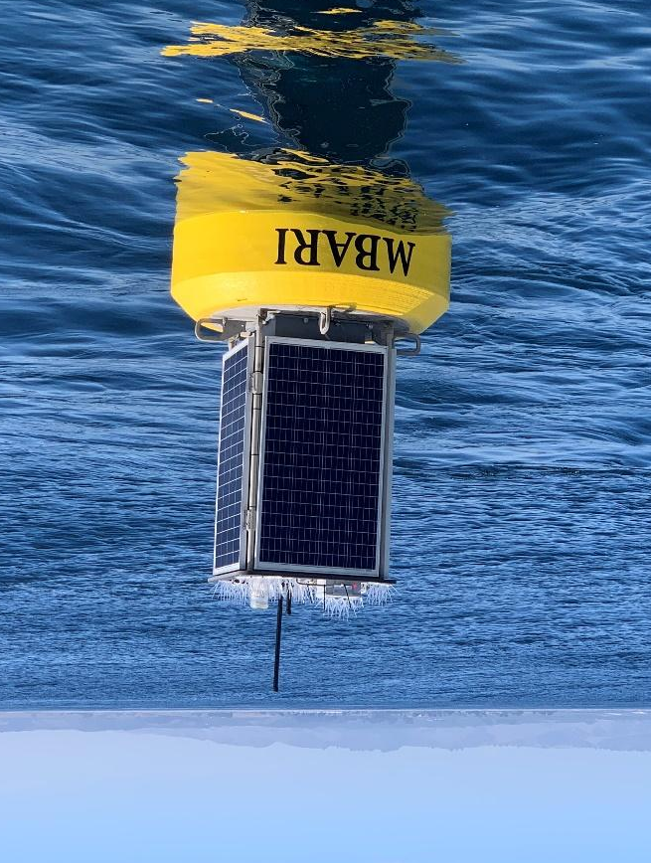
Figure 1: Surface expression of the AUV docking system that is currently deployed. Solar energy is stored on the buoy and transferred to the AUV dock, near the seafloor, via a cable.

These activities lie within the strategic plan’s overarching goal to “develop or adapt innovative technologies that allow AUV operations to be conducted anywhere along the continental shelf, at any time. The stand-alone buoy-based dock can be deployed by a small vessel anywhere on the continental shelf, providing a 500-km zone of AUV range coverage. This flexible positioning option combined with a dramatic expansion of the operational window will allow new event-response and time-series missions, as well as operations across lunar cycles and through seasons, including under sea and lake ice where scientific observations have so far been denied.

The proposed project includes elements that involve intellectual property of an external entity and hold the promise of subsequent technology transfer in conjunction with that external company.

Nature and Scope of the Proposed Project
Please provide a sense of the scale and scope of the proposed work. Is this a large de novo R&D effort, modest platform/sensor integration, targeted science investigation with minimal or no engineering needs, extension of current program, small-scale scoping exercise expected to lead to a larger effort, or other? If the project is intended to be multiple years, how will the anticipated level of effort likely change over time?

This project is the continuation of the AUV docking work done over the last 5 years. It is a medium-sized R&D effort, involving a team of 9 MBARI engineers and technicians. The scope and the budget for 2026 is similar to previous years. We are likely to continue requesting funds at a similar level over the coming years.

We also plan to collaborate with several scientists at MBARI who will use the AUV dock to support scientific research.

Does this activity relate to one or more 2026 proposals your team is submitting?
If so, provide a list of relevant projects by project/DQ # and provide a brief description of how they are related. Since resources are limited and cuts during Phase 1 are likely, please indicate where this project fits in the hierarchy of your priorities. Does this proposal take precedent over other ongoing or planned activities?

- LRAUV Technology Development #902101: AUV development, docking missions.
- Plankton Proxies #901910: We will be supporting the upwelling event response with the dock.
- MBARI Wave Energy Conversion #901405: Integration of the dock with the wave energy buoy.
- SURF Center #901205. We will be supporting an eDNA sampling deployment with LRAUV Brizo
- Bioinspiration lab #901809. We will be supporting video surveys with LRAUV Triton.

Anticipated Shared Resource Needs
What staffing is required to advance the work in 2026 (e.g., is this a multi-faceted engineering development or a targeted science investigation that does not require significant use of shared personnel)? Is in-house or contract manufacturing needed? What level of ship/ROV/AUV (DMO) support is likely? If this is intended to be a multi-year effort, please provide a rough indication of anticipated shared resource needs over the duration of the project (e.g., will stay flat, will significantly increase in Year X, will significantly decrease by Year Y).

We are requesting 1370 hours of engineering time and 1250 hours of technician time.

We are requesting 2 days of R/V Paragon support

R/V Shana Rae will be contracted for 4 days to deploy and recover the AUV docking mooring but the funds will be requested by project 901405 (Wave-energy buoy).

Anticipated Expenses
What rough order of magnitude direct expense budget is anticipated annually over the course of the project? Is procurement of specialized capital equipment or outside contractors required? Will there be annual travel?

The budget for 2026 is $56000.
No procurement of specialized capital equipment is required.
No travel is expected.

Intellectual Property (IP) Considerations
Do you anticipate a need for a cooperative research and development agreement or licensing arrangement with an external entity? Will the work potentially result in a patentable product or service? Will novel IP and/or custom-made equipment be created, and how might it be disseminated (e.g., license agreement and/or collaborations)?

For additional guidance please review MBARI’s intellectual property internal web page: https://mww.mbari.org/itd/ip/.

This project relies on a license agreement from Northrop-Grumman for the enabling technology of the Niobium material, which Northrop has patent protection for. This license agreement was originally for a five-year term and is expiring on March 1st, 2026. In the case the license expires or is terminated, the agreement has a provision that grants MBARI the right to use “Licensed Products that have been Developed and put into LICENSEE’s service prior to the effective date of such expiration or termination”. Therefore, a renewal of the license agreement isn’t strictly necessary for us to continue to use the docking components we have. However, technically we would be prohibited from continuing development, which could preclude making some improvements to capabilities we have in mind. Northrop is agreeable to renewing this license agreement under the existing terms, and we were told that this should be straightforward, could involve a further license fee (we paid a $50,000 License fee for the first five years and we expect it to be approximately the same for the second five years). So, this is a decision that will need to be made this fall, and should be started in September to avoid a crunch in the new year and a placeholder of $50,000 has been included in the project budget. It may be possible to make that a yearly fee or otherwise negotiate. We would plan to include Keith Berets as legal counsel in any extensions.
In addition to the License Agreement, our arrangement with Northrop Grumman includes a Joint Ownership Agreement that spells out how the intellectual property generated by our efforts can be used by each side. This Joint Ownership Agreement does not expire on such a short time-line, and is in force until the last of any patent comprising the Joint Intellectual Property. The patent that describes our AUV docking system was awarded and assigned jointly to MBARI and Northrop on January 14th, 2025, so we have decades of runway on the Joint Ownership Agreement. This agreement spells out many different scenarios of subsequent use and commercialization of our work. In particular, Northrop has the right to license the Joint Intellectual Property to a third party, and in that case MBARI is scheduled to receive 25% of all revenues from such a license. They are currently pursuing this path which could make the docking technology available to other AUV developers.

Data
What types of data will be generated? Please estimate generated data in gigabytes (GB) or terabytes (TB). How will they be managed/stored? Are any special data visualization needs anticipated?

All of the data generated by this project will be engineering test data. They will be stored in the project library and will be of moderate size. Science users of the AUV dock will take care of storing the data they generate.

Anticipated Impact
Who are the consumers of the instruments, methods, technology, and data that will be generated within and beyond MBARI? Will the project create tangible connections with other organizations (e.g., academic, NGO, MBA, MBNMS, state or federal agency)?

By creating the technology needed for a long-term presence of AUVs in the ocean, we aim to enable capabilities of autonomous oceanographic observing and process characterization over extended time scales and in remote locations that lack shore support. Therefore, the consumers of this development are ocean observing systems and those interested in making such measurements.

Specifically at MBARI, many of the users of LRAUVs can benefit from using the docking station. First and foremost, it allows much longer deployments, which can be very useful for time-series measurements, such as the upwelling surveys performed in 2024 and 2025 for Monique Messie and Steve Haddock. The docking station is also highly valuable for researchers interested in event response surveys, where the AUV stays at the dock most of the time, ready to start measurements when an event of interest occurs. The eDNA surveys using ESP are a good example.
Recently, LRAUVs have been used to perform video surveys (planktivore, Chiton, etc..). These surveys consume a lot of energy for lighting and data processing, further limiting their duration. Moreover, these surveys generate huge data sets that are difficult to transfer from the LRAUV to shore. In addition to solving the energy problem, the dock offers a solution to transfer data to shore, while the AUV is charging.

Anticipated Outreach Needs
Thinking about the audiences/consumers you highlighted in the question above, do you anticipate needing to create outreach assets to help increase your impact? If so, please specify whether you anticipate needing to work with ITD and also specify what type of asset (story, graphic, animation, video, etc.) you might need.

No specific outreach activities are planned.

Continuing Projects Only: Status Report
Briefly provide an update of the current project relative to what was proposed for 2025 by responding to the prompts below. If the project includes multiple subproject projects, please list each of these under a subheading as you deem appropriate.

Current status of project and results to date

2021 and 2022: Development of latch, charge rod, and power transfer device and first test mooring
We spent much of 2021 designing and testing the latch mechanism, the niobium charge rod and the power transfer device. We first tested it in MBARI’s test tank. In 2022 we built and deployed a simple buoy-supported docking system for over 6 months. We succeeded in docking the AUV to it and transferred power from the buoy to the LRAUV. This system was well suited for testing the mooring system, the AUV docking behavior, the latch and the power transfer device. However it was not suited for a long deployment and lacked some critical functions, including high power charging, and high-speed data transfer.

2023-2024: Fabrication of a new mooring and 3 deployments
In 2023 we designed and built an improved system (figure 2). We collaborated with WHOI to design and build the mooring. We also built a new power transfer device to allow the reliable transfer of higher power. On the AUV side, we made numerous upgrades to the docking hardware.
The mooring includes a stretch hose and a recoverable anchoring system. These features increase the reliability and durability and make deployment and recovery easier and safer. Moreover, the buoy carries a housing with a battery pack large enough to fully recharge the LRAUV. This mooring is suitable for year-round operations.
The mooring was deployed from October 2023 to February 2024, from June 2024 to January 2025 and is currently deployed since June. Over these 3 deployments, we performed numerous engineering tests and have increased the reliability and the performance of the system significantly. Over these 3 deployments, the AUV was docked successfully over 200 times.
During 2024 and the 2025, the dock was used to support an AUV performing time-series surveys of upwelling over several weeks.
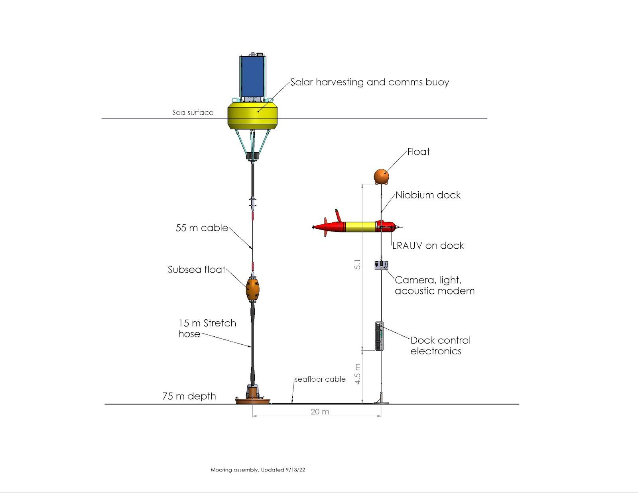
Figure 2: Schematic of the docking mooring currently deployed in North Monterey Bay.

What percentage of labor and budget have been used through the 1st half of year?

We have used 35% of the labor and about 35% of the budget. We do not expect to exceed the budget.

Will you complete the current year’s scheduled work?

To a large extent, we are planning to complete the scheduled work.

Significant changes from previous project proposal

We had optimistically planned to combine the docking station with the wave-energy buoy in 2025, but this proved unrealistic. Instead, we will be using the solar buoy, which is adequate for the work we are doing this year.

Over the past two years, what peer-reviewed publications, education and/or outreach activities have resulted directly from this project? Please be brief.

None

All Projects: Specific Plans for 2026

Research Activities

We are planning to use the docking system to support three event-response and time-series scientific surveys, as detailed below. In addition, we will make the dock available for the NOWRDC demonstration.

1- Upwelling survey in North Monterey Bay (September-October 2026)
In April 2024 and in June 2025, we deployed LRAUV Pontus dock to support an upwelling survey for several weeks.
We are proposing to repeat a similar experiment in September and October 2026. Pontus will be deployed to run daily transects for 30 days and will recharge its battery on the dock during the day. We expect to run a simple Sci2 YoYo mission and the bioluminescence proxies for various plankton groups (diatoms, dinoflagellates, larvaceans, copepods) will be calculated on-board and transmitted to shore. The goal of the deployment is to characterize the succession of plankton communities following upwelling, which can only be achieved from the daily resolution permitted by docking. The duty cycle of this mission will be modified from shore, based on the variability of the oceanography.

2- ESP survey in Central Monterey Bay (September 2026)
LRAUV Brizo is being outfitted with the docking hardware and will be deployed in September 2025 to undertake adaptive eDNA sampling.. This experiment will be repeated in 2026.

3- Siphonophore monitoring using LRAUV Galene carrying Chiton or Chiton-like payload (November 2026)
A limiting factor in deploying imaging payloads on the LRAUV is the high power consumption of the imaging system. This results in less frequent sampling or short duration (~ 4 days) deployments. By providing both recharging and data access during a deployment, the dock will enable us to significantly extend the deployment duration and to increase the sampling frequency to a time scale of months. With onboard machine learning and object identification, we can use the data access provided by the dock to send summary statistics along with example images to shore without recovering the LRAUV. A user can then command the vehicle to perform dense sampling during times of high abundance of target species and then recharge and return to a monitoring mode. The ability to toggle between monitoring and sampling without recovery greatly increases our chances of observing changes in siphonophore distributions over day/night cycles.
Deployment plan:
- Deploy for one month
- (Monitoring) Run horizontal transects at different depths conserving battery and fitting within the available docking recharge envelope.
- (Sampling) If high abundance of siphonophores are detected during a transect, send example images to shore for confirmation, and then begin dense sampling to capture changes in day/night distributions of siphonophores while abundance remains high or several days pass.
- Return to Monitoring and charging.

Engineering/technology development

1- Wave-energy to power the AUV docking station
A weakness of the docking buoy is that it can barely provide enough energy to keep one AUV running (the solar system generates 15 W on average). By contrast, the wave-energy buoy developed by MBARI can provide over 200 W on average. We are therefore proposing to combine the two systems so that the AUV dock is powered by the wave energy buoy. This would allow running several AUVs at the same time or running missions that require more energy, such as imaging. This work will be done in collaboration with the wave-energy project (901405) which happens to have many of the same team members.A lot of work will go into designing a new mooring that includes the wave-energy buoy and the AUV dock (figure 3). Much of this work will be done by project #901405 (wave energy buoy). 902106 will cover the design and fabrication of the docking part of the mooring (far right on figure 3), and will include many elements from the current system. We will design and build a complete new set of electronics and subsea housings and niobium rod.

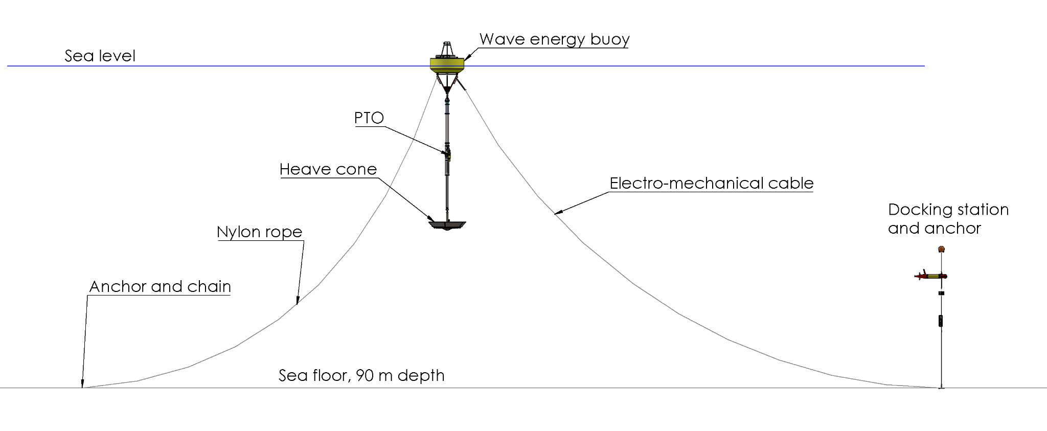
Figure 3: Schematic of the proposed wave-energy-powered docking mooring.

2- Video guidance to improve docking reliability
Currently the AUV relies on acoustic signals to home in on the dock. While this technology has proved adequate and reliable, its low precision results in frequent misses of the dock by the approaching AUV. When the AUV misses, it tries again until it succeeds, wasting time and energy and causing additional wear. We are proposing to investigate the use of video to help guide the AUV over the last few meters of its approach. In addition to saving time and energy, this would allow the use of a more compact latching device and could make docking easier for an AUV carrying certain payloads (such as Planktivore).
The method will require lighting of the docking station. We will purchase COTS lights or design our own and mount them at the top and the bottom of the niobium rod (the AUV’s target). We will outfit the AUV with a COTS camera and mount it near the nose of the AUV. We will write software that will allow the AUV to detect the lights and guide the AUV toward them. Finally we will perform trials at sea.

3- Improved data transfer
Currently, the docking station allows data transfer between the AUV and the docking station, using ethernet-over-power at a speed of about 500 kbps. While this is useful to transfer commands or small data files, it is insufficient for large data sets such as video. We are therefore proposing to investigate several new ways of transferring data.
The first and most straightforward approach is to improve the existing system. We have noticed that the niobium rod acts as an electrical capacitor in water, which greatly reduces the strength of the data signal. We believe that we can solve this problem by modifying the shape of the niobium rod and by tuning the electronics properly. This could lead to speeds of 10 Mbps. We are proposing to build a new niobium rod, to test it in the lab and at sea. This task is not expected to be very time consuming nor very challenging.
The second approach involves designing and building a radio transmitter (under certain conditions, radio transmission can be achieved underwater, over short distances), which has the potential of yielding a much higher data-transfer rate (on the order of 100 Mbps). However, this would be a much more challenging task. It would involve specifying and purchasing broadband radio transmitters, designing a radio antenna, waterproofing the components and performing tests in the lab and at sea. Because this would be a complicated and time-consuming research project, we propose to undertake a feasibility study and to start preliminary lab testing of such a system. We can continue this work in the future if it looks promising.

4- Upgrade, maintenance and installation of docking hardware on AUVs.

So far, three AUVs have been outfitted with the docking hardware (one has been retired) . We are planning to outfit two more. Triton will be outfitted in late 2025 for video surveys and Opah (deep LRAUV) in 2026 for planktivore surveys.
We are regularly making upgrades to the system or replacing worn-out or broken components. We are requiring funding to perform these tasks which occur regularly throughout the year.

5- The docking station will be made available for the NOWRDC demonstration.

Beyond 2026
This group is highly interested in continuing development work, and support of science in the future and plans to submit a new 3-year proposal for 2027-2029. We are considering various activities:
- build and deploy a dock at MARS to support operations using the deep LRAUV,
- support more science deployments in Monterey Bay, using the solar or wave-powered dock,
- develop a system that allows the AUV to recharge its battery at the wave-energy dock, transit to a remote experiment site, and transfer the energy to the experiment with a secondary docking station,
- start development of AUV DORADO docking.

Field programs (detail ship requirements/deployments/diver requirements)
In addition to describing anticipated field programs, please be sure to include requirements for specific platforms and equipment (Dorado AUVs, LRAUVs, Wave Glider, mini ROV, etc.) for each proposed field program so that expectations are clear. Requests must also be entered in the budget entry system. Note that AUV deployment numbers and diver requirement questions are also included in the Compliance and Planning Considerations Form described at the end of this proposal form.

There will be one deployment of the AUV dock, coupled with the wave-energy buoy, from August to December 2026. The dock will be used to support:
- LRAUV Brizo in September for ESP work,
- LRAUV Pontus in September and October for upwelling survey,
- LRAUV Triton in November for camera survey (Triton camera),
- possibly LRAUV Opa with planktivore.

In addition, the dock will support a combination of the AUVs as part of the NOWRDC demonstration.

AUV operations during these experiments will be performed as part of 902101 and other projects. R/V Paragon may be needed for occasional maintenance on the mooring.

Piloting/Watchkeeping
If you plan to use a platform that requires piloting/watchkeeping, please provide a high level staffing plan, including who will be responsible for these duties, by completing the chart below.

Staffing for piloting and watchkeeping of LRAUVs will be requested by project #902101 (LRAUV Technology Development), and scientists using the LRAUVs for their research.

Specific deliverables

Data transfer:
We will design, build and test a new docking rod with a short niobium section and a long plastic section to improve the performance of the data transfer using ethernet-over-power. We will perform preliminary tests of radio transmission with COTS equipment in a lab setting.

Video guidance:
We will develop and test a video-guidance approach system (LRAUV outfitted with camera, onboard guidance software, dock lights).

Wave powered dock:
We will design and install electronics necessary to support docking on the wave energy buoy.
We will design and build a complete new docking mooring (anchor, cables, subsea housing, acoustic modem, light, camera and new set of electronics).

Upgrade, maintenance and installation of docking hardware on AUV:
We will outfit LRAUV Opa with the docking system and planktivore.
We will perform maintenance and upgrade on all docking LRAUVs.

Milestones and required personnel (see personnel classification list for staff classifications)

Tasks will run in parallel, therefore, milestone dates are not chronological.

2026 Project Start Date:  01/01/2024 | Milestone 1 | Milestone 2 | Milestone 3 | Milestone 4 | Milestone 5 | Milestone 6 | Total Resources (in hours) for each resource category for all milestones listed here
Milestone Date | 08/01/2026 | 09/01/2026 | 08/01/2026 | 06/01/2026 | 12/01/2025 | 09/01/2026
Milestone Description | New rod & electronics for high-speed data transfer | Feasibility study on radio data transfer, including lab tests. | Integration of docking system with wave energy buoy | New dock mooring design and assembly | Design and test of video guidance system | Fabrication and installation of docking hardware on AUV
Electrical Engineer | Stern 80  Jensen 10 | Stern 80  Jensen 10 | Jensen 120 | Jensen 10 |  |  | 350
Software Eng-Embedded | Kieft 10 | Kieft 10 | Kieft 10 | Kieft 10 | Kieft 10  Ander. 120 |  | 170
Mechanical Engineer | Ham. 10  Caz. 80  Hob. 20 | Ham. 20  Caz. 40  Hob. 20 | Ham. 20  Caz. 200  Hob. 20 | Ham. 20  Caz. 150  Hob. 20 | Ham. 10  Caz. 120  Hob. 20 | Caz. 80 | 850
Electrical Tech | 40 | 40 | 40 | 40 | 40 | 40 | 240
Mechanical Tech | 40 | 10 | 60 | 60 | 60 | 40 | 270
EE Tech | McClure 20 | McClure 40 | McClure 80 | McClure 40 | McClure 40 | McClure 40 | 260
Machinist | 100 | 40 | 40 | 100 | 100 | 100 | 480

Budget justification

We are requesting $56000 for hardware, materials, equipment and supplies.
- Materials and components for the fabrication and maintenance of latches and power transfer devices: $15100
- $6700 for 1 Ultra Motion actuator,
- $500 for docking payload housing,
- $1000 for printed parts,
- $500 for hardware,
- $1000 for niobium brushes,
- $5000 for one LRAUV nose shell,
- $500 for materials.

- Materials and components for the fabrication of the new wave-powered dock mooring, associated electronics and device: $25500
- $2000 for new modified docking rod,
- $1000 for material for subsea housing
- $500 for float, lines, cable, hardware, anchor $2000
- $15000 for Benthos acoustic modem and transducer
- $3000 for dock light
- $2000 for connectors
- $1000 camera wiper
- $1000 for dock camera and housing

- Materials, components, supplies for data transfer electronics: $5000
- $5000

- Materials, components and supplies for video guidance system: $5300
- $2000 for light
- $1000 for connectors and cables
- $1300 for camera (Deep Water Exploration)
- $1000 for camera housing

- Miscellaneous expenses $5000.

Project team

The team in 2026 will be similar to 2025’s, with the addition of George Stern.
François Cazenave: project management, mechanical design, lab testing, fabrication, assembly and deployment supervision.
James McClure: electrical design and assembly (dock, power transfer device, buoy telemetry and power system).
Scott Jensen: electrical design (wave powered docking, data transfer).
George Stern: electrical design (data transfer).
Andy Hamilton: system engineering, project management, IP issues.
Brett Hobson: mechanical design, electrical design, LRAUV integration and operations. Much of Brett’s labor will be requested as part of 902101.
Brian Kieft: Docking related software on LRAUV, in-lab and at-sea testing. Much of Brian’s labor on the project will be requested as part of 902101.
Quinn Shemet: Docking related software on LRAUV, in-lab and at-sea testing. Much of Quinn’s labor on the project will be requested as part of 902101.
Michael Anderson: Docking related software on LRAUV and video guidance systems.

External consultants/contractors
If you propose to engage an external consultant/contractor, please attach a sufficiently detailed SOW and budget proposal from the vendor. If approved, a fully executed Independent Contractor Agreement must be in place before work can begin.

None

Project lab and office space requirements
In addition to any changes to current space usage, please also include anticipated office and lab needs for students, postdocs, collaborators, etc.

We are currently using the left-side bench and storage in B222 and would like to continue to do so.

Risk matrix (development and infrastructure projects only)

 | Technical Risk | Organizational Risk | Tech Transfer Risk | Labor Estimate Risk
High
Medium | x | x | x | x
Low

Compliance and Planning Considerations

All responses must be recorded in the Google form linked below. A form must be submitted for every project.

Link to Google Compliance and Planning Considerations form -OR- https://forms.gle/uKJrxRuRaBHUL8vT8

Development and infrastructure projects must complete the risk matrix (see end of the proposal form).
Not all projects will require all four titles to be filled in. Please indicate individuals only for those titles that are appropriate for your project.
This category includes transfer of hardware, know-how, publications, presentations, etc.
Modify layout/text of chart, as needed.

