Mars Benthic Ecology Control Labview Code Documentation
Chad Kecy

The MARS Benthic Ecology control software was written using LabView and is configured as a state machine. A description will follow which will also reference the attached graphical flowchart and the reference sections of this document.

The general operating principle of the state machine is to act as a one-shot multivibrator. Instead of closing the main loop around the measured temperature, this code uses a pulse (heat on) followed by a rest period (heat off). These two times added together is considered one period. The reference temperature is measured after every rest period. If our measured temperature is still below our set point, a complete period is launch again (heat on + rest). However, if after a rest period, the measured temperature is above our set point, an additional rest period is launched. These additional rest periods will continue until the measured temperature is equal to or less than the set point.

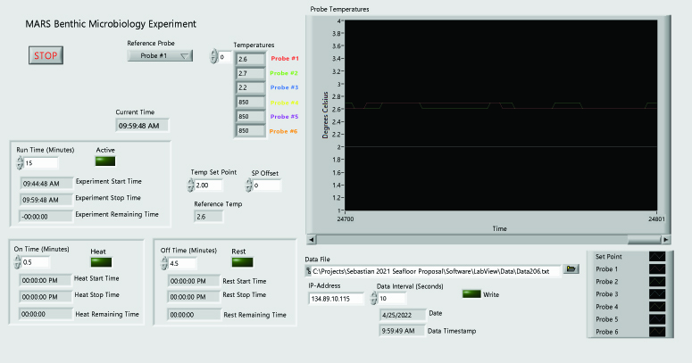
Figure One: Labview Front Panel

States:
Initialize
This state occurs only once at the start of the program being executed. It assigns values to necessary variables and activates the three electro-mechanical relays.

Read Temps
This state is used to read the measured temperatures from the RTDs. It also contains an internal CASE structure which checks to see if the loop is in its first pass. This allows the state machine to grab the starting temperatures outside of the main loop for use as initial conditions. Every pass after the first is in the main loop. The Boolean variable, First Loop is used for this function.

H/R Period?
This state checks to see if we are in the middle of a Heat/Rest period. If true, there are no temperature checks, and the main loop is entered once again. If false, this indicates a rest period just ended, thus the reference temperature needs to be compared to the set point.

Compare Temps
This state is used to compare the selected reference RTD probe’s temperature versus the user-entered temperature set point. A second user-defined variable, SP Offset, is optionally used. This variable allows for the small temperature difference in the benthic soil where the reference RTD probe is physically located versus the location of the core sampler. Experimentally, this value was found to be 0.6 degrees Celsius for the current set up in the Seawater Lab in building A. If the measured temperature is found to be above the set point, then an additional rest period is launched. However, if the measured temperature is found to be below the set point, then a full Heat+Rest period is launched.

Bypass Start
This state is used to check for an initial set of conditions where the measured benthic soil temperature is above the set point at the start of the code execution. This allows the system to be run in an, essentially, read only mode. This is useful for knowing general background conditions (temperatures) in the area. Lowering the Temp Set Point front panel below the Reference Temp puts the system into bypass mode.

Start Heat Time
This state starts the timer for the Heat On portion of the HR period.

Heat Var Assign
Once in a heating cycle, this state assigns necessary variables and calculates the remaining time in the current heat cycle.

Start Rest Time
This state starts the timer for the Rest On portion of the HR period.

Rest Var Assign
Once in a resting cycle, this state assigns necessary variables and calculates the remaining time in the current rest cycle.

SSRs On
Once in a heating cycle, this state activates the relays needed to turn on the immersion heaters in the benthic soil.

SSRs Off
Once in a resting cycle, this state de-activates the relays needed to turn on the immersion heaters in the benthic soil.

Graph
This state updates the front panel graph with the measured temperatures and the user-defined reference temperature.

Data Timer
This state monitors the current time and compares it to the user-defined data interval used for logging. If true, data is logged.

Log Data
This state writes key variables to a text file with a filename and location determined by the user. At the current time, headers are not included in the text file. The columns in the data file are as follows:
Date
Time
Reference Temperature
Temp #1
Temp #2
Temp #3
Temp #4
Temp #5
Temp #6
Heat On? (True or False)
Reference Probe Number
Heat On Time
Heat Off Time
Set Point Offset

End Timer
This state checks to see if the current experiment has reached its user-defined Run Time.

Bypass End
This state checks to see if the system is still in bypass mode. If true, the entire main loop is started again. If false, the status of the heat mode is checked.

Heat Mode?
This state checks to see if the system is in a heat or rest cycle.

Heat Time Elapsed?
This state checks to see if the current heat cycle has reached its user-defined time limit. If it has, then a rest cycle is started. If the timer has not elapsed, then the system stays in the current heat cycle.

Rest Time Elapsed?
This state checks to see if the current rest cycle has reached its user-defined time limit. If it has, a new HR period is initiated. If the timers has not elapsed, then the system stays in the current rest cycle.

HR Restart
This state assigns a variable which allows a new HR period to begin.

Stop
This state is used to cleanly end the experiment. All relays (both electro-mechanical and solid-state) are turned off and variables are set to false.

Controls:
IP-Address (String)
The current assigned IP address is 134.89.10.115

Temp Start Address (U16)
The default value is 0.

Temp Read Port (U16)
The default value is 502

Coil Start Address (U16)
The default address is 512

Coil Remote Port (U16)
The default value is 502

On Time (SGL)
A user-defined number in minutes which indicates how long the immersion heaters stay on during a heat cycle.

Off Time (SGL)
A user-defined number in minutes which indicates how long the immersion heaters stay off during a rest cycle.

Reference Probe (U8)
A drop down menu which allows the user to define which temperature probe is used as the reference for comparison against the Temp Set Point.

Temp Set Point (SGL)
A user-defined number in degrees Celsius which indicates the temperature the soil will be heated to.

SP Offset (SGL)
A user-defined number in degrees Celsius. This variable allows for the small temperature difference in the benthic soil where the reference RTD probe is physically located versus the location of the core sampler.

Data Interval (SGL)
A user-defined number in seconds which indicates how often data will be saved.

Run Time (SGL)
A user-defined number in minutes which indicates how long the experiment will run.

Indicators:
Current Time (Time Stamp)
Experiment Start Time (Time Stamp)
Experiment Stop Time (Time Stamp)
Experiment Remaining Time (DBL)
Heat Start Time (Time Stamp)
Heat Stop Time (Time Stamp)
Heat Remaining Time (DBL)
Rest Start Time (Time Stamp)
Rest Stop Time (Time Stamp)
Rest Remaining Time (DBL)

Active (B) – Indicates that an experiment is in progress.
Set to TRUE in Initialize
Set to FALSE in Stop

First Loop (B, hidden) – A Boolean which indicates the first pass through the state machine.
Set to TRUE in Initialize
Read Temps Case: True -> H/R Period? False -> Graph
Set to FALSE in H/R Period?

Bypass (B, hidden) – A Boolean which indicates that the measured reference temperature is already higher than the desired set point when the experiment is initially launched.
Set to TRUE in Initialize
Bypass Start Case: True -> Read Temps False -> Start Rest Time
Set to FALSE in Heat Var Assign
Bypass End Case: True -> H/R Period? False -> Heat Mode?
Set to FALSE in Stop

HR Period (B, hidden) – A Boolean which indicates whether we’re in the middle of a heat/rest period.
Set to FALSE in Initialize
H/R Period? Case: True -> Read Temps False -> Compare Temps
Set to TRUE in Heat Var Assign
Set to TRUE in Rest Var Assign
Set to FALSE in HR Restart
Set to FALSE in Stop

Heat (B) – A Boolean which indicates the system is in a heating cycle.
Set to FALSE in Initialize
Set to TRUE in Heat Var Assign
Set to FALSE in Rest Var Assign
Heat Mode? Case: True -> Heat Time Elapsed? False -> Rest Time Elapsed?
Set to FALSE in Stop

Rest (B) – A Boolean which indicates the system is in a rest cycle.
Set to FALSE in Initialize
Set to FALSE in Heat Var Assign
Set to TRUE in Rest Var Assign
Set to FALSE in Stop

On State (B, hidden) – Indicates that the SSRs are ON
Set to FALSE in Initialize
Set to TRUE in SSRs On
Set to FALSE in SSRs Off
Set to FALSE in Stop

Off State (B, hidden) – Indicates that the SSRs are OFF
Set to TRUE in Initialize
Set to FALSE in SSRs On
Set to TRUE in SSRs Off
Set to FALSE in Stop

Temperatures (DBL, array)
A 1D array where the current measured temperature values are stored. These are later written to a data file with a frequency determined by the Data Interval variable.

Reference Temp (SGL) – The temperature (in degrees Celsius) which is used as the reference against the user-defined setpoint.

Probe Temperatures (Waveform Chart) – A plot of the six temperature probes (only three used currently) and the user-defined setpoint.

Write (B)
A simple Boolean indicator which is quickly illuminated during a write cycle.

Date (String)
The current date.

Data Timestamp (String)
The current time.

Constants:
Heat Init (B, array)
A six variable Boolean array which turns on the three electro-mechanical relays.

Heat On (B, array)
A six variable Boolean array which turns on the three solid-state relays, thus turning on the immersion heaters.

Heat Off (B, array)
A six variable Boolean array which turns off the three solid-state relays, this turning off the immersion heaters.

All Off (B, array)
A six variable Boolean array which turns off all six relays (thee electro-mechanical and three solid-state)

