Tracing the path of carbon export in the ocean

February 2022 Research Highlight
Colleen Durkin
Carbon Flux Ecology Lab

The rain of marine snow from the surface ocean to the deep sea is a key component of the ocean’s carbon cycle. This process, called the biological carbon pump, is difficult to accurately quantify and model in part because of the complex ecological processes involved in transporting carbon out of the surface and transforming it as it sinks. Technological advances are making it easier to quantify the surface phytoplankton populations that fix organic carbon and their biological diversity at a global scale (e.g. ocean color satellites, genetic sequencing), but integrating these observations into models of the biological carbon pump currently rely on theoretical or statistical relationships rather than direct observations.

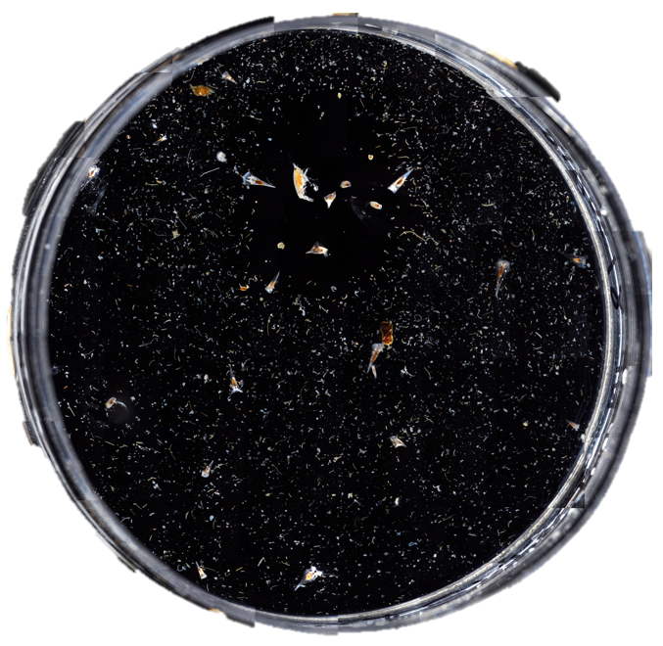
In a study recently submitted for publication, we developed a new sampling approach to bridge this observational gap between surface phytoplankton production and the resulting carbon export and present a framework for integrating these data into mechanistic models of the biological pump (see above figure). The sinking particles responsible for exporting carbon from the surface ocean were collected in sediment traps containing a gel layer. This allowed us to isolate individual particles and sequence the DNA communities within distinct particle types. By comparing these DNA sequence communities with those in the overlying surface ocean, we identified which taxa were exported and the particle types in which they were packaged. This is important because each particle type is formed by a different ecological mechanism, and affects the quantity and depth to which carbon will be sequestered.

This work is an important first demonstration of how DNA sequencing and imaging can be combined to quantitatively resolve mechanisms of carbon export. An important aspect of this work is to resolve microscopic details in a way that can be related back to larger ecosystem and ultimately back to the global scale.
Above: Top-down view of a collection jar containing a gel layer that enables the gentle collection, isolation, and imaging of individual sinking particles.

Submitted publication:

Durkin, C.A., I. Cetinić, M. Estapa, Z. Ljubešić, M. Mucko, M. Omand. Tracing the path of carbon export in the ocean though DNA sequencing of individual sinking particles.

