Colleen Durkin
Carbon Flux Ecology Lab
Project Highlight February 2023

Phytoplankton cells in the twilight zone
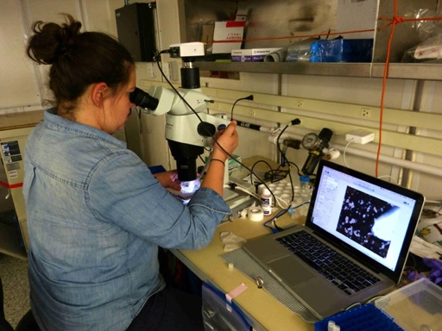
Whenever I look at sinking particles from the ocean’s “twilight zone” (100-500m) I always see individually sinking phytoplankton cells. How could these tiny cells possibly sink fast enough to be found that deep? How do they fit into our conceptual model of the biological carbon pump? Annie Bodel was a part-time MBARI technician and current MLML Masters student whose thesis research quantified the importance of these deep sinking cells. We collected sinking particles for 1 month in two locations: the iron-limited subarctic North Pacific and in the North Atlantic at the end of the spring diatom bloom. We were surprised to see the amount of sinking cells vary so much over time during these month-long research cruises, and also that the two ocean basins had completely opposite patterns of flux with depth. 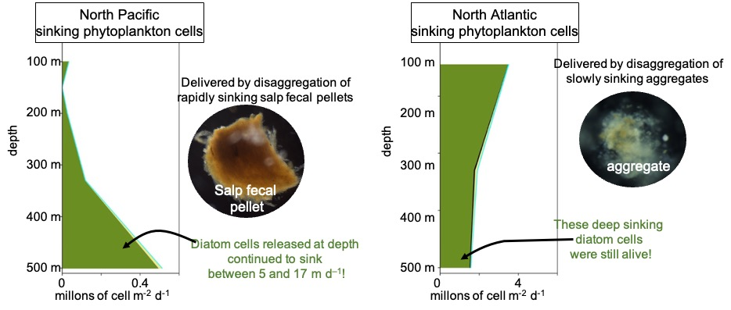
Figure 1 Annie Bodel counting phytoplankton in sediment trap samples. She will defend her MLML Masters thesis this February.
Additional contextual data collected during these NASA funded cruises enabled us to reach 5 important conclusions:
1) Time and space variation in cell fluxes are an indicator of particle disaggregation, a process that is extremely difficult to observe and quantify.
2) The depth that cells are delivered (disaggregated) at depth depends on the particle in which they were packaged.
3) Once released at depth, these individual cells continue to sink.
4) Some of these cells are still alive and capable of growing if brought back to the light. This makes them more nutritious source of food to deep sea organisms, and also means they have the potential to seed future blooms if mixed back into the surface ocean.

