Colleen Durkin
Research Highlight, June 2022

What causes episodic high carbon flux to the seafloor in the California Current, and why are these events increasing?

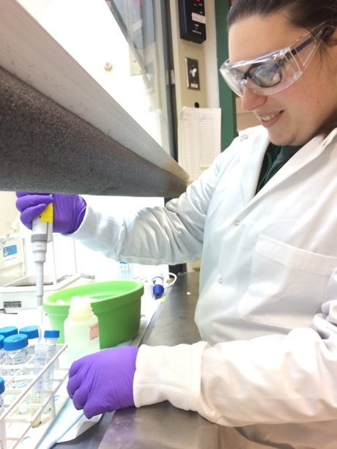
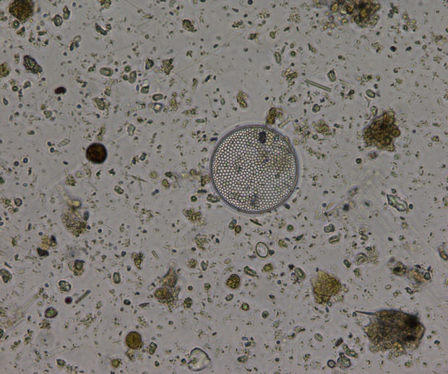
Carbon export in the CA Current has been increasing over the last three decades, a key finding of Ken Smith’s 33-year timeseries at Station M. Episodic pulses of particles raining down to the seafloor have been increasing in magnitude and frequency, driving the long-term trend. Although Ken’s work at Station M has established that the ecology of the deep sea is tightly coupling with surface ocean processes, we still did not know the mechanisms generating the episodic particle pulses of carbon or why they were increasing over time. To identify mechanism driving episodic fluxes, we quantified the phytoplankton composition within sinking particles collected at Station M during high flux events and compared them to the composition in particles immediately before and after the event. This work was the Masters research of former MLML student Cynthia Michaud and a collaboration between the Durkin and Smith labs, supported in part by the CA SeaGrant.
A microscopic view of particles collected during a high carbon flux event at Station M. Here, a large diatom cell is present among the detritus.
MLML Masters student Cynthia Michaud performed microscopy and chemical analysis of archived samples collected at Station M.

We initially assumed that these episodic carbon pulses were caused by the rapid export of coastal phytoplankton blooms within the local region. We did find evidence that the large pulses are initially produced by coastal blooms, but also found that the sinking particles are highly processed through pelagic ecosystems before reaching the deep sea, suggesting that the particles sank relatively slowly through the meso- and bathypelagic and likely originated from locations more distant from the Station M study site. The increase in carbon export to the deep sea in the CA Current is certainly linked to changes in the initial export of coastal phytoplankton blooms. However, our results highlight the critical role that meso- and bathypelagic ecosystems play in transforming carbon as it sinking to the deep ocean and the need to create a better framework for tracking carbon export in dynamic physical environment.

Cynthia recently published the results of her thesis work in Limnology and Oceanography Letters, for which she received an Early Career Publishing Award.
e
d
c
b
a

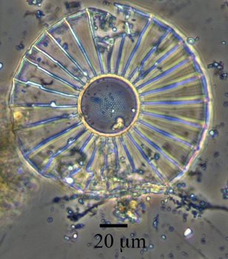
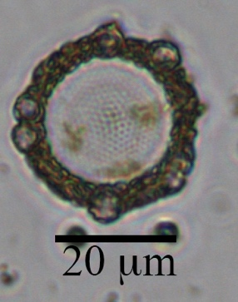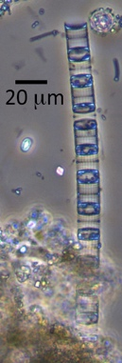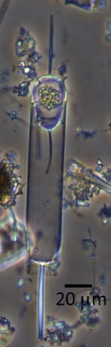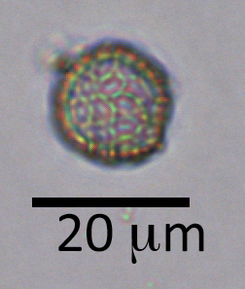
Examples of phytoplankton cells seen in archived Station M sediment trap samples. a)Diatom Planktoniella. b) Thalassiosira diatom with Reticulofeistra coccolithophore cells and liths attached to the outer silica frustule, c) A chain of intact Skeletonema diatoms containing chlorophyll. Skeletonema is a coastal bloom-forming diatom. d) A Ditylum diatom forming a resting spore. At 4000 m deep, this cell is unlikely to wake in spite of employing this survival strategy. e) A coccolithophore cell, which is covered in calcium carbonate liths. Changes in taxonomic composition and the presence of intact versus fragmented cells helped determine the ecological source and relative freshness of sinking particles.

