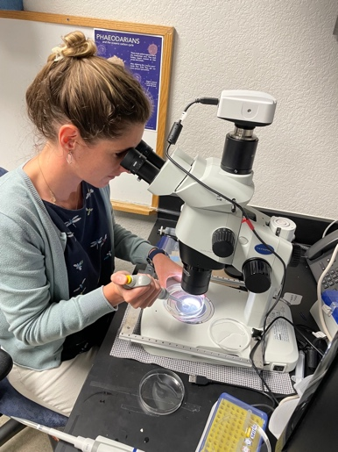
Colleen Durkin
Carbon Flux Ecology Lab
Project Highlight June 2023

Formation of glass by Rhizaria
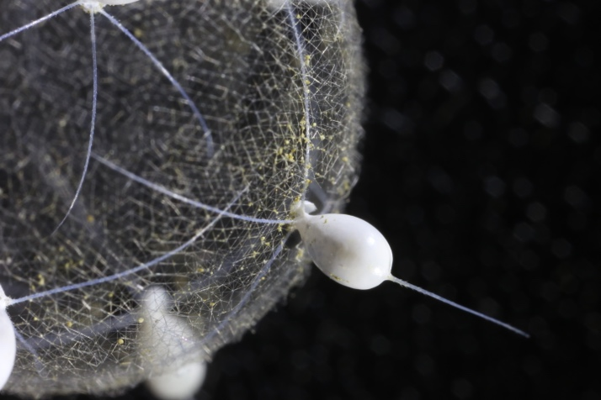
Rhizaria are a diverse group of heterotrophic protists and include the radiolarians and phaeodarians that produce silica cell structures. Phaeodarians are “giant” deep sea protists that intercept sinking marine snow and their importance in deep ocean carbon cycling has been increasingly recognized. Unfortunately, very little is known about the basic cell biology of these organisms because they are very delicate, difficult to sample, and have never been cultured. Marie Curie postdoctoral fellow Natalia Llopis Monferrer is taking advantage of MBARI’s unique access to these deep ecosystems to learn how these organisms produce their intricate glass cell structures. In collaboration with Steve Haddock’s team, we will collect the giant protists with ROV Ventana and use culturing technologies developed by the Monterey Bay Aquarium to keep them alive long enough to observe silica production.
Marie Curie Postdoc, Dr. N. Llopis Monferrer, isolating radiolarians in the Carbon Flux Ecology Lab.

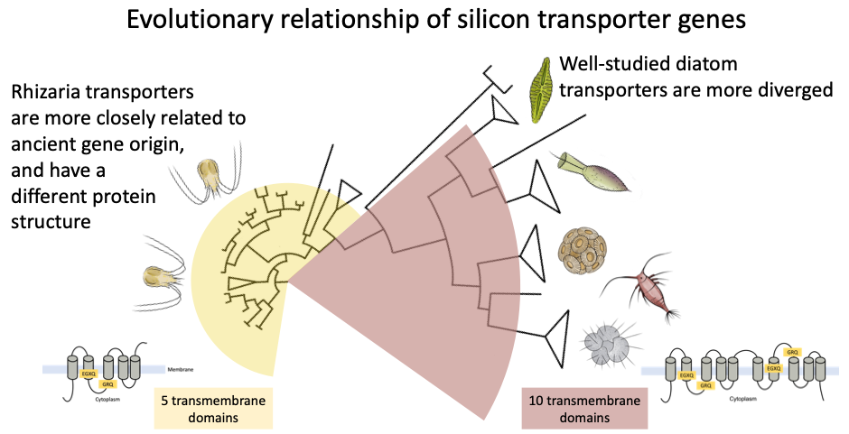
First, Natalia is utilizing the molecular datasets previously generated by the Haddock lab team to discover how rhizaria evolved the ability to take up silicic acid from seawater. She identified the most comprehensive dataset of rhizarian silicon transporters to date, and found that they encode a version of this gene that is deeply rooted in the evolutionary tree with a very different protein structure than diatoms. This data is already providing clues about why rhizaria have a distinct role in the ocean’s silicon cycle, and will also allow us to better survey environmental genetic data. This is the first step to resolving the ecological and biogeochemical role of these elusive organisms.
Phaeodarian cells create intricate glass stuctures, but we know very little about their biology. Photo: N. Llopis Monferrer

