Colleen Durkin
Research Highlight, October 2022

What types of marine snow particles can the AyeRIS imager detect?

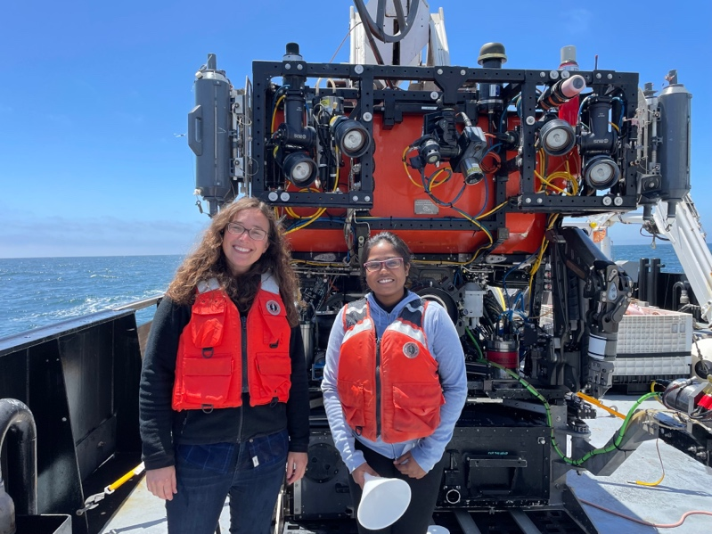
The underwater imaging systems developed at MBARI have enabled countless discoveries and breathtaking observations of the mysterious creatures that live in the deep sea. These images are also filled with “marine snow”, the diverse types of sinking particles that transport carbon and fuel the ecosystems of the deep ocean. MBARI intern Sachithma Edirisinghe spent her summer advancing our ability to use the AyeRIS camera system to study the ecology of marine snow and carbon export. The camera was developed by the Bioinspiration Lab team, and has had several successful deployments on the Galene LRAUV and has imaged many 100,000’s of objects in the water. Sachithma implemented a semi-supervised image classification program to generate a well curated dataset of both the animals and particle types that can be observed by AyeRIS.
Colleen and Sachithma using the cabled imager (EyeRIS) during a cruise with the Pelagic-Benthic Coupling lab team.

We are excited to use this curated dataset to train a machine learning image classifier to analyze the large dataset generated by this instrument. Already, it looks like we can detect the animals that produce and consume sinking particles, and a variety of different types of sinking particles. AyeRIS will allow us to map the location of these ecological interactions across space. These types of observations will help us to better study the ecological interactions that control the export of carbon to the deep sea.

This work brought together the expertise of the Bioinspiration Lab and the Carbon Flux Ecology lab. Thanks especially to Paul Roberts, Henry Ruhl, and Eric Orenstein.

