STT deployments Monterey Bay
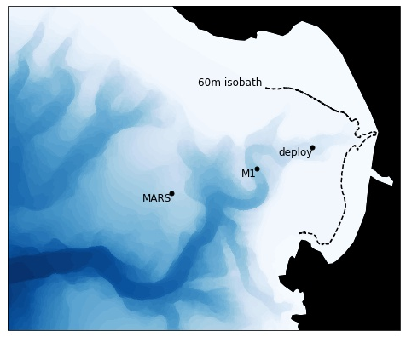
Pre-cruise preparation:

1) Connect/assemble trap lines and floats
2) Filter seawater
3) Make formalin brine
4) Make unfixed salty brine
4) prepare 2 gel jars
5) Fill trap tubes
- 1 formalin only (POC and DNA)
- 1 salt brine (resurrection exp.)
- 1 gel jar
- 1 gel jar with formalin

6) Prepare filter station and roller tanks
7) combust GFFs
8) pack supplies* needed at sea
9) activate hobo loggers
10) activate spot tracker
11) activate flasher

*see packing list below

Day 0
Deploy: 21 May 2023

At sea operations
Depart: 0900 on Paragon
Approximate location:
36.78 N, -121.92 W

1) Deploy drifting sediment trap
2) Collect net tow (down to 50 m?)
3) Collect water from Niskin bottle (5m and 50 m)
4) Hyperpro?
5) ISIIS profile?
6) Planktivore profile?

On land operations
1) Filter 500 mL seawater for POC and Chl
2) Run fresh net tow and seawater samples on Planktoscope
3) Download data from ISIIS/Hyperpro/Planktivore
4) Incubate surface seawater in roller tank (with camera?)

Overnight: Track location of trap with Spot Tracker

Day 1
Recovery: 22 May 2023

At sea operations
Depart @ 9 on Paragon

Location: Hopefully outside the 60 m isobath and away from whales

1) Recover STT
2) Secure collection tubes but do not process
3) Return to land

On land operations
1) Deactivate hobo loggers and download data
2) Deactivate Spot tracker and flasher
3) Rinse all gear with freshwater
4) Allow collection tubes to settle for 1 hr
5) Filter formalin tube for POC and DNA on combusted GFF
6) Collect fresh particle sample and incubate in light/dark treatments
7) Image both gel samples
8) Isolate particles from gel for DNA
9)Check on aggregation potential in roller tanks

Day 4 or so?
Breakdown resurrection experiment.
1) Preserve samples
2) Run on Planktiscope

*Supplies needed at sea:
Sample log
Pens/pencils
Zipties
Snips
Knife/multi-tool
Locking clips
Cheap/old drill with hex bit for hose clamps
Hose clamps
Neoprene strips
Electrical tape
Tube rack/holder
Bungees/ropes to tie down with
Milk crate to hold trap frame
Nets
Bottles for net tow sample
Cooler
Carboys for seawater
Manual Niskin-bottle (from Chavez lab??)
ISIIS?
Planktivore?
Hyperpro?

