This document is a quick start supplemental guide to the official BlueBoat documentation. Please review the assembly, software, operators, and integration guides for more in depth knowledge of this system.

Connecting to the BlueBoat
- Ensure that the PC connected to the base station has the correct IP address of 192.168.1.1. Please note that for some reason, the base stations USB C port is directional, if you cannot connect try flipping the USB C. Open QGroundcontrol (QGC) to confirm connection and telemetry.
List of modifications from stock BlueBoat
- VN300 connected to RPI4 USB port – this logs INS data on the RPI4. – Note the GPS antennas are disconnected
- Ethernet switch added to connect WBMS
- Waterproof Arducam added (can be turned off if bandwith is limited under ‘video’ section in QGC or on BlueOS page)
- InertialSense RUG-3-IMX-5-DUAL for logging RTK GPS and INS data.
- 24V regulator (in port hull) to power WBMS
- WBMS BlueTrail port connected to ethernet switch
- Higher gain antennas on both the boat and base station

VN300 Guide
- Please review “VN300 Serial Logger Instructions.docx” to start and stop logging remotely via SSH to RPI4.
InertialSense RTK GPS Guide
- (Work in progress add guide here)

WBMS Guide
- The current IP address of the WBMS is 192.168.1.56, download the WBMS GUI and remotely start and stop logging. – Akshay is working on a script to record the data onboard the internal RPI4.
- Reference WBMS manuals
Joystick Setup
- This must be reconfigured on a new PC, see below screenshots:
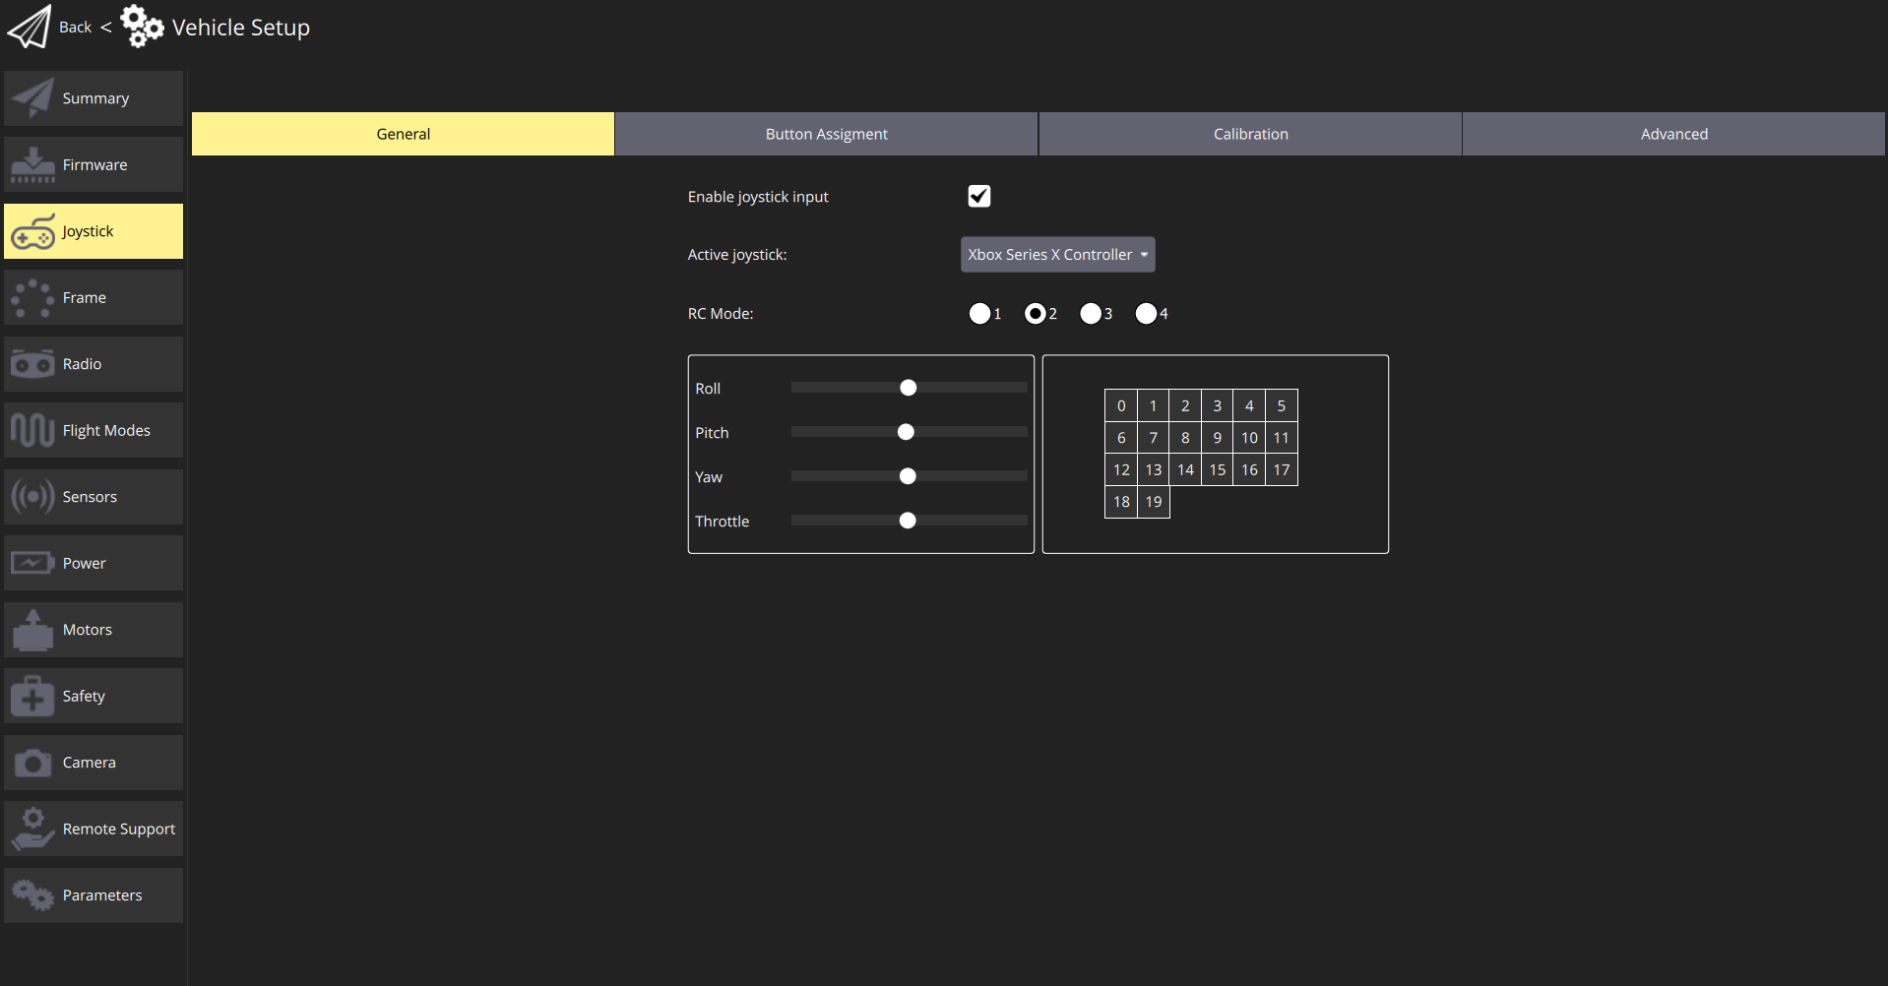
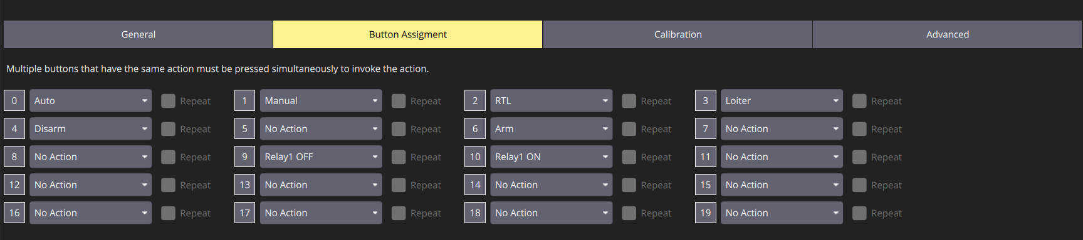
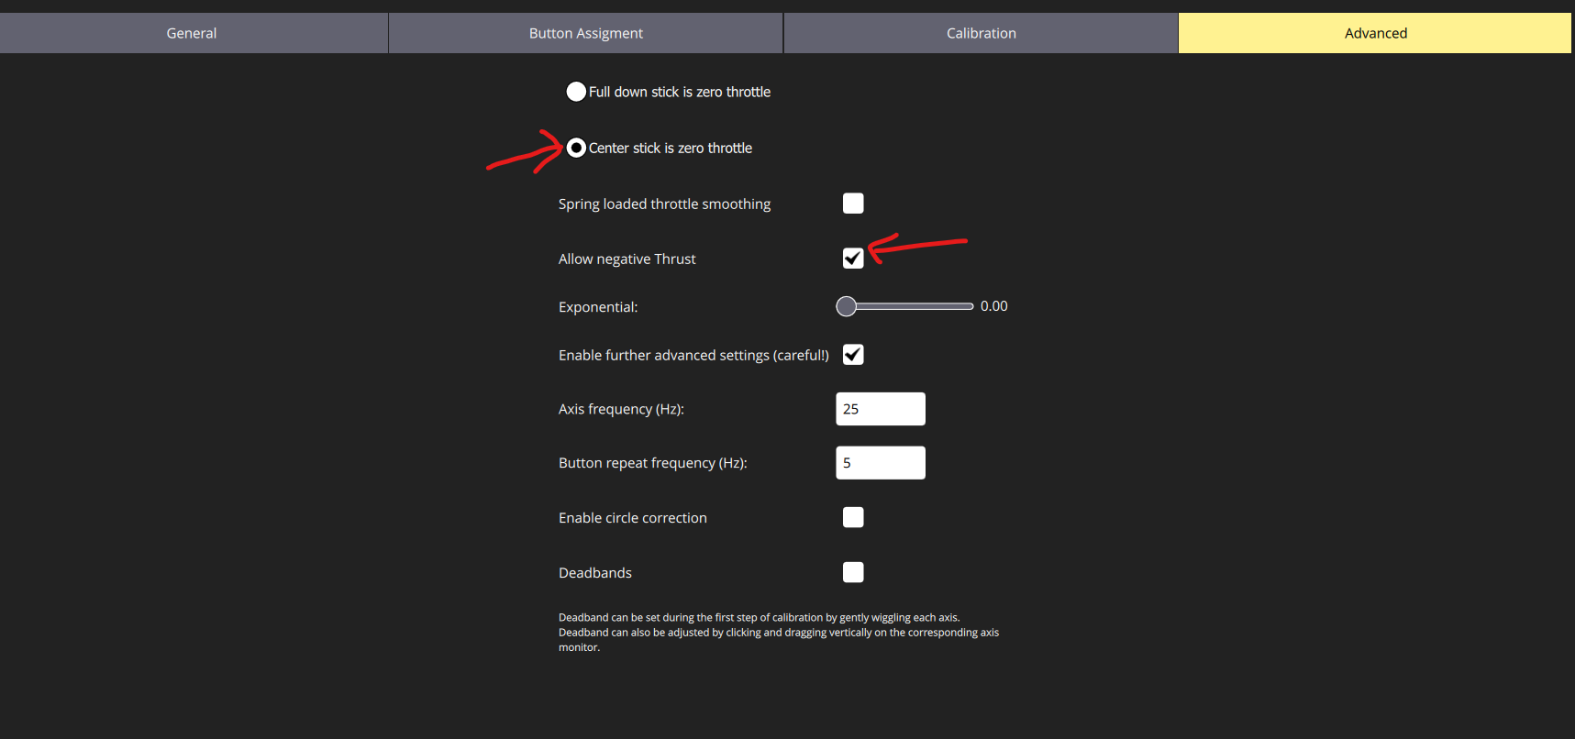
If the thrusters start up in manual mode with no stick input, do a joystick calibration
Operations
- The most important thing to setup is failsafes, you can do so on the BlueOS webpage (192.168.2.2 in a browser). These will change depending on the situation. For example, if you are in a marina and the Wi-Fi link between the base station and the ground station disconnects, the best option may be to put the boat in loiter mode rather than trying to return to home and crash into boats or other objects in between you. If you are out at sea piloting the blueboat from a vessel and get disconnected, if you select return to home as an option the boat may start heading to the GPS positions from where it was launched that it thinks is home. Unless you have a dynamic home point it may be better to loiter in position. If you launched from a beach, return to home makes the most sense because its unlikely there are any obstacles in the way, and the home point is static. Use your best judgement in the situation and review how failsafes work and test them before launch. It is also best to have a recovery plan in case the boat flips or fails in an unexpected way (kayak or vessel recovery).

Add table of IP addresses

