This is a guide on how to set up a relay on the BB using a PWM/servo pin. You can actuate the relay by using a button on the joystick, or by using a custom action LUA script in Qgroundcontrol.
Here is a link with more info.
Qgroundcontrol V5.0.5+:

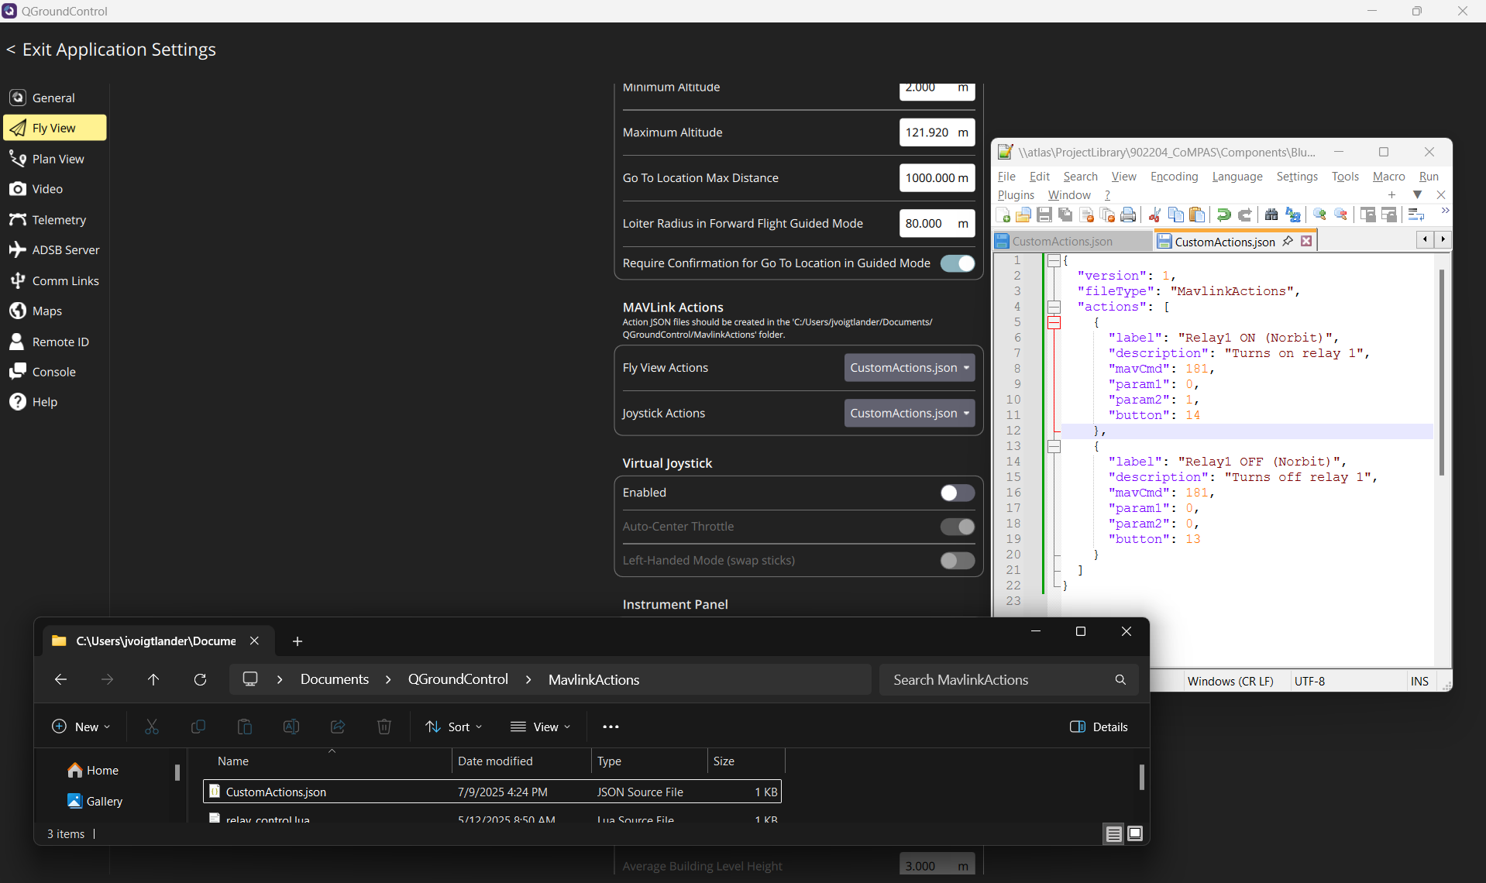
- Create an actions file, with the MAVLink commands you want to be able to send:
~/Documents/QGroundControl/CustomActions/FlyViewActions.json:

FlyViewAction.json:

{
"version": 1,
"fileType": "CustomActions",
"actions":
[
{
"label": "Relay1 ON",
"description": "Turns on relay 1",
"mavCmd": 181,
"param1": 0,
"param2": 1
},
{
"label": "Relay1 OFF",
"description": "Turns off relay 1",
"mavCmd": 181,
"param1": 0,
"param2": 0
}
]
}

- Enable Custom Actions in QGC’s Application Settings (access via the top left corner). This step is only required for QGC versions before the upcoming 4.5 release
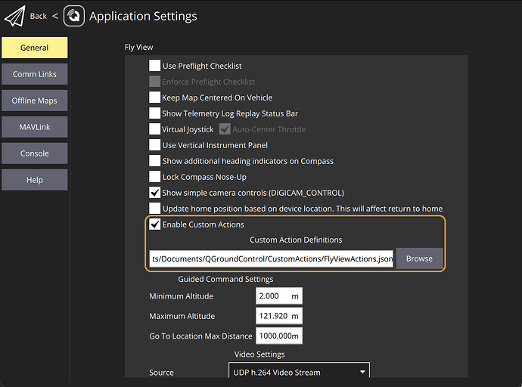
- Access the actions when in Fly View, by clicking the “Action” button in the left sidebar, and pressing the relevant action button(s) in the popup at the bottom of the screen. You may need to restart QGC after the actions file location is first configured. The actions popup can be scrolled sideways to see additional actions, if more than a few are available

Joystick Buttons for QGC >= 4.5
- Create an actions file, with the MAVLink commands you want to be able to send: ~/Documents/QGroundControl/CustomActions/JoystickCustomActions.json:
JoystickCustomActions.json:
{
"version": 1,
"fileType": "CustomActions",
"actions":
[
{
"label": "Servo5 HIGH",
"description": "Sets servo 5 to a high PWM value",
"mavCmd": 183,
"param1": 5,
"param2": 1900
},
{
"label": "Servo5 LOW",
"description": "Sets servo 5 to a low PWM value",
"mavCmd": 183,
"param1": 5,
"param2": 1000
},
{
"label": "Relay1 ON",
"description": "Turns on relay 1",
"mavCmd": 181,
"param1": 0,
"param2": 1
},
{
"label": "Relay1 OFF",
"description": "Turns off relay 1",
"mavCmd": 181,
"param1": 0,
"param2": 0
}
]
}

- Select the actions file from where you saved it, via the Application Settings in the top left corner
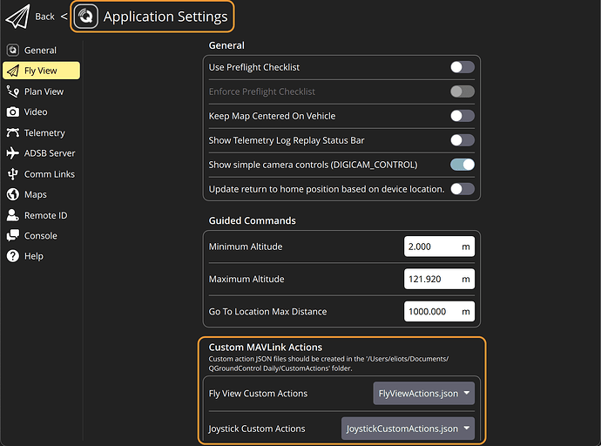
- Access the actions when in Fly View, by clicking the “Action” button in the left sidebar, and pressing the relevant action button(s) in the popup at the bottom of the screen. You may need to restart QGC after the actions file location is first configured. The actions popup can be scrolled sideways to see additional actions, if more than a few are available

For GQC <4.5:

- Create a JoystickMavCommands.json file: The filename is hardcoded in QGC, so must match exactly
JoystickMavCommands.json:
{
"comment": "Joystick MAV commands",
"version": 1,
"commands": [
{
"id": 181,
"name": "Relay1 ON",
"param1": 0.0,
"param2": 1.0
},
{
"id": 181,
"name": "Relay1 OFF",
"param1": 0.0,
"param2": 0.0
}
]
}
- Save it where your QGroundControl instance gets run from. In Windows this is inside the folder where you installed it: e.g. C:\\Program Files\QGroundControl\JoystickMavCommands.json
- Configure your joystick buttons via the Vehicle Setup options. You’ll need to scroll to the bottom of the actions dropdown to find your custom options
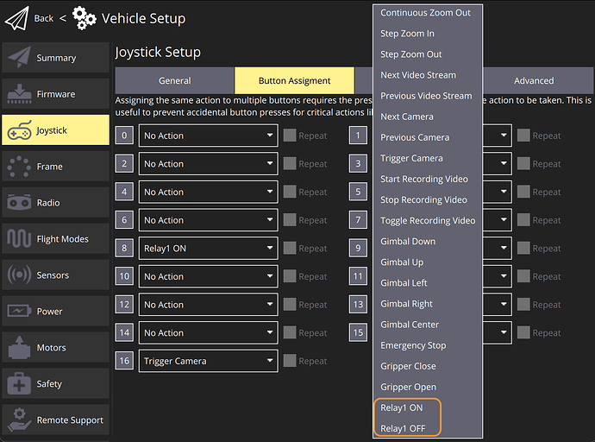

Relay configuration:
While the servo PWM commands typically provide direct control over flight controller servo output pins, the relay output pins are selectable from the available servo output pins, which needs to be set up in the autopilot parameters before the relay can be used.
When using a Navigator Flight Controller it is possible to see the state of the relay pins as 0/1 in the SERVO_OUTPUT_RAW MAVlink messages (e.g. via the MAVLink Inspector).

Blueboat:
- Allow the relevant servo pin to be used as a relay output, by setting its SERVOn_FUNCTION parameter to GPIO (-1)
  - “n” is the pin number being configured (e.g. 9) – This is on physical Servo pin 9
- Allow the relay number to be used as a servo output relay, by setting the RELAYn_FUNCTION to Relay (1), and rebooting the autopilot
  - “n” is the relay number being configured (e.g. 1)
- Connect the relay number to its servo output pin via the RELAYn_PIN parameter – use 9
- Set up custom joystick button functions using the DO_SET_RELAY (181) and/or DO_REPEAT_RELAY (182) MAVLink commands, and configure the joystick button function(s) as desired

Schematics: 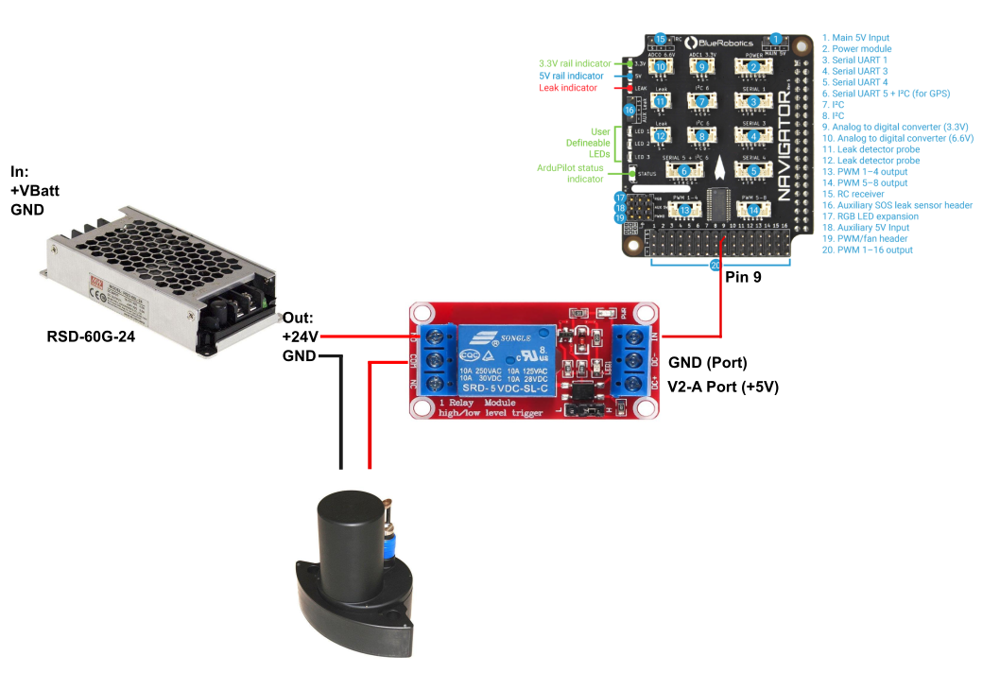
How to confirm the relay is on:
