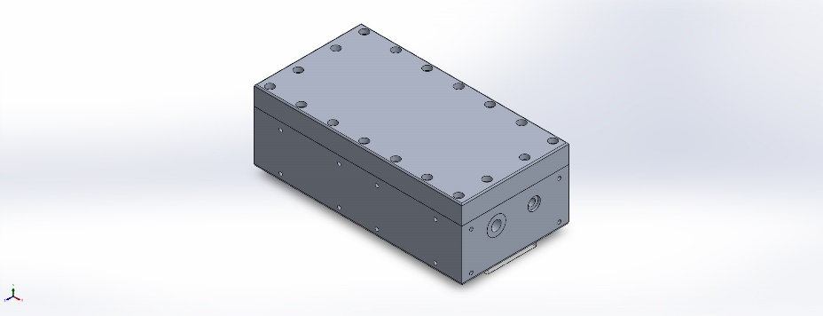
  Simulation of testAssemblyNewHousing
  Date: Tuesday, August 29, 2023
  Designer: kiwi
  Study name: Static 4
  Analysis type: Static
  Table of Contents
  Description 1
  Assumptions 2
  Model Information 2
  Study Properties 3
  Units 3
  Material Properties 4
  Loads and Fixtures 5
  Connector Definitions 5
  Interaction Information 6
  Mesh information 6
  Sensor Details 7
  Resultant Forces 7
  Beams 7
  Study Results 8
  Conclusion 9

Description
No Data

Assumptions

Model Information

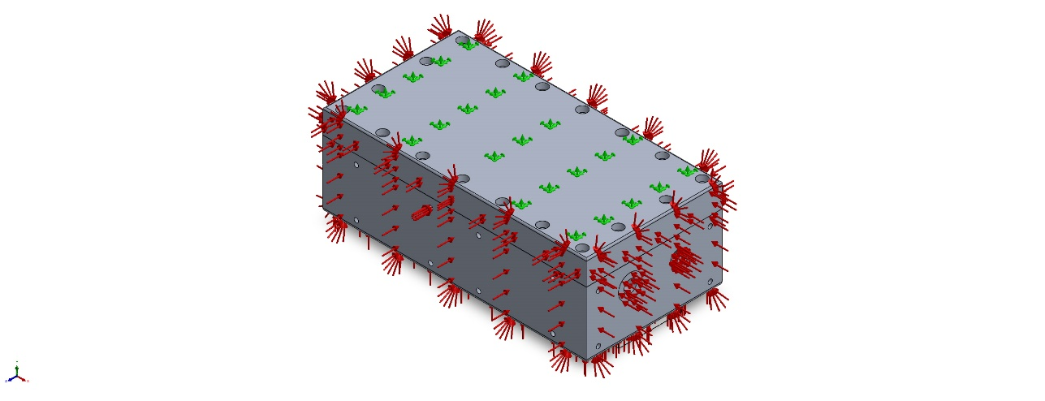
Model name: testAssemblyNewHousing
Current Configuration: Default
Solid Bodies
Document Name and Reference | Treated As | Volumetric Properties | Document Path/Date Modified
Combine10  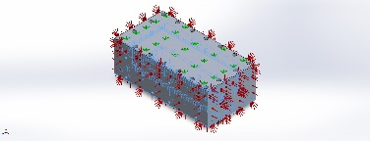 | Solid Body | Mass:1.88206 kg  Volume:0.000697059 m^3  Density:2,700 kg/m^3  Weight:18.4442 N | C:\Users\kiwi\Documents\902204_CoMPAS\ME.Drawings\Mola Camera Short Version\AMoleCamHousingV2.SLDPRT  Aug 28 14:16:57 2023
Combine4  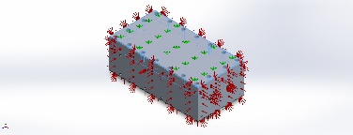 | Solid Body | Mass:1.18625 kg  Volume:0.000422152 m^3  Density:2,810 kg/m^3  Weight:11.6252 N | C:\Users\kiwi\Documents\902204_CoMPAS\ME.Drawings\Mola Camera Short Version\Lid2.SLDPRT  Aug 28 15:26:46 2023
Fillet6  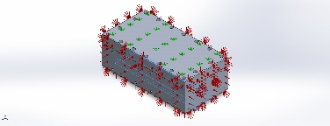 | Solid Body | Mass:0.136197 kg  Volume:0.000113497 m^3  Density:1,200 kg/m^3  Weight:1.33473 N | C:\Users\kiwi\Documents\902204_CoMPAS\ME.Drawings\Mola Camera Short Version\windowSized.SLDPRT  Aug 29 08:50:15 2023

Study Properties
Study name | Static 4
Analysis type | Static
Mesh type | Solid Mesh
Thermal Effect: | On
Thermal option | Include temperature loads
Zero strain temperature | 298 Kelvin
Include fluid pressure effects from SOLIDWORKS Flow Simulation | Off
Solver type | Automatic
Inplane Effect: | Off
Soft Spring: | Off
Inertial Relief: | Off
Incompatible bonding options | Automatic
Large displacement | Off
Compute free body forces | On
Friction | Off
Use Adaptive Method: | Off
Result folder | SOLIDWORKS document (C:\Users\kiwi\Documents\902204_CoMPAS\ME.Drawings\Mola Camera Short Version)

Units
Unit system: | SI (MKS)
Length/Displacement | mm
Temperature | Kelvin
Angular velocity | Rad/sec
Pressure/Stress | N/m^2

Material Properties
Model Reference | Properties | Components
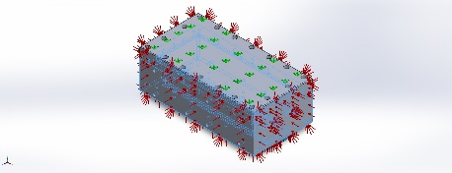 |  | SolidBody 1(Combine10)(AMoleCamHousingV2-1)
  Name: | 6061-T6 (SS)
  Model type: | Linear Elastic Isotropic
  Default failure criterion: | Unknown
  Yield strength: | 2.75e+08 N/m^2
  Tensile strength: | 3.1e+08 N/m^2
  Elastic modulus: | 6.9e+10 N/m^2
  Poisson's ratio: | 0.33
  Mass density: | 2,700 kg/m^3
  Shear modulus: | 2.6e+10 N/m^2
  Thermal expansion coefficient: | 2.4e-05 /Kelvin
Curve Data:N/A
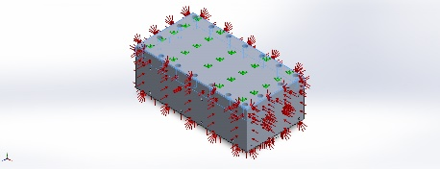 |  | SolidBody 1(Combine4)(Lid2-1)
  Name: | 7075-T6 (SN)
  Model type: | Linear Elastic Isotropic
  Default failure criterion: | Unknown
  Yield strength: | 5.05e+08 N/m^2
  Tensile strength: | 5.7e+08 N/m^2
  Elastic modulus: | 7.2e+10 N/m^2
  Poisson's ratio: | 0.33
  Mass density: | 2,810 kg/m^3
  Shear modulus: | 2.69e+10 N/m^2
  Thermal expansion coefficient: | 2.36e-05 /Kelvin
Curve Data:N/A
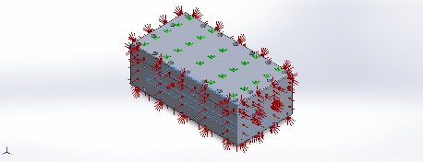 |  | SolidBody 1(Fillet6)(windowSized-1)
  Name: | Acrylic (Medium-high impact)
  Model type: | Linear Elastic Isotropic
  Default failure criterion: | Unknown
  Yield strength: | 4.5e+07 N/m^2
  Tensile strength: | 7.3e+07 N/m^2
  Elastic modulus: | 3e+09 N/m^2
  Poisson's ratio: | 0.35
  Mass density: | 1,200 kg/m^3
  Shear modulus: | 8.9e+08 N/m^2
  Thermal expansion coefficient: | 5.2e-05 /Kelvin
Curve Data:N/A

Loads and Fixtures
Fixture name | Fixture Image | Fixture Details
Fixed-1 | 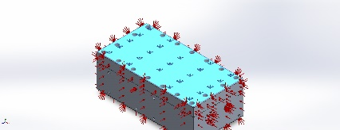
  Entities: | 1 face(s)
  Type: | Fixed Geometry
Resultant Forces
Components | X | Y | Z | Resultant
Reaction force(N) | -552.312 | -346,490 | 3.9366 | 346,491
Reaction Moment(N.m) | 0 | 0 | 0 | 0

Load name | Load Image | Load Details
Pressure-1 | 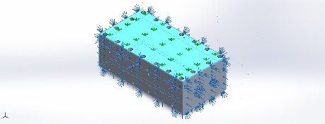
  Entities: | 21 face(s)
  Type: | Normal to selected face
  Value: | 2,250
  Units: | psi
  Phase Angle: | 0
  Units: | deg

Connector Definitions
No Data

Interaction Information

Interaction | Interaction Image | Interaction Properties
Global Interaction | 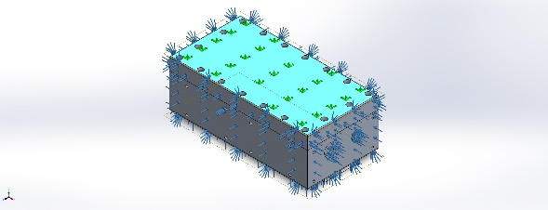
  Type: | Bonded
  Components: | 1 component(s)
  Options: | Independent mesh

Mesh information
Mesh type | Solid Mesh
Mesher Used: | Blended curvature-based mesh
Jacobian points for High quality mesh | 16 Points
Maximum element size | 0.844462 in
Minimum element size | 0.0422231 in
Mesh Quality | High
Remesh failed parts independently | Off

Mesh information - Details
Total Nodes | 464523
Total Elements | 304668
Maximum Aspect Ratio | 891.99
% of elements with Aspect Ratio < 3 | 97.4
Percentage of elements with Aspect Ratio > 10 | 0.24
Percentage of distorted elements | 0
Time to complete mesh(hh;mm;ss): | 00:00:24
Computer name: | GREATWHITE

Sensor Details
No Data

Resultant Forces

Reaction forces
Selection set | Units | Sum X | Sum Y | Sum Z | Resultant
Entire Model | N | -552.312 | -346,490 | 3.9366 | 346,491

Reaction Moments
Selection set | Units | Sum X | Sum Y | Sum Z | Resultant
Entire Model | N.m | 0 | 0 | 0 | 0

Free body forces
Selection set | Units | Sum X | Sum Y | Sum Z | Resultant
Entire Model | N | 6.92848 | -31.2327 | -27.374 | 42.1049

Free body moments
Selection set | Units | Sum X | Sum Y | Sum Z | Resultant
Entire Model | N.m | 0 | 0 | 0 | 1e-33

Beams
No Data

Study Results

Name | Type | Min | Max
Stress1 | VON: von Mises Stress | 2.246e+05N/m^2  Node: 463039 | 5.877e+09N/m^2  Node: 167145
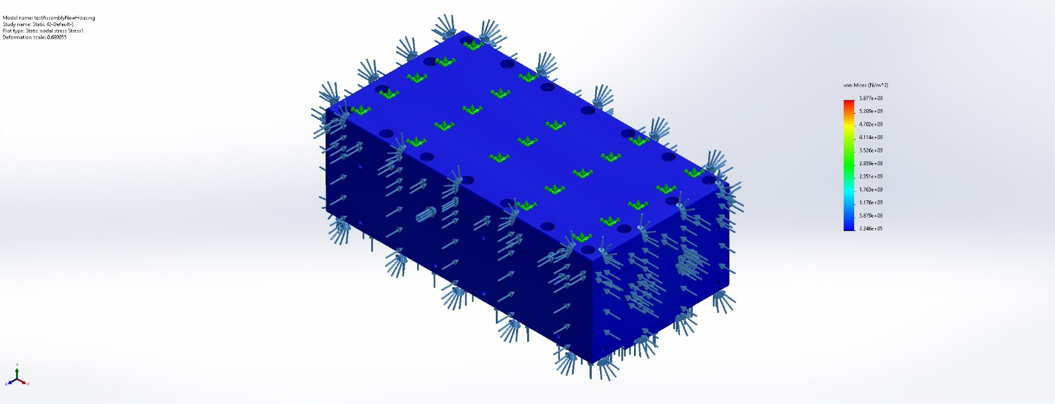
testAssemblyNewHousing-Static 4-Stress-Stress1

Name | Type | Min | Max
Displacement1 | URES: Resultant Displacement | 0.000e+00mm  Node: 303785 | 3.073e+01mm  Node: 457920
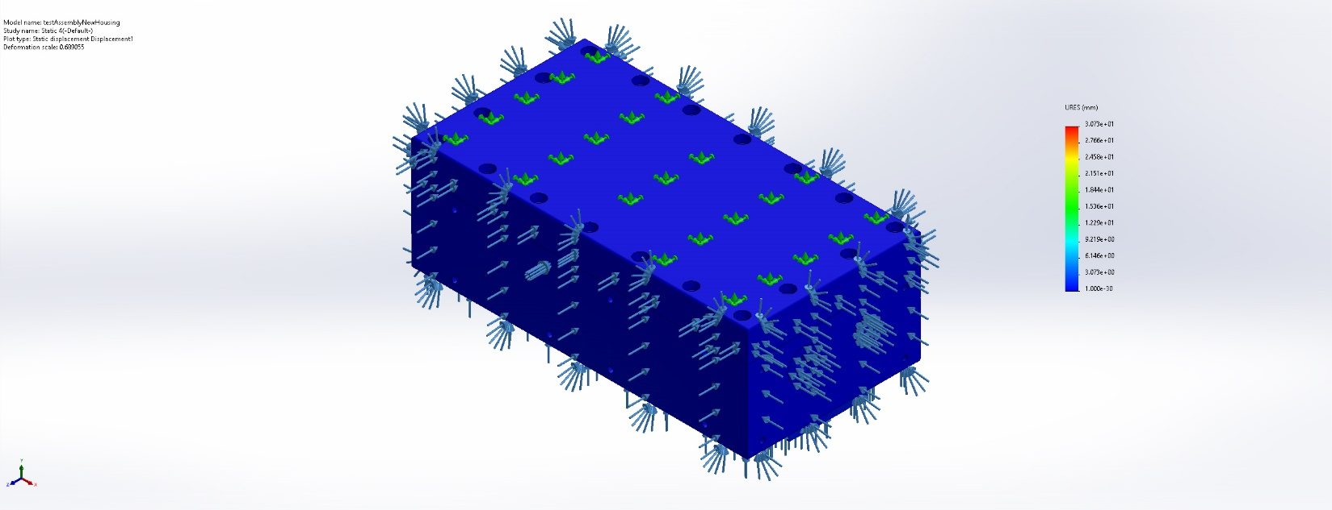
testAssemblyNewHousing-Static 4-Displacement-Displacement1

Name | Type | Min | Max
Strain1 | ESTRN: Equivalent Strain | 3.862e-06  Element: 66752 | 4.767e-01  Element: 280753
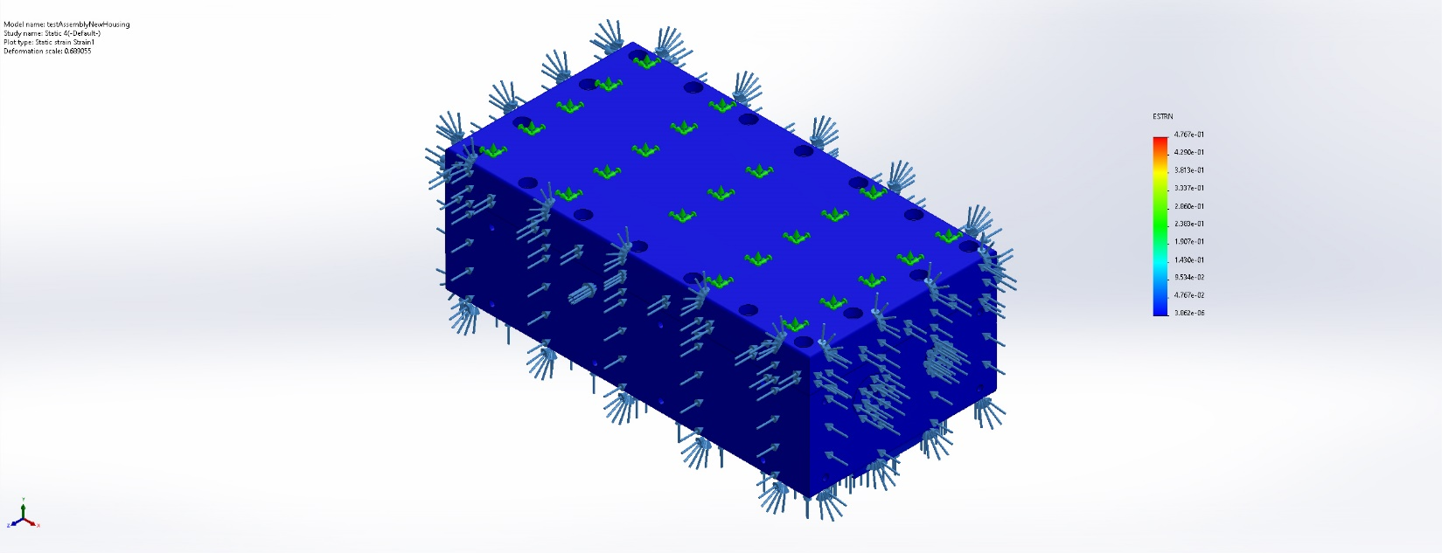
testAssemblyNewHousing-Static 4-Strain-Strain1

Conclusion

