Piscivore Project
Overview
The Piscivore project’s objective is to observe ocean predators and prey. The current system contains 2 cameras, one pointed forward, one aft which are mounted on MBARI’s LRAUV, Long Range Autonomous Under Water Vehicle, an underwater drone. The drone has inertial guidance and surfaces periodically to get GPS lock and updated mission plans from on shore pilots via satellite or cell networks. The drone is typically configured with temperature, depth, salinity, and chlorophyl sensors with space for additional specialized payloads. The rear facing camera images a lure which is used to attract predators in the near vicinity via light and pressure waves. Lighting may be added but adversely affects battery life and is typically not used. Current science use cases include fish population estimates and environment characterization; additional science use cases emerge with specialized payloads which benefit from positive visual identification of animals in the vicinity.
The cameras record constantly during the day and are turned off at night. Cameras run at 1080p, 60fps and record h.264 video onto a 1.5TB SD card, camera field of view hasn’t been fully characterized but is roughly 80 degrees. The camera systems are repackaged from a commercial product; all details regarding the sensor, image processing, lens and compression profiles are unknown.
The camera systems are packaged in a 50mm inner diameter tube from Blue Robotics. They consume about 2.2W and run off a 12V power rail supplied by the AUV. The aft facing camera is attached to a carbon fiber pole which moves the lure far enough away from the vehicle that predators will be attracted to it. The lure is mounted ~1.5m in front of the camera. Foam is used to help balance and ballast the AUV after the payload is attached.
After a mission, recordings are post processed by a machine vision model MBARI is continuously improving which automates animal detection, identification and uses frame time to overlay the video with asynchronously collected LRAUV meta data regarding location, depth, temperature and salinity in a searchable database. Currently the system has only been deployed in the Monterey Bay; missions last about 1wk and are typically limited by recording space and sometimes power (when consumed by lighting or other payloads).
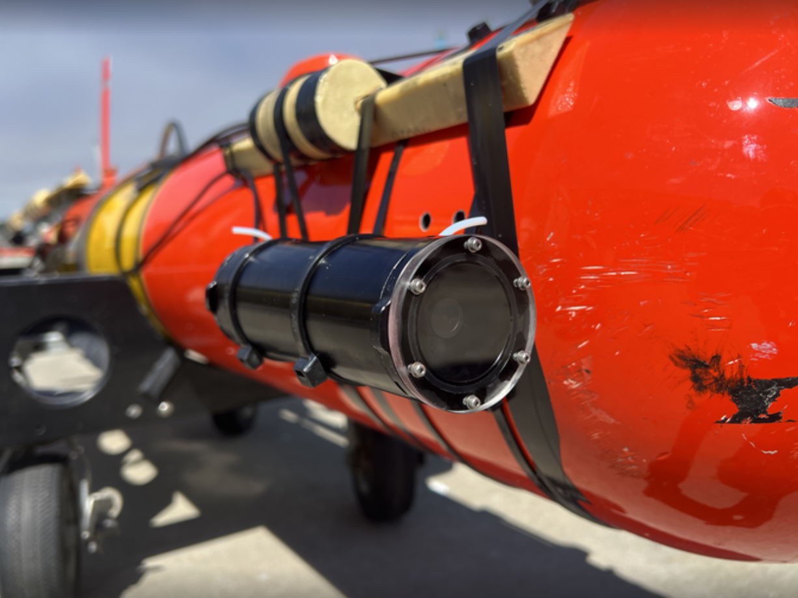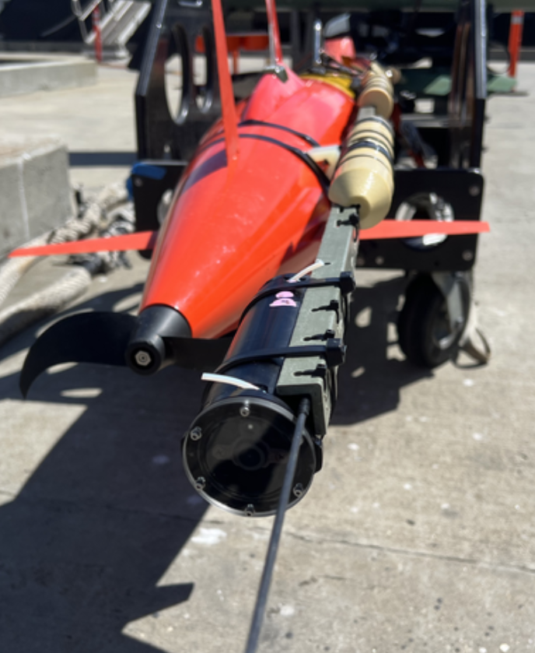
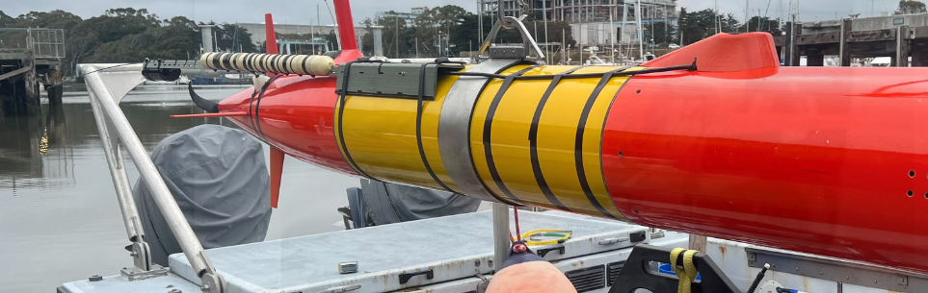

Example images from the cameras
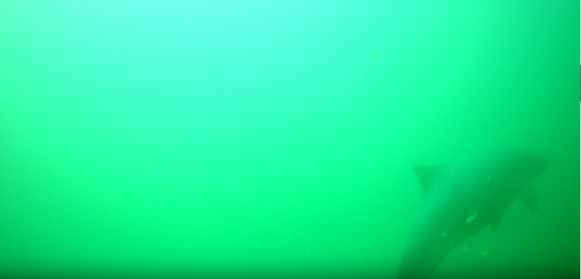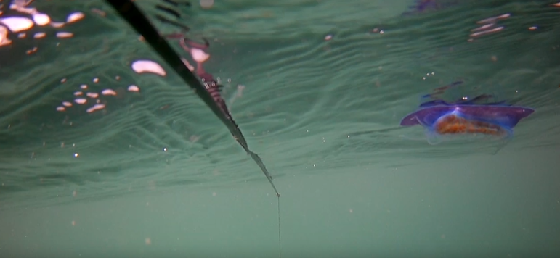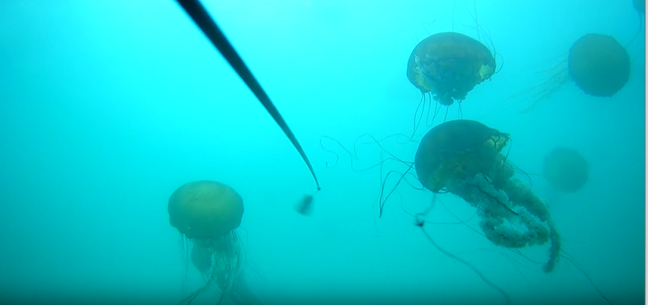

System Objectives
Physical/Environmental characteristics
- The card shall be no greater than 70mm by 200mm fitting in a 75mm diameter tube with a goal of fitting in a 50mm diameter tube.
- The card shall be capable of operating in ambient temperatures ranging from 5C to 40C.
- The card will be capable of operation at 5kPa.
- The card shall have an interface for an SD card or M.2 key M solid state hard drive for data collection which must also fit in the mechanical envelope
- The card will have a programming interface capable of loading firmware updates, updating models or configuration settings using a GUI, shell or webpage.
- The card will have a serial port for low speed communication with the LRAUV
Card preferences and specs:
- Dimensions less than 70mm by 200mm, allowing it to fit in a 50 -75 mm diameter tube housing. (larger size imparts drag that increases the power budget)
- Operating temperatures: from 5C to 40C.
- Operating pressure to 5kPa.
- Writes to a solid -state memory (e.g. microSD, harddrive) at least 1.5 TB and fits in housing.
- Programmable interface for firmaware, model updates, settings configuration (GUI, shell or web),
- Serial port for communication with the LRAUV
Imaging Preferences:
- Low light, high dynamic range image sensor with a resolution no less than 1080p 30fps with a goal to support a video resolution of 4k, 60fps.
- Image sensor control should be tuned to actively optimize gain and white balance of the image sensor based on the changing conditions encountered in the water column.
- To facilitate post processed stereo vision, the card shall support input/output of a periodic sync signal to synchronize frame collection between separate processor cards.
- The card will facilitate active lighting control by generating an analog, PWM or serial output as light levels sink below a configurable setting
Image Data Processing
- Image sensor data will be processed in real time to remove lens distortion determined from a lens calibration routine and image sensor noise such as fixed pattern noise and speckle.
- The card shall be capable of running at least 2 object detection models; one smaller model will run on every or nearly every (decimated) frame and will be capable of determining if the frame contains something more than empty water and a second more complicated model will run on no less than every 3rd frame at 30fps to characterize what animals are in the frame.
- The animal labeling model will be provided by MBARI and should be able to be updated by MBARI periodically
- Images containing more than empty water will be saved in nonvolatile memory using lossless or near loss less compression; image file names and meta data will contain the current time and date.
- A detection summary for each frame passed through the animal detection model will be stored in a file.
System
- The system will run Linux and at least one processing core with 100megabytes of ram will be available to run an MBARI designed application which will digest the frame detection summary and send commands to the LRAUV. The application may be changed and reconfigured before each deployment.
- The system will be capable of enabling a wifi connection and hosting a webserver for the first few minutes after it is started. The webpage will display system health and a decimated video feed. It may also contain model/firmware upload and configuration parameters.
- The system shall not be damaged by power interruptions; data files in the process of being written may be corrupted.
- The system will contain a real time clock synchronized over the wifi connection capable of keeping count during power dropouts up to 24 hours and maintaining an accuracy better than +/-1s per 24 hour interval; a battery fitting within the space requirements may be used.
- The system shall be configured to optimize power; power would ideally accept 3V up to 28V.
- To verify integrity of the housing, the system will incorporate a temperature, pressure and humidity sensor or provide an I2C bus where a sensor can be connected. Sensor readings will be displayed on the webpage and be written to a file.

