Supporting Information for
Deep sea carbon export is measurably enhanced by daily vertical migrations of midwater animals

Kelly J. Benoit-Bird^{1*}, Christine L. Huffard¹, Paul R. McGill¹, Chad M. Waluk¹, Richard G. Henthorn¹, Irene Hu¹, Colleen Durkin¹

¹Monterey Bay Aquarium Research Institute

*Kelly J. Benoit-Bird
Email: kbb@mbari.org

This PDF file includes:

Figures S1 to S3

Figures

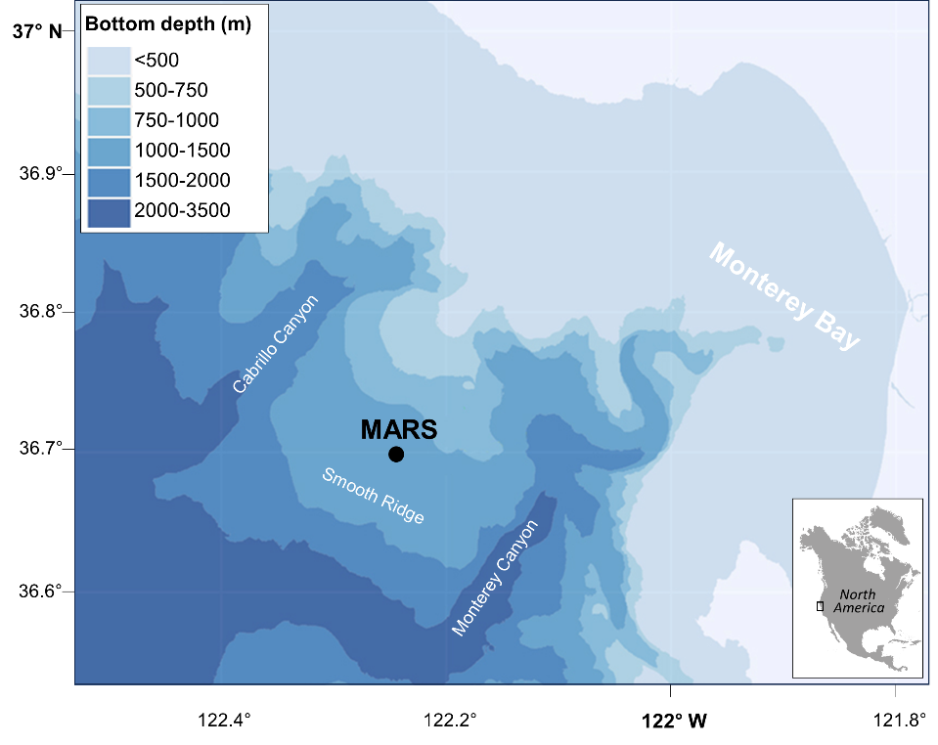

Fig. S1. A map of the Monterey Accelerated Research Station (MARS) site on the west coast of North America along with nearby bathymetric features.

Fig. S2. Power spectra were used to explore the temporal patterns in measurements and models of potential drivers of the observed patterns during the study period: normalized spectral density of 20-minute-resolution data of (A) attenuance measured in the particulate carbon trap, (B) depth of scatterers from the echosounder, (C) modeled clear-sky solar irradiance (53), (D) current speed measured with a seafloor current sensor at MARS (E) modeled tidal height (National Oceanic and Atmospheric Administration Station 9413450, Monterey, CA).

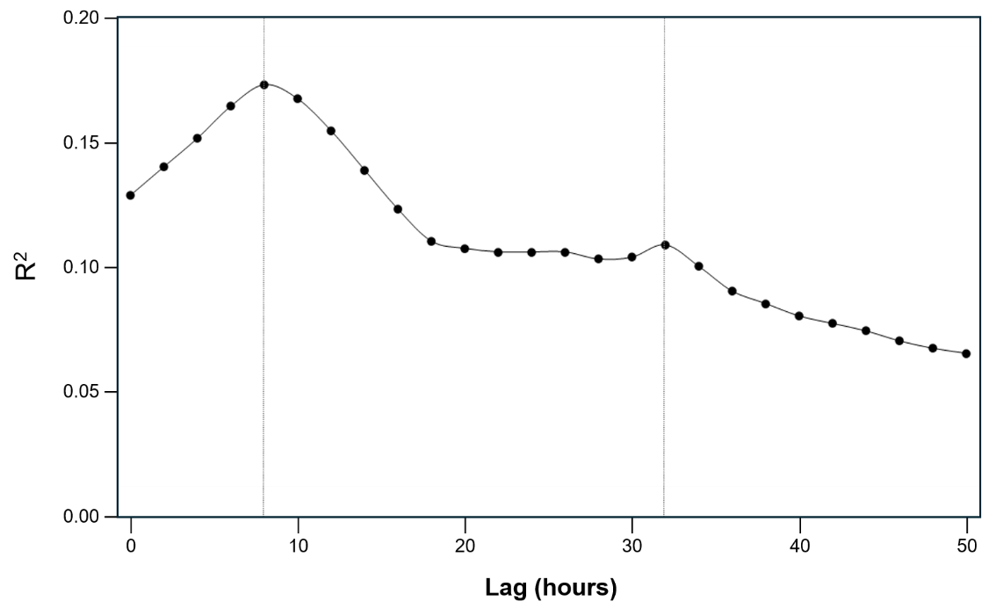

Fig. S3. A correlogram showing the regression coefficient of best subsets multiple regression models relating attenuance measured in the optical particulate carbon trap with measures of acoustic scattering, fluorescence, and tidal data at various time lags. All data were in 20-minute bins, resulting in a sample size of ~5600. The significant predictors of attenuance in the final model were weighted-mean depth of all scattering (+), a proxy of scattering layer biomass (NASC, +), acoustic density within scattering layers (mean S_{v}, +), and the peak density of schools (maximum S_{v}, +). The correlogram shows a peak in the strength of this relationship at 8 hours with a smaller peak at a daily harmonic of this lag, 32 hours.

