SES triggering algorithm update May 15, 2024
Take-home message:
Use a rolling mean of 150 hours, and a trigger threshold slope of 0.01110322671999997
Details:
Based on battery assessments, we won’t be able to collect three samples an hour for three months. I looked at how the algorithm would perform if we only had one sample per hour. To simulate this, I divided the original MARS dataset into 3 subsets (A,B,C) by selecting every 3rd row starting with rows 0,1,2.
We’re using the change in attenuance from one sample to the next (= slope) as the basis for triggering. For each subset, I found every combination of rolling mean (rm) and percentage of maximum slope that we might actually consider (rm 23—336 hours, percent max slope 80--100), and then found the number of triggers that we’d end up with for that combination. For example, a combination of rm150 and 80 percent slope takes the following steps:
1. Find the 150-sample rolling mean (= average of each new sample and the prior 149 samples)
2. Find the difference between each rolling mean value and the prior rolling mean value (= slope).
3. Omit the first 150 rows from the time series.
4. Find the maximum slope for this trimmed time series, and multiply it by 0.8 (= 80% max slope).
5. Use this value as the trigger threshold. Any time the 150-sample rolling mean slope goes above this value, it’s counted as a trigger.
The heatmap below shows the average number of triggers for each permutation of rm and percent slope across these three subsets. From below, it’s easy to see we’ve been way overshooting the rolling mean. Plus, the percent slope doesn’t actually matter much once we start getting into the higher rolling means.

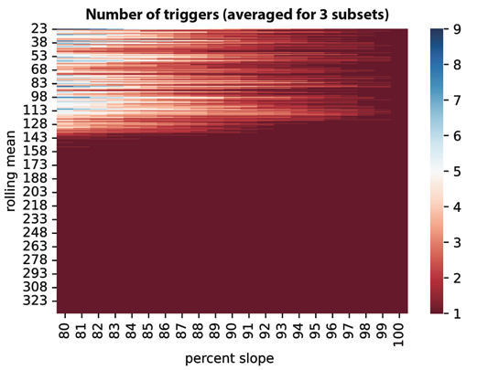
Sensitivity doesn’t change much beyond rolling means of 145. Because we don’t want too many triggers, I chose a 150-sample rolling mean and 100% maximum slope, and tested this algorithm on the three subsets. Each one would have one trigger (which makes sense- we’re finding the maximum slope of each subset after trimming off the first 150 samples). These max slopes (= trigger threshold) and trigger dates were:
Subset A: 0.011649288960000004 increase in atn/hour (based on 150-hour rm); 2023-08-16 11:26:00
Subset B: 0.011970133059999999 increase in atn/hour (based on 150-hour rm); 2023-08-01 22:41:00
Subset C: 0.01110322671999997 increase in atn/hour (based on 150-hour rm); 2023-08-01 23:22:00
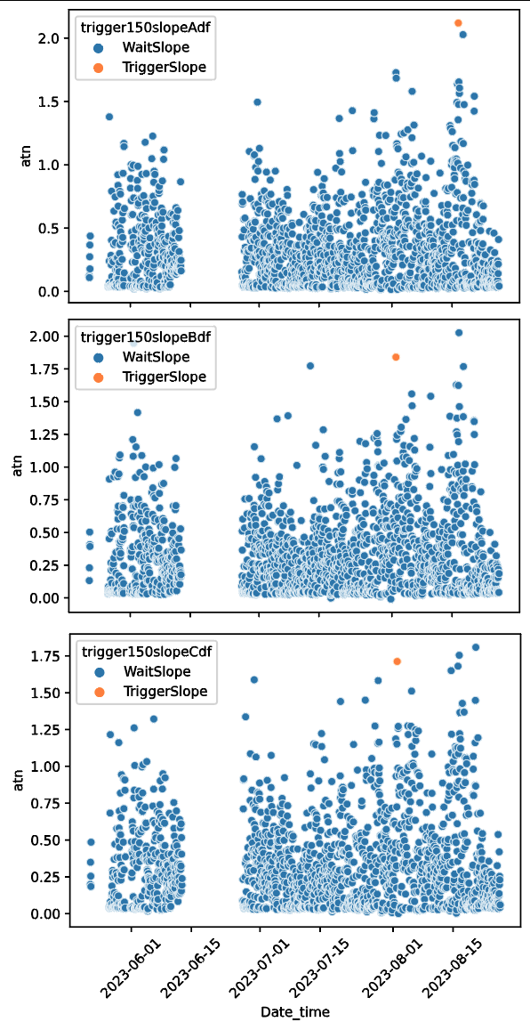
The average trigger threshold for all of these is a slope of 0.011574216246666658 increase in atn/hour (based on 150-hour rm). Using this threshold for all subsets yielded:
Subset A: 1 trigger, on 2023-08-16 11:26:00 (same as above)
Subset B: 1 trigger, on 2023-08-01 22:41:00 (same as above)
Subset C: No trigger

Tried again using subset C’s trigger threshold and got:
Subset A: 2 triggers: 2023-08-16 11:26:00 (as above) and 2023-08-01 22:20:00 (near B’s trigger above)
Subset B: 2 triggers: 2023-08-01 22:41:00 (as above) and 2023-06-01 19:16:00 (new trigger)
Subset C: 1 trigger: 2023-08-01 23:22:00 (as above)

Using this trigger, all three subset simulations picked up the event on 1 Aug. Subset B also triggered on 1 June (plots on next page). Subset A also triggered on 16 Aug. All three of these periods are both high flux and high slope (see exploration of dates at end).
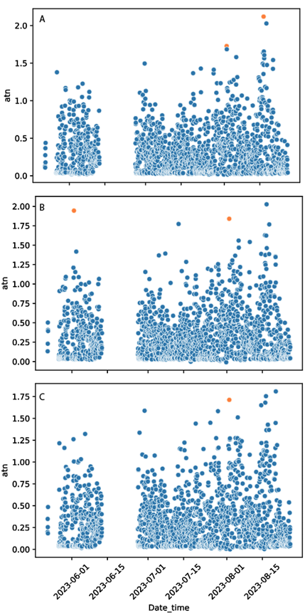
Given that this is a testing phase, I’d rather overtrigger than under-trigger. I think we should use the threshold for subset C as our trigger slope, and a 150-hour rolling mean. Because we’re going to be sampling over the summer and early fall, when production is fairly high, I think chances are good we’ll hit these conditions during our deployment.
Visualizing triggers by dates:
Triggers by dates across permutations: X = date, y = permutation (rm, % slope combo), color = # triggers for that whole day, helped visualize how commonly various permutations triggered on 1 August (the vertical bar of lighter colors, second from the right; example from subset B).
