Motivation
The definition of a pulse event is arbitrary, and defined by the user’s interests. We can draw from climatology research on extreme events, which may define exceptional events as ones that meet or exceed some threshold [e.g. 2 standard deviations (SD) above the mean, or 95th percentile of the data distribution]. In our case, we’re interested in understanding high magnitude carbon flux events.
Challenges to defining a pulse event
When sampling at high temporal resolution, such as every hour or even multiple times an hour, it’s not uncommon to get very high spikes in the data that might not necessarily signify what we’d think of as an important high-flux event. It just takes one very large poop in one sample to look like something big is happening. Our challenge is to try to tell the difference between these isolated outliers and a more persistent event.
Options
A very common way to address spikiness in the data is to “smooth it” by finding a rolling average. When trying to understand the nature of data peaks, it makes sense to use a centered rolling average. For example, for a 5-day rolling mean, you average the value for the day of interest, plus the two days before and after. The reason to choose this approach is that it preserves the timing of data peaks. The drawback is that it isn’t the sort of approach we could use for triggering, because we can’t see into the future. The next question is to decide how long a period to smooth over. 3 days? 5 days? The plot below shows the raw data (full MARS time series), with moving averages of 24 hours, 3 days, 5 days, 7 days, and 14 days. Horizontal lines identify the threshold of each respective time series’ mean + 2 SD.
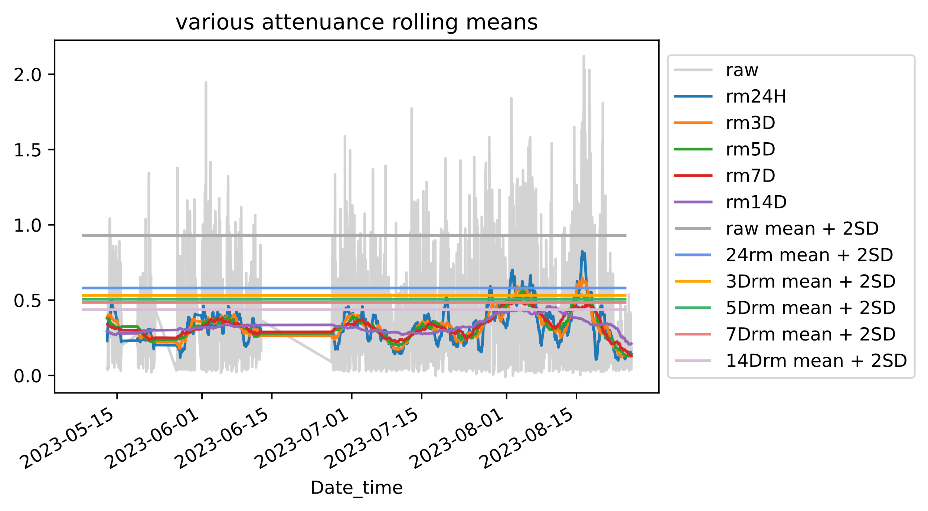
From this we can see that, even with the different rolling mean options, certain periods are consistently picked up as exceeding the respective mean + 2SD thresholds. The plot below shows, for each sample, how many of the different rolling means exceeded their respective mean + 2SD thresholds. All samples with 3 or more of these occurred in August.
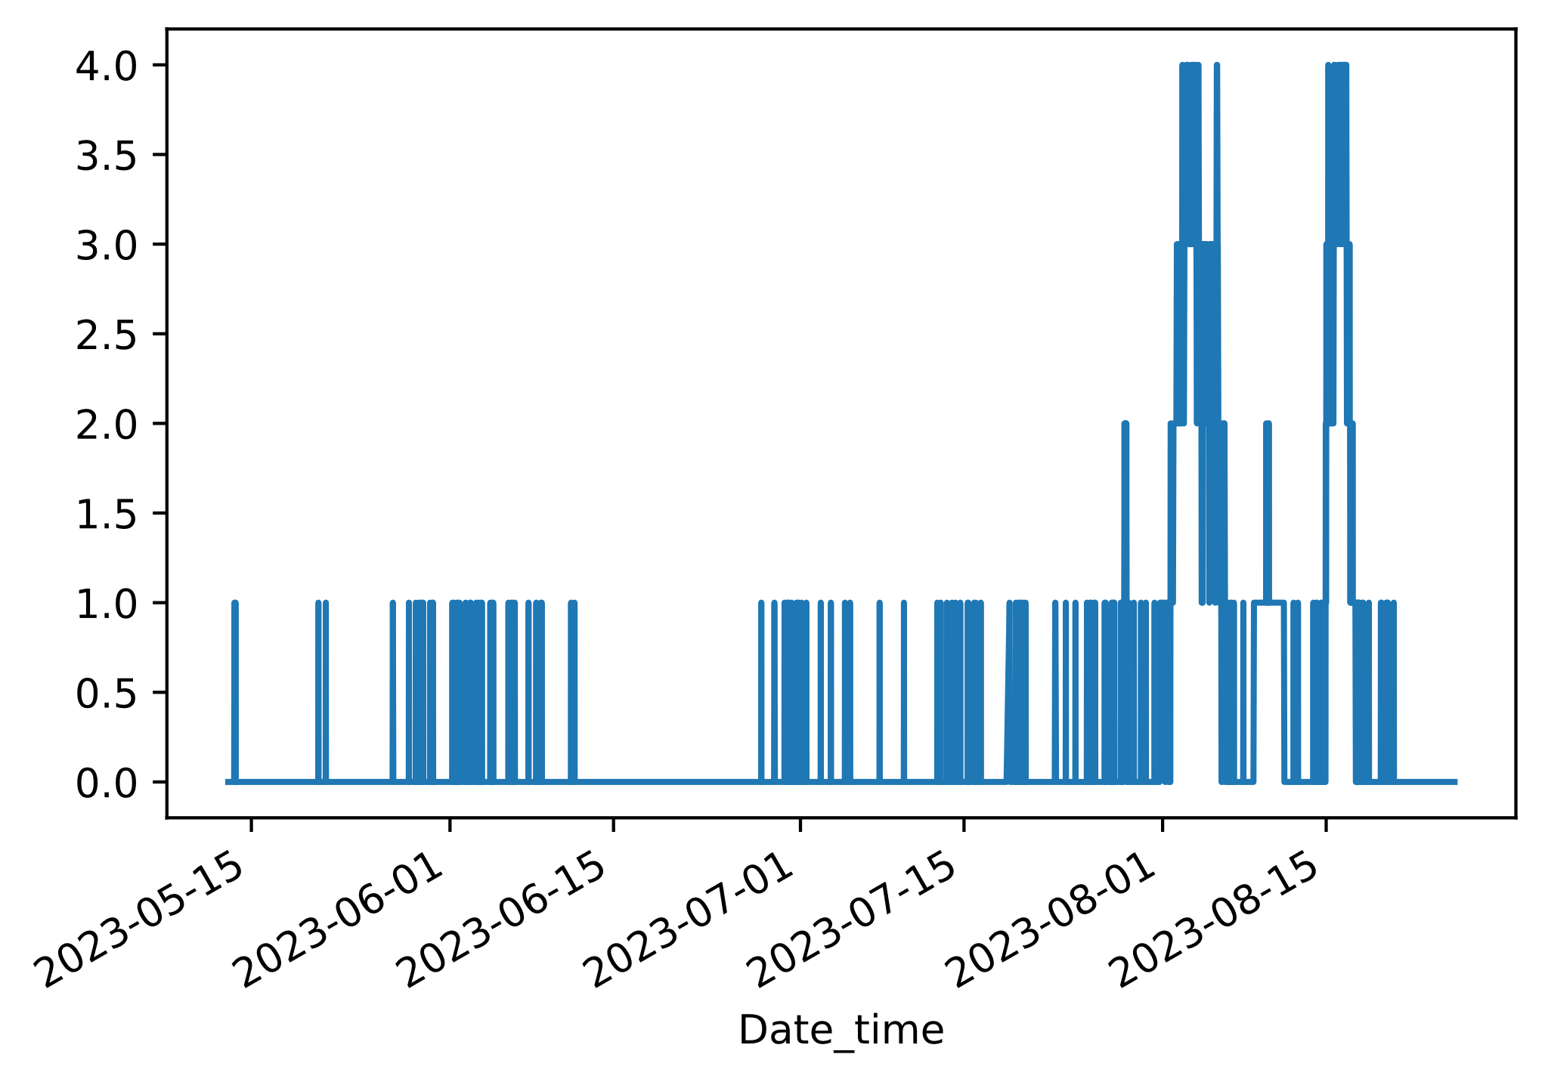
Zooming in on August, we can see how each of these rolling means (colors) sees these events compared to the raw data (gray). Two periods (first few days in August, and then again two weeks later) may be pulse events. Whether we categorize them as such depends entirely on our own decisions and definitions.
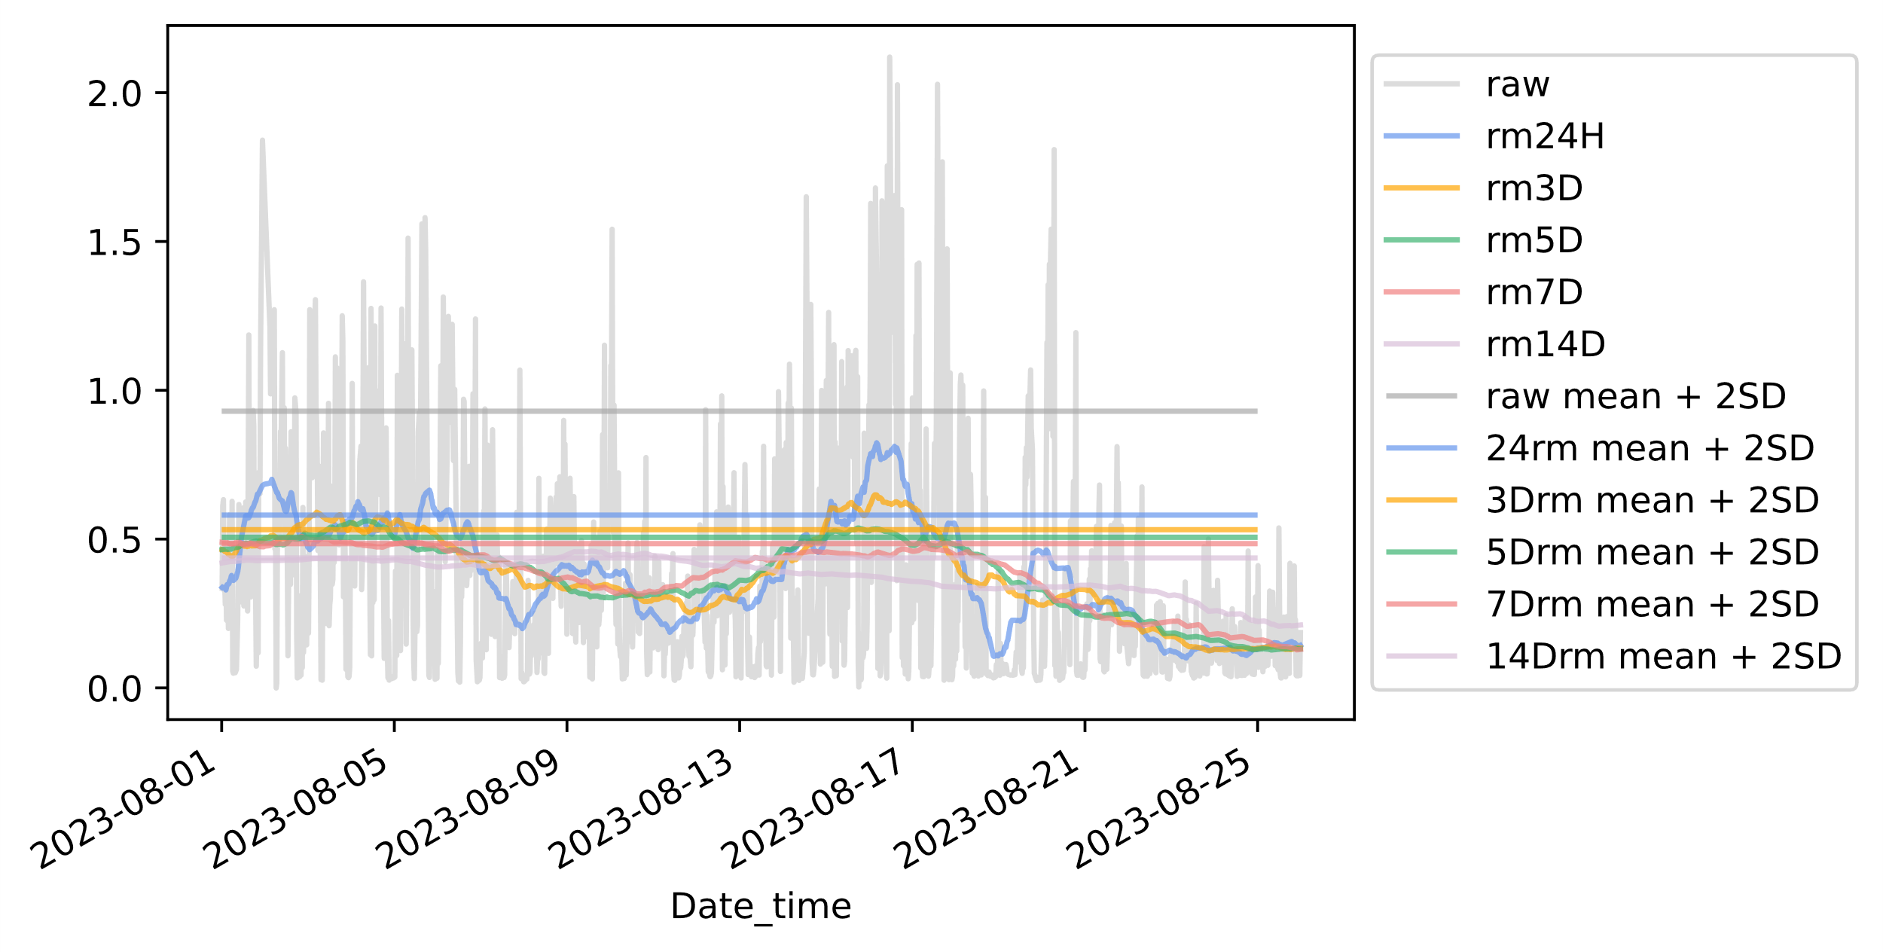
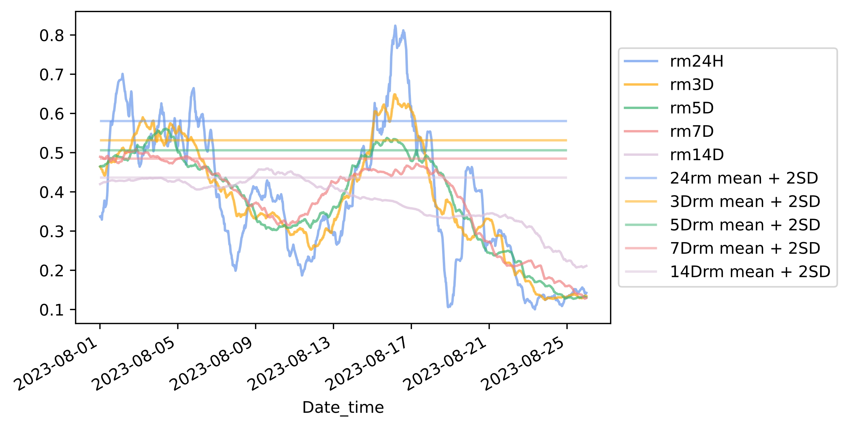
The trickiest steps are to define which rolling mean to use (1 or many?) and when a pulse event starts and ends. By looking at just the rolling means, we can see that some aren’t appropriate for the time scale in which we’re interested. The 14D rolling mean only finds one pulse, and it occurs when the other rolling means and raw data values are lower. It completely misses the early and mid-August peaks. We can therefore eliminate that treatment from our analysis. The 7D rolling mean only identifies the early peak as a pulse event. Does that mean the early August peak is more important than the mid-August peak? Or that the 7D rolling mean just isn’t sensitive enough? There’s no perfect answer to that. It just depends on our science needs. Here we’re interested in big flux events. To us, very high-magnitude periods (mid-August) are important even if they are brief, as are periods of elevated flux that are more prolonged (early August). This means we can ignore the 7D rolling mean and focus on the shorter smoothers.
Whether we consider the early August period to be one pulse event, or up to five events (e.g. if strictly following when the 24H rolling mean goes above and below its threshold) is arbitrary. Whether this event is considered to start/end when it goes above/below the mean + 2SD threshold, or instead starts and ends when crossing a lower threshold (like a mean, or 1 SD) is also arbitrary.
Pulse definition
Acknowledging the influence of arbitrary decisions on our understanding of pulses, if we define pulse events according to the following conditions:
- Value exceeds dataset mean + 2SD for at least 3 of the following datasets: raw values, 24H rolling mean, 3-day rolling mean, and 5-day rolling mean.
- “Pulse” starts with the first time this condition is met, and ends when the following 24 hours do not meet this condition.
then we have two pulse events in the last MARS dataset:
- 8/2/2023 16:40 – 8/5/2023 17:26 (73 hours)
- 8/15/2023 0:11 – 8/17/2023 00:03 (48 hours)
Triggering goals
Does our triggering code pick up these events? Yep, but with different timing. The backward-looking 150-sample rolling mean slope trigger works great picking up these (and only these) two events if using a trigger threshold of 0.011 slope. [Note- this doesn’t care that it’s not 150 hours. It’s just 150 samples and does fine]. Details sorted in descending order of max slope:

Date_time | Rm150slope | Before, during, or after event? | How soon before? | How far into pulse? | How soon before end?
2023-08-16 15:44:00 | 0.0132057 | during | NA | 39h | ~8 h
2023-08-16 11:26:00 | 0.0130167 | during | NA | 36h | ~11h
2023-08-01 22:41:00 | 0.0120656 | before | ~18h | NA | NA
2023-08-01 23:22:00 | 0.0112031 | before | ~17h | NA | NA
2023-08-01 22:20:00 | 0.0111957 | before | ~18h | NA | NA

The brief event in mid-August isn’t triggered until it’s already underway, while the early August event is triggered before it starts. Both options have their merits, depending on the battery life of the instrument being triggered. The event in mid-August is triggered three hours after the peak raw attenuance and ~11 hours after the peak 24 h rolling mean for that event. Still, fairly close to the peak. The event in early August is triggered in time for something like an AUV to be deployed to go sample it. It’s great to see that there are no false positives. The trigger slope has to go down fairly low before picking up non-pulse periods. Lowering the threshold to 0.0103 would capture the mid-August event on 2023-08-14 13:02:00, less than 12 hours before it starts. It’s worth considering using this threshold.
Date | Pulse event | Slope
8/16/2023 15:44 | Mid-Aug (during) | 0.01320573
8/16/2023 11:26 | Mid-Aug (during) | 0.013016674
8/1/2023 22:41 | Early Aug (before) | 0.012065556
8/1/2023 23:22 | Early Aug (before) | 0.011203127
8/1/2023 22:20 | Early Aug (before) | 0.011195744
8/17/2023 14:01 | Mid-Aug (after) | 0.010935565
8/1/2023 23:43 | Early Aug (before) | 0.010922528
8/16/2023 14:05 | Mid-Aug (during) | 0.010870511
8/14/2023 13:02 | Mid-Aug (before) | 0.010644215
8/16/2023 18:03 | Mid-Aug (during) | 0.010395151
7/28/2023 12:40 | none | 0.010244626

