Approach to finding SES trigger for MARS

- The attenuance values are super erratic, so we need to have some sort of rolling averaging to smooth things out. But how much is enough vs too much? I asked what rolling mean would lead to the fewest triggers if it triggered at any value ≥ prior deployment mean + 99.99% confidence interval (which requires prior knowledge). A rolling mean with a window of 1153 samples (16 days) leads to the fewest triggers. The plot of “attenuance₁₁₅₃” (a 1153 sample rolling mean of attenuance) colored by whether a value exceeded this trigger shows that it picks up the big peak on 1 August. (*note I could look into running this with a rolling CI₁₁₅₃ but don’t think it would be all that different)
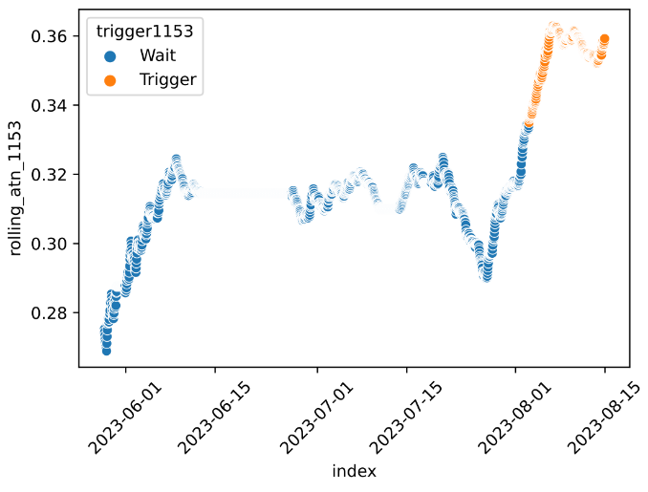
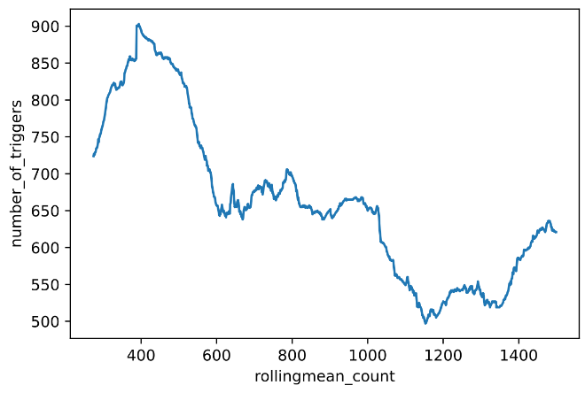

- But if we look at the raw time series colored using the same trigger, we see we miss the peak. That’s not a surprise. Because it’s based on a rolling mean, it’s always going to miss the peak.
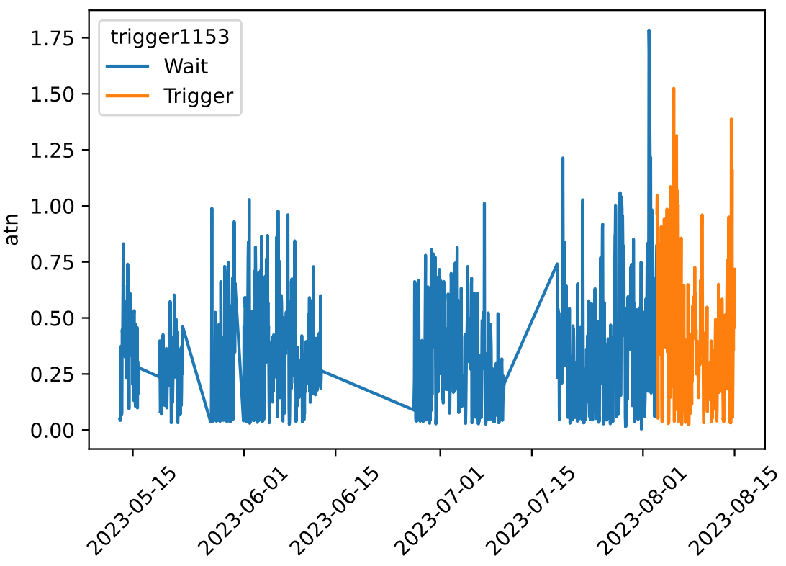

- So let’s see how this compares to the a proxy for slope (this is percent change from one attenuance₁₁₅₃ value to the next. The pattern is almost identical to time series of the raw differences). The confidence interval trigger from above misses the most rapid changes, in addition to the peak magnitudes.

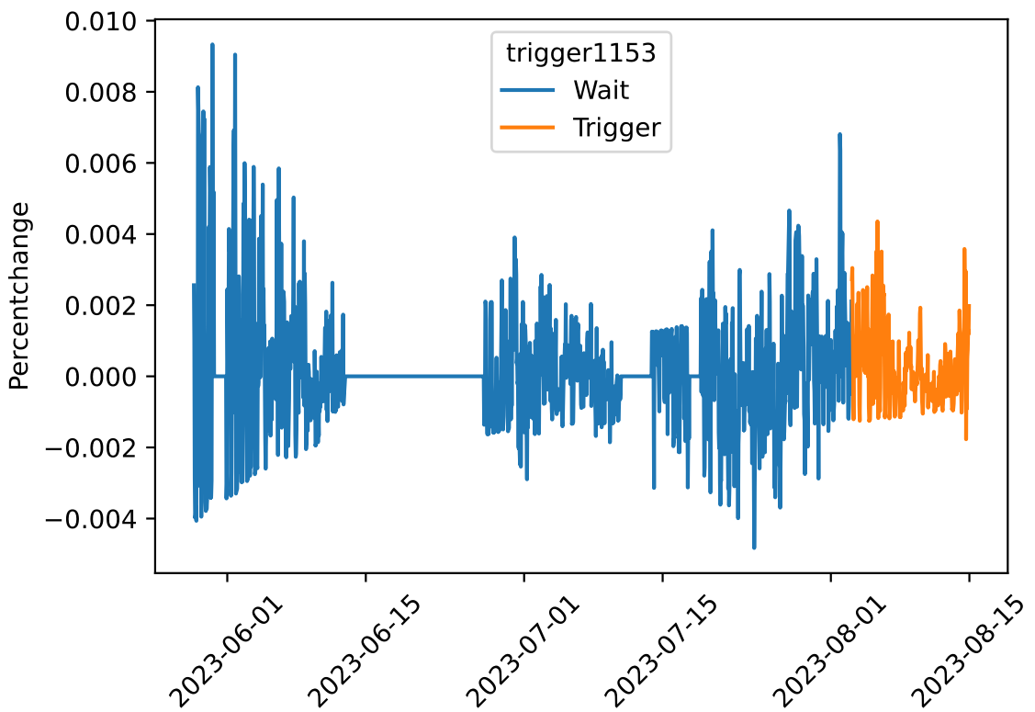
- Can we make a trigger based on the slope? Below is the time series of raw attenuance with the point with the maximum slope (of the attenuance₁₁₅₃) in orange (left), after omitting the first 1153 time series values. For this time period, this trigger finds the peak without knowing the magnitude of the peak ahead of time. But it does require prior knowledge of slopes. Setting the trigger to 80% of that value triggers 1 hour before the peak (right). Note- these are scatter plots because the trigger points aren’t easy to see in a line plot version. It’ll be interesting to test this approach with Station M SES data too, to see if it finds those peaks.
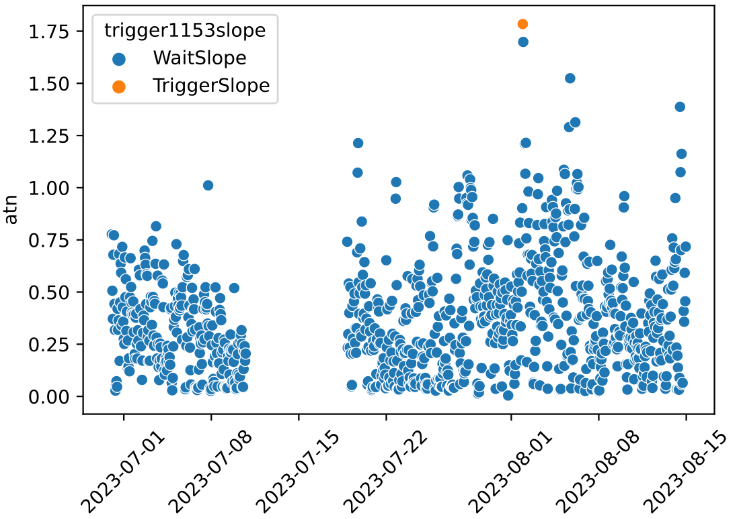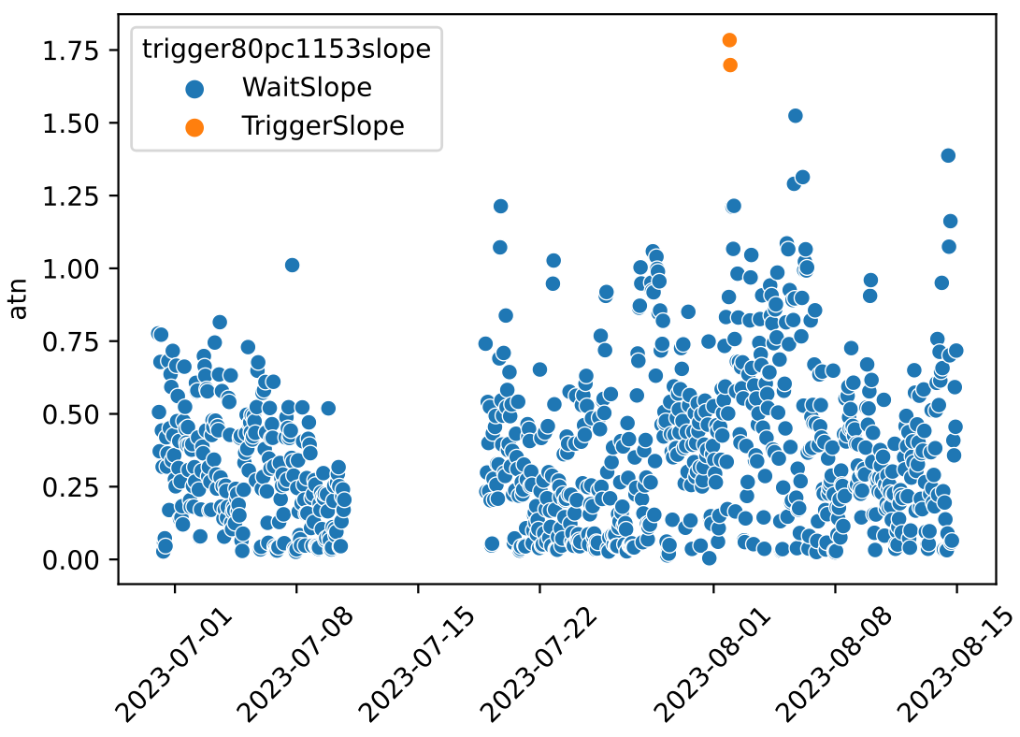

- If we dial it back to pick up the samples with the three highest slopes, then we would also trigger on July 27, 5 days before the peak. This is cool in this case, because we’d get the run up to the peak, but using this alone to trigger, we run the risk of over-triggering, if it doesn’t end up going up.
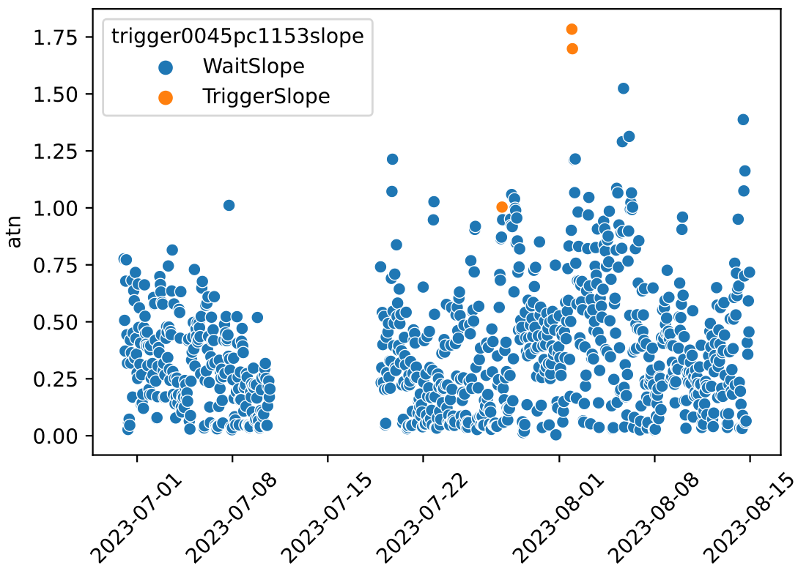

What if we combine a slope-based trigger with a magnitude-based trigger? Options to consider, and discuss next week:
- Trigger by slope, but wait for a certain time until magnitude reaches a certain level to confirm the trigger.
  - If we used that approach here, we’d set an alert on July 27 and then wait for it to go up. Magnitude went up a little on the 28th, but went back down again and didn’t rise much until the immediate spike on the 1st, when we would have triggered anyway based on slope.
- Trigger by slope OR magnitude.
  - This might be a more flexible option, but would require more prior knowledge of an exact magnitude we’d be aiming for.

