Calculate attenuance flux:

STEP 1) First calculate atn flux (change in atn per hour), accounting for the fact that we collect for only five minutes per hour

SES_OTC['F_atn'] = SES_OTC['atn']/(5/60)

STEP 2) Using this value (which is F_{atnkd}) calculate POC flux.
Applying values for F_{atnkd} in table 3 to:
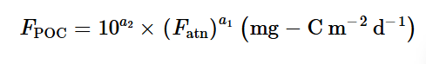
SES_OTC['POCmodel_mg']= (10**3.4 * SES_OTC['F_atn']**0.94) * 2 (multiplied by two because collection area is 0.5m² and we need to get it to m²)

Then- numbers are so high so converted to g
SES_OTC['POCmodel_g']= SES_OTC['POCmodel_mg']/1000
