SES and SINKER comparison
Quick summary:
SES has been deployed at MARS (~900 m depth) as a lander and offshore on a mooring (~3000 m depth). SINKER has been deployed at MARS (~900 m depth). I applied the SES triggering algorithm to SINKER to see if we can export this method off-the-shelf but it looks like we will need to modify it to detect SINKER’s peaks. I then used a sliding window cross correlation to see if SINKER’s peaks might have been sourced inshore (SINKER change would lead SES change), offshore (SES change would lead SINKER change) or broadly over the region (no lag). Looks like all options might occur. Correlations between these two instruments are strong at the daily level.
These plots aren’t tidied up.

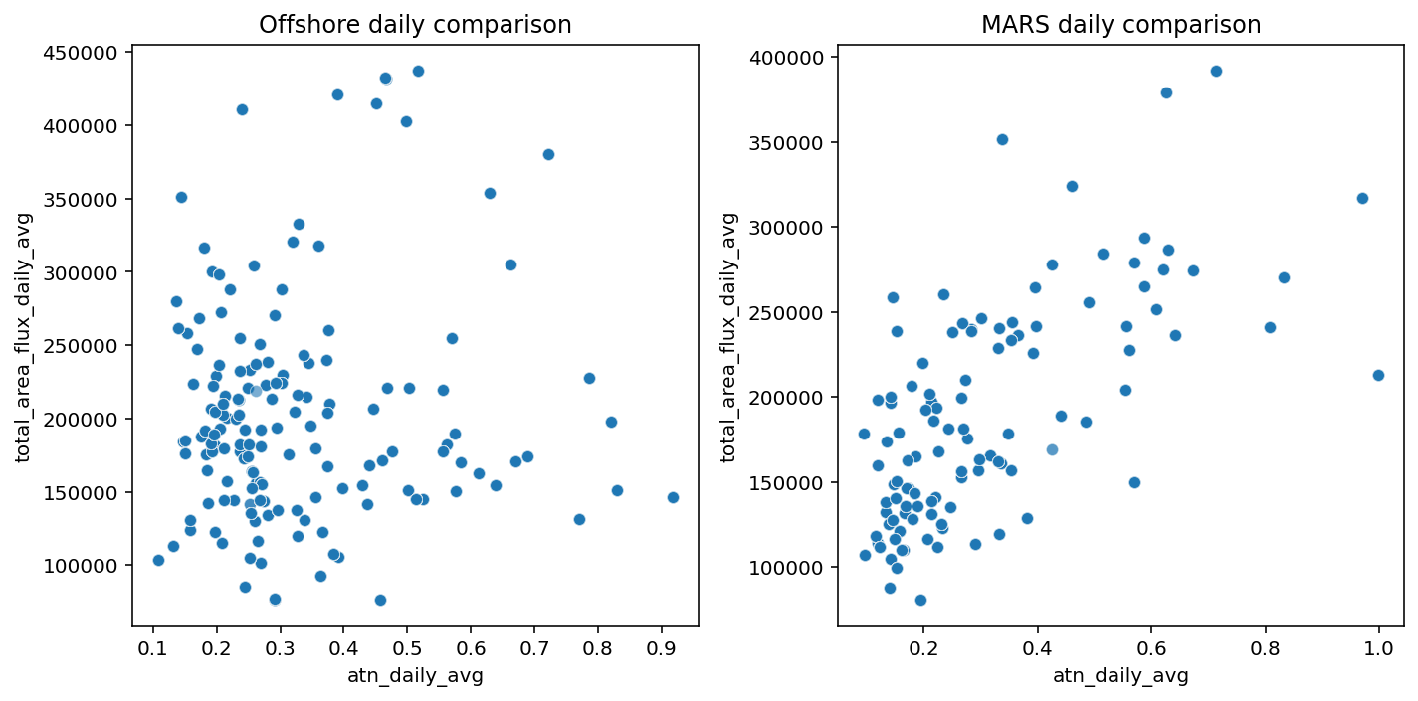
Fig 1. Comparison of SES attenuance (x) and SINKER total area flux (y) daily averages, when SES was offshore (left) and at MARS (right)
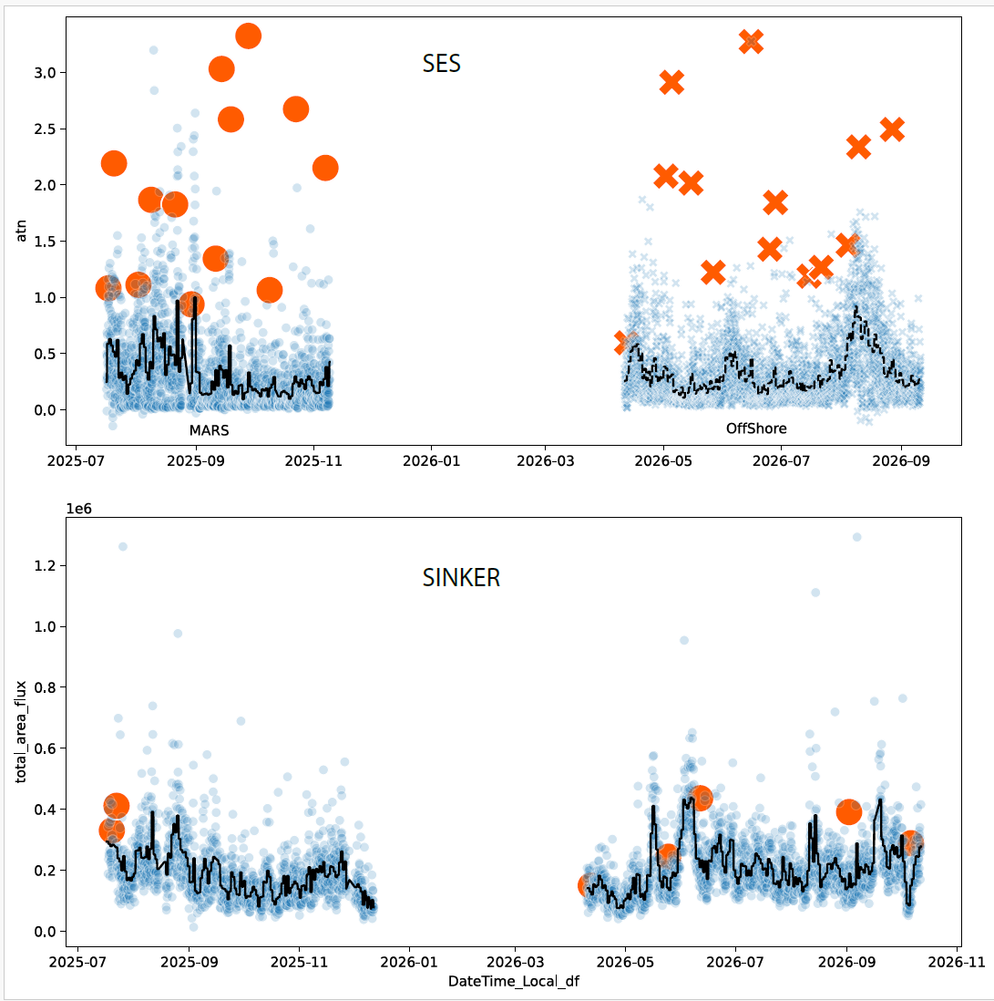
Fig 2. Top- SES attenuance with triggers, for both deployments. Bottom- SINKER with triggers using same algorithm. Needs work.

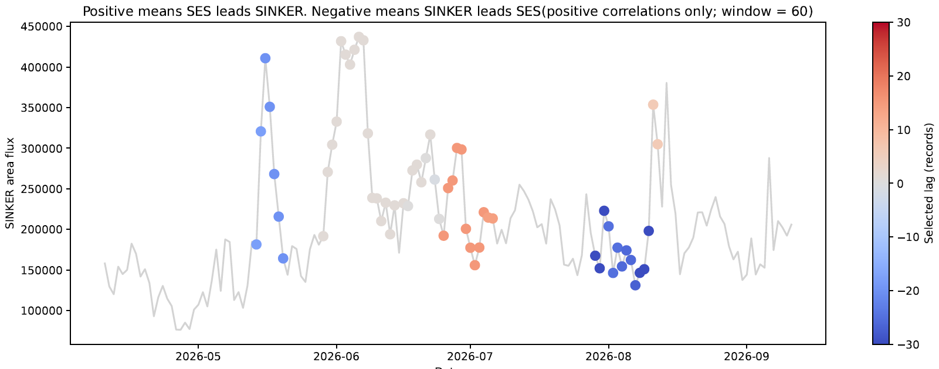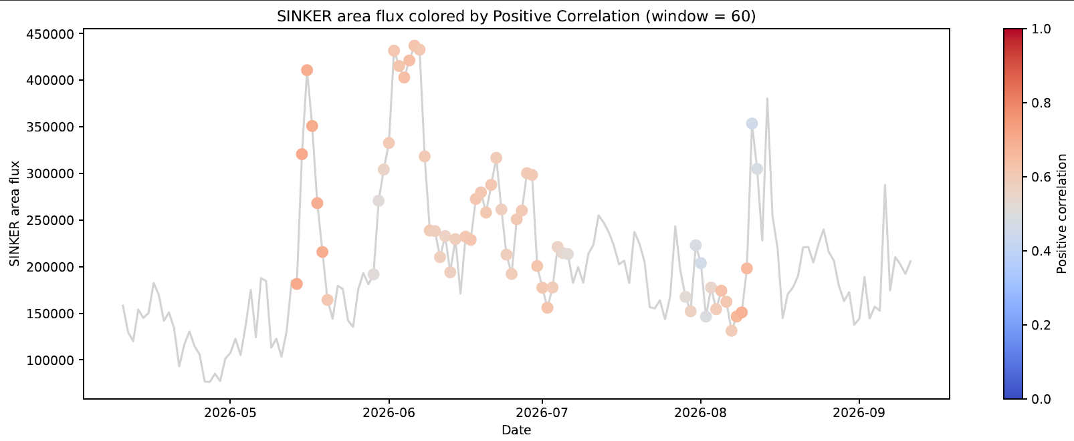
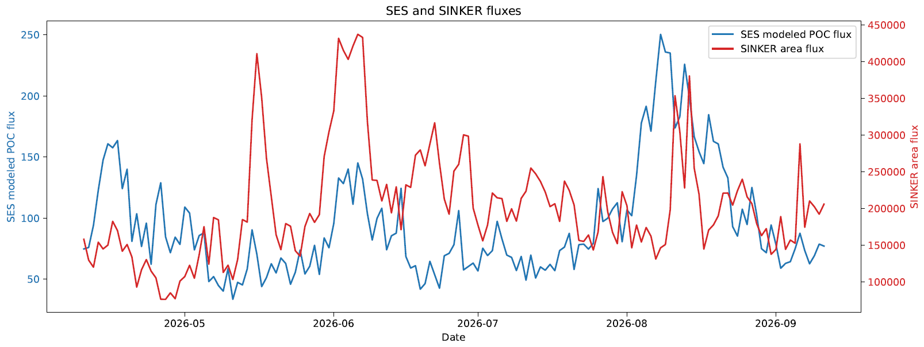

Fig 3. Sliding window cross correlation with lags (max lag = 30 d, window = 60 d) for the period when SES was offshore and correlation between instruments was ≥ 0. Top) SINKER area flux colored by lag associated with the max correlation between SES and SINKER fluxes. A positive lag (red) means the SES leads SINKER (Possibly offshore source reaches SINKER), a negative lag means SINKER leads SES (possibly inshore source reaches SES), and no lag means they change at the same time (possibly broad event over the region). Middle) SINKER area flux colored by strength of correlation associated with lags above. Only positive correlations were considered because a negative correlation doesn’t make functional sense. Bottom) SES and SINKER fluxes

