2025 Sedimentation Event Sensor (SES) and Trigger Trap (TT) MARS deployment summary, preliminary results—902305

Engineering highlights:
- The SES successfully conducted real-time event-detection via onboard image analysis, and then sent commands to the sediment trap sampling within minutes.
- Two deployments were recovered in 2025:
  - Dec 2024-June 2025: The SES sent X trigger commands, 0 of which were acknowledged and yielded collections by the TT. The problem was a faulty modem on the TT, preventing it from receiving messages.
  - July – Nov 2025: The SES sent

Science highlights:
- Mass flux measured from TT collections correlated significantly with attenuance calculated from SES images, and decently matched a modeled mass flux vs. attenuance relationship published last year (Estapa et al. 2023).
- Rapid rises and declines in attenuance may be used to define the beginning and end of pulse events.
- The two high-flux events detected had different compositions—one had lots of fish fecal pellets while the other had more phytodetritus. Both lasted 7 days.
- Attenuance patterns differed from those we saw last year. Attenuance was highest in the middle of the day, unlike in 2023, when we saw peaks before sunrise and sunset.
Deployment details:
The SES and TT were deployed autonomously as separate landers from the RV Rachel Carson on 20 June 2024. Each lander was equipped with a Benthos Modem for acoustic comms, a homer, and three surface beacons (VHF, Argos, and flasher). An Aquaphox pH sensor was secured to each frame, approximately 1.5 m above bottom. A Lowell TCM tilt current meter was carried down by the ROV Ventana and deployed on the seafloor near each lander to record currents.
The SES used a collect time of five minutes for samples, followed by a ~60-minute flow-through period. The triggering algorithm was set to identify periods when the slope of 150 hour rolling mean attenuance > |0.01110322671999997|. The SES was also set to send five pre-scheduled triggers. The TT collect time was 3 hours.
Recovery day (18 September 2024) was calm as can be at MARS. With the ROV Ventana we collected the TT current meter, released the TT weight tray, transited to the SES, collected the SES current meter, released the SES weight tray, recovered the SES weight tray with some weights, and recovered the ROV. Both landers surfaced as planned, but none of the beacons communicated in a timely manner. Eventually they did, but it took a while. Luckily weather was very calm and we could see the packages on the surface. We retrieved the landers, and then did another dive to retrieve more weights. The remaining weight package was retrieved the following day by John Ryan’s group.

Data and sample processing:
Attenuance was calculated from SES images using a Python script that removed the background. Occasional gaps in the attenuance dataset (due to attenuance being calculated as infinite, which we need to troubleshoot) were linearly interpolated.
Sediment trap samples were examined briefly and photographed under a microscope. We looked for “swimmers” to remove them, but they were conspicuously absent, perhaps due to the very short collect time. Samples were then filtered onto 25 mm glass fiber filters, dried (60 °C for ~ 18 h), and weighed to calculate mass flux (mg m⁻² d⁻¹), which was compared to attenuance calculated for the three hours the sediment trap cups were open. A subset of these (many, many) filters was sent to UCSB for carbon analysis.
All plots and analyses were completed in Python.

Preliminary results:
The SES took 1830 sample images (five-minute collect time), and 25 blanks (zero-minute collect time). Blanks occasionally had a small amount of material, which then cleared, suggesting occasional entrainment of material in the SES carousel, but not long-term buildup.
The SES’s onboard analysis of its images identified two rapid rises in attenuance, each followed by a rapid decline in attenuance 7 days later. We confirmed these results with our own analyses of the SES images (Figure 1). Rapid rises in attenuance identified the onset of high-flux conditions, while rapid declines signaled a return to lower-flux (“normal”) conditions. Rapid rise and decline in attenuance may be used to define the onset and end of high-flux pulse events in a way that others can replicate, which is a very practical thing.
The TT received and acknowledged six of the nine triggers sent by the SES, yielding six sediment trap cup collections for comparison with SES images (two rising attenuance, one declining attenuance, and three pre-scheduled). Based on visual inspection of SES images and sediment trap cup contents, each of the two high-flux pulse events sampled differed in composition and development (Figure 1, Table 1).Environmental conditions leading up to these events also differed (Figure 1). Attenuance calculated from SES images did a fairly good job of estimating patterns in mass flux measured from TT samples (Figure 2). Even with the poor correspondence of sediment trap cup # 6’s values, mass flux correlated significantly with attenuance (Spearman ρ = 0.52, P = 0.03). The relationship between mass flux and attenuance was similar to one modeled in a recent calibration of global optical sediment trap data (Estapa et al. 2023), except our y-intercept was higher, and mass flux would have been considerably over-estimated by the model for our high-attenuance events.
To explore whether attenuance might be driven by resuspension of seafloor sediments, we compared attenuance patterns to current speed from the tilt meter. Current speed peaked in the afternoon, while attenuance peaked mid-day. Cross correlation analysis did not identify a significant lagged correlation between the two (i.e. change in current speed wasn’t predictably followed by a change in attenuance at any particular lag). Both current speed and attenuance showed different diel patterns each month, with June being especially variable for both (Figure 3). But there’s clearly more to the story -- they both have similar autocorrelation patterns (Figure 4), and microscopy showed we clearly have some sediment making its way into the samples. But based on the SES images and microscopy, sediments probably contribute a small portion of mass and carbon detected compared to fecal pellets and phytodetritus.

Next steps:
It's clear that a lot more about carbon flux mechanisms can be gleaned from identifying the particle types in the SES images. I very much look forward to making progress in that area.
These deployments allow further investigation into the definition of pulse events.
See how many decimals we really need to go out to in our calculations. Would two decimals give us the same answers?
There’s more to be learned from the fluorescence data.

Changes for next time:
- We need to improve beacons and surface expressions. Next time we’ll plan to add a bicycle flag for better long-distance visibility.
- Due to improved SES performance, we might be able to sample more often without draining the battery.
- To ensure better receipt of the SES’s acoustic signal by the TT we need to:
  - pay more attention to the direction the modems are facing during deployment to minimize acoustic signal blocking by syntactic foam, and
  - set the SES to repeat trigger comms several times.
- Only one pH sensor and one tilt meter worked (both on the SES, luckily). pH drift was significant (Figure 1) and will need to be addressed in the next deployment.
- Because we’ll be deploying in winter, with lower fluxes than seen during prior deployments, we’ll need to set the trigger threshold lower. We are collaborating with Yanwu to incorporate an adaptive triggering algorithm that keeps track of the number of triggers, and changes the threshold if needed.
- Next time we’ll remove salts, and centrifuge the sediment trap samples for freeze-drying/weighing and CHN analysis rather than filtering onto GFFs.
- We’re still fiddling with the fluorescence data.
- I need to work out a better post-recovery pH sensor calibration system. I’ve been in touch with Yui and his team about plans for the next deployment.

Table 1. General comparison of high-flux pulse events identified by the SES.

 | First pulse event | Second pulse event
Onset | 7/1/2024 10:00 | 9/4/2024 16:00
Duration | 7.2 days | 7.4 days
Attenuation vs. mass flux | Better correspondence between mass flux and attenuation | Poor correspondence between mass flux and attenuation
Qualitative pattern | Had a more gradual and consistent rise and fall | Very rapid rise to the highest atn measure, and then a rapid drop off.
General impression of composition | fish fecal pellets > phytodetritus | phytodetritus >  fish fecal pellets
Trigger frame | 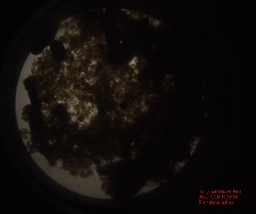 | 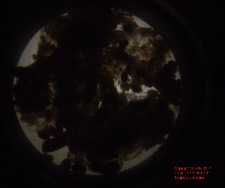
Representative composition frame | 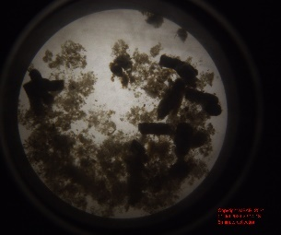 | 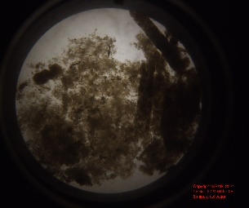

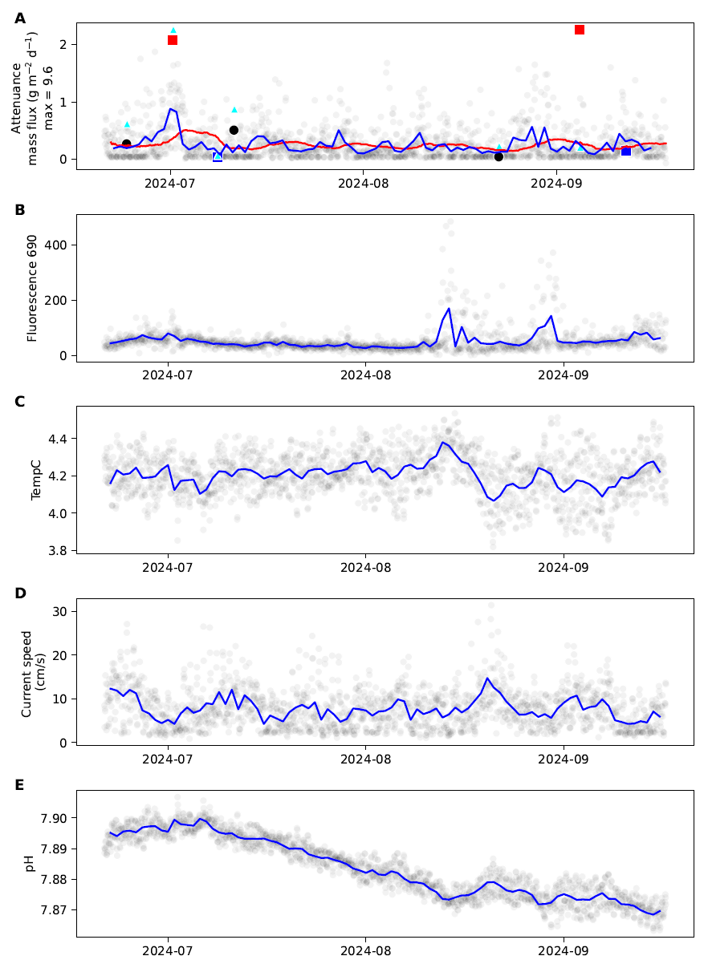
Figure 1.
Time-series plots of SES and TT data. For all panels, transparent gray dots = hourly data, and blue lines = daily average. A) Attenuance calculated from SES images (red squares = rapid-increase trigger points, blue squares = rapid-decline trigger points, black dots = scheduled trigger points) and mass flux measured from TT samples (blue triangles, scale not yet shown). B) sample fluorescence recorded by the fluorometer on the SES; C) ambient seawater temperature recorded by the pH sensor approximately 1.5 m above bottom on the SES frame; D) ambient water current speed recorded from a tilt meter deployed on the seafloor a few meters from the SES; E) ambient seawater pH as recorded approximately 1.5 m above bottom on the SES frame (we clearly need to work on that sensor’s drift).

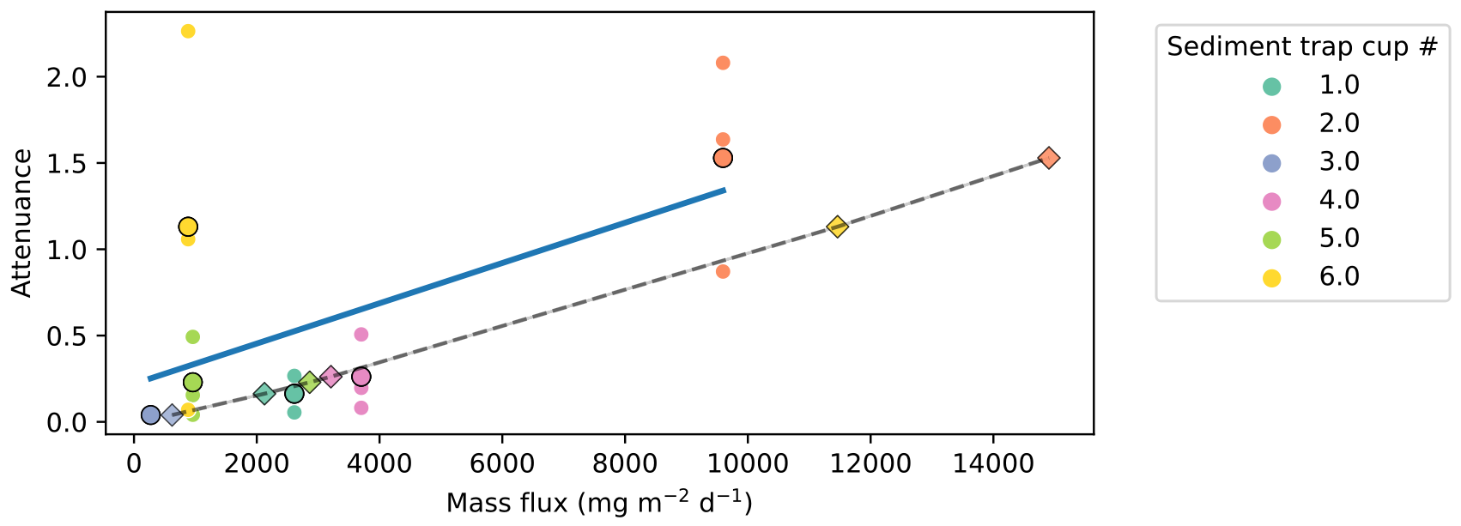
Figure 2. Comparison of mass flux measurements from the trigger trap samples and attenuance calculated from SES images. Blue line = linear regression of mass flux_{TT} vs. attenuance_{SES}. Dashed line = modeled relationship between attenuance and mass flux from Estapa et al. 2023 (mass flux_{modeled} = 1.03 e+04 * attenuance_{SES}^{0.87}). Markers are colored according to sediment trap cup (dots where mass flux_{TT}, diamonds where mass flux_{modeled}).

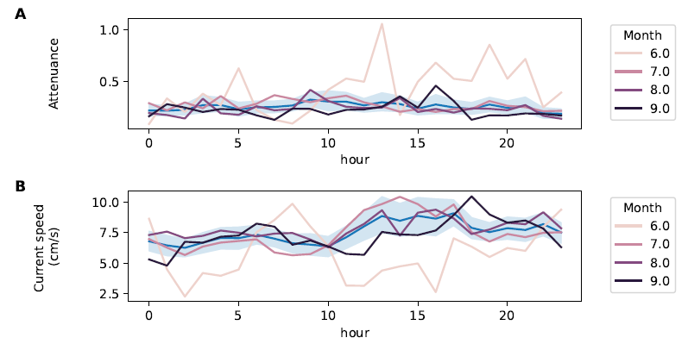
Figure 3. Attenuance (A) and current speed (B) by hour of the day, colored by month of year, with mean ± 95% confidence interval in blue.

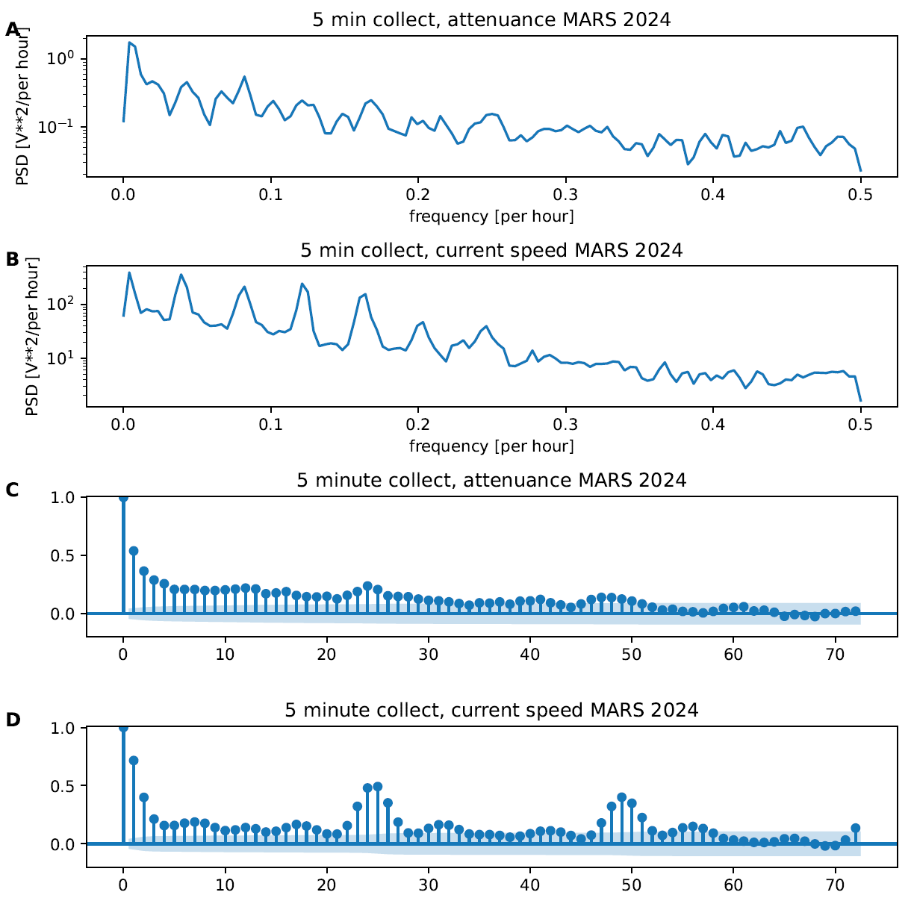
Figure 4. Periodicity (A, B) and autocorrelation (C, D) of attenuance and current speed

