Head scratchers:

- Attenuance: Temperature at 890 m and moon phase explained the most variance in attenuance. Hour of the day was also important, but less so. Current speed was not significant. In total this model explained 15% of the variance in attenuance.
# Formula:
(Main_Hourly_SES_MARS$atn) ~ s(mooninterp) + s(hour) + +s(Speed_cm_s) + s(Temperature_C)

Approximate significance of smooth terms:
edf Ref.df F p-value
s(mooninterp) 7.053 8.108 13.648 < 2e-16 ***
s(hour) 5.750 6.922 7.414 < 2e-16 ***
s(Speed_cm_s) 2.351 2.963 1.407 0.201
s(Temperature_C) 1.000 1.000 25.839 9.36e-07 ***
---
Signif. codes: 0 ‘***’ 0.001 ‘**’ 0.01 ‘*’ 0.05 ‘.’ 0.1 ‘ ’ 1

R-sq.(adj) = 0.141 Deviance explained = 15%
-REML = -33.848 Scale est. = 0.053354 n = 1504

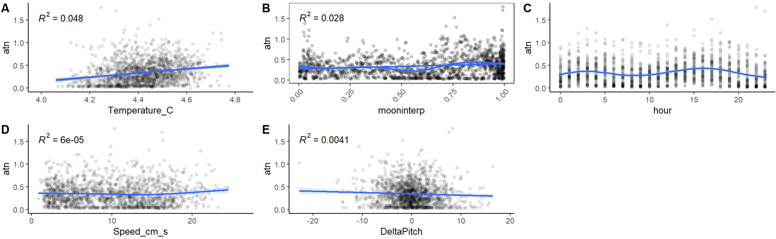
Figure 1: Variable considered for inclusion in the attenuance GAM. A—D were included in the model. Relationship with moon phase isn’t linear, so that R² is not important.

- To understand what mechanism might link temperature and attenuance, first we need to explore what drives changes in temperature. If temperature is driven by tides, then we might see a correlation between temp and moon phase, current speed, and tiltmeter pitch (which correlates with current speed). Would an inverse correlation between temperature and change in tiltmeter pitch indicate a type of downward pumping or some other physical mechanism bringing new water masses to the site (Smooth Ridge)? And since we have hour of the day, I threw that one in too.
The change in pitch of the tiltmeter explained the most variance in Temp. Next was hour of the day, followed by moon phase. Current speed and tiltmeter pitch also correlated, but less strongly. All told, these variables explained 44.6% of variance in temperature at 890 m depth. Looking deeper into the relationship between temp and hour of the day, we see that this relationship seems to have spring-neap variation (last plot). So- change in temp appears to be tidal. But why does the change in pitch mean so much more than pitch itself?
#Formula:
(Main_Hourly_SES_MARS$Temperature_C) ~ s(mooninterp) + s(hour) +s(Speed_cm_s) + s(DeltaPitch) +s(Pitch_degrees)

Approximate significance of smooth terms:
edf Ref.df F p-value
s(mooninterp) 7.787 8.616 16.694 < 2e-16 ***
s(hour) 8.150 8.804 25.364 < 2e-16 ***
s(Speed_cm_s) 3.217 4.023 9.039 5.95e-07 ***
s(DeltaPitch) 2.583 3.350 104.513 < 2e-16 ***
s(Pitch_degrees) 5.479 6.661 7.270 < 2e-16 ***
Signif. codes: 0 ‘***’ 0.001 ‘**’ 0.01 ‘*’ 0.05 ‘.’ 0.1 ‘ ’ 1

R-sq.(adj) = 0.436 Deviance explained = 44.6%
REML = -1405.5 Scale est. = 0.0083 n = 1503

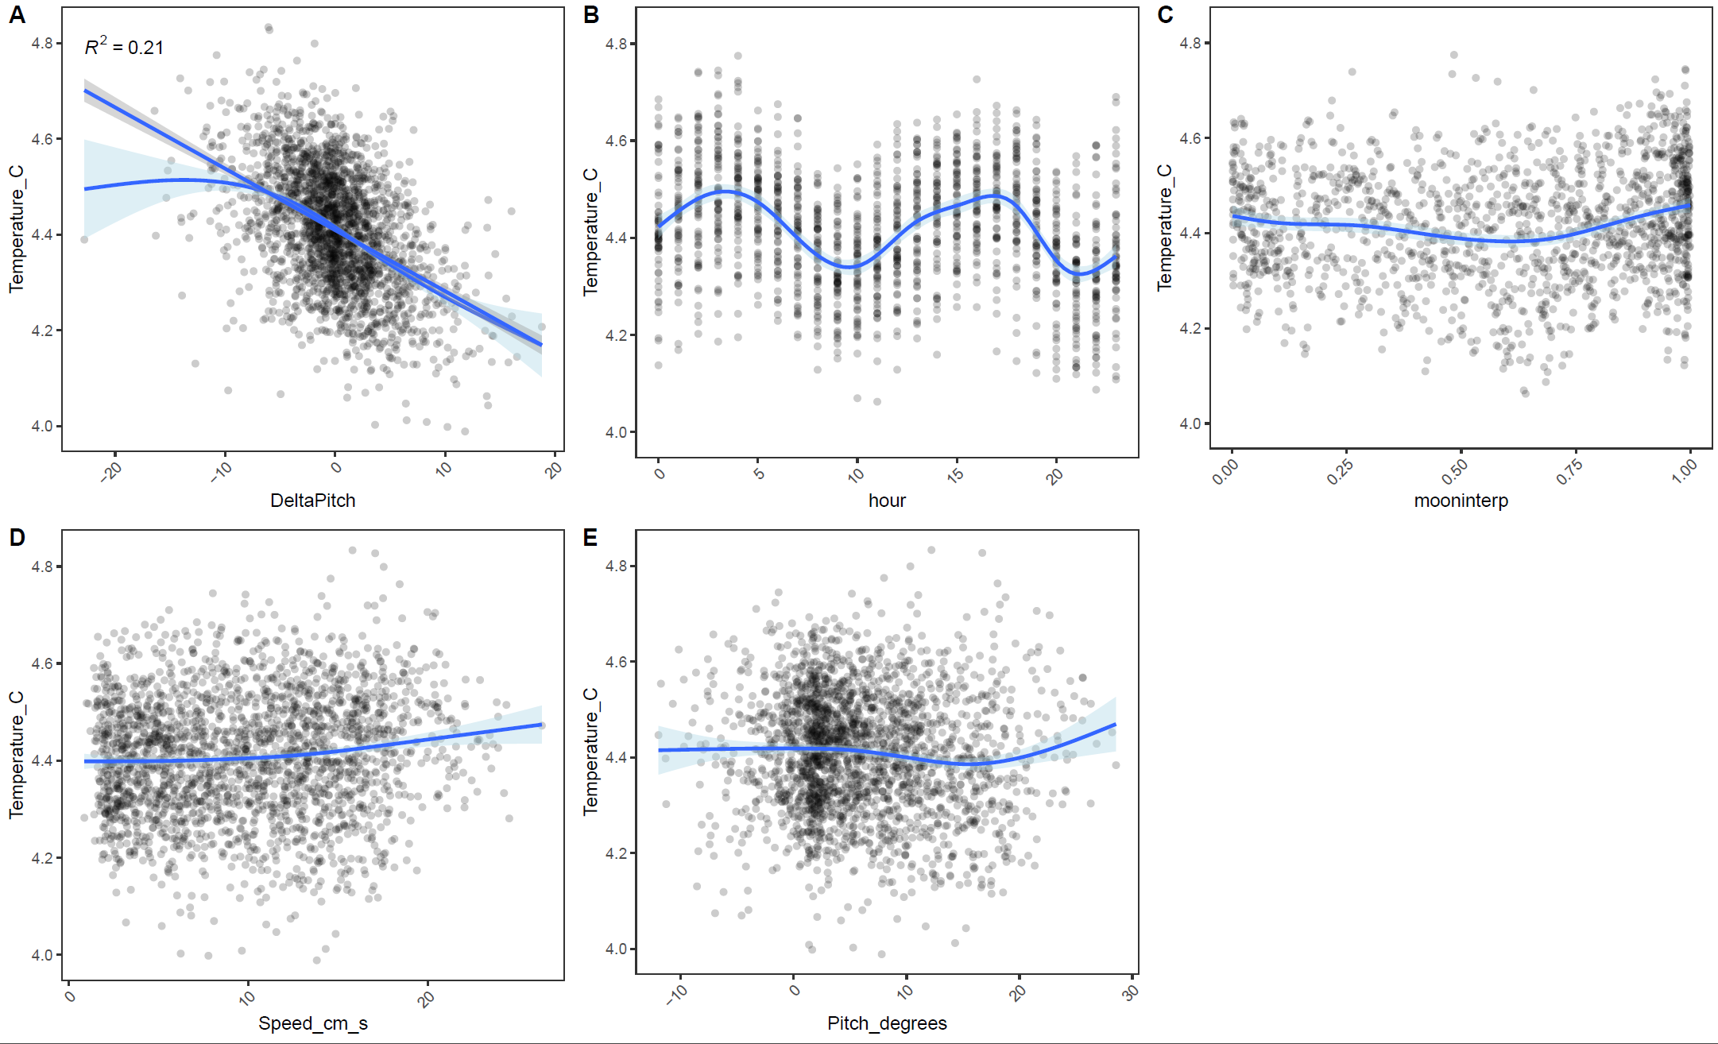
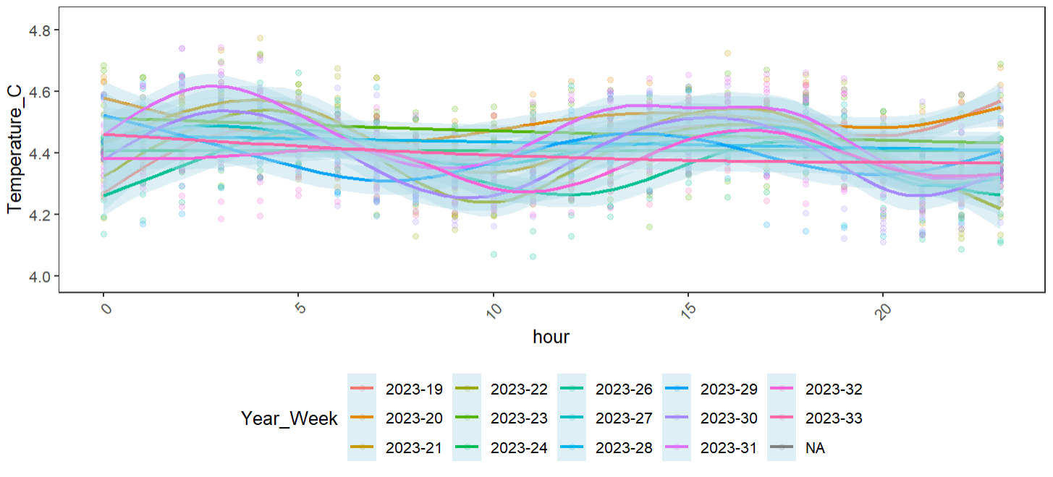

- So does this mean attenuance is tidal after all?
Maybe partly, but other things are going on (see plot below). I can’t find any relationship between current speed and attenuance. Even the peak lag of 7 hours between current speed and attenuance doesn’t show much. So- if this story involves tidal resuspension, it might not be local.

