2023 Sedimentation Event Sensor (SES) MARS deployment summary, preliminary results—902305

Science take-homes: Attenuance had two separate daily cycles: one that peaked before sunrise, and another that peaked before sunset. Tides might be a contributing factor. Attenuance was also higher during the full moon than on dimmer evenings. Biological communities were important sources of variability to be explored further. Looking forward to getting to the current meter data too!

Engineering take-homes: Meticulous servicing prior to deployment really paid off! We’ll work to identify the problems with the existing acoustic modems, and hope communication will improve with the new modems. The zero-collect-time method will be modified so the slide backs up and takes the blank image, rather than passing underneath the funnel opening.

Deployment details:
The SES was deployed autonomously as a lander from the RV Rachel Carson on 8 May 2023 (Fig. 1). It was equipped with a Benthos Modem for acoustic comms and cable for plugging into MARS. Two Lowell TCM tilt current meters were deployed nearby to record currents. The SES was plugged into MARS and collected data successfully for the duration of its deployment, with a collect time of five minutes, followed by a 15-minute flow-through period. A daily zero min collect time “blank” was added to the schedule partway through the deployment. Communication with the SES, and data download, via MARS went smoothly, and the images were the clearest yet for this instrument. However, the Benthos Modem on the SES did not communicate with the Wave Glider. Material was seen in the blanks because the slide briefly passed under an open funnel. In the future, the carousel will backtrack to take the blank. Recovery was performed by the Rachel Carson crew on 24 October 2023. Communication between shore-based and at-sea team members was facilitated greatly by the Telepresence team. Upon recovery a crab was found in the funnel opening (Fig.1), probably explaining the low sedimentation values we’d been seeing since mid-August 2023. Current meters could not be recovered at the time, and are scheduled for recovery next week.

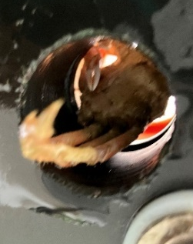
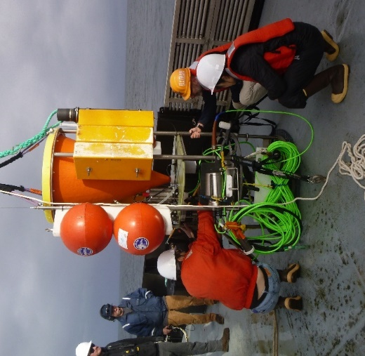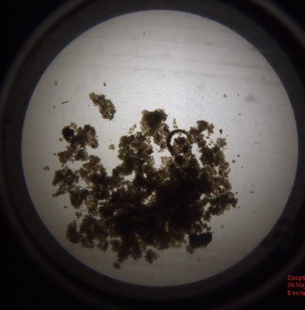
Figure 1. (left) SES deployment day; (middle) example sample image; right) crab in funnel opening

Data processing:
Attenuance (“atn” in plots) was calculated from images using a Python script that removed the background. Attenuance may be considered a proxy for POC flux. Lunar illumination, and times of sunrise and sunset, were generated in Python (ephem). In the absence of data from the current meters, tidal data for Moss Landing were downloaded from NOAA (https://tidesandcurrents.noaa.gov/noaatidepredictions.html?id=9413616&legacy=1). Tidal change was calculated as the rate of change in tidal height from the previous hour (units = m/h), hoping to get insights into current speeds.
Data were merged and averaged hourly, and the “crab clog” period beyond Aug 14 was trimmed. For analysis of periodicity and autocorrelation, the dataset was further trimmed to start on June 27, to eliminate large gaps.
I’ve played with the fluorescence data, but putting that aside until we have particle types.

Preliminary results:
Signal analysis (Welch’s spectral density) did not reveal clear cycles in attenuance. However, autocorrelation peaked at lags of 24–25 and 49 hours (Fig. 2 top left). Interestingly, so did autocorrelation in tidal height (Fig. 2 bottom left). These results indicate daily cycles in both the magnitude of particle flux and the dominant tidal signal. Change in tidal height (not shown) positively autocorrelated at lags more in line with semidiurnal tides (12–13, 25, 37, 49–50 hours respectively).
Attenuance peaked at around 5 pm, a few hours before sunset. A smaller peak was seen a few hours before sunrise (Fig. 2 right, top panel). Tidal height in Moss Landing peaked slightly before sunset, and troughed around sunrise (Fig 2. middle panel). Tides fell fastest a few hours before dawn, and rose fastest over a prolonged mid-day period (Fig 2. bottom panel). While the timing of the tides shifted as the deployment went on, the timing of peaks in attenuance did not do so consistently, either as time went on or in relation to the solstice (not shown).
On a longer time scale, moon phase is known to affect zooplankton populations in the midwater. Attenuance detected by the SES at Station M also involved lunar cycles. Lunar illumination also appeared to influence attenuance at MARS. Attenuance was higher when modeled lunar illumination was brighter (Fig. 3).
Biological drivers clearly added variability to this system. Different material was detected by the SES during full moon peaks in July versus August. More material fell during the August full moon, especially as thick fecal pellets (Fig. 4). We plan to look into changes in fecal pellet type over hourly-to-monthly time scales, and compare these changes to changes in the zooplankton communities identified by the echosounder.

Caveats: Important missing pieces of this flux puzzle must be acknowledged: 1) temporal offsets between the tides at Moss Landing vs. those at MARS, 2) unknown particle packaging depths, 3) unknown particle sinking speeds, and 4) unknown degrees of sediment resuspension. However, many of these details are tractable with receipt of the current meters, collaboration with active acoustics studies, and developments by the CFE lab. Lots to be excited about.

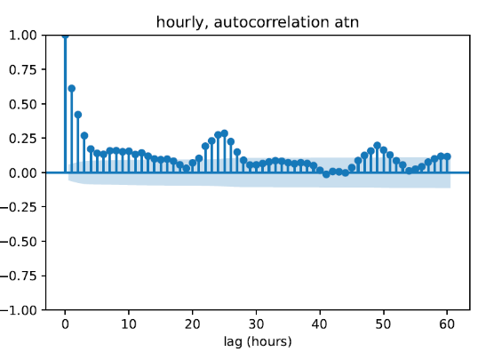
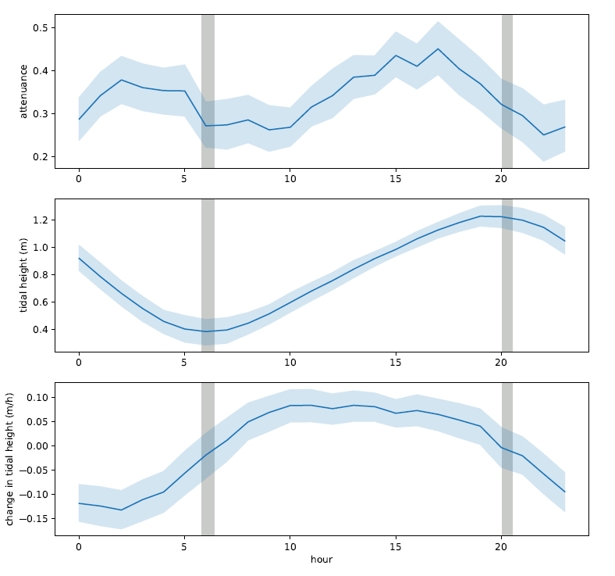

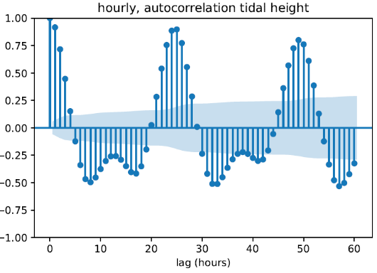

Figure 2. Autocorrelation plots of (top left) SES attenuance data and (bottom left) Moss Landing tidal height, both showing peaks at lags of 24–25 and 49 hours; (right) Diel patterns in attenuance, tidal height, and tidal change are given. Gray bars represent the span of sunrise and sunset times during the full dataset.
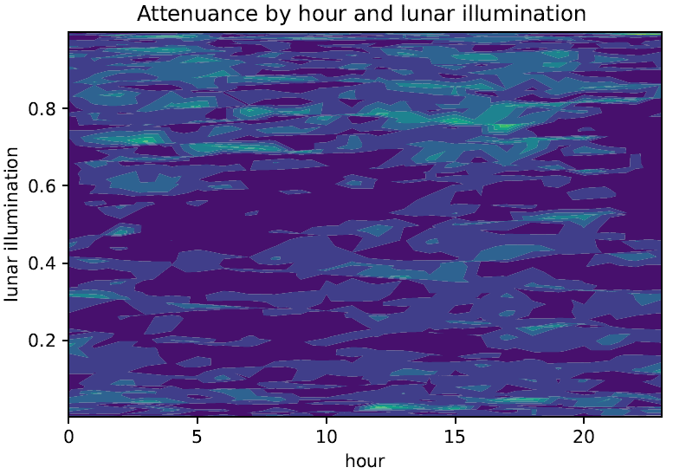
Figure 3. Attenuance across hours and moon phases (new moon lunar illumination = 0, full moon lunar illumination = 1). Warmer colors indicate higher attenuance.

Fig 4. 8 pm to 6 am (the first picture taken per hour) for the full moons on 3 July (left) and 1 Aug (right) 2023.

