Telepresence helps save the day: October 24, 2023
Setting: On October 24, the MARS team was on the Carson to pull the node and bring it back to shore for upgrades. This operation was expected to take most of the bottom time for the day. Early in the dive, Ventana experienced a problem with the hydraulics that required ROV recovery and fix on the deck. This would take enough time that the team would no longer have time to recover the MARS node.
Opportunity: It seemed likely that there would still be time for another dive after the Ventana was recovered and fixed. Wanting to make the most of that calm-weather day at MARS, rather than simply returning to shore, Kavi identified a possible backup plan-- switch operational plan mid-day and recover the SES from MARS instead, which had been planned for October 26th.
Challenges: Knute had to track down the SES team, get the go-ahead to recover, discus the cruise plan, and make sure the operations could be done successfully with no one on the SES team at sea.
More opportunities!: Thanks to good communications on the Carson, Knute was able to email us and then call me from his cell phone to discuss the plan, and confirm the go-ahead. While I am sure the team on board could have done everything we needed to do that day, it would have involved many emails and cell phone calls back and forth. Luckily we didn’t have to go through those stressful steps. Telepresence was up and running.
What Telepresence gave us: The Telepresence team quickly looped us into the day’s operations. The SES team was onsite, and gathered in Harbor Conference room to follow along with operations at sea. We were able to communicate seamlessly with the control room to direct ROV operations, which was especially helpful when trying to view various aspects of the SES to check for clogging. When using the pull pin for recovery, we had the opportunity to bring in Evan, who had designed the system. He was able to describe how to access the safety pull, and send pictures of the system. Evan hadn’t planned to come with us to sea later in the week. Telepresence gave him the flexibility to join operations for a brief period when he was most needed, and then get back to his many other tasks here onsite.
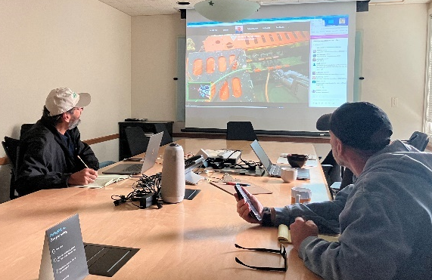. 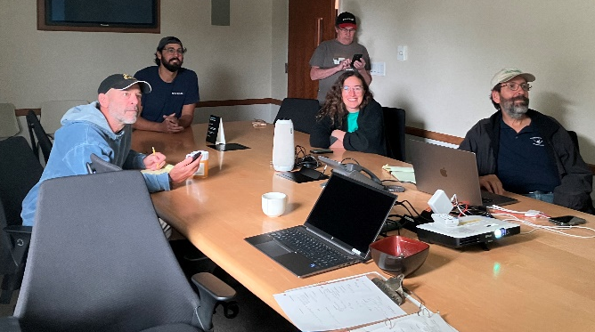
Figures: SES team joining recovery operations via Telepresence
Final outcome: Thanks to quick-thinking by everyone on board the Carson that day, and the telepresence team, DMO was able to make a mid-day switch in operations teams, saving the institute from having to recover from a lost day at sea. We got all the ROV footage we needed, and the SES was recovered successfully. This freed up our originally-scheduled day later that week for use by the MARS team, to complete their successful recovery of the MARS node.

