Deploy location: 36.06084, -122.66486
Water depth: 3370 m
Is it in the Sanctuary? No
Is there bottom trawling at this location?-Probably not high risk
https://www.arcgis.com/apps/mapviewer/index.html?layers=11e60c7b1e734a6999457dedd0a28667
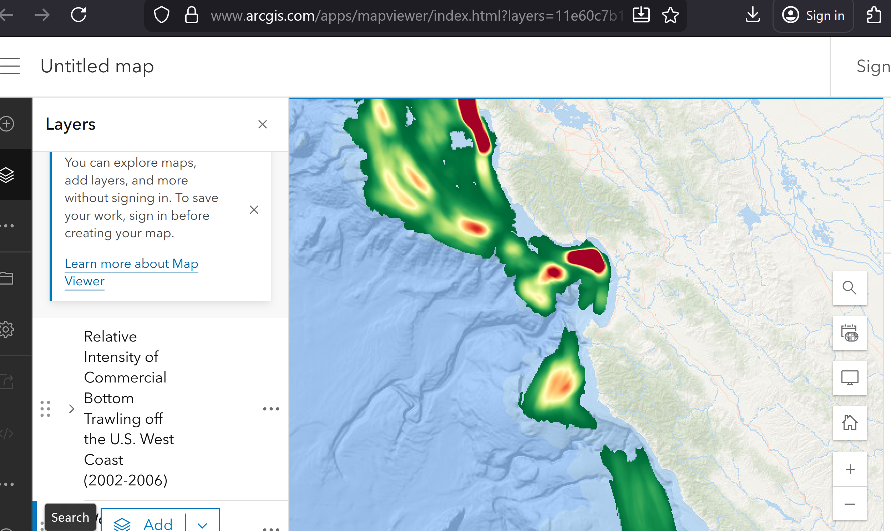

Trap depths: Talk with Crew and check line options to see if we can get these closer
SES 300 mab
Trigger Trap 350 mab
Conventional Sediment trap 400 mab

