SES: Person to contact with questions: Crissy Huffard, x1839, chuffard@mbari.org
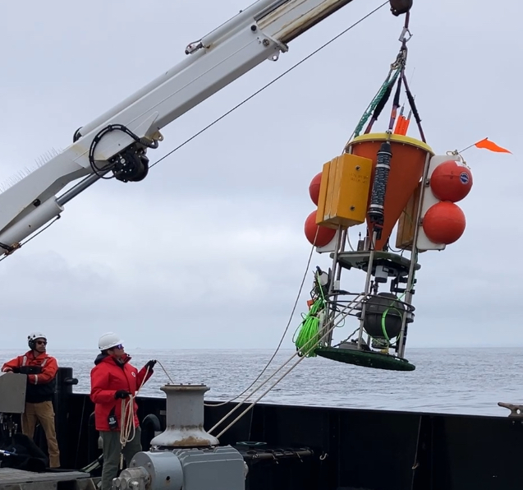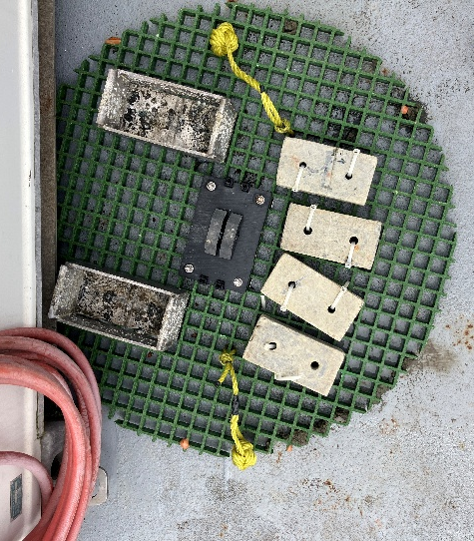
- SES (left image, being deployed July 2025):
  - About 7 ft tall to baffle, plus a few feet to top of beacons and bridle.
  - ~1176 lbs dry, 180 lbs wet weight (this is from Station M deployments…we should get you updated weights, but in the meantime this is about the scale)

- Ballast:
  - As lander: Round fiberglass grid weight tray (weight tray on deck, edge partially under science van on right)
    - Has two pull pins (one safety, one main). 200 lb total ballast as currently deployed:
      - 100 lb of attached lead bricks
      - another 100 lb of removable bricks, requiring two dives for full recovery.
  - On Mooring: Strongback with acoustic releases (and pull pin backup), as at Station M. Will be looking back into Station M deployment diagrams to configure for offshore deployment for next year.

- Beacons (currently deployed. These sometimes swap around a bit, but we keep track and try to put on recovery precruise)
  - VHF: 154.580 XEOS XMB-11K
  - Argos ID 284850 XEOS XMA-11K (emails go to Crissy, Irene, Rich, Alana, Brett Hobson)
  - Homer (currently #10)
  - Flasher
  - Bike flag that is zip tied down and will be raised by ROV during recovery

- Deployment options
  - Lander (currently)
  - Mooring (Station M, future)
  - Autonomous (up to one year on batteries)
  - Plugged into MARS (sky’s the limit)

- What’s it do, anyway?
  - Takes pics of sinking marine snow to help study/quantify carbon sequestration (examples below)
  - Acts as low power long-duration system able to monitor conditions and then trigger another (higher power, battery hungry) instrument to wake up and do its thing
