Target journal:
PNAS (The preferred length of these articles is 6 pages, but PNAS allows articles up to a maximum of 12 pages. For example, a standard 6-page article is approximately 4,000 words, 50 references, and 4 medium-size graphical elements (i.e., figures and tables).)

They use a template for submission. The Methods come at the end of these papers which is worth considering for how the other sections are framed.

Deep sea carbon export is measurably enhanced by daily vertical migration of midwater animals

Authors: Kelly, Crissy, Colleen,
Rich, Irene, Paul McGill, Chad

Potential reviewers: Amy Maas, Debbie Steinberg, Jerome Pinti, Daniele Bianchi, Santiago Hernandez-Leon

Keywords: Diel Vertical Migration, carbon sequestration, active carbon flux, deep sea, fishes, climate

Abstract

Introduction
The ocean has buffered us from the worst effects of climate change, absorbing more than 90% of the excess heat and ~30% of carbon dioxide generated by the burning of fossil fuels (Reid et al. 2009). Without ocean life, carbon dioxide in Earth’s atmosphere would be twice as high today (Friedlingstein et al. 2006). The biological processes that move carbon dioxide from the atmosphere into the ocean, referred to as the biological carbon pump, begin with photosynthetic organisms near the ocean’s surface fixing dissolved carbon dioxide into organic matter (Falkowski et al. 1998). If this organic matter sinks or is transported into the deep sea, it can evade equilibrium with the atmosphere, and may be stored in the ocean for tens to thousands of years (Pasquier et al. 2025). Understanding the pathways for long-term carbon storage in the ocean is critically important for understanding marine food webs, predicting the ocean’s efficiency as a carbon sink, forecasting feedbacks in climate forcing, and informing climate engineering efforts (Siegel et al. 2016).

Diel vertical migration, a key biological process for a wide variety of ocean animals, plays a significant but not well quantified role in carbon transport (Clements et al. 2026; Hernández-León et al. 2019). Throughout the global ocean, zooplankton and nekton migrate vertically, spending nights foraging in food-rich surface waters and days avoiding predators in the dark refuge of the deep sea (Iwasa 1982). An estimated ten million tons of migrators (Irigoien et al. 2014) create a biological conveyer belt, actively transporting carbon consumed near the surface to the deep sea (Steinberg et al. 2000) tens of times faster than passive sinking (Brierley 2014), increasing the opportunities for that carbon to remain out of the atmosphere. Global models estimate that 5-50% of total carbon flux (Archibald et al. 2019; Brierley 2014; Pinti et al. 2023) and 10%-90% of particulate organic carbon flux (Boyd et al. 2019; Nowicki et al. 2022) may be mediated by diel vertical migration. To put these estimates of carbon dioxide removal and storage in context, it is possible that this daily movement behavior of ocean animals is three times as important to the health of our planet as the Amazon rainforest before its widespread disturbance (Heinrich et al. 2021). Yet, diel migration arguably remains the most poorly constrained factor in the biological pump, largely because it has not been possible to measure its contributions directly (Clements et al. 2026; Pinti et al. 2023; Saba et al. 2021). We sought to fill this important gap by coupling sustained, high-temporal resolution measurements of particulate organic carbon flux to the seafloor with concurrent observations of the vertical distribution and diel behavior of midwater animals, directly linking the behavior of midwater animals to carbon flux.

Methods
Concurrent measurements of diel migration by ocean fauna and carbon flux to the deep seafloor were made over a period of 92 days in May-August of 2023 using sensors attached to the Monterey Accelerated Research System (MARS) cabled observatory node. The MARS observatory provides power and real time data to a site on outer Monterey Bay approximately 900 m deep at 36˚ 43’ N, 122˚ 11’ W on a continental slope topographic feature known as Smooth Ridge (Figure S1). Monterey Bay, an open embayment on the central California coast, is part of the California Current Large Marine Ecosystem, a dynamic and productive ecosystem strongly influenced by wind-driven seasonal upwelling (Checkley Jr and Barth 2009; Huyer 1983).

Animals in the water column
An upward-looking echosounder provided a nearly continuous record of the distribution abundance of acoustic scatterers throughout the water column during the study period. The calibrated, Simrad EK60 echosounder transmitted a 38 kHz, 2.048 ms ping upward every 2.5 s using a pressure-compensated Simrad 38-DD transducer with a 7º beam (see details in Urmy and Benoit-Bird 2021; Urmy and Horne 2016). Data were transmitted to shore where they were recorded and monitored in real time. Operating at 38 kHz, the echosounder was most sensitive to macrozooplankton and micronekton (cm and larger scale), particularly fishes (Benoit-Bird and Lawson 2016).

Echosounder data were processed using Echoview 14.1 software. First, ambient noise, noise spikes, and echoes from the surface were removed. Acoustic backscatter data were then split into two parts following Benoit-Bird and Waluk (2021): aggregations of high intensity scattering that primarily represent fish aggregations including schools in the upper 200 m of the water column, and scattering values that remained consistent at a given depth through time of the scattering data, e.g., scattering layers. The depth that encompassed 97.5% of the total scattering was used to define the bottom of scattering layers. Twenty-minute average metrics were calculated for total scattering, aggregations of fish, and scattering layers including: a proxy of total biomass (total scattering or NASC), mean density of scattering (mean S_{v}), peak density of scattering (maximum S_{v}), the height of scattering features, and the biomass weighted mean depth (depth that splits the total scattering equally; center of mass). These metrics of scattering patterns were also calculated over daily intervals. Daily metrics also included a metric of the extent migration calculated as the change in biomass weighted mean depth from the hour centered at midnight to the hour centered at noon.

Particle fluxes at the seafloor
Particle fluxes at the seafloor were monitored by the Sedimentation Event Sensor, an optical particulate carbon trap that collects and images sinking particles (McGill et al. 2016). Particles entered the 0.5 m² funnel opening and accumulated on a 25 mm diameter slide for a 5-minute collection period every 20 minutes. The sample was excited with blue LED light at 470 nm, and a fluorometer measured emission at 690 nm center wavelength with a 10 nm bandwidth. This reading indicates the possible presence of chlorophyll (Yentsch and Phinney, 1985) and fresh surface-derived material. Front- and back-lit macro images were then collected, after which the sample was discarded before the next collection began 15 minutes later. Back-lit images were used to calculate the amount of light attenuated by particles on the collection plate (attenuance, atn), which has a quantitative relationship with carbon flux (Estapa et al.). For each collect interval, a background image was created from the maximum red channel pixel values of the preceding 20 images. Attenuance was calculated as the mean of the negative log-transformed ratio of the red-channel pixels in the sample image normalized to the background image pixel values.

Statistical analyses
To identify significant temporal cycles in both pelagic fauna and carbon flux, spectral analysis was conducted on the minute resolution weighted-mean depth of scattering and 20-minute resolution attenuance data from the optical particulate carbon trap. A 5-sample Hamming window was used in the Fourier transformation to reduce spectral leakage. Resulting spectra were normalized to identify the power content of the signal as a function of period.

To examine time-of-day effects in the attenuance data, each attenuance value was converted to a daily z-score; the daily mean attenuance was subtracted from each of that day’s measurement and divided by the day’s standard deviation. Approximately 85% of sampling days showed distinct peaks in attenuance between 0200-0500 and 1400-1900 with a mean z-score within these intervals of ≥+0.2 and at least 3 data points with z-score of ≥+1. The relative height of these peaks, a measure of the diel variability in attenuance, was described as the ratio between the average of each day’s diel peaks and the average of all attenuance values on the same day.

Potential drivers of particles reaching the seafloor were explored at both the original sampling resolution and at daily scales. Before analyses, each variable was assessed for normality and homoscedasticity, transformed as appropriate, and outliers (Cook’s D>0.025) trimmed. Akaike’s information criteria (AICC) was used to select explanatory variables for inclusion in each model. For variables with tolerance values less than 0.1, indicating collinearity, only the strongest variable was retained in final models. The 20-minute resolution echosounder metrics, along with particle sample fluorescence, tidal height, and change in tidal height over the previous 20 minutes (National Oceanic and Atmospheric Administration Station 9413450, Monterey, CA) were used as explanatory variables of attenuance in the optical particulate carbon trap in a best-subsets linear regression model. Regression was repeated, offsetting the acoustic variables relative to attenuance in 2-hour steps up to 50 hours to identify the lag between observed animal processes in the water column and export of carbon at the seafloor. Data were then aligned using the best-fit lag before calculating daily metrics for each data set. Daily explanatory metrics were used to predict average daily attenuance and diel variability in attenuance flux using both best subset multiple linear regressions and generalized additive models.

To aid in data interpretation and intercomparison, attenuance was converted to an estimate of carbon flux (mg C m⁻² d⁻¹) following Estapa et al. (2024). In addition to the total carbon flux each day, the proportion of the daily carbon flux accounted for by the twice daily peaks was estimated as the difference between the daily average flux and the average flux measured outside of the twice daily peak periods, leaving a 1-hour margin around each peak (12 hours of data each day: 0600-1300 and 2000-0100). The difference between the average and background flux was normalized to a fraction of the total daily flux. Linear regression was used to explore the potential relationship between the average daily carbon flux and the proportion accounted for by diel peaks.

Results
Sustained, concurrent, high-temporal resolution measurements from an optical particulate carbon trap and an upward- looking echosounder revealed considerable variation in midwater animal abundance and behavior as well as particulate export to the seafloor over the ~4-month period of the study (Figure 1). Carbon flux was calculated from the light attenuance measured in optical particulate carbon trap imagery. The mean daily estimated carbon flux to the seafloor during the study period was 0.27 gC m⁻² d⁻¹ ± 0.10, (standard deviation=0.10, 95% CI [0.12,0.51]). The observed variation in carbon flux within a day (standard deviation=0.20) was approximately double the variation observed between days with two peaks and two nulls in attenuance measured daily (Figure 2). The timing of these peaks remained relatively consistent throughout the study period and accounted for, on average, 29% of daily carbon flux (standard deviation=0.21, 95% CI [1.7,73.9]). There was no significant linear relationship between daily total carbon flux and the proportion accounted for in the twice daily peaks (f=0.64; df=1,91; p=0.43).

Twice-daily peaks in carbon flux matched the temporal variations of the overlying animal populations, as detected by the echosounder. Spectral analysis showed two dominant temporal scales in both the attenuance and scattering depth data (Figures 3 and S2). Each time series showed a strong peak in variation at 12 hours and another at 24 hours, characteristic of a repeating, twice-daily pattern in each record that were consistent with the expectations of a diel vertical migration. Multiple linear regression examining the relationship between the characteristics of water column scattering and attenuance revealed a significant relationship (R²=0.14; p<0.01) with 4 predictors, all with a positive relationship to attenuance: weighted mean depth of total scattering, total biomass of layers (NASC of layers), density within layers (S_{v} within layers), and the peak density of aggregations (maximum S_{v} of outliers). Using these same predictors at various lags, the peak correlation was observed by shifting the attenuance data earlier by eight hours relative to the acoustic data set (Correlogram Figure S3; R²=0.17; p<0.01). This offset of the daily pattern in flux attenuance is overlaid with the daily pattern in water column scattering in Figure 4.

Best-subsets multiple linear regressions related the characteristics of water column scattering with daily flux and diel variability in flux (Table 1). Both daily models were significant, with diel variability in attenuance predicted more effectively than daily mean attenuance. Using a generalized additive model improved the daily mean attenuance prediction by about 0.07 relative to the multiple linear regression. Most variables were best fit by a linear relationship when penalties for the number of splines were included, though some showed rolloff at extreme high or low values. The improvement from the GAM came largely from an interaction between noon depth and migration. Attenuance tended to increase when daytime biomass was deeper and when migration range was higher. However, deep layers that did not migrate also contributed significantly to higher attenuance. This interaction did not appear in the GAM for Diel Attenuance Variability, indicating that these deep, non-migrating features did not strongly contribute to the appearance of diel peaks.

Flux to the deep seafloor was calculated from attenuance values. On average, 76.9 mg C m⁻² d⁻¹ particulate carbon reaching the seafloor each day was within twice daily peaks in flux (±59.8 sd, 95% CI [5.0,225.7]). Total daily particulate carbon export to the seafloor averaged 275.7 mgCm⁻²d⁻¹ (± 101.8 sd, 95% CI [118.4,504.2]). An average of 29% (±29.2 sd, 95% CI [1.7,73.9] of particulate carbon reaching the seafloor each day was within twice daily peaks in flux.

Discussion
Models and calculations have indicated that diel vertical migration by zooplankton and nekton can substantially enhance carbon export, yet the magnitude and variability of this contribution remain key uncertainties in quantifying the biological carbon pump. Here, we combine sustained, high-temporal-resolution measurements from an echosounder and an optical particulate carbon trap to directly link changes in the abundance, vertical distribution, and diel movements of midwater animals with carbon flux to the seafloor. We observed twice-daily peaks in carbon flux to the seafloor that were tightly coupled to the diel vertical movements of midwater micronekton, particularly fishes, but likely also zooplankton and other invertebrates not well represented in the acoustic measurements. On average, diel migrators contributed 29% of total daily particulate carbon export to the seafloor. Between 5.0 and 225.7 mg C m⁻² d⁻¹ of particulate carbon reaching the seafloor each day was within peaks in flux associated with diel migration. Previous studies that attribute carbon flux to micronekton diel migration only extend to the bottom the surface mixed layer and include total carbon flux, but those estimates (30 mg C m⁻² d⁻¹ ) were still substantially lower than the values measured here for only the particulate component of export to the deep sea. (Davison et al. 2013; Hidaka et al. 2001). By directly quantifying the contribution of vertical migration to deep-sea particulate carbon export, we provide compelling new evidence that behaviorally mediated transport is a significant component of the biological carbon pump.

Many of the variables we measured can be parameterized in process models of the biological pump that incorporate vertical migration (Archibald et al. 2019; Bianchi et al. 2013). Patterns of acoustic scattering from midwater animals explained approximately 30% of the variability in daily mean attenuance from particulate carbon and 46% of the diel variability in attenuance. Our results provide empirical constraints on which variables may be most important in driving carbon export in the ocean, reducing uncertainties and guiding model use. Biomass is often the most sensitive term in existing models of mesopelagic animal contributions to carbon flux (McMonagle et al. 2024; Saba et al. 2021) but measures are highly uncertain (Hidalgo and Browman 2019; Irigoien et al. 2014). At least during upwelling when the overall biomass of midwater, a proxy of biomass of acoustic scatterers was not a strong predictor of mean daily flux and did not significantly contribute to diel peaks in flux. We found instead that the depth structure and diel behavior of scatterers were the most important predictors of carbon flux. When scattering layers were deeper during the day and migration extended through more of the water column, mean daily export and diel variability in export both increased. Midwater animals provided an active pathway for carbon transport, with greater export occurring when animals remained deeper during the day and migrated farther toward the surface at night. These results suggest that behavioral characteristics of diel vertical migration may be more important in regulating carbon export than implied by sensitivities in current geophysical models (McMonagle et al. 2024).

Particulate carbon flux measured at the seafloor was offset from correlated midwater animal measurements by eight hours. To reach the seafloor, animal fecal pellets would need to sink ~600 m from the daytime average depth of the scattering layer or closer to ~900 m from the nighttime depths. To drive an 8-hour delay, the average sinking speed of fecal pellets would need to be 1800-2700 m day⁻¹. Fecal pellet sinking rates from pelagic animals vary widely depending on the animal group, individual size, and even their diet (Atkinson et al. 2012; Fowler and Small 1972; Yoon et al. 2001). Large, dense fecal pellets can sink extremely rapidly with fish fecal pellet sinking rates reaching thousands of meters per day (Saba and Steinberg 2012). The sinking rate of 1800-2700 m day⁻¹ inferred here falls within the range measured for mesopelagic fish fecal pellets (147-2739 m d⁻1, mean =1028 m day⁻¹, Robison and Bailey 1981). Rapid decent would allow these pellets to bypass the upper-ocean remineralization zone, particularly if pellets were released from below the surface mixed layer.

The calculated 8-hour delay between animal behavior and the arrival of particulate carbon at the seafloor indicates that the majority of particulate carbon that reached the seafloor was generated just before the onset of upward migration at dusk until just after animals reached the surface and again beginning the last hour that animals remained near the surface, throughout their downward descent, and during the first hours of their return to daytime depths. Carbon could have been released throughout the night as animals were feeding but results here suggest fecal pellets released high in the water column did not make it to the seafloor. Some studies with micronektonic animals have suggested fecal pellet production has a single mode that lags feeding (Clarke 1980; Youngbluth et al. 1989), consistent with this hypothesis.

Our data supports the hypothesis that fish pellet production is mediated by both migratory behavior and the time of feeding. If fecal pellet production was only associated with the time of feeding, we would not expect to see the increase in particulate matter observed at the seafloor before and shortly after sunset, prior to feeding by migrating animals. An alternative explanation is that mesopelagic fishes release fecal material at depth and during migration, rather than only after feeding, consistent with observations of well-digested food remaining in fish guts before ascent (Kinzer and Schulz 1985). Retaining dense fecal pellets for the downward migration, and releasing them just before upward migration, could aid buoyancy adjustments necessary for vertical movement (Alexander 1972; Bone 1973) while simultaneously enhancing carbon export to depth. This “ballast hypothesis” is consistent with the observed timing of fecal pellet delivery to the seafloor.

Scattering layers were not the only biological features that contributed to predicting levels of carbon flux and its diel variability. Though less significant than the effects of scattering layers, proxies of fish density in schools and the diel change in mean depth of these schools were significant predictors of carbon flux to the seafloor. Small schooling fish play an important role in structuring upwelling ecosystems (Cury et al. 2000). They are typically found close to the surface during the day, but often disperse and move deeper to forage at night (Kaltenberg and Benoit-Bird 2009), the reverse of typical diel migration. During the study period, northern anchovy (Engraulis mordax) were highly abundant and overwhelmingly dominated the biomass of schooling fishes (NOAA). Small pelagic fish exert a major control on the trophic dynamics of upwelling ecosystems (Cury et al. 2000). With their massive populations and rapidly sinking fecal pellets (Saba and Steinberg 2012; Staresinic et al. 1983), they likely play a key role in carbon flux in coastal upwelling zones including by a diel component that has not previously been recognized.

This study provides the first empirical measurements of the effects of midwater micronekton migration on carbon flux to the deep seafloor. Although carbon flux was highly variable throughout the study, vertically migrating micronekton, especially fishes, accounted for approximately 30% of particulate organic carbon flux to the deep sea. These findings highlight an underappreciated ecosystem service, carbon sequestration mediated by animal behavior. Global-scale models have suggested that mesopelagic fishes may be among the most important contributors to ocean carbon storage on climate-relevant, century timescales (Pinti et al. 2023). This sequestration is thought to be driven largely by the production of fecal pellets released at depth, where rapid sinking enhances carbon transfer to the deep ocean, increasing their contribution to long-term carbon storage relative to their share of total carbon flux (Pinti et al. 2023). Our results provide empirical support for these predictions, emphasizing the value in extended, high temporal resolution measurements of particulate export in the deep sea in understanding the critical role of marine ecosystems in the global carbon cycle. While models of vertical migration-driven carbon export are often complex and incorporate many interacting variables, our observations identify the metrics that may exert the strongest influence under natural conditions. These observations are important in developing more realistic and accurate carbon models that include variables that can be empirically constrained and validated.

Diel vertical migration remains one of the most uncertain components of the biological carbon pump, highlighting the need for more in situ observations that will transform our ability to measure and predict ocean carbon sequestration. Innovative observational technologies are bringing us closer to fulfilling this need. Our integration of temporally resolved optical carbon trap measurements with echosounder observations of animal behavior is a powerful new approach to disentangle active components of the biological pump driving carbon export and sequestration. Another recent study similarly utilized the high resolution in situ imaging technologies to measure diel patterns of zooplankton and their corresponding fecal pellet fluxes, supporting our conclusion that sub-daily variability in animal behavior strongly influences carbon packaging, sinking, and attenuation in the upper ocean (Song et al. 2026). As sustained observations become increasingly feasible across diverse marine habitats, this observational framework offers new opportunities to empirically quantify the role of animal-mediated transport in the biological carbon pump. Long-term and wide-ranging observations with echosounders already exist (Haris et al. 2021; Smith et al. 2018; Wall et al. 2016). With additional validation, these data have the potential to serve as proxies for changes in carbon export, providing us the opportunity to resolve changes in carbon flux that may already have occurred in a rapidly changing climate. As interest grows in marine carbon dioxide removal strategies (Oschlies et al. 2025), commercial-scale exploitation of mesopelagic fishes is contemplated (Standal and Grimaldo 2021), and deep-sea mining threatens the habitat and behavior of mesopelagic animals (Drazen et al. 2020), understanding and predicting the contributions of marine ecosystems to the health of our planet is increasingly urgent.

Acknowledgements
The cabled observatory was supported by the crew of the R/V Rachel Carson, the pilots of the ROV Ventana, Craig Dawe, Knute Brekke, and Bryan Touryan-Schaefer. John Horne and Sam Urmy collaborated on the deployment of the cabled echosounder. Evan Mattiasen supported the Sedimentation Event Sensor deployment. Meg Estapa helped refine and check the model used for converting image attenuance to carbon flux. This work was supported by the David and Lucile Packard Foundation through the Monterey Bay Aquarium Research Institute. The National Science Foundation funded installation and maintenance of the MARS cabled observatory through awards 0739828 and 1114794.

References
Alexander, R. M. 1972. The energetics of vertical migration by fishes. Symposium of the Society for Experimental Biology 26: 273–294.
Archibald, K. M., D. A. Siegel, and S. C. Doney. 2019. Modeling the impact of zooplankton diel vertical migration on the carbon export flux of the biological pump. Global Biogeochemical Cycles 33: 181–199.
Atkinson, A., K. Schmidt, S. Fielding, S. Kawaguchi, and P. Geissler. 2012. Variable food absorption by Antarctic krill: Relationships between diet, egestion rate and the composition and sinking rates of their fecal pellets. Deep Sea Research Part II: Topical Studies in Oceanography 59: 147–158.
Benoit-Bird, K. J., and G. L. Lawson. 2016. Ecological Insights from Pelagic Habitats Acquired Using Active Acoustic Techniques. Annual Reviews of Marine Science 2016.8: 463–490.
Benoit-Bird, K. J., and C. M. Waluk. 2021. Remote acoustic detection and characterization of fish schooling behavior. The Journal of the Acoustical Society of America 150: 4329–4342.
Bianchi, D., C. Stock, E. D. Galbraith, and J. L. Sarmiento. 2013. Diel vertical migration: Ecological controls and impacts on the biological pump in a one‐dimensional ocean model. Global Biogeochemical Cycles 27: 478–491.
Bone, Q. 1973. A note on the buoyancy of some lantern-fishes (Myctophoidei). Journal of the Marine Biological Association of the United Kingdom 53: 619–633.
Boyd, P. W., H. Claustre, M. Levy, D. A. Siegel, and T. Weber. 2019. Multi-faceted particle pumps drive carbon sequestration in the ocean. Nature 568: 327–335.
Brierley, A. S. 2014. Diel vertical migration. Current Biology 24: R1074–R1076.
Checkley Jr, D. M., and J. A. Barth. 2009. Patterns and processes in the California Current System. Prog Oceanogr 83: 49–64.
Clarke, T. A. 1980. Diets of fourteen species of vertically migrating mesopelagic fishes in Hawaiian waters. Fish Bull 78: 619–640.
Clements, D. J. and others 2026. Active carbon transport by diel vertical migrating zooplankton: calculated and modeled, but never measured. Annual Review of Marine Science 18: 301–326.
Cury, P. and others 2000. Small pelagics in upwelling systems: patterns of interaction and structural changes in “wasp-waist” ecosystems. ICES Journal of Marine Science 57: 603–618.
Davison, P., D. Checkley Jr, J. Koslow, and J. Barlow. 2013. Carbon export mediated by mesopelagic fishes in the northeast Pacific Ocean. Prog Oceanogr 116: 14–30.
Drazen, J. C. and others 2020. Midwater ecosystems must be considered when evaluating environmental risks of deep-sea mining. Proc Nat Acad Sci 117: 17455–17460.
Estapa, M. L., C. A. Durkin, W. H. Slade, C. L. Huffard, S. P. O'Neill, and M. M. Omand. 2024. A new, global optical sediment trap calibration. Limnology and Oceanography: Methods 22: 77–92.
Falkowski, P. G., R. T. Barber, and V. Smetacek. 1998. Biogeochemical controls and feedbacks on ocean primary production. Science 281: 200–206.
Fowler, S. W., and L. F. Small. 1972. Sinking rates of euphausiid fecal pellets. Limnology and Oceanography 17: 293–296.
Friedlingstein, P. and others 2006. Climate–carbon cycle feedback analysis: Results from the C 4 MIP model intercomparison. Journal of Climate 19: 3337–3353.
Haris, K., R. J. Kloser, T. E. Ryan, R. A. Downie, G. Keith, and A. W. Nau. 2021. Sounding out life in the deep using acoustic data from ships of opportunity. Scientific Data 8: 23.
Heinrich, V. H. and others 2021. Large carbon sink potential of secondary forests in the Brazilian Amazon to mitigate climate change. Nature communications 12: 1785.
Hernández-León, S. and others 2019. Zooplankton and micronekton active flux across the tropical and subtropical Atlantic Ocean. Frontiers in Marine Science 6: 535.
Hidaka, K., K. Kawaguchi, M. Murakami, and M. Takahashi. 2001. Downward transport of organic carbon by diel migratory micronekton in the western equatorial Pacific:: its quantitative and qualitative importance. Deep Sea Research Part I: Oceanographic Research Papers 48: 1923–1939.
Hidalgo, M., and H. I. Browman. 2019. Developing the knowledge base needed to sustainably manage mesopelagic resources, p. 609–615. Oxford University Press.
Huyer, A. 1983. Coastal upwelling in the California Current system. Prog Oceanogr 12: 259–284.
Irigoien, X. and others 2014. Large mesopelagic fishes biomass and trophic efficiency in the open ocean. Nature communications 5: 3271.
Iwasa, Y. 1982. Vertical migration of zooplankton: A game between predator and prey. Am Nat 120: 171–180.
Jensen, A. R. and others 2023. pvlib iotools—Open-source Python functions for seamless access to solar irradiance data. Solar Energy 266: 112092.
Kaltenberg, A. M., and K. J. Benoit-Bird. 2009. Diel behavior of sardine and anchovy schools in the California Current System. Marine Ecology Progress Series 394: 247–262.
Kinzer, J., and K. Schulz. 1985. Vertical distribution and feeding patterns of midwater fish in the central equatorial Atlantic: I. Myctophidae. Mar Biol 85: 313–322.
McGill, P. R., R. G. Henthorn, L. E. Bird, C. L. Huffard, D. V. Klimov, and K. L. Smith Jr. 2016. Sedimentation event sensor: New ocean instrument for in situ imaging and fluorometry of sinking particulate matter. Limnology and Oceanography: Methods 14: 853–863.
McMonagle, H., J. K. Llopiz, A. E. Maas, D. K. Steinberg, A. F. Govindarajan, and T. E. Essington. 2024. Quantifying uncertainty in the contribution of mesopelagic fishes to the biological carbon pump in the Northeast Atlantic Ocean. ICES Journal of Marine Science 81: 2037–2051.
NOAA. California current integrated ecosystem assessment data access. Available from: https:// ceanview.pfeg.noaa.gov/cciea-plotting/.
Nowicki, M., T. DeVries, and D. A. Siegel. 2022. Quantifying the carbon export and sequestration pathways of the ocean's biological carbon pump. Global Biogeochemical Cycles 36: e2021GB007083.
Oschlies, A., L. T. Bach, K. Fennel, J.-P. Gattuso, and N. Mengis. 2025. Perspectives and challenges of marine carbon dioxide removal. Frontiers in Climate 6: 1506181.
Pasquier, B. and others 2025. The sequestration efficiency of the deep ocean. Geophysical Research Letters 52: e2025GL116799.
Pinti, J. and others 2023. Model estimates of metazoans' contributions to the biological carbon pump. Biogeosciences 20: 997–1009.
Reid, P. C. and others 2009. Impacts of the oceans on climate change. Advances in marine biology 56: 1–150.
Robison, B., and T. Bailey. 1981. Sinking rates and dissolution of midwater fish fecal matter. Mar Biol 65: 135–142.
Saba, G. K. and others 2021. Toward a better understanding of fish‐based contribution to ocean carbon flux. Limnology and Oceanography 66: 1639–1664.
Saba, G. K., and D. K. Steinberg. 2012. Abundance, composition and sinking rates of fish fecal pellets in the Santa Barbara Channel. Scientific Reports 2: 716.
Siegel, D. A. and others 2016. Prediction of the export and fate of global ocean net primary production: The EXPORTS science plan. Frontiers in Marine Science 3: 22.
Smith, L. M. and others 2018. The ocean observatories initiative. Oceanography 31: 16–35.
Song, Y., M. Omand, C. Durkin, M. Estapa, and D. Steinberg. 2026. Diel dynamics of zooplankton fecal pellet flux revealed by integrated optical observations and modeling. Limnology and Oceanography in press.
Standal, D., and E. Grimaldo. 2021. Lost in translation? Practical-and scientific input to the mesopelagic fisheries discourse. Marine Policy 134: 104785.
Staresinic, N., J. Farrington, R. B. Gagosian, C. H. Clifford, and E. M. Hulburt. 1983. Downward transport of particulate matter in the Peru coastal upwelling: Role of the anchoveta, Engraulis ringens, p. 225–240. Coastal upwelling its sediment record: Part A: Responses of the sedimentary regime to present coastal upwelling. Springer.
Steinberg, D. K., C. A. Carlson, N. R. Bates, S. A. Goldthwait, L. P. Madin, and A. F. Michaels. 2000. Zooplankton vertical migration and the active transport of dissolved organic and inorganic carbon in the Sargasso Sea. Deep-Sea Res I 47: 137–158.
Urmy, S. S., and K. J. Benoit-Bird. 2021. Fear dynamically structures the ocean’s pelagic zone. Current Biology 31: 5086–5092. e5083.
Urmy, S. S., and J. K. Horne. 2016. Multi-scale responses of scattering layers to environmental variability in Monterey Bay, California. Deep Sea Research Part I: Oceanographic Research Papers 113: 22–32.
Wall, C. C., J. M. Jech, and S. J. McLean. 2016. Increasing the accessibility of acoustic data through global access and imagery. ICES Journal of Marine Science 73: 2093–2103.
Yoon, W., S. Kim, and K. Han. 2001. Morphology and sinking velocities of fecal pellets of copepod, molluscan, euphausiid, and salp taxa in the northeastern tropical Atlantic. Mar Biol 139: 923–928.
Youngbluth, M. J., T. G. Bailey, P. J. Davoll, C. A. Jacoby, P. I. Blades-Eckelbarger, and C. A. Griswold. 1989. Fecal pellet production and diel migratory behavior by the euphausiid Meganyctiphanes norvegica affect benthic-pelagic coupling. Deep Sea Research Part A. Oceanographic Research Papers 36: 1491–1501.

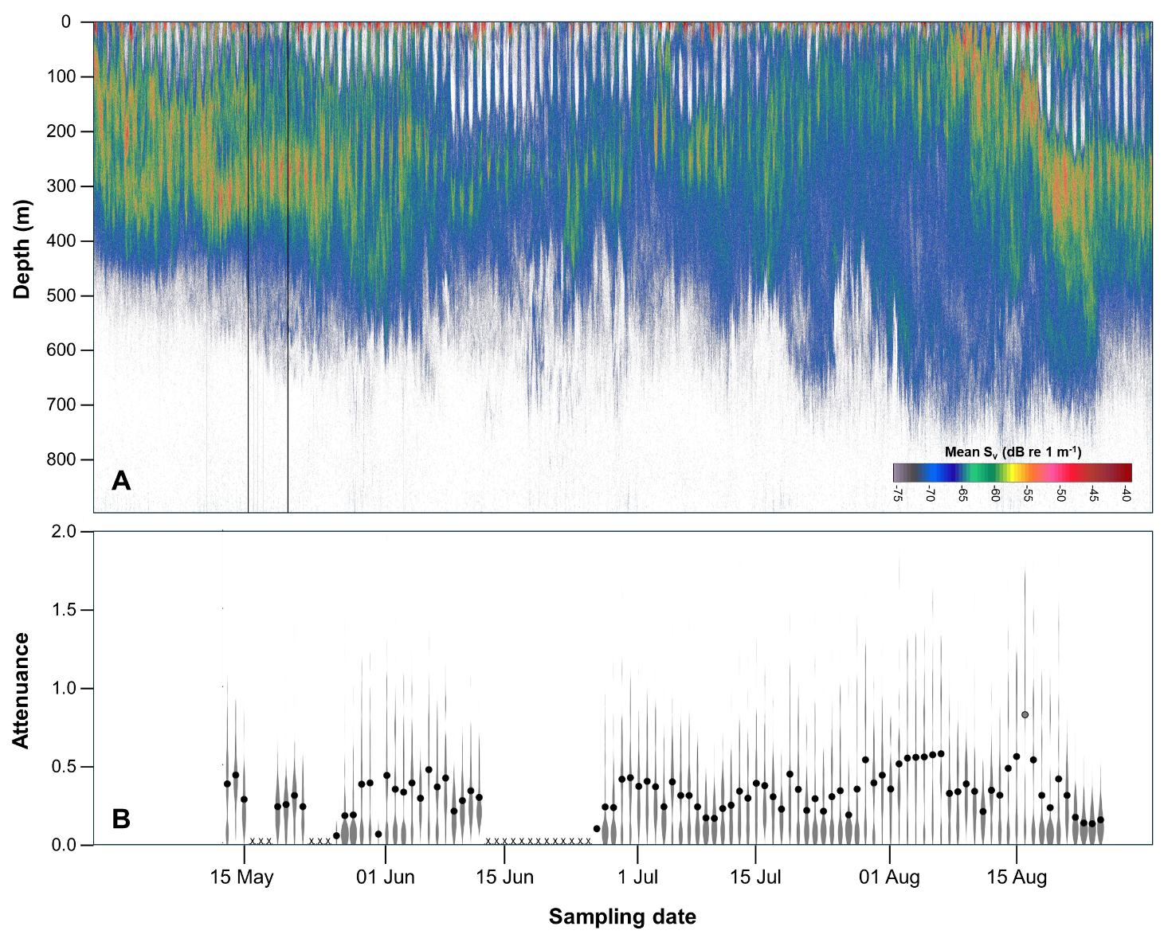

Figure 1. A. The vertical distribution of acoustic volume backscatter at 38 kHz, a proxy for the density and biomass of midwater animals throughout the sampling period in 2023. Black vertical bands represent missing data during short gaps in sampling. B. The distribution, density, and summary statistics for the amplitude of attenuance measured in the particulate carbon trap for each day throughout the study. In gray, the violin plots show the data density where wider section represent more data points for attenuance values. Black circles represent the median value for each hour while days when sampling did not occur are denoted with an x.

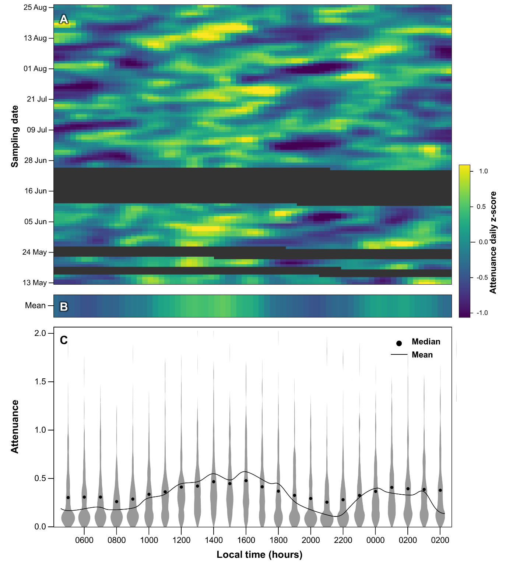
Figure 2. Attenuance measured in the particulate carbon trap as a function of time of day. A. Normalized attenuance throughout the sampling period. Raw values were converted to a daily z-score where the daily mean was subtracted from the value in each 20-minute sampling bin and divided by the day’s standard deviation. This minimizes differences in absolute attenuance between days while highlighting daily patterns. Gaps in sampling are highlighted in dark gray. B. The mean daily pattern in attenuance z-scores. C. The distribution, density, and summary statistics of the amplitude of attenuance over the study period are shown in one-hour bins. In gray, violin plots show the data density where wider section represent a greater number of data points. Black circles represent the median value for each hour while the black line shows the mean.
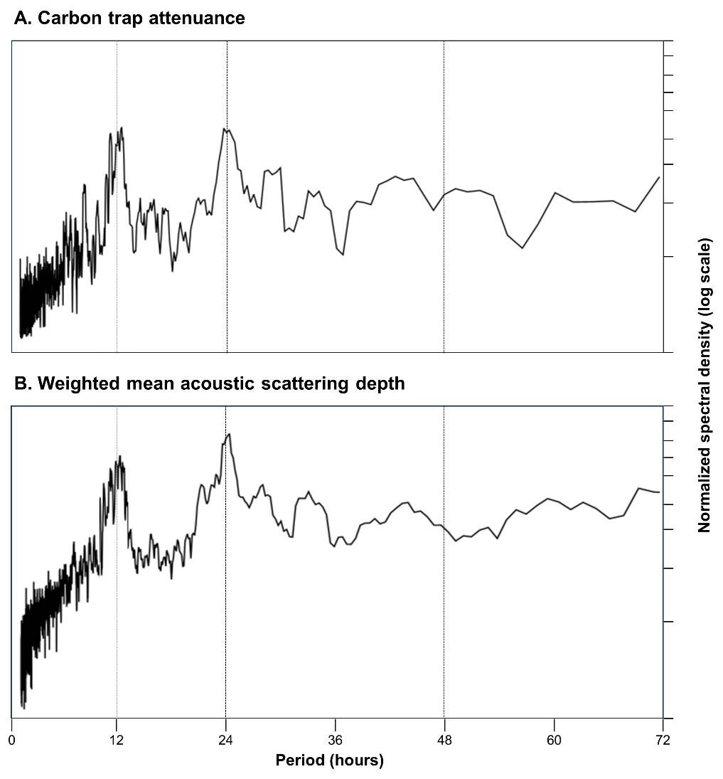
Figure 3. The normalized spectral density of 20-minute resolution data of attenuance from the particulate carbon trap (A) and mean scattering depth of animals measured by the echosounder (B). Both datasets show dominant signals around 12 and 24 hour periods.

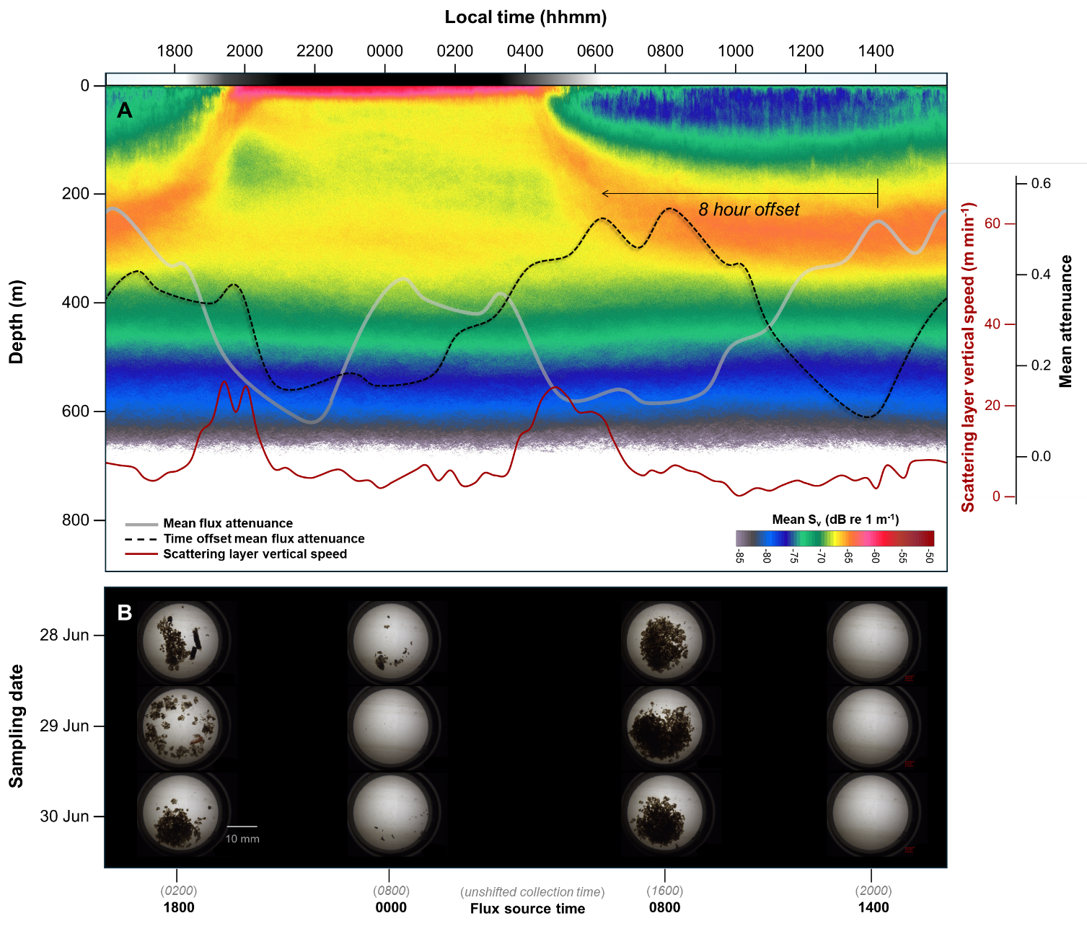

Figure 4. A. A composite echogram shows the average daily pattern of acoustic scattering strength as a function of depth over the study period. Overlaid on this as a red line is the vertical speed of the change in the weighted mean depth of scattering, highlighting the timing of vertical migration. The gray line shows the mean attenuance measured in the particulate carbon trap while the black dashed line represents the same data offset 8 hours earlier to match the strongest observed correlation with the acoustic data. B. Images from the particulate carbon trap taken near the peaks and nulls in the measured attenuance on each of three consecutive days from the middle of the study period. Over each of the selected days, diel peaks accounted for ~35% of the total carbon flux of ~0.3 gCm⁻²d⁻¹. These samples illustrate the patterns observed in carbon flux and the forms of carbon found in the trap throughout each diel cycle.

Table 1. Summary of best subsets multiple regression models for daily mean and diel variability (diel peak/mean) attenuance values from the particulate carbon trap at the MARS cabled observatory. Attenuance and fluorescence data collected by the particulate carbon trap were shifted 8 hours earlier to align with the echosounder data before daily values were calculated (n=92 days).
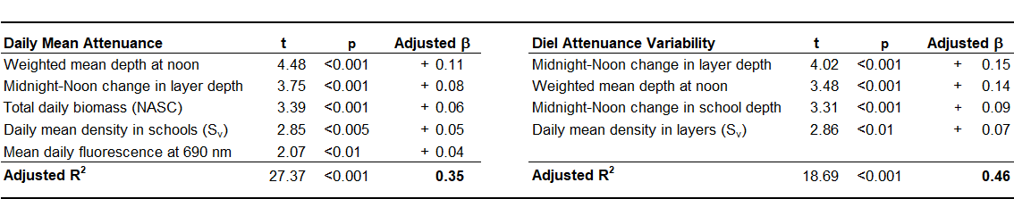

Explanatory variables are listed in descending order of importance for each model. The slope of the relationship for each explanatory variable is shown along with its adjusted beta. The R² for each model adjusted for the number of variables in the model is also shown.

Supplemental material

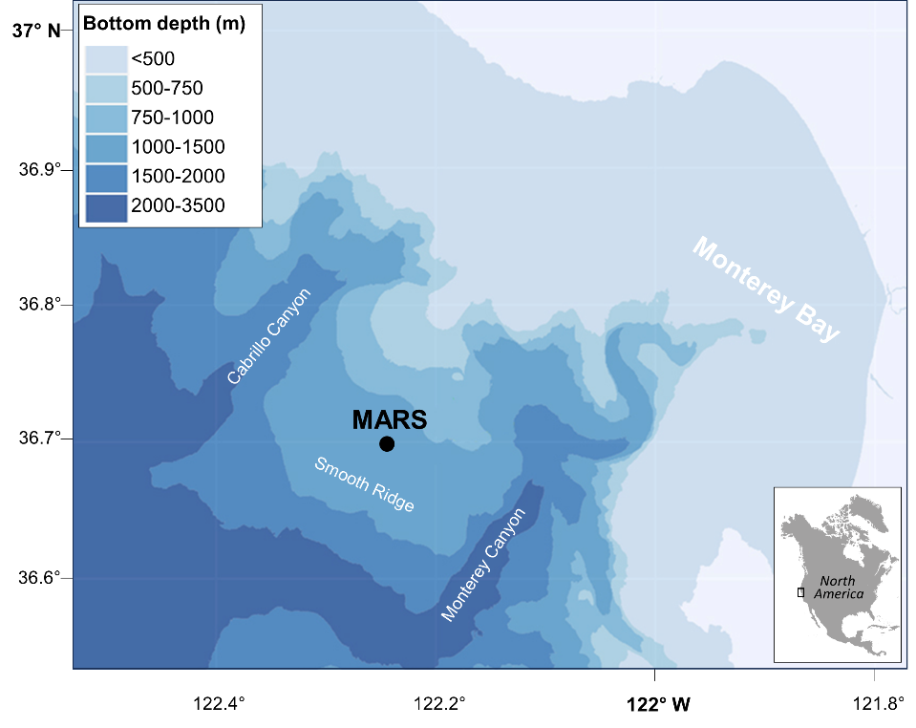
Supplemental Figure 1. A map of the Monterey Accelerated Research Station (MARS) site on the west coast of North America along with nearby bathymetric features.

Supplemental Figure 2. Power spectra were used to explore the temporal patterns in measurements and models of potential drivers of the observed patterns during the study period: normalized spectral density of 20-minute resolution data of (A) attenuance measured in the particulate carbon trap, (B) depth of scatterers from the echosounder, (C) modeled clear-sky solar irradiance (Jensen et al. 2023), (D) current speed measured with a seafloor current sensor at MARS (E) modeled tidal height (National Oceanic and Atmospheric Administration Station 9413450, Monterey, CA).
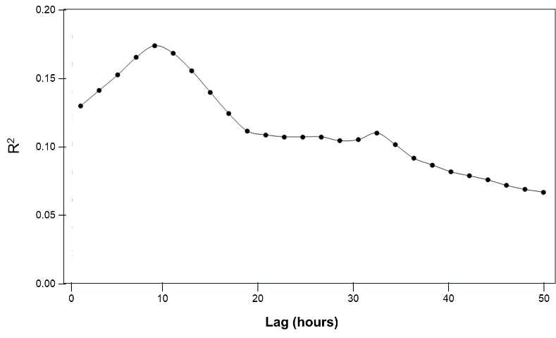
Supplemental Figure 3. A correlogram showing the regression coefficient of best subsets multiple regression models relating attenuance measured in the carbon trap with measures of acoustic scattering, fluorescence, and tidal data at various time lags. All data were in 20-minute bins, resulting in approximately in a sample size of ~5600. The significant predictors in the final model were weighted mean depth of all scattering (+), a proxy of scattering layer biomass (NASC, +), acoustic density within scattering layers (mean S_{v}, +), and the peak density of schools (maximum S_{v}, +). The correlogram shows a peak in the strength of the relationship at 8 hours with a smaller peak at a daily harmonic of this lag, 32 hours.

