Project Number: | 902305

Project Start: Jan. 1, | 2024 | Project Duration (in years): | 2 of 3¹

Please indicate if proposal includes requests for any of the following (mark all that apply).

 | X |  |  | X
Ship Time |  |  | ROV |  |  | AUV |  |  | Wave Glider |  |  | Mini ROV

Please indicate what type of project is being proposed (mark only one).

 |  |  |  | X |  |  | X
Feasibility/Scoping  [<100 days effort] |  |  | Development |  |  | Research |  |  | Infrastructure² |  |  | Education |  |  | Time Series |  |  | Institute Initiative

Project Manager: Crissy Huffard
Principal Investigator: Crissy Huffard
Lead Scientist: Colleen Durkin
Lead Engineer: Rich Henthorn

Project Title: Event Detection using the Sedimentation Event Sensor

Please indicate which category best describes the project theme (mark only one).

 | X
Ocean  biogeochemistry |  |  | Ecosystem dynamics |  |  | Ocean visualization |  |  | Exploration & discovery

Please indicate percentage of effort on this project anticipated for 2024 toward these three highest institutional goals from the Strategic Roadmap (percentage total should equal 100%).

Goal | Innovate and Build | Explore and Protect | Inspire and Engage
Percentage | 80 | 10 | 10

- ABSTRACT (all projects)
Briefly provide a high-level summary of the project (ideally no more than 1/2 page).

Problem/need:
High-magnitude carbon flux events can represent a significant fraction of deep-sea carbon sequestration. However, perhaps because they are short-lived and unpredictable, these “pulse” events are understudied, and missing from global carbon flux models. Studying pulse events poses significant logistical challenges. We need in situ instrumentation that can detect pulse events as they occur, and trigger other nearby instruments to change their sampling schedule, or wake up and monitor additional parameters. These advancements work toward more strategic use of power-hungry autonomous instrumentation needed to evaluate numerous possible drivers and ecological impacts of pulse events.

Goals/timeline:
The Sedimentation Event Sensor (SES) images sinking material and can communicate with other instruments using underwater acoustic modems. We will develop a means for the SES to detect pulse events as they occur, and trigger other instruments (modified McLane sediment trap, concurrently proposed SINKER instrument) to initiate or modify sampling during a pulse event. This algorithm and communication pathway will be designed so that it can be used by other instruments in addition to the SES. This project will continue in 2024 by:
- developing triggering algorithms and simulating pulse events using existing data,
- conducting autonomous deployments of the SES at MARS to characterize variability of particle types and magnitudes at that site, and
- assessing feasibility of modifying an existing McLane sediment trap for autonomous triggering.

- PROPOSAL (all projects)

Background
What fundamental problem does this project address?

- Importance: High-magnitude carbon flux events can represent a significant fraction of deep-sea carbon sequestration. They also appear to be associated with short- and long-term deep-sea deoxygenation.

- Knowledge gaps: Perhaps because they are short-lived and unpredictable, these “pulse” events are understudied, and missing from global carbon flux models.

- Problem: Studying pulse events poses significant logistical challenges. Ship-based surveys cannot stand by waiting for them to take place. A few autonomous instruments have the persistence needed to document when pulse events occur, but they are currently constrained to measuring a few parameters with a fixed temporal resolution. We need in situ instrumentation that can detect pulse events as they occur, and trigger other nearby instruments to change their sampling schedule, or wake up and monitor additional parameters. These advancements work toward more strategic use of power-hungry autonomous instrumentation needed to evaluate numerous possible drivers and ecological impacts of pulse events.

What makes this work relevant to MBARI and the Packard Foundation?

- On the technology side, event response and adaptive sampling algorithms are areas that have been of interest at MBARI for a long time. The techniques that we develop could lend themselves to work and interest of many developments and field programs (LRAUV, Canon, SINKER, Canyon studies).

- On the science side, being able to trigger sampling based on the occurrence of an event will allow researchers to use a suite of power-hungry autonomous instruments to study important but unpredictable events.

- Members of our team developed the SES, and have spent the last ten years studying pulse events at Station M so that we can better understand deep-sea carbon sequestration.

Is this effort linked to other internal or externally funded projects or collaborative efforts?

- This project takes advantage of context and expertise gained from the Pelagic-Benthic Coupling group (901618), and will provide data and engineering advancements useful to the Carbon Flux Ecology lab (902111).

- We envision collaborating with the Carbon Flux Ecology group to use the SES to trigger sampling by SINKER (902306).

- We look forward to collaborating with Yanwu Zhang (Targeted Sampling by Systems of Autonomous Vehicles, 901513) to discuss shared needs, challenges, and progress. Both of our projects seek to target sampling of evolving ecological events/features using multiple instruments. Key differences between these projects are that ours focuses on changes over one dimension (time), and there is no option to resample to verify event condition. By contrast, TSSAV involves numerous autonomous instruments tracking features using four dimensions of input, and has the ability to retrace three of those dimensions to verify feature condition.

Where does this work fit into the ~5–10 year plan for your group, at MBARI, and in the field?

- In the near-term, this work transfers technology and knowledge from the Pelagic Benthic Coupling lab (ended in 2023) to the Carbon Flux Ecology lab.
- Mid-term, it develops a means to calibrate estimates of carbon flux based on imaging systems (SES, SINKER--902306) with those based on physical samples (McLane sediment traps).
- It will also provide a flexible event-triggering algorithm that can be used by other groups at MBARI (e.g. LRAUV)
- Longer term, we aim to link the growing interest in studying episodic carbon flux events with the ongoing external development of scalable but power-limited automatic sampling methods (e.g. Minions).

[Click here to enter text]

Nature and Scope of the Proposed Project
- Use existing data from prior SES deployments (primarily at Station M), and prior sediment trap deployments near MARS to:
  - mathematically define pulse events and develop an algorithm that identifies early indicators of their occurrence,
  - test the algorithm using simulated pulse events to evaluate chances of false positive and negative triggering events
- Refine code needed for the SES to conduct data/image analysis and run the algorithm onboard
- Design a modification to configure a conventional McLane sediment trap with a modem, and develop a conceptual plan for triggering it acoustically through the SES
- Continue deployment of the SES near MARS to:
  - collect data about variability of particle type, quantity, and time variability during anticipated high and low flux periods
  - Take advantage of this deployment for McGill and Henthorn to teach Hu and Huffard how to operate the SES

Does this activity relate to one or more 2024 proposals your team is submitting?

This project uses developments by the Pelagic Benthic Coupling group (901618) to increase sampling efficiency by the Carbon Flux Ecology lab (902301), and SINKER (902306), with the common goal to quantify carbon flux through the water column.

Anticipated Shared Resource Needs
Ship days:
- Rachel Carson: If we can stay on MARS, do we need any ship days?

Facilities:
- Machine shop:
  - Configure McLane trap for communication with SES
- Test tank
  - Ensure proper buoyancy and ballast for modified McLane trap

Anticipated Expenses
2024: <$50K

- MARS port fees ($12k)
- Satellite communication fees
- Ballast for modified McLane trap

Intellectual Property (IP) Considerations

None

Data

What data will be generated?

Images (TIFF files) and logs/data (CSV):
<1 Tb

How will they be managed/stored?

Images from the SES deployments at MARS will be stored on Project Library and incorporated into the VARS for images once Brian Schlining is done upgrading that software.

Data files, analyses, and codes will be stored on a share created for this project on Project library.

Anticipated Impact
We aim to produce event detection algorithms that are agnostic to the type of data used. Our aim is to produce a workflow that is useful to any research group wishing to study unpredictable, short-lived, significant events by using one low-power autonomous instrument as a controller to initiate sampling by other autonomous instruments.

Anticipated Outreach Needs

None this year

Continuing Projects Only: Status Report
Briefly provide an update of the current project relative to what was proposed for 2023 by responding to the prompts below. If the project includes multiple subproject projects, please list each of these under a subheading as you deem appropriate.

Current status of project and results to date

- SES deployment at MARS:
  - Thanks to port availability and supporting funds to cover port fees, the SES was deployed and plugged into MARS in May 2023.
  - Rich Henthorn has developed code that allows us to view images.

- Initial insights into particle flux variability
  - Fluxes are very high, at levels that would clog conventional sediment traps:
  - Thanks to port availability and supporting funds to cover port fees, the SES was deployed autonomously at MARS in May 2023.
  - Rich Henthorn has developed code that allows us to view recently-collected images and access fluorescence data.
  - Colleen Durkin developed a Python code to estimate modeled carbon flux from particle composition and attenuance (Figure 1).
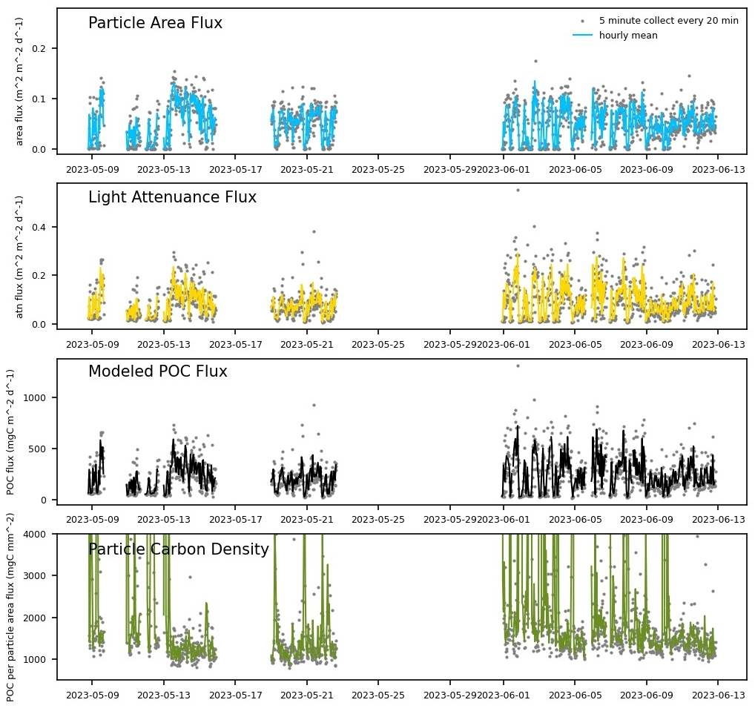
Figure 1. Preliminary data from SES at MARS showing variability of particle and carbon flux at that site.

What percentage of labor and budget have been used through the 1st half of year?

[Click here to enter text]

Will you complete the current year’s scheduled work?

[Click here to enter text]

Significant changes from previous project proposal

[Click here to enter text]

Over the past two years, what peer-reviewed publications, education and/or outreach activities have resulted directly from this project? Please be brief.

[Click here to enter text]

All Projects: Specific Plans for 2024

Research Activities

[Click here to enter text]

Engineering/technology development

[Click here to enter text]

Field programs (detail ship requirements/deployments/diver requirements)

In addition to describing anticipated field programs, please be sure to include requirements for specific platforms and equipment (Dorado AUVs, LRAUVs, Wave Glider, mini ROV, etc.) for each proposed field program so that expectations are clear. Requests must also be entered in the budget entry system.

[Click here to enter text]

Specific deliverables

[Click here to enter text]

Milestones and required personnel (see personnel classification list for staff classifications)

[Click here to enter text]

2024 Project Start Date:  MM/DD/2024 | Milestone 1 | Milestone 2 | Milestone 3 | Milestone 4 | Milestone 5 | Total Resources (in hours) for each resource category for all milestones listed here
Milestone Date
Milestone Description
Electrical Engineer
Software Eng-Embedded
Software Eng-Info Eng
Mechanical Engineer
Mechanical Eng-Division
Mechanical Eng-Mfg
Associate Engineer
Electrical Tech
Software Tech
Mechanical Tech
Machinist
Divers
Video Lab
(Add other categories/rows as needed)

Budget justification

[Click here to enter text]

Project team

[Click here to enter text]

External consultants/contractors
If you propose to engage an external consultant/contractor, please attach a sufficiently detailed SOW and budget proposal from the vendor. If approved, a fully executed Independent Contractor Agreement must be in place before work can begin.

[Click here to enter text]

Project lab and office space requirements
In addition to any changes to current space usage, please also include anticipated office and lab needs for students, postdocs, collaborators, etc.

[Click here to enter text]

Risk matrix (development and infrastructure projects only)

 | Technical Risk | Organizational Risk | Tech Transfer Risk | Labor Estimate Risk
High
Medium
Low

Compliance Considerations

All responses must be recorded in the Google form linked below. A form must be submitted for every project.

Link to Google Compliance Considerations form -OR- https://forms.gle/wVCb9VRRuYBU5yvF8

This date and number should remain the same for the duration of the project. If your project start date for 2024 is not January 1, please indicate the start date in the first cell of the milestone chart. Format for duration example: “Year 2 of 5”.
Development and infrastructure projects must complete the risk matrix (see end of the proposal form).
Not all projects will require all four titles to be filled in. Please indicate individuals only for those titles that are appropriate for your project.
This category includes transfer of hardware, know-how, publications, presentations, etc.
This number should be the same number you entered on the web budget resource requests for this particular resource.

