Project Number: | 902305

Project Start: Jan. 1, | 2026 | Project Duration (in years): | 3¹

Please indicate if proposal includes requests for any of the following (mark all that apply).

 | - |  |  | - |  |  |  |  |  | X
Ship Time  (requested in 902111) |  |  | ROV  (requested in 902111) |  |  | AUV |  |  | Wave Glider |  |  | Mini ROV

Please indicate what type of project is being proposed (mark only one).

 |  |  |  | X
Feasibility/Scoping  [<100 days effort] |  |  | Development |  |  | Research |  |  | Infrastructure² |  |  | Education |  |  | Time Series |  |  | Institute Initiative

Project Manager: Crissy Huffard
Principal Investigator: Crissy Huffard
Lead Scientist: Colleen Durkin
Lead Engineer: Rich Henthorn

Project Title:
Event Detection by the Sedimentation Event Sensor

Please indicate which category best describes the project theme (mark only one).

 | X
Ocean  biogeochemistry |  |  | Ecosystem dynamics |  |  | Ocean visualization |  |  | Exploration & discovery

Please indicate percentage of effort on this project anticipated for 2026 toward these three highest institutional goals from the Strategic Roadmap (percentage total should equal 100%).

Goal | Innovate and Build | Explore and Protect | Inspire and Engage
Percentage | 80 | 10 | 10

- ABSTRACT (all projects)

Problems/needs:
Sporadic, high-magnitude carbon flux events (“pulse events”) can represent a significant fraction of deep-sea carbon sequestration, but they are unpredictable and logistically hard to study. We need low-power, high-persistence instruments that can detect pulse events as they occur, and then trigger higher-power instruments nearby to wake up and monitor additional parameters. We need to demonstrate this is possible in a variety of deployment configurations.

To improve global carbon flux estimates, we need better alignment between methods used to observe particles sinking in the deep sea and the methods used to observe surface ocean particles from space. Meeting this goal requires new developments to apply aspects of remote sensing to deep-sea studies.

Pulse events differ in their carbon quantity, freshness, and biological sources. To study different pulse event types, we need instruments that can evaluate multiple data streams when deciding whether to trigger additional sampling.

Progress to date: 902305 (2023-2025)
We modified the Sedimentation Event Sensor (SES) to detect pulse events as they occurred using real-time onboard image analysis, and initiate sampling by a nearby sediment trap (Trigger Trap) based on the rate of change in image attenuance values. In 2024, the SES successfully initiated sampling by the Trigger Trap when the two instruments were deployed as landers near MARS. In December 2024 we added adaptive triggering to the algorithm. The SES can now bracket its trigger threshold throughout a deployment based on the recent trigger rate.

Goals/timeline:
We propose to expand the SES and Trigger Trap event detection operational range to offshore/mooring conditions in 2026 and 2027, to evaluate in-line modem communications. We also propose to evaluate, and ideally add, a fluorescence or multispectral imaging system to the SES for use in dual-channel decision-making, and to better match satellite-based carbon flux estimates (2026: feasibility, 2027: development, 2028: testing at MARS)

- PROPOSAL (all projects)

Background
Provide context for the project, being sure to address these questions:
- What fundamental problem does this project address, and why is it important?

Importance
  - Sporadic, high-magnitude carbon flux events (“pulse events”) can represent a significant fraction of deep-sea carbon sequestration, but they are missing from global carbon flux models.
  - Instruments that can detect unpredictable pulse events as they occur, and trigger other instruments nearby to wake up and monitor additional parameters, help make better use of power-hungry oceanographic instruments.

Knowledge gaps
  - Current global carbon flux models perform poorly when trying to model pulse events from satellite data.
  - Pulse events differ in their carbon quantity, freshness, and biological sources. Different pulse event types may require different trigger criteria.

Engineering challenges
  - To match remote sensing spectra used to study carbon export from space with the spectra of particles sinking in deep sea, we will need to develop new imaging capabilities.
  - To study different pulse event types, we need instruments that can evaluate multiple data streams when deciding whether to trigger additional sampling.
  - Pulse event detection algorithms need be tested in a wide range of deployment conditions before they can be exported to other research groups.

- What makes this work relevant to MBARI and the Packard Foundation?

  - On the technology side, event response and adaptive sampling algorithms are areas that have been of interest at MBARI for a long time. The techniques that we develop could lend themselves to work and interest of many developments and field programs (LRAUV, Canon, SINKER, Canyon studies).

  - On the science side, being able to trigger sampling based on the occurrence of an event will allow researchers to use a suite of power-hungry autonomous instruments to study important but unpredictable events.

- Is this effort linked to other internal or externally funded projects or collaborative efforts

- This project will provide data and engineering advancements useful to the Carbon Flux Ecology lab (902111). Also, al ship time for this project in 2026 is requested in the 902111 proposal.
- We envision collaborating with Carbon Flux Ecology group to use the SES to trigger sampling by SINKER.
- This project provides a collaborative test bed for adaptive, bracketed triggering approaches developed for Targeted Sampling by Systems of Autonomous Vehicles (901513).

- Where does this work fit into the ~5–10 year plan for your group, at MBARI, and in the field?

  - In the near-term, this project develops a means to calibrate estimates of carbon flux based on imaging systems (SES, SINKER--902306) with those based on physical samples (McLane sediment traps).
  - Longer term, we aim to link the growing interest in studying episodic carbon flux events with the ongoing external development of scalable but power-limited automatic sampling methods (e.g. Minions).

  - It will also provide a flexible event-triggering algorithm that can be used by other groups at MBARI (e.g. LRAUV)
  - The eventual goal is to incorporate the SES and TT into the Carbon Flux Ecology lab’s science instrumentation suite, used regularly in combination with SINKER to study carbon sequestration.
  - Algorithm developments can be adapted to guide event-detection/adaptive triggering in other MBARI assets.

Nature and Scope of the Proposed Project
Please provide a sense of the scale and scope of the proposed work. Is this a large de novo R&D effort, modest platform/sensor integration, targeted science investigation with minimal or no engineering needs, extension of current program, small-scale scoping exercise expected to lead to a larger effort, or other? If the project is intended to be multiple years, how will the anticipated level of effort likely change over time?

This proposal is an extension of a current program (902305-- Event detection by the Sedimentation Event Sensor, ending in 2025).

Nature and scope 2026:
- Deploy the SES and Trigger Trap offshore on a deep, subsurface mooring.
  - Use adaptive triggering algorithm that can raise/lower the threshold for triggering if the triggering rate is too low/high.
  - Calibrate SES attenuance to carbon flux measured from Trigger Trap samples.
  - Use the Wave Glider to communicate with the SES and retrieve recent image attenuance to evaluate whether it has clogged
- Evaluate performance of triggering algorithm in offshore conditions.
- Evaluate feasibility of replacing SES fluorometer with fluorescence imaging system.

Expenses:
We expect the expenses to decrease each year:
~$75K in 2026
~$50K in 2027
~$25K in 2028

Personnel:
We expect personnel time to be about the same as current labor budgets for 902305. It’s possible 2027 will be a slightly busier year fabricating a fluorescence or multispectral imaging system.

Ship requests:
We are requesting no ship time (beyond those already requested in 902111) for 2026 and 2027. We plan to request four Carson days in 2028.

Does this activity relate to one or more 2026 proposals your team is submitting?
If so, provide a list of relevant projects by project/DQ # and provide a brief description of how they are related. Since resources are limited and cuts during Phase 1 are likely, please indicate where this project fits in the hierarchy of your priorities. Does this proposal take precedent over other ongoing or planned activities?

All ship needs for this project’s deployments are being requested in the CFE lab proposal (902111).

Anticipated Shared Resource Needs
What staffing is required to advance the work in 2026 (e.g., is this a multi-faceted engineering development or a targeted science investigation that does not require significant use of shared personnel)? Is in-house or contract manufacturing needed? What level of ship/ROV/AUV (DMO) support is likely? If this is intended to be a multi-year effort, please provide a rough indication of anticipated shared resource needs over the duration of the project (e.g., will stay flat, will significantly increase in Year X, will significantly decrease by Year Y).

Project team includes:
- Rich Henthorn
- Irene Hu
- Ben Jansen
- Alana Sherman
- Crissy Huffard
- Colleen Durkin
- Yanwu Zhang
- Denis Klimov

Ship days:
- 2026: Deploy (April) and recover (September) the SES and Trigger Trap on the CFE lab’s Packard cruises, which are requested separately in their proposal (902111).
- 2027: Deploy and recover the SES and Trigger Trap on the CFE lab’s Packard cruises, which will be requested separately in their proposal (902111).
- 2028: Two Rachel Carson cruises (12 h)--one to deploy and plugin at MARS (early spring) and one to unplug/recover (late fall)

Facilities:
- Machine shop:
  - 2026: outfit SES and Trigger Trap for mooring deployment
  - 2027-2028: Fabricate and refine fluorescence or multispectral imaging system
- Test tank
  - all years

Wave Glider:
- 2026, 2027: Pass by location of SES and Trigger Trap deployment to check status (1 per offshore deployment)

Anticipated Expenses
What rough order of magnitude direct expense budget is anticipated annually over the course of the project? Is procurement of specialized capital equipment or outside contractors required? Will there be annual travel?

2026: <$75K
- outfit the SES and Trigger Trap for mooring deployment
- Batteries: SES, Trigger Trap, modem, releases
- Modem to replace one on Trigger Trap that is not currently working and might be broken beyond repair.
- Spare parts, hardware and maintenance

2027: <$50K
- Batteries: SES, Trigger Trap, modem, releases
- Fluorescence imaging system components

2028: <$25K
- SES MARS port fees, Trigger Trap and modem batteries
- Conference for Huffard, Henthorn to present science and engineering results

Intellectual Property (IP) Considerations

No

Data
What types of data will be generated?

Images (TIFF files) and logs/data (CSV):
2026: 2 TB
2027: 2 TB
2028: 4 TB

Images from the SES deployments will be stored on the VARS for images server (\\atlas.shore.mbari.org\VARS_Stn-M_Image_Archive), and incorporated into the VARS for images database.

Data files, analyses, and codes will be stored on a share created for this project (either on Project library, or a separate folder, whichever IS prefers).

Anticipated Impact

We are designing this project to be useful to oceanographic institutes, both within and beyond MBARI, who seek to study unpredictable events in the ocean. We aim to produce event detection algorithms that are adaptive to the type of data used, making decisions based on one or two data streams.

Anticipated Outreach Needs

We welcome collaboration with the Science Communication team to develop outreach materials to highlight collaborative engineering and science developments.

Continuing Projects Only: Status Report
Briefly provide an update of the current project relative to what was proposed for 2025 by responding to the prompts below. If the project includes multiple subproject projects, please list each of these under a subheading as you deem appropriate.

Current status of project and results to date

The SES deployment on MARS in 2023 provided preliminary data, which guided our design of a triggering algorithm. We tested this initial algorithm in 2024, with co-deployment of the SES and TT, which yielded 6 successful triggers. Adaptive triggering, which brackets triggering threshold, was added to this algorithm in December 2024. These deployments have provided interesting ecological and engineering results.

Ecology:

Understanding that we may not see large interannual pulses during all deployments, we considered any noticeable peaks in sinking material quantity (image attenuance) to be pulses. Each of these pulses was dominated by different sinking particles, indicating a variety of mechanisms driving carbon flux. Aggregates and large fecal pellets were abundant during pulse and non-pulse periods alike, though the relative contributions varied (Figure 1).

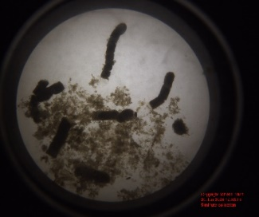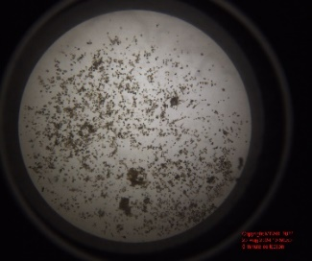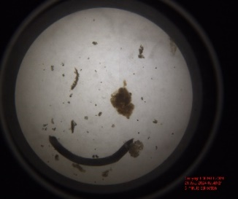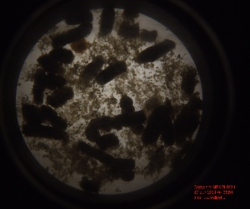
Figure 1. Example SES images showing different particle types and quantities.

On the deployment in 2024, we used an algorithm that triggered when the slope in 150-h rolling mean attenuance exceeded a particular threshold. Attenuance rise and fall were both included as possible triggers. The result was a defined start (Figure 2 red squares) and end (Figure 2 blue squares) to each pulse. Additional triggers were scheduled (Figure 2 black dots). Together these paired SES attenuance and TT sediment trap samples allowed comparison between image and laboratory analysis. Generally, mass flux (Figure 2 blue triangles, scale not included) and image attenuance correlated (Figure 3). This dataset provided ground-truthing for a model based on global sediment trap values (Figure 3).

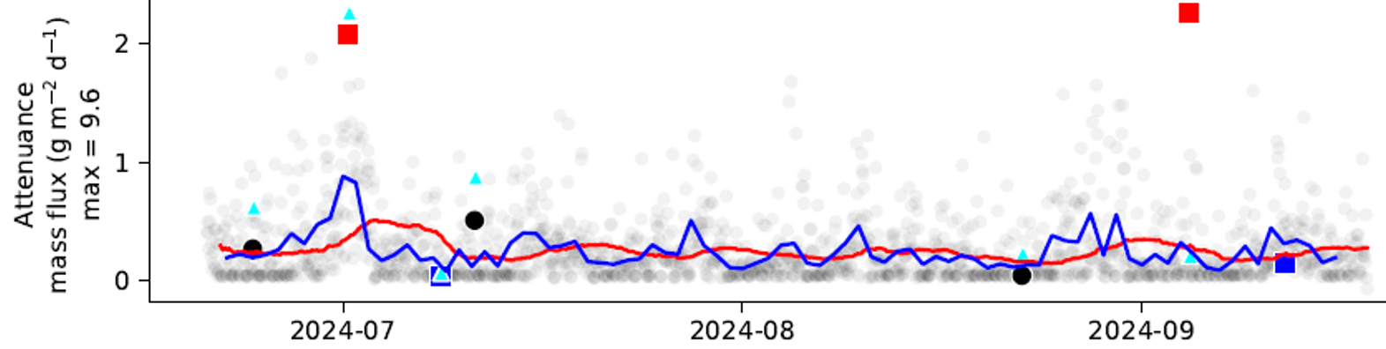
Figure 2. SES attenuance (left scale) and TT mass flux (no scale given) data time series. Attenuance calculated from SES images (red squares = rapid-increase trigger points, blue squares = rapid-decline trigger points, black dots = scheduled trigger points) and mass flux measured from TT samples (blue triangles, scale not shown). Transparent gray dots = hourly attenuance, and blue line = daily average, red line = 150 hour rolling mean used for triggering algorithm.

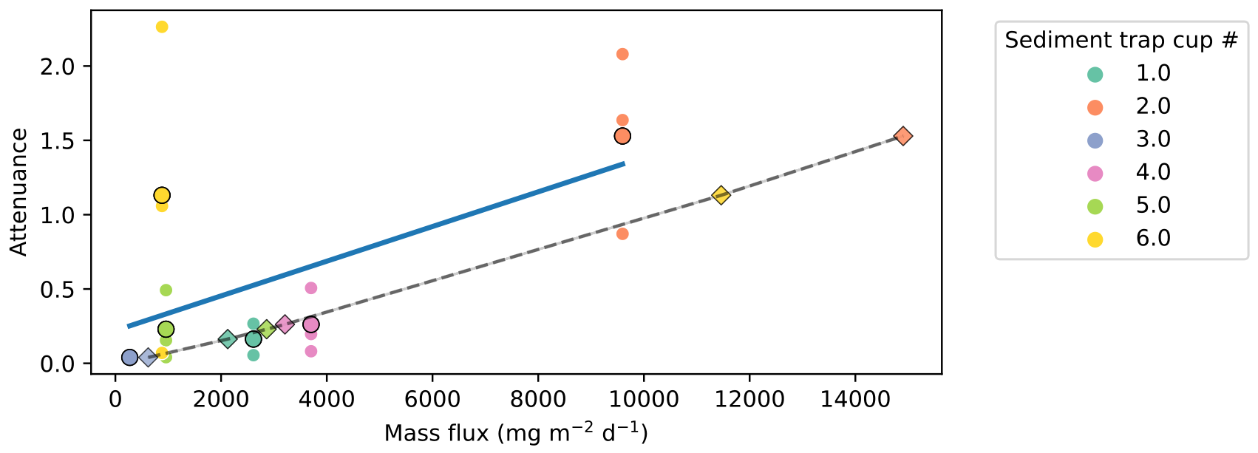
Figure 3. Comparison of mass flux measurements from the trigger trap samples and attenuance calculated from SES images. Blue line = linear regression of mass flux_{TT} vs. attenuance_{SES}. Dashed line = modeled relationship between attenuance and mass flux from Estapa et al. 2023 (mass flux_{modeled} = 1.03 e+04 * attenuance_{SES}^{0.87}). Markers are colored according to sediment trap cup (dots where mass flux_{TT}, diamonds where mass flux_{modeled}).

Engineering:

During the 2024 deployment, the SES conducted real-time on-board image analysis and event detection, sending commands that initiated sediment trap sampling within minutes. The SES also used less battery than expected, likely thanks to improved software and hardware efficiency. 6 of 9 acoustic commands sent by the SES were received and initiated sampling by the TT. The trigger commands sent aligned with periods we would have considered pulses and would have wanted to sample. Other than three commands not being received by the TT, the system performed exactly as planned. To improve on this, additional command attempts have been added.

The SES was loaded with an adaptive triggering algorithm for its Dec 2024-June 2025 deployment, detecting 8 pulses, and sending 11 commands to the TT (8 triggered, 3 scheduled). Throughout the deployment it verified triggering rate was on target. Unfortunately the TT modem did not receive transmission during the deployment, and will need to be repaired or replaced with another omnidirectional modem. We will try using a directional modem generously transferred to us by the Wave Glider group in 2025, but are not sure this will work well for our needs.

One significant achievement by the engineering team has been the transfer of Paul McGill’s SES responsibilities to the rest of the team. In collaboration with Rich Henthorn and Paul McGill, Irene Hu has made significant progress documenting SES operations in detail.

What percentage of labor and budget have been used through the 1st half of year?

18 (UPDATE)%. This is on pace with the workload planned for the year.

Will you complete the current year’s scheduled work?

Yes

Significant changes from previous project proposal

Compared to the last round of this project, addition of multi-spectral or fluorescence imaging and deployment offshore on a mooring are the most significant changes.

Over the past two years, what peer-reviewed publications, education and/or outreach activities have resulted directly from this project? Please be brief.

Huffard C.L., C.A. Durkin, I. Hu, P.R. McGill, E. Matiassen (2025) Optical sediment trap reveals mechanisms influencing deep-ocean carbon sequestration. Offshore Technology Conference doi:10.4043/35813-MS

Huffard, C.L. , C. Durkin, Y Zhang, R Henthorn, I Hu, P McGill, A Sherman (2024) Periodicity of sedimentation rates revealed by a high-temporal-resolution view of the biological carbon pump. Ocean Sciences New Orleans, LA USA

All Projects: Specific Plans for 2026

Research Activities

      - We will continue to evaluate the performance of the SES event detection algorithm during deployments.
      - We will refine calibration of SES-based carbon flux estimates to Trigger Trap sample data, and evaluate influence of different particle types on estimate performance and uncertainty.
      - Compare flux measurements from our instruments to environmental conditions (bottom currents, bottom-water pH and oxygen)
      - We will publish scientific results.

Engineering/technology development

      - We will expand the SES and Trigger Trap event detection operational range to offshore/mooring conditions. This deployment will help us evaluate in-line modem communications. The location will be chosen strategically to compliment SINKER data (CFE 902111), and study nearshore-offshore carbon transport.
      - We will assess the feasibility of adding a fluorescence or multispectral imaging system to the SES.

Field programs (detail ship requirements/deployments/diver requirements)

In addition to describing anticipated field programs, please be sure to include requirements for specific platforms and equipment (Dorado AUVs, LRAUVs, Wave Glider, mini ROV, etc.) for each proposed field program so that expectations are clear. Requests must also be entered in the budget entry system. Note that AUV deployment numbers and diver requirement questions are also included in the Compliance and Planning Considerations Form described at the end of this proposal form.

Ship time for deployment (April 2026) and recovery (September 2026) is requested separately in 902111’s proposal.

We request 1 Wave Glider deployment in May 2026 to check on the SES and TT.

Piloting/Watchkeeping

NA

Specific deliverables

- Deploy the SES and TT offshore on a deep subsea mooring to test performance of adaptive triggering algorithm in offshore conditions (lower fluxes than MARS) and modem communications on a mooring string. Check on SES and TT with Wave Glider.
- Assess feasibility of adding florescence or multispectral imaging to SES.
- Evaluate performance of event detection algorithms.
- Calibrate SES attenuance from TT sample carbon analysis.
- Publish science results: mathematical definitions of pulses, variety of particle types during pulses, correspondence between SES and TT flux estimates, and possible mechanisms driving variability in flux

Milestones and required personnel (see personnel classification list for staff classifications)
2026 Project Start Date:  01/01/2026 | Milestone 1 | Milestone 2 | Milestone 3 | Milestone 4 | Milestone 5 | Total Resources (in hours) for each resource category for all milestones listed here
Milestone Date | Spring 2026 | All year | All year | Fall 2026 | All year
Milestone Description | Deploy (April) SES and TT on mooring offshore, recover September | Assess feasibility of adding florescence or multispectral imaging to SES | Evaluate performance of event detection algorithms | Calibrate SES attenuance from TT sample carbon analysis | Publish science results
Milestone Priority for 2026  (Rate 1-5) | 1 | 1
Electrical Engineer | IH- | IH-  DK-
Software Eng-Embedded | RH- | RH-
Mechanical Tech | BJ- | BJ-
Sr. Research Specialist | CH-80 | CH-20 | CH-100  YZ-20 | CH-80 | CH-120  YZ-20 | CH-400

Budget justification: $67,200

- Strongback and other updated hardware for mooring deployment ($5000)
- Batteries ($3000 for Benthos modem batteries, $400 for over-the-counter batteries to run the TT and beacons, $200 for current meter, $14,600 for SES deployment)
- Modem to replace one on Trigger Trap that is not currently working ($40,000)
- Spares and maintenance ($5000 for connectors, cables, o-rings, titanium hardware).

Project team

Colleen Durkin
Rich Henthorn
Irene Hu
Crissy Huffard
Ben Jansen
Denis Klimov
Alana Sherman
Yanwu Zhang

External consultants/contractors

None

Project lab and office space requirements
- Individual workstations: algorithm development, analysis, paper writing
- High-bay/Machine shop: temporary use during deployment preparation
- Test tank: check ballast and test before deployments

Risk matrix (development and infrastructure projects only)

 | Technical Risk | Organizational Risk | Tech Transfer Risk | Labor Estimate Risk
High
Medium | X
Low |  | X | X | X

Compliance and Planning Considerations

All responses must be recorded in the Google form linked below. A form must be submitted for every project.

Link to Google Compliance and Planning Considerations form -OR- https://forms.gle/uKJrxRuRaBHUL8vT8

This date and number should remain the same for the duration of the project. If your project start date for 2026 is not January 1, please indicate the start date in the first cell of the milestone chart. Format for duration example: “Year 2 of 5”.
Development and infrastructure projects must complete the risk matrix (see end of the proposal form).
Not all projects will require all four titles to be filled in. Please indicate individuals only for those titles that are appropriate for your project.
This category includes transfer of hardware, know-how, publications, presentations, etc.
This number should be the same number you entered on the web budget resource requests for this particular resource.
E.g., enter a rating of 1 for highest priority, 5 for lowest priority.

