Project Number: | 902305

Project Start: Jan. 1, | 2026 | Project Duration (in years): | Year 2 of 3¹

Project Title: Event Detection using the Sedimentation Event Sensor

Project Manager: Crissy Huffard
Principal Investigator: Crissy Huffard
Lead Scientist: Colleen Durkin
Lead Engineer: Rich Henthorn

Note: Not all projects require entries for each title. Please only indicate individuals for titles appropriate for your project. Definitions for each position are found in the instructions for internal 2027 proposals.

- PROPOSAL (all projects)

Is this a feasibility study [<100 days (800 hours) of total labor requested]?
Yes

X No

Abstract or Background
Please provide a copy of the project abstract or background information. Please be sure to address: What fundamental problem does this project address? What makes this work relevant to MBARI (see our Strategic Roadmap Priorities and Challenges) and the Packard Foundation? Where does this work fit into the ~5–10 year plan for your group, at MBARI, and in the field?

Abstract/background narrative:

What fundamental problem does this project address?
- Sporadic, high-magnitude carbon flux events (“pulse events”) can represent a significant fraction of deep-sea carbon sequestration, but they are unpredictable and logistically hard to study. We need low-power, high-persistence instruments that can detect pulse events as they occur, and then trigger higher-power instruments nearby to wake up and monitor additional parameters. We need to demonstrate this is possible in a variety of deployment configurations.

- To improve global carbon flux estimates, we need better alignment between methods used to observe particles sinking in the deep sea and the methods used to observe surface ocean particles from space. Meeting this goal requires new developments to apply aspects of remote sensing to deep-sea studies.

- Pulse events differ in their carbon quantity, freshness, and biological sources. To study different pulse event types, we need instruments that can evaluate multiple data streams when deciding whether to trigger additional sampling.

What makes this work relevant to MBARI and the Packard Foundation?
- On the technology side, event response and adaptive sampling algorithms are areas that have been of interest at MBARI for a long time. The techniques that we develop could lend themselves to many developments and field programs (LRAUV, Canon, SINKER, Canyon studies).
- On the science side, being able to trigger sampling based on the occurrence of an event will allow researchers to use a suite of power-hungry autonomous instruments to study important but unpredictable events. Adding a fluorescence imaging system to the SES would also provide new insights into mechanisms driving deep-sea carbon sequestration

Where does this work fit into the ~5–10 year plan for your group, at MBARI, and in the field?
- In the near-term, this project develops a means to calibrate estimates of carbon flux based on imaging systems (SES, SINKER--902306) with those based on physical samples (McLane sediment traps).
- Longer term, we aim to link the growing interest in studying episodic carbon flux events with the ongoing external development of scalable but power-limited automatic sampling methods (e.g. Minions).
- It will also provide a flexible event-triggering algorithm that can be used by other groups at MBARI (e.g. LRAUV, SINKER)
- The eventual goal is to incorporate the SES and TT into the Carbon Flux Ecology lab’s science instrumentation suite, used regularly in combination with SINKER to study carbon sequestration.
- Algorithm developments can be adapted to guide event-detection/adaptive triggering in other MBARI assets.

Select relevant challenges in the table below, and complete the narrative in the space provided above.

Strategic Priorities and Challenges
Innovate and Build |  | Explore and Protect |  | Inspire and Engage
Build scalable technologies to improve ocean health assessments | ☒ | Explore and observe life in a dynamic ocean | ☐ | Share what we learn to inspire and inform ocean conservation | ☒
Map the deep seafloor at high resolution | ☐ | Study the impacts of climate change and other ocean threats | ☒ | Make ocean science and engineering careers accessible to all | ☐
Advance ocean-based artificial intelligence | ☒ |  |  | Invest in our people and foster a diverse and inclusive workforce

Does this activity relate to one or more 2027 proposals your team is submitting?
Is this effort linked to other internal or externally funded projects or collaborative efforts? If you plan to submit more than one Phase 1 proposal (internally or externally funded), please provide a list of those projects by Project or DQ#, and please make clear how this project relates to the others you plan to submit and where it ranks in your overall priorities. Does this proposal take precedent over other ongoing or planned activities? Please complete the tables as indicated, and provide any additional text in the space below. (Add more rows as needed.)

Project # | Project Name | Start Year | End Year | Priority  (1, 2, 3, etc.)

Add additional details here, as needed:

[Click here to enter text]

Continuing Projects Only: Status Report
Provide a brief update of the current project relative to what was proposed for 2026. If the project includes multiple subprojects(or milestones), please list each under a subheading as you deem appropriate.

Current status of project to date, including results and any significant changes from the previous project proposal

- Milestone 1--Deploy SES and Trigger trap:
We developed and incorporated a dual-channel triggering algorithm, prepared the system for deployment, tested it in the test tank, and deployed the mooring from the RV David Packard in April 2026. It is scheduled for recovery in September 2026. Calm seas on deployment day offered a chance for many new crew members to do a walkthrough of the mooring to learn its components and deployment method (Figure below).
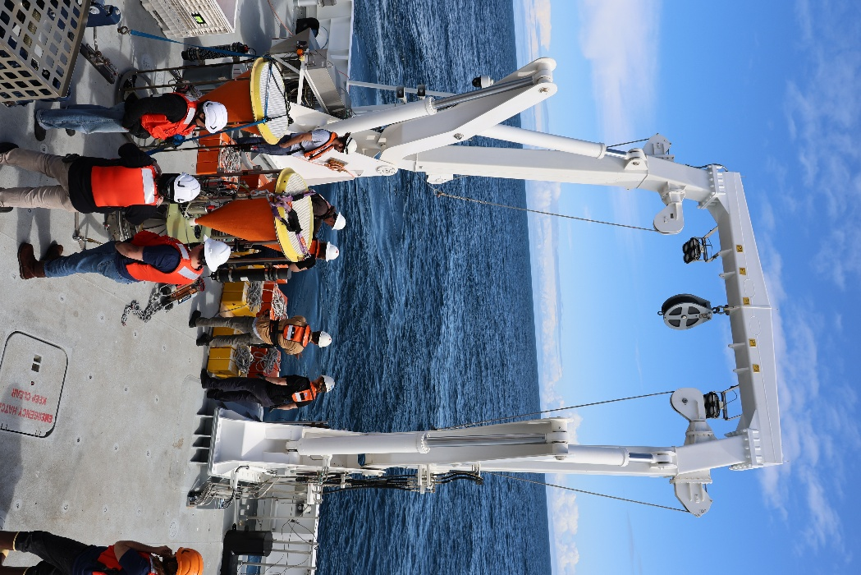

- Milestone 2--Assess feasibility of fluorescence imaging system:
We are currently learning from the Rover fluorescence imaging system and SES software architecture to see what cameras might be compatible, what optics/lighting they would require, and what image processing/storage and hardware space might be required. We will then assess the energy demand and software of the system to determine, as a team, whether adding this system would be feasible. We are thinking of adding a remote camera head plumbed into the main SES “brains” so that the system can be deployed alongside the current fluorometer. We have a long record of fluorometer data but interpreting these data has been difficult. Pairing the fluorometer with a fluorescence imaging system will help us make better use of prior measurements.

- Milestone 3--Evaluate performance of event detection:
This evaluation is currently underway, drawing from data collected during this and the previous years of deployment. We submitted an abstract to Oceans 2026 to present these results, and plan to submit a short paper to an IEEE journal on this topic by year end.

The figure below shows an example of a correctly performed trigger, with triggering image and associated attenuance value highlighted in red. The SES’s on-board, real-time image analysis and triggering algorithm correctly identified the pulse event and sent a command to the trigger trap.

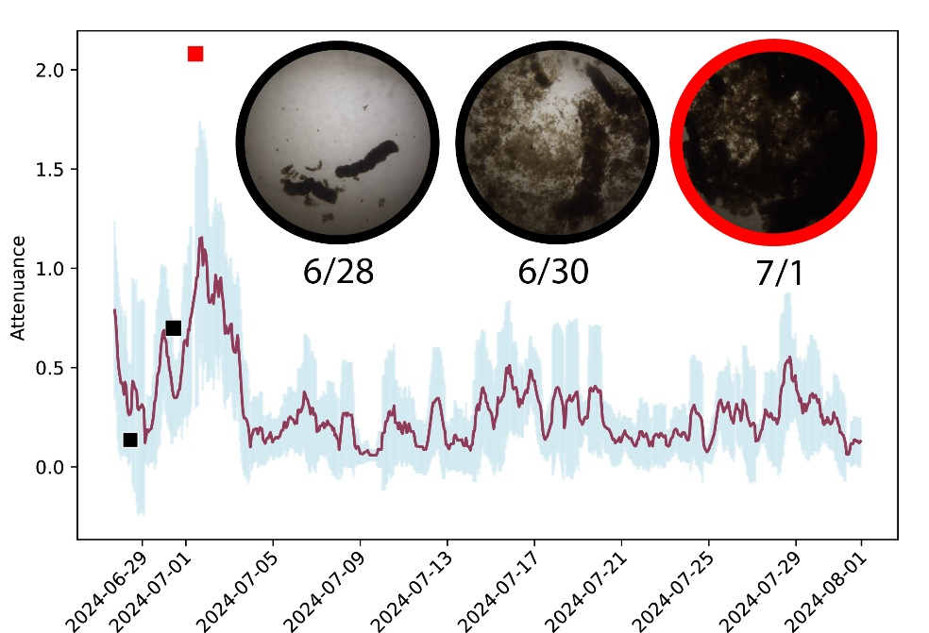

- Milestone 4--Calibrate SES images to Trigger trap samples:
To do in September after mooring recovery and sample retrieval.

- Milestone 5--Publish science results:
Our initial plan to publish science results is a little delayed a bit to make time for an opportunity to collaborate with KBB to synthesize SES and Echosounder results from MARS, and quantify role of diel vertical migration on carbon storage in the deep sea. Our plan for this and next year is to collaborate with the CFE lab (902305) to examine possible connections between inshore and offshore carbon flux.

What percentages of labor and budget have been used through the 1st half of year?

Budget: 51%
Labor: 53%

Will you complete the current year’s scheduled work?

Yes

List the last three peer-reviewed publications and/or other significant products, data sets, education and/or outreach activities, and similar activities that have resulted directly from this project? Please be brief.

Huffard, C. L., Durkin, C. A., Hu, I., McGill, P. R., & Mattiasen, E. (2025, April). Optical Sediment Trap Reveals Mechanisms Influencing Deep-Ocean Carbon Sequestration. In Offshore Technology Conference (p. D011S004R002). OTC.

All Projects: Major Activities for 2027

Research and/or Engineering Plans
Please provide an outline of research activities and/or engineering development plans (WBS, schedule, design, design reviews, manufacturing, prototyping, I&T, test deployments). Milestones—significant events in the timeline of a project useful for tracking progress—should be referenced here and included in the milestone chart below, as appropriate for your project. Include a maximum of five milestones.

We have five milestones planned for 2027:

- Deploy (April) SES and TT on mooring offshore: This will be our second offshore deployment, with two main goals:
  - Continue to understand performance of the dual-channel algorithm in offshore conditions We might find we need to modify triggering thresholds based on current conditions. When we deployed in April, there were large uncertainties about the strength of the forecasted El Niño. If we had known the event would progress so rapidly, and would be expected to be so strong, we might have lowered our thresholds, expecting lower flux. Regardless, having the SES and TT in the water for this spring/summer/early fall will provide a very interesting test of the system in unexpected conditions.
  - Share data with CFE la to collaborate on paper about offshore/inshore connections
The CFE lab’s SINKER provides an excellent high-temporal-resolution, very-detailed inshore compliment to the SES’s data. We look forward to having two years of data for comparative analysis and publication.
- If feasible, add florescence imaging to SES:
If our testing and feasibility analysis from this year show that it will be possible to add a fluorescence imaging system to the SES, then we would like to do so in 2027.
- Refine event-detection algorithms, add to SINKER:
Because the event-detection algorithm is instrument-agnostic, we plan to add it to the SINKER, which transmits data to shore real-time via MARS. We plan to use the modified SES triggering algorithm to have SINKER trigger other deployments, such as STTs, LRAUV, or Wave Glider.
- Calibrate SES attenuance from TT sample carbon analysis:
We continue to work toward calibrating the SES carbon flux model from image analysis to lab-analyzed samples from the Trigger Trap. Unfortunately, despite perfect performance by the SES and its triggering system, our last two deployments did not deliver Trigger Trap samples because of modem and mechanical problems.
- Publish science and engineering results:
We have so many exciting results and are very eager to share them with the broader community!

Specific Deliverables
Please briefly describe the anticipated deliverables (e.g., applications / tools, datasets, products) for the project.

- Deploy the SES and TT offshore on a deep subsea mooring to test performance of dual channel adaptive triggering algorithm in offshore conditions and modem communications on a mooring string. Check on SES and TT with Wave Glider.
- If fluorescence system is determined to be feasible by the end of this year, then build it and begin testing, aiming for deployment on MARS in 2028.
- Refine event-detection algorithms, and apply them to data from another instrument (SINKER).
- Calibrate SES attenuance from TT sample carbon analysis under large El Niño conditions.
- Publish science results: mathematical definitions of pulses, variety of particle types during pulses, correspondence between SES and TT flux estimates, and possible mechanisms driving variability in flux.

Field programs (detail ship requirements/other asset deployments/diver requirements)
In addition to describing anticipated field programs, please explain clearly all requirements for shared assets, platforms, and equipment (Dorado AUVs, LRAUVs, Wave Glider, MiniROV, etc.) for each proposed field program.

Asset resource requests must also be entered in the budget entry system. Note that AUV deployment numbers and diver requirement questions are also included in the Compliance and Planning Considerations Form described at the end of this proposal form.

Ship time for deployment (April 2027) and recovery (September 2027) is requested separately in 902111’s proposal.

We request 1 Wave Glider deployment in May 2027 to check on the SES and TT

Milestones and required personnel (see personnel classification list for Engineering and DMO staff classifications)
Please complete the milestone chart as necessary for your project. The milestone chart must clearly account for all of the shared labor resources required, grouped by project milestones. All labor resources listed in the milestone chart must be entered into the Adaptive accounting system. You may use initials for specific individuals.

Please verify that the labor entries in Adaptive match the entries in the milestone chart BEFORE submitting the final proposal.

2027 Project Start Date:  MM/DD/2027 | Milestone 1 | Milestone 2 | Milestone 3 | Milestone 4 | Milestone 5 | Total Resources (in hours) for each resource category for all milestones listed here
Milestone Date | Spring, fall 2026 | All year | All year | Fall 2026 | All year
Milestone Description | Deploy (April) SES and TT on mooring offshore, recover September | If feasible, add florescence imaging to SES | Refine event-detection algorithms, add to SINKER | Calibrate SES attenuance from TT sample carbon analysis | Publish science and engineering results
Milestone * Priority for 2027  (Rate 1-5) | 1 | 1
Electrical Engineer | IH-150 | IH-150  DK-120 | IH-20 |  | IH-20 | IH-340  DK-120
Software Eng-Embedded | RH-120 | RH-160 | RH-100 |  | RH-10 | RH-400
Mechanical Tech | BJ-100 | BJ-200 |  |  |  | BJ-300
Sr. Research Specialist | CH-100 | CH-80 | CH-20 | CH-50 | CH-180  YZ-20 | CH-430  YZ-40

*E.g., enter a rating of 1 for highest priority, 5 for lowest priority.

Budget justification
Enter budgets in the Adaptive accounting system and provide descriptions and justification for each request in the system. Label each expense description in Adaptive with an identifier (e.g., Milestone 1: Materials for EM Cable Terminations $4,000). If details in Adaptive are tied to specific tasks, then no further justification is required. If budget requests are not explained in Adaptive, please add more detail here.

The totals for each budget request and category detailed here must match the totals entered in Adaptive. Please verify BEFORE submitting the final proposal.

Total requested: $58,300 if no new modem needed. $98,300 if new modem is needed.
- Strongback and other updated hardware for mooring deployment ($5,000). This joins the releases to the ballast and is a single use item.
- Batteries ($3,000 for Benthos modem batteries, $400 for over-the-counter batteries to run the TT and beacons, $14,600 for SES deployment).
- Spares and maintenance ($3,000 for connectors, cables, o-rings, titanium hardware).
- Camera, filters, lighting, housing components for fluorescence imaging system if determined feasible. While we aim to use spares if possible many spares are over 15 years old and no longer supported or considered high quality imaging systems ($30,000).
- Ballast ($1000)
- Argos satellite beacon service ($1300)
- Possibly: We are using a very old directional modem on this deployment as a spare for one that flooded during testing right before we headed out to see. If this works during out current deployment, then we can use it again next year. But we will have no spares, which leaves us feeling a bit precarious. If we find in September that the current modem doesn’t work in the deployment configuration we’re using (mooring) then we’ll need to request funds for a new one.

Project team
Specify internal and external collaborators.

Crissy Huffard
Rich Henthorn
Colleen Durkin
Irene Hu
Ben Jansen
Denis Klimov
Alana Sherman
Yanwu Zhang

External consultants/contractors
If you propose to engage an external consultant/contractor, please attach a sufficiently detailed SOW and budget proposal from the vendor. If approved, a fully executed Independent Contractor Agreement must be in place before work can begin.

None

Long-Term Planning Considerations
Please describe any commitments on internally or externally funded projects that have implications beyond 2027. This could include commitments of shared assets, labor resources, ship time, international multiyear programs, large-scale expeditions, etc.

None

Compliance and Planning Considerations

All responses must be recorded in the Google form linked below. A form must be submitted for every project.

Link to Google Compliance and Planning Considerations form -OR- https://forms.gle/HW2tJDJdPzXHadyg9

This date and number should remain the same for the duration of the project. If your project start date for 2027 is not January 1, please indicate the start date in the first cell of the milestone chart. Format for duration example: “Year 2 of 5”.

