Acoustic modem:
On: Off:
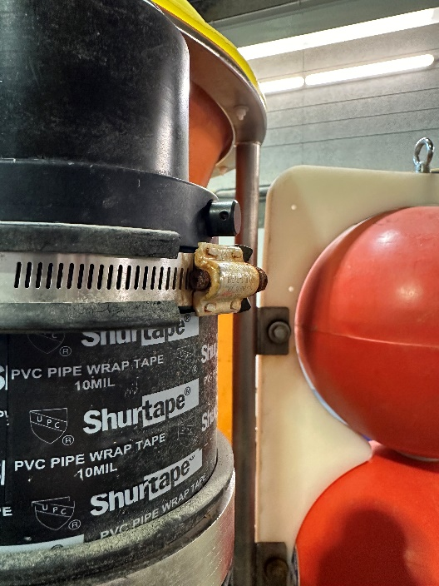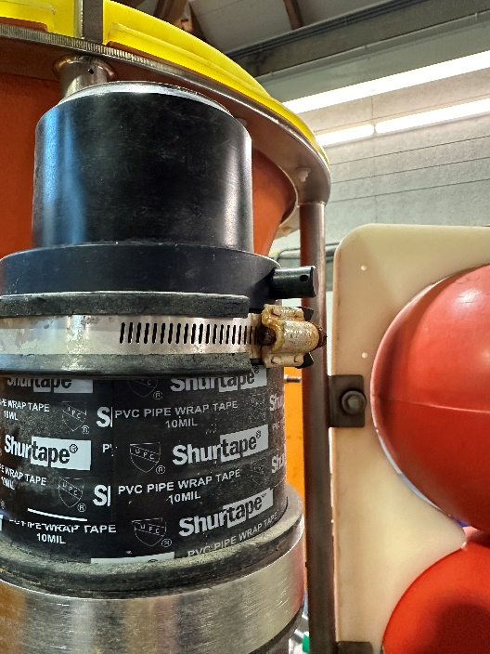
If forget to turn on, water pressure at depth will push it in, unless a pin is inserted.

HomerPro: Underwater locator beacon
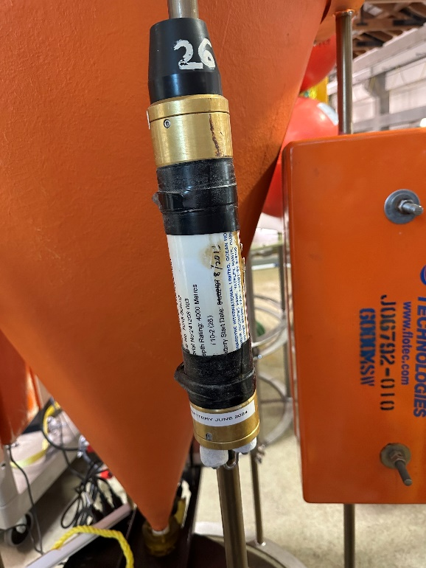
Fleet is maintained by DMO. Batteries are good for ~3 years, check battery install date and give to DMO techs for replacement if about to expire.
VHF, Strobe, and Argos beacons:
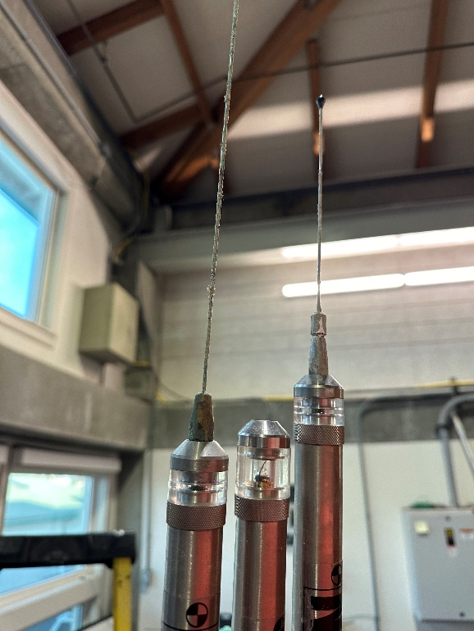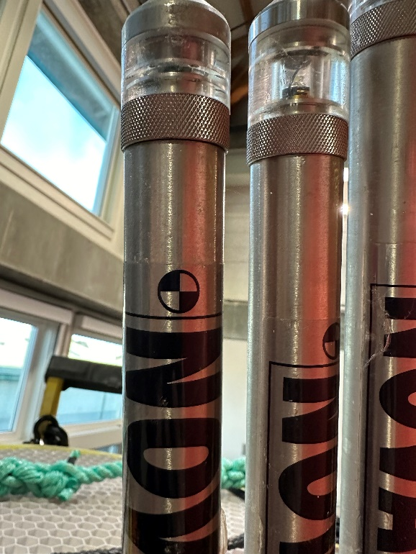
Argos has the shorter antenna (higher frequency). In the above photo, the zinc has corroded on the VHF Beacon antenna, so the antenna needs to be changed.
- Turn on/off by holding the battery to the mark. Lights blink to indicate status
  - One blink of light = ON, two blinks = OFF
  - Strobe and VHF Beacon will blink to show the state they are changing to.
  - Argos: upon first hold of magnet, blinks to tell you what state it’s currently in. Continue to hold magnet to change the state (second set of blinks).

- Strobe
  - For helping us see the system in the ocean
  - Set to turn on only in the dark (ie night) to conserve battery
  - To verify before deployment, cover with a hand to see it blink.
- VHF Beacon
  - Radio direction finder; during recovery, we give its frequency to the bridge to help them find our system
  - To verify before deployment, tune VHF receiver to the right frequency, and check for its beeps (if no receiver, can call bridge and ask if they hear it)
- Argos
  - Transmits GPS coordinates that are sent to the email distro list
  - A one-way system that transmits blindly and hopefully a satellite will pick it up
  - To verify before deployment, can tune the receiver to the Argos frequency. It most likely won’t decode, but listen for the burst of radio modem activity as it transmits.
  - If there are any problems with setup, billing, etc we will simply not receive the message, so helpful to test ~wk before deployment to make sure we get the emails
Important information for each beacon (eg frequency, Argos ID) is written on the sticker, but it’s often covered by tape. Before deployment, unearth information and write it on a more visible tape on the beacon.
Also before deployment: check/change batteries, check/change antenna, check Argos message

