Last updated 7/18/25
Standard turnaround: check all batteries
- Servicing for Beacon, strobe, radio: separate document
- Check on Homer Pro
- Change batteries in acoustic modem
  - Can use a crane to remove, or ME techs can help… prob a 2 person job
  - Detailed instructions in the manual that comes with each set of batteries
  - Nut driver for hose clamps: 5/16” (nuts may be rusted… need to specify S.S. bolt w/ S.S. hose clamp)
- Change batteries in battery sphere
Battery sphere:
- ME techs can help with opening and closing
- Protect O-ring surface w/ covers
- On closing, make sure to properly service O-rings
  - Inner: -282
  - Outer: -283
- Be sure to use anti-seize on the titanium screws
Battery turnaround for standalone:
- New batteries: label with date, voltage
- Pull out desiccants
- Only the connectors need to be undone, other connections can stay in place. Pull out pin and rest the plate to the side, standing on its side
- Removed battery: label date, voltage, and “USED”, and Kapton tape to seal the connector.
- New batteries in: crisscross them, orientation not important
- Tape around batteries should be taut… do one side, then pull batts, then tape the other side
- Put top plate on so the wires from the bottom have some slack
- Any battery can plug into any plug
- Redo any zipties (wire management), coil things as much as possible but leave some slack for wires from battery
- Put in fresh desiccant
Converting from MARS mode to standalone:
- Follow schematic for battery-only wiring, use the battery-only interface top plate
- Leave the VICOR bottom plate in, but tuck its wires underneath and out of the way
- The plate covering the VICOR can only go on one way. The spacing of its standoffs was widened to straddle the VICOR bottom plate.
- Four wires (red, orange, brown, black) need to be terminated with ring terminals (red barrel, size the ring for the terminals on the plate)
- The ethernet needs a pass-through connector to join two RJ45s
- Install wires, from the base of the housing, into appropriate screw terminals, and can ziptie and secure the rest
- Twice as many batteries go in for standalone as MARS mode, because the top plate needs less clearance. The pin goes in the top hole, and may need to screw down the plastic rod to get it to a better height.
Converting from standalone to MARS mode
- Follow schematic for MARS interface wiring, use the MARS/VICOR interface top plate.
- VICOR sits at the bottom of the battery sphere, but wires from it may have been tucked underneath the base plate. Free them and stretch to the top.
- Half as many batteries go in for MARS mode relative to standalone; they are for backup if power goes down on MARS.
  - If they fail, we may need to restart the mission once MARS comes back.
  - If using alkaline batteries, they are in parallel; wires come up and go to the screw terminals.
  - Lithium batteries need to be 2S and might need to use the connector harnesses made for the standalone battery plate
  - The pin goes in the middle hole; may need to unscrew the plastic rod slightly to raise the hole so the pin can fit with the top plate in
- Trace path of power from shorting plug to lug terminals out to controller, and wire as per diagram (mostly screwing in wires to the screw terminals)
- Install DSL box, which will talk to the modem in the SIIM can (ethernet converted to DSL to pass over longer cables)
- Probe connectivity +375V to pin 1, 375 return to pin 10
- Testing:
  - Connect through SES’s MARS port to SIIM can’s extension port
  - Set up a 600V high voltage power supply – check voltage and current output by plugging in multimeter with bananas (check current limit by plugging in for amps measurement)
  - MARS Port Test cable (bananas/ethernet to MINK10) with a MARS F-F green cable can be used to connect the power supply and computer to the SIIM can’s MARS port. Red/black twisted pair bananas go to pins 1 and 10 and should be used to supply 375V (yellow/black were used for 48V). Cable is in the care of MARS HQ in Building D.
  - Check power and comms using this setup. Can ping and ssh
  - Deck test: need to figure out our port on MARS and IP addresses, and configure SES accordingly through its deck cable. Then hook up SIIM can’s real MARS connector and plug into MARS wet node simulator. Check that we can ssh in.
- Package wires in housing bundle to avoid smashing by housing lid or rattling during transit
- Put in fresh desiccant
- Before sealing battery chamber, check for no connection between case and 375 V
- Setup to be mounted to the SES for all the MARS hardware (cable, SIIM can, plug) – documented in images, including disassembly in videos IMG_4774-4777. ROV pilots handle cable coiling etc.
- Wet node simulator test: all cables etc should be fully immersed in the water to test for ground faults

SIIM can: Science Instrument Interface Module
- Paul’s scheme to allow communications from MARS over longer distances, since DSL can travel further than ethernet
- Schematics for different SIIM cans are in “900733 Extension Cables – MARS” in Project Library
- Often will need two SIIM cans, one on MARS side and one on device side. For us (uses Rover’s), all the device side hardware is inside the battery sphere. MARS side has a modem, the PSU to power it, and 375V passed through to power the VICOR
- SIIM modems were previously powered by MARS 48V (safer than 375 V), but was rewired because new MARS doesn’t have 48V
- SAE port for vacuum / vent: connect to vacuum / nitrogen, pull vacuum to ~10” (?? 1/3 atm?), then seal, then put in nitrogen to ~1 atm
- Usually this should not need servicing… I think.

Other MARS testing/setup
Servicing inside camera and fluorometer housings: does not need to be done every time
- Check/replace batteries
  - TS7250 clock battery
  - Lithium battery on modem side of optoisolator
- Replace all O-rings
- Anti-seize on titanium screws
- Clean all optical surfaces – alcohol and kimwipes as first pass. For white residue, used GT glass liquid diamond polish with hand drill and poof (borrowed from ROV pilots)
To reinstall a housing
- Grease O-ring (minimally) & install
- Clean everything again, fastidiously- including windows, plastic, etc- anything not cleaned will fall and settle on the surface
- Fill w/ filtered ethanol/water
- Smush on housing – tube points upward
- Pour liquid (ethanol/water) into tube
- We had some problems with leakage. Went away after cleaning the radial O-ring within the housing, and securing the screws with Loctite (leakage path was through the housing)
- Get bubbles out: use overhead crane to turn SES almost completely on its side. Shake the SES, top off tubes, shake it some more. Also tried to use a syringe in the past (on video)
Carousel maintenance, eg to replace window or wiper
- Window is WG11513 – SP from Thorlabs
- When replacing carousel, remember to put in correct orientation, so the slide comes down at the correct point
Standalone Battery top plate, before and after installation:
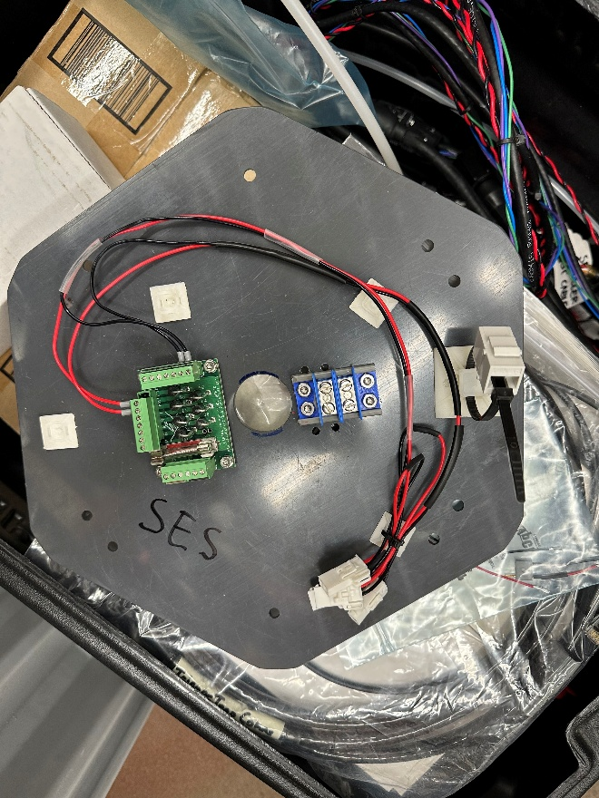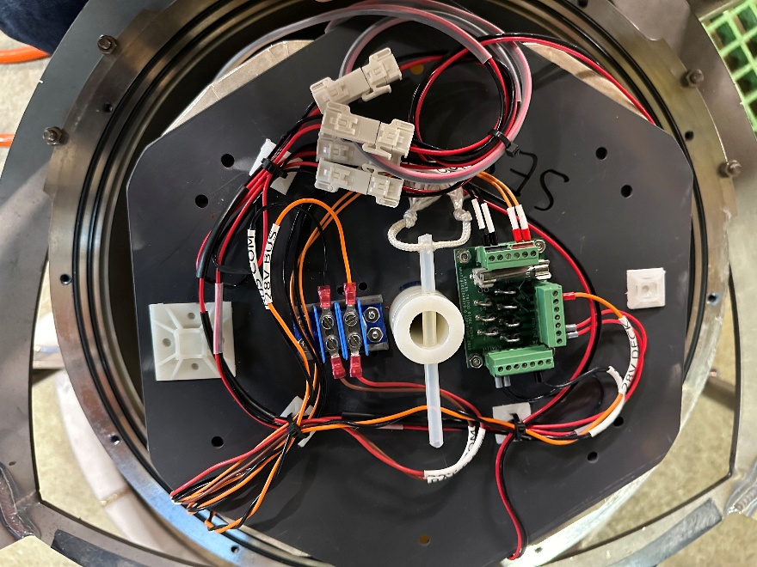
MARS battery plate, before and after installation
