SINKing Ecology Robot (SINKER) 902306 Colleen Durkin, Francisco Chavez, Paul Roberts, Alana Sherman, Paul McGill, François Cazenave, Rich Henthorn, George Stern, Enoch Nicholson
The SINKER (SINKing Ecology Robot) will measure variability of carbon flux to the seafloor and the ecological source of this variation. The instrument will be moored on the seafloor and initially designed for deployment at the MARS cabled observatory. When sinking particles settle through a vertical collection cylinder, they will be imaged by a set of cameras, and images will be used to identify particle types (e.g., fecal pellet, aggregate, organism) and to calculate their carbon fluxes and sinking speeds.
Engineering Activities
- The project team had a very productive sprint in Nov/Dec 2023 to complete a field-deployable build of the SINKER MARS interface, Sediment Camera, and Sinking Column.
- Tank testing of the Sediment Camera and port-wiping mechanism was completed prior to mobilizing on ROV Ventana for a Dec 13 cruise. Unfortunately, the cruise was cancelled due to ship crew illness.
- Preliminary mechanical and electrical design for the SINKER battery packs to support autonomous deployment were completed before the end of 2023.

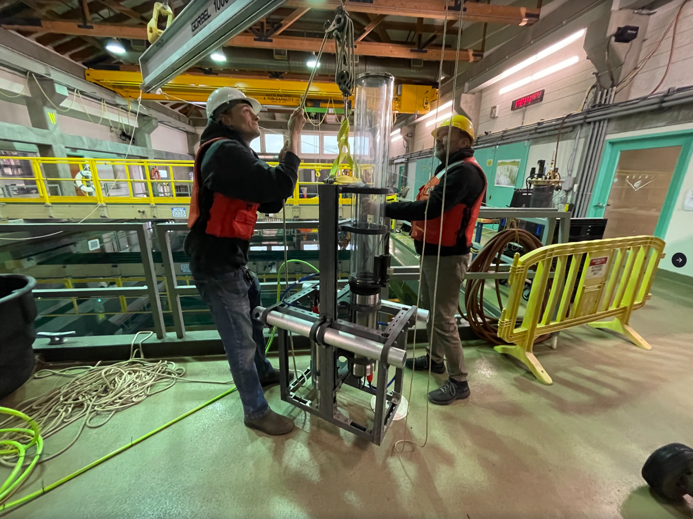
Figure 1: Engineers Enoch Nicholson and Rich Henthorn preparing to deploy SINKER in the test tank.

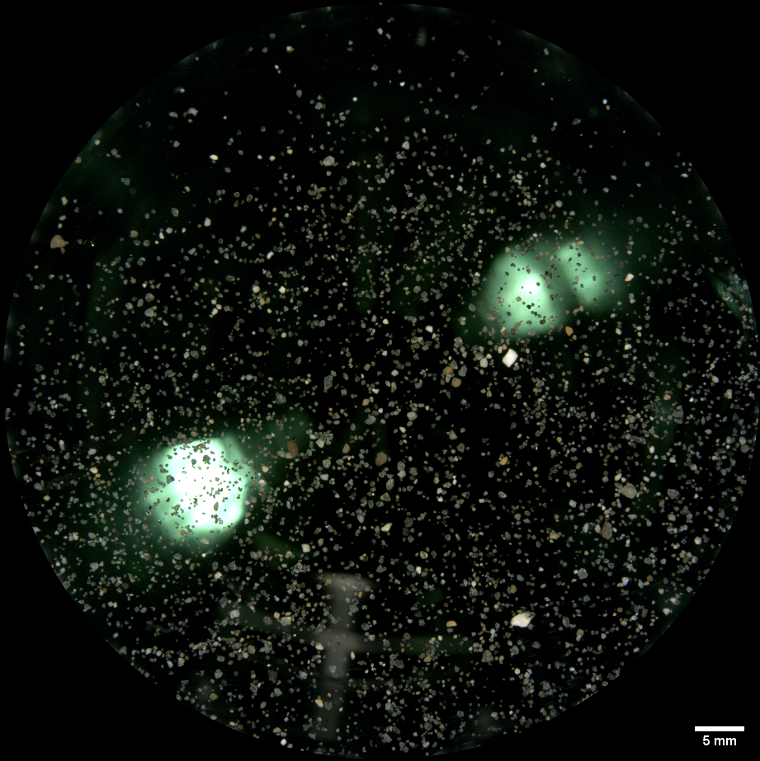
Figure 2: Test tank image of sand from the low-magnification sediment camera. The tank lights are visible in the background. Scale bar is shown in the bottom right corner of the image.
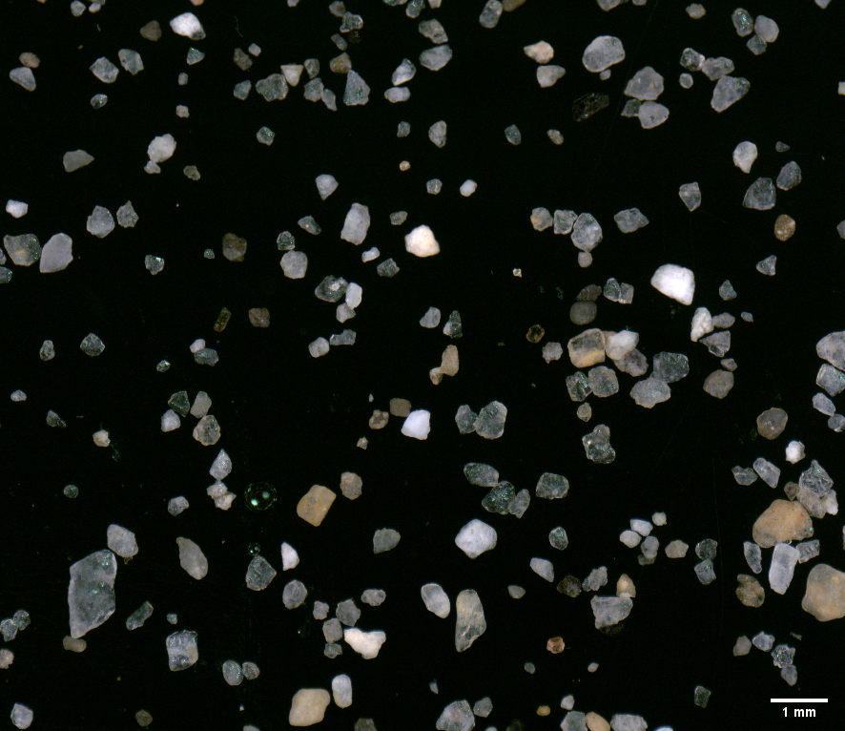
Figure 3: Test tank image of sand from the high-magnification sediment camera. Scale bar is shown in the bottom right corner of the image.

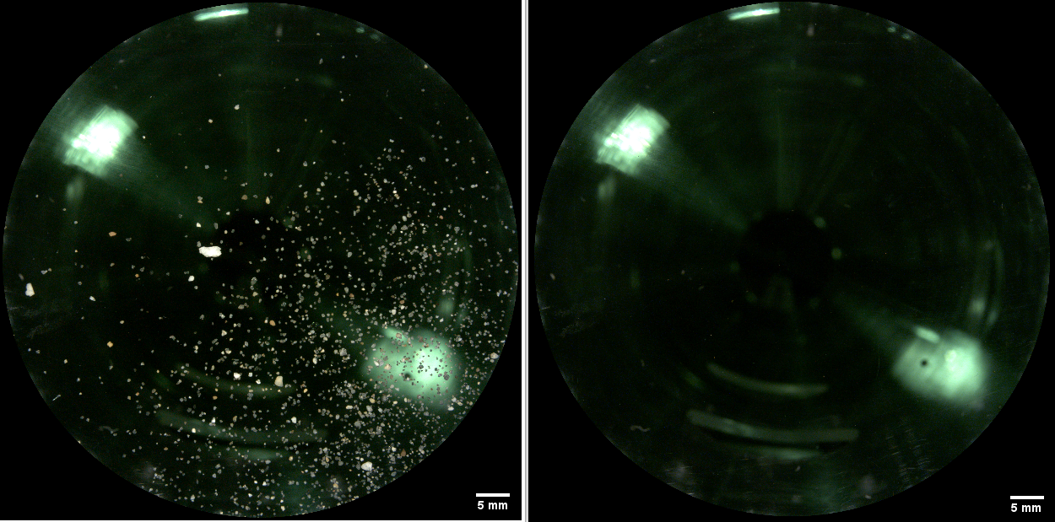
Figure 4: Comparison between low-magnification camera image before (left) and after (right) running the wiper confirming removal of over 90% of the sand on the port.

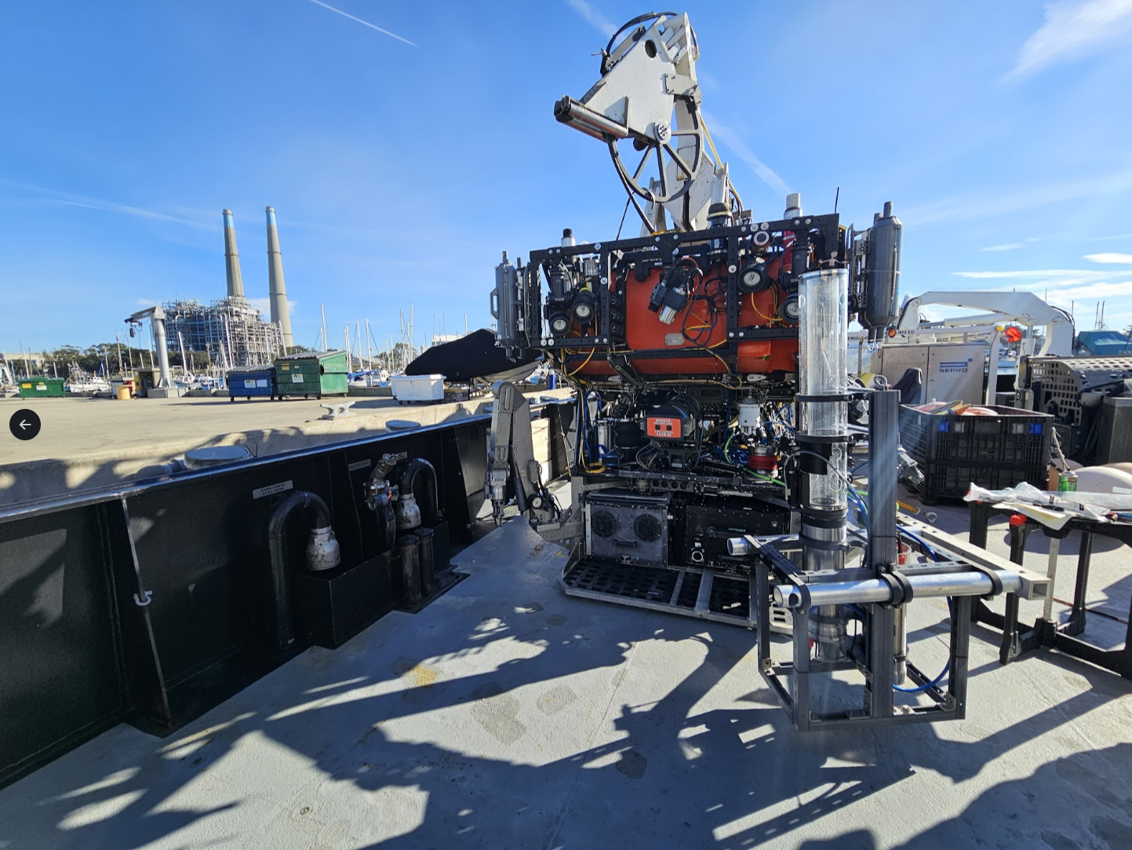
Figure 5: SINKER mounted on ROV Ventana after passing all vehicle integration tests.

