SINKing Ecology Robot (SINKER) 902306 Colleen Durkin, Francisco Chavez, Paul Roberts, Rich Henthorn, George Stern, Enoch Nicholson, James McClure, Karen Salamy, Danelle Cline
The SINKER (SINKing Ecology Robot) will measure variability of carbon flux to the seafloor and the ecological source of this variation. The instrument will be moored on the seafloor and initially designed for deployment at the MARS cabled observatory. When sinking particles settle through a vertical collection cylinder, they will be imaged by a set of cameras, and images will be used to identify particle types (e.g., fecal pellet, aggregate, organism) and to calculate their carbon fluxes and sinking speeds.
Engineering Activities
- Design of the MARS deployment frame design is complete (Figure 1) and fabrication will begin in April. The frame will allow autonomous and cabled deployments of SINKER at MARS during scheduled ship days in July, August, and December 2025.
- The project team is preparing for an autonomous deployment of SINKER near MARS during March 10 through March 17. Preparation includes building a set of 4, 1 KWh battery packs (Figure 2), software for autonomous recording events, data logging from a Nortek Signature 1000 current profiler, and integration of SINKER onto an existing elevator.
- Danelle Cline and Karen Salamy joined the project team in Jan 2025 and are working on the design of a shore-side dashboard to aid in control and visualization of SINKER images when deployed at MARS.

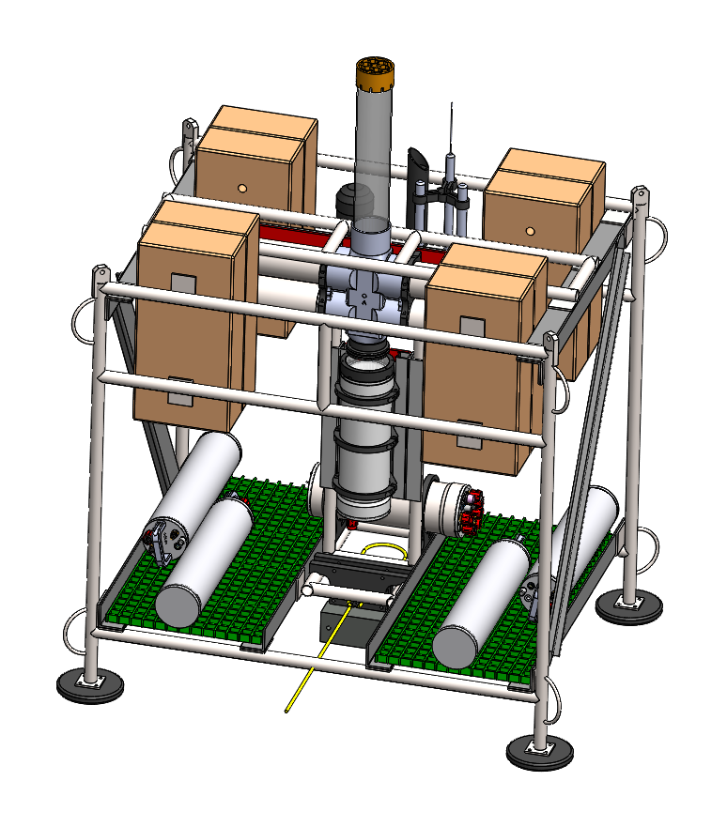
Figure 1: Completed design for the MARS deployment frame. The frame integrates SINKER into an elevator-like welded titanium frame with space for batteries during autonomous deployment or MARS cable during cables deployment.

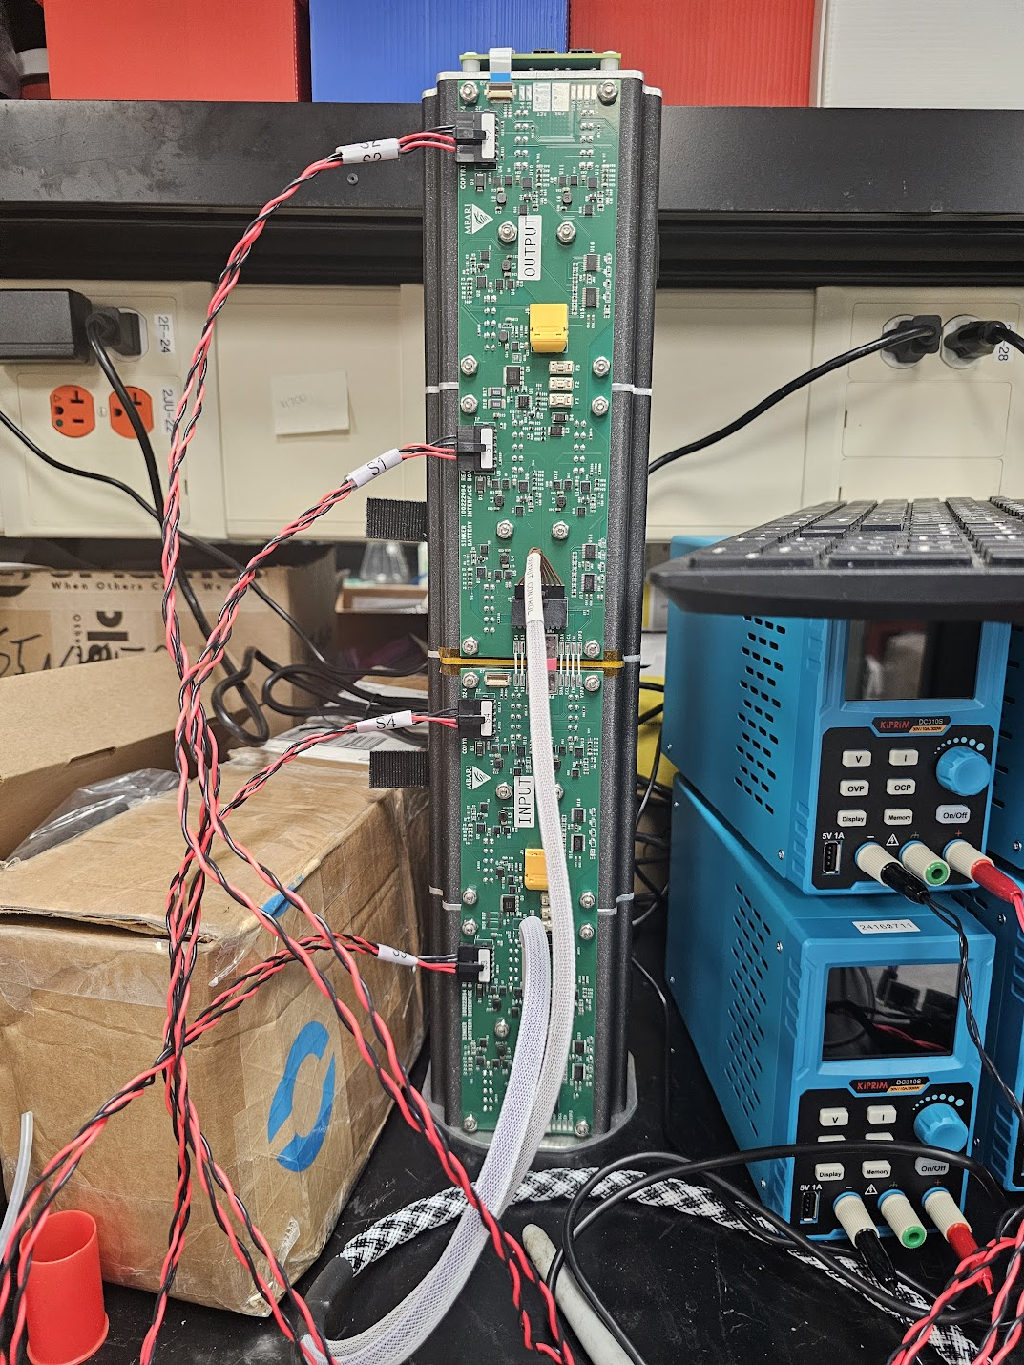
Figure 2: Bench testing and charging one of the new battery parks for SINKER. The pack is made up of 12 Inspired Energy modules with custom electronics to enable charging/discharging and the ability to daisy chain packs together.

