SINKing Ecology Robot (SINKER) 902306 Colleen Durkin, Francisco Chavez, Paul Roberts, Alana Sherman, Paul McGill, François Cazenave, Rich Henthorn, George Stern, Enoch Nicholson
The SINKER (SINKing Ecology Robot) will measure variability of carbon flux to the seafloor and the ecological source of this variation. The instrument will be moored on the seafloor and initially designed for deployment at the MARS cabled observatory. When sinking particles settle through a vertical collection cylinder, they will be imaged by a set of cameras, and images will be used to identify particle types (e.g., fecal pellet, aggregate, organism) and to calculate their carbon fluxes and sinking speeds.
Engineering Activities
- The project team has completed two field deployments of SINKER on Ventana with the dual-magnification sediment cameras, port wiper, and vehicle/MARS interface system (Figure 1).
- The Bioinspiration Lab dye injector was used to visualize flow around and inside of the SINKER sinking column while at depth providing essential insight in performance of the sinking column (Figure 2).
- Field deployments revealed several essential upgrades to the sinking column and wiper mechanism to enable accurate measurements of sinking particle flux, and reliable port cleaning at depth. These upgrades are in design and fabrication now and are targeting a July 2024 test deployment.
- The MBARI 4k science camera along with the SINKER illumination were used to allow in situ visualization of particle sinking inside of the sinking column with high spatial and temporal resolution.
- Particle accumulation during a 1-hour test was measured in both magnifications of the sediment camera with sufficient resolution to identify and size objects in the range of 50 um up to several centimeters (Figure 3).

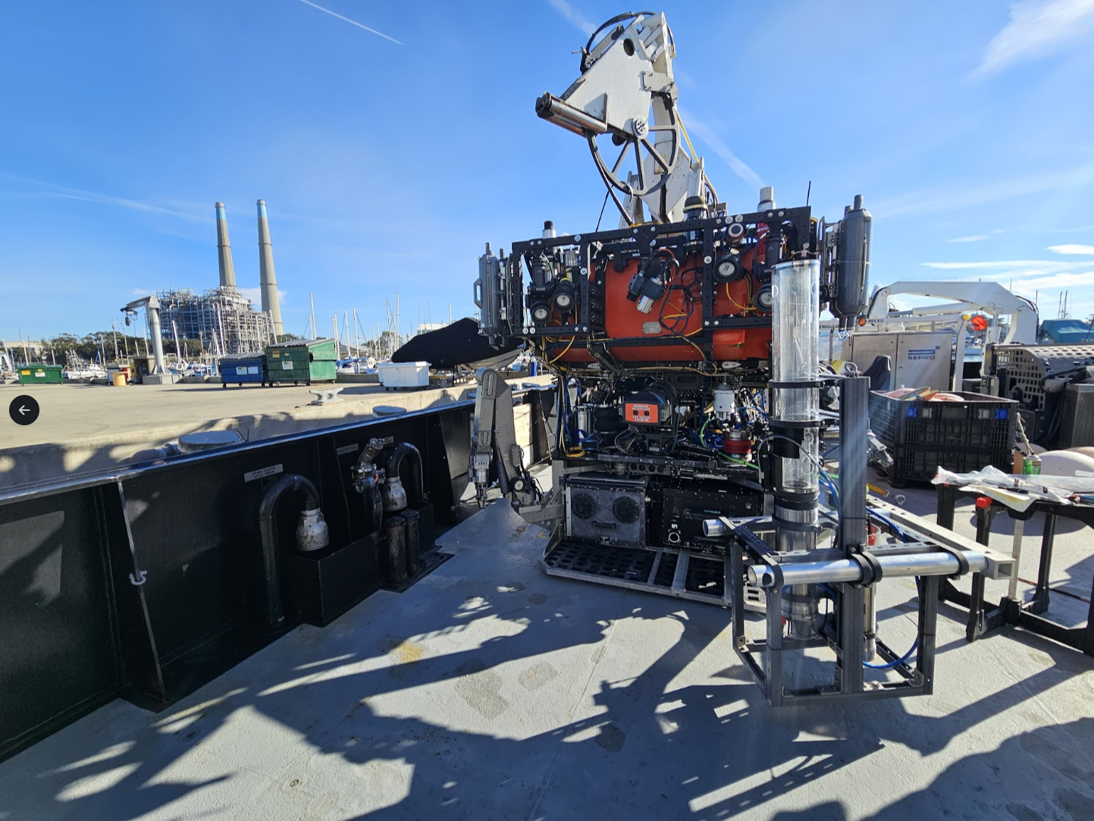
Figure 1: SINKER mounted on ROV Ventana awaiting deployment

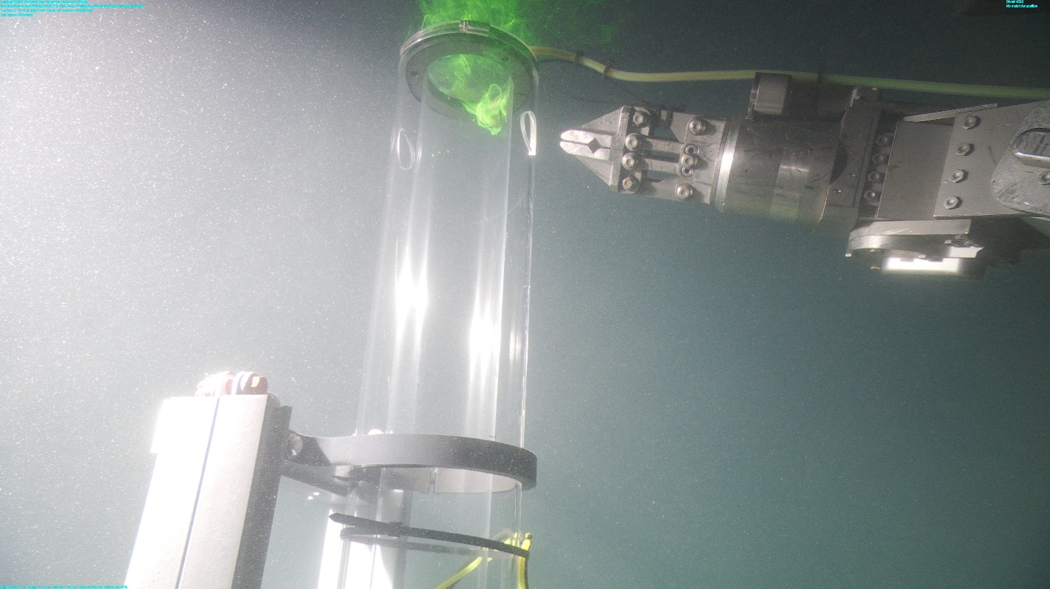
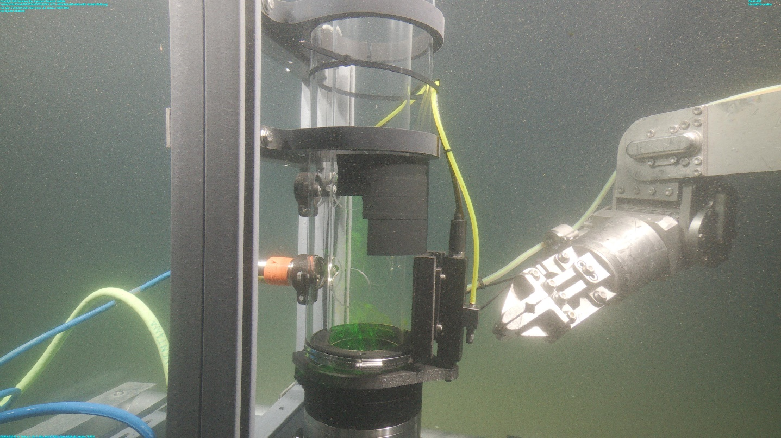
Figure 2: Visualizing flow inside the top and bottom of the SINKER sinking column using the Bioinspiration Lab dye injector attached to the starboard manipulator and MBARI 4k science camera.

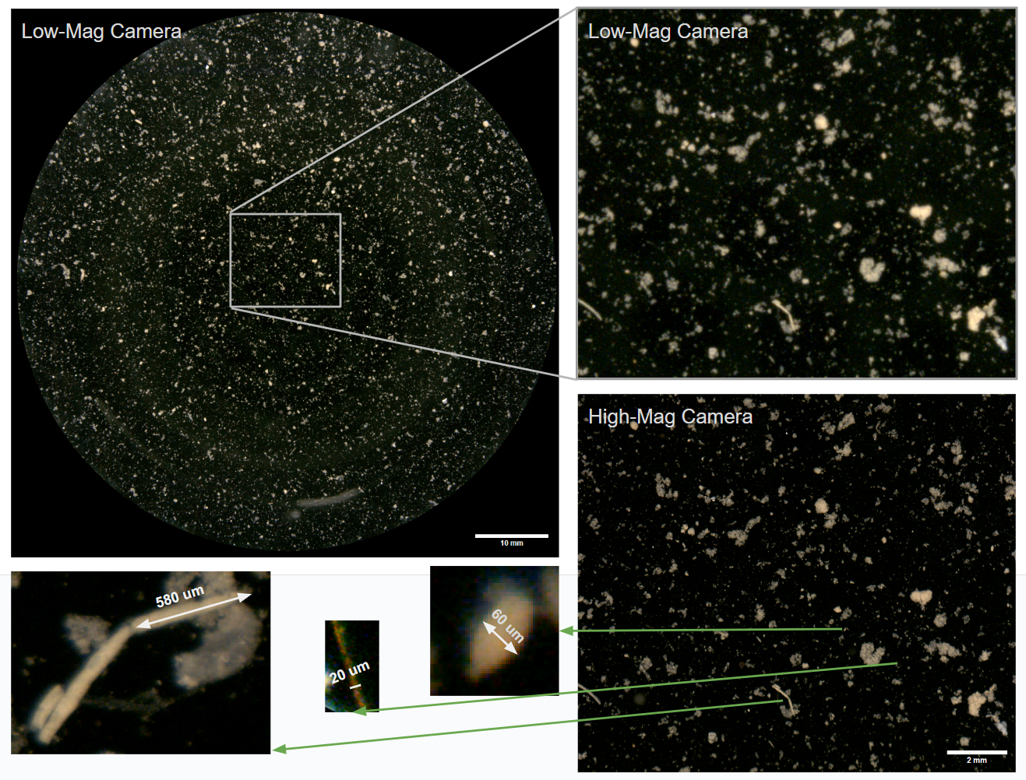
Figure 3: Example of sinking particle accumulation measured in both the low-mag and high-mag cameras. The high-mag camera (bottom right) is co-registered with the low-mag camera (top left, top right) providing views of the same particles with over 7x the magnification. Examples of identifiable fecal pellets and sinking particles selected from the high-mag image are shown in the bottom left with size scale.

